Topic-3
1)Code:
let price=1100.0
let q=3
let subtot = price * Double(q)
let hascoupon=true
var discount : Double = hascoupon && subtot>1000 ? 10.0 : 0
let dis = subtot - (subtot*discount/100)
let gst = dis*18/100
let tot = dis+gst
print("Each persons share: \(tot/4)")
let amount = 1234
let hundreds = amount / 100
let remainder = amount % 100
print("Hundreds: \(hundreds)")
print("Remainder: \(remainder)")

Output:
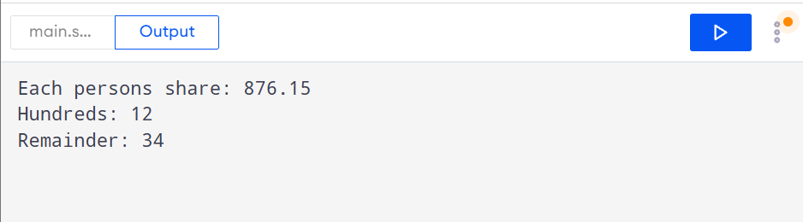
2)
func leap(_ n : Int) -> Bool{
if n%4 == 0 && n%100 != 0 {
return true
}
if n%400 == 0 {
return true
}
return false
}
print(leap(1900))
print(leap(2000))
print(leap(2024))
print(leap(2026))
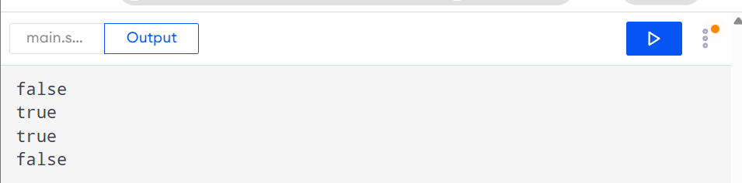
b)Code:
let n = 20
if (1...100).contains(n) {
print("It is between 1 to 100")
}
else {
print("Its not in range")
}
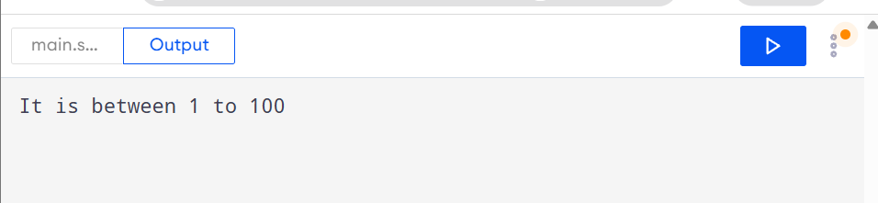
c)Code:
for i in 1...12 {
if i%2 == 0 && i%10 != 0 {
print("Follows condition: \(i)")
}
else {
print("Not Follows condition: \(i)")
}
}
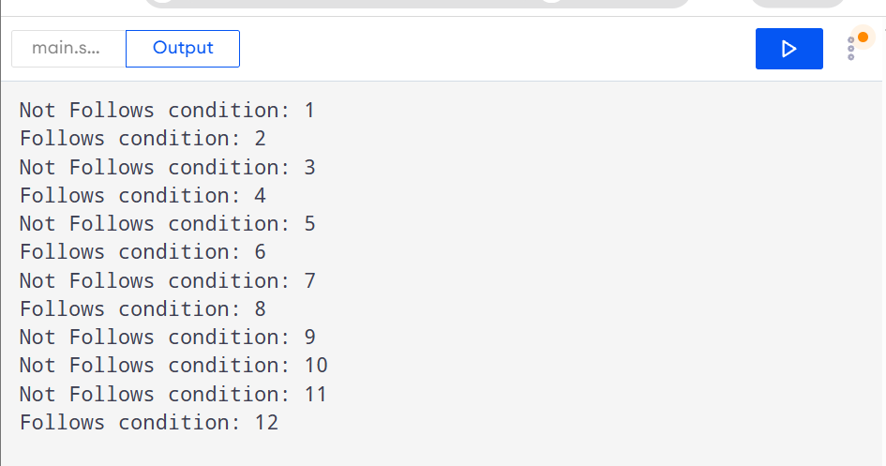
d)Code:
let nickname: String? = nil
print(nickname ?? "Guest")
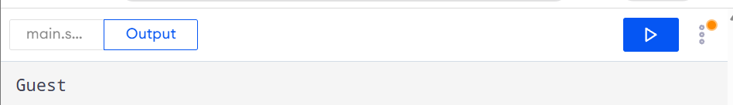
3)Output:
3
1
-1
3.5
6
true
8
2 7 5
0

