Topic -2
1)
Code:
let studentName = "Swathi"
let roll: String = "717823f257"
var semester: Int = 7
var cgpa: Double = 8.3
let isHosteller: Bool = true
print("name: \(studentName) , rollnumber: \(roll) , Semester: \(semester)")
semester += 1
cgpa = 9.0
print("Semester: \(semester) , cgpa: \(cgpa)")
studentName = "Swathi S"
print(type(of: studentName))
print(type(of: roll))
print(type(of: semester))
print(type(of: cgpa))
print(type(of: isHosteller))

Output:
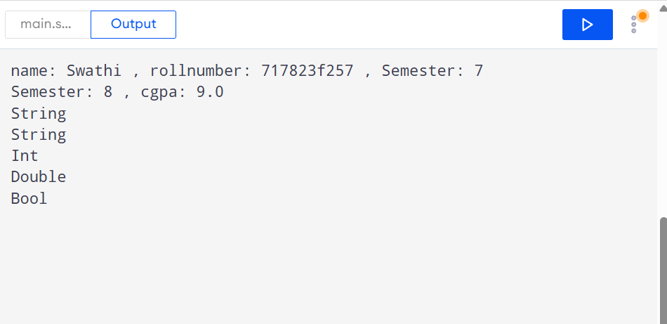
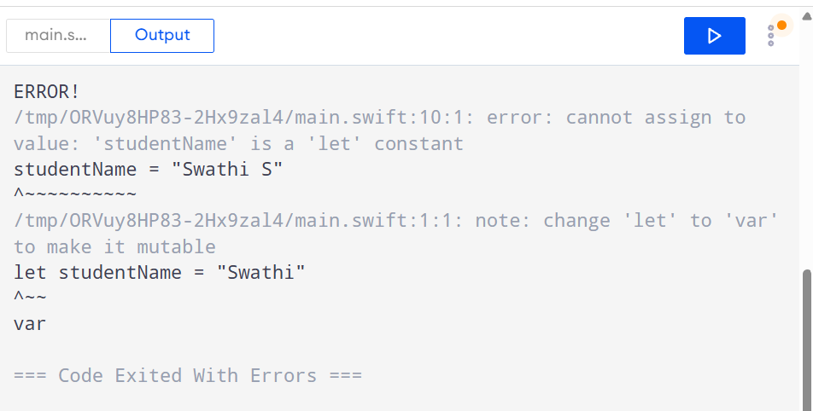

2)Code:
import Foundation
var celsius = 57.9
var f = (celsius*9/5 + 32)
var k = (celsius + 273.15)
print(String(format: "%.1f", f))
print(String(format: "%.1f", k))

print("Changing celsius value")
celsius = 10.9
f = (celsius*9/5 + 32)
k = (celsius + 273.15)
print(String(format: "%.1f", f))
print(String(format: "%.1f", k))
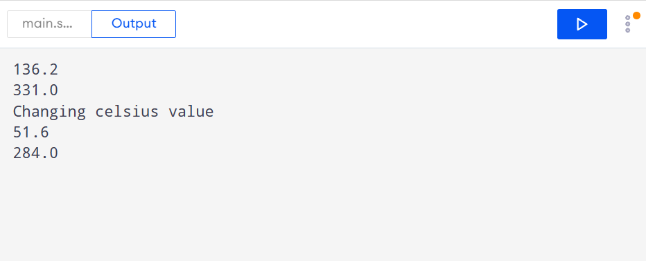
3)Output:
Errors are:
Int and Double do not mix
Constant value does not changes.
Assigning value of string to int
Corrceted code:
let price = 250
var quantity: Int = 3
let taxRate = 0.18
let total = Double(price) * Double(quantity) * taxRate
var title = "Order"
print(total)
Output:135.0

