1)
a)Code:
var lang: [String] = ["Swift", "UIKit", "SwiftUI"]
lang.append("Networking")
lang.insert("Testing", at: 1)
if let index = lang.firstIndex(of: "UIKit") {
lang.remove(at: index)
}
lang.sort()
print(lang)
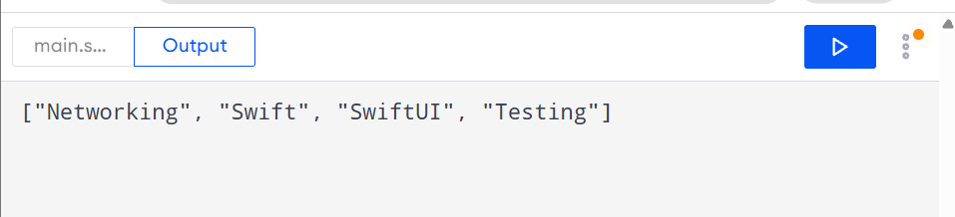
b)Code:
var names: Set<String> = ["Swathi","Tommy"]
names.insert("Swathi")
names.insert("Swathi")
print(names.count)
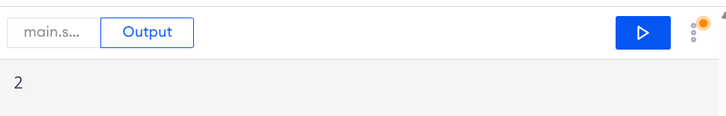
c)Code:
var stud: [String:Int] = [
"Java":90,
"Swift":40,
"Python":60
]
print(stud)
stud["C++"]=10
stud["Python"]=70
print(stud)
print(stud["Go"] ?? -1)
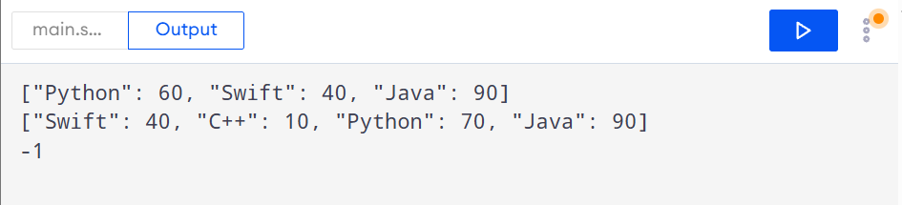
d)Code:
var stud: [String:Int] = [
"Java":90,
"Swift":40,
"Python":60
]
for (key,value) in stud {
print(key,value)
}
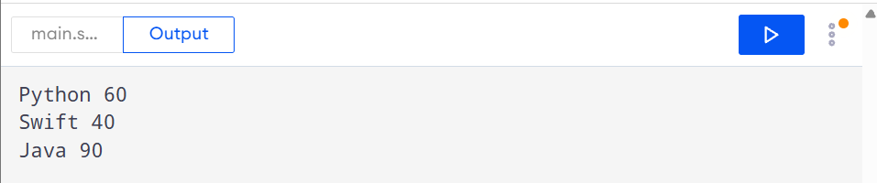
e)Code:
var stud: [String:Int] = [
"Java":90,
"Swift":40,
"Python":60
]
var max=0
var name=""
for (key,value) in stud {
if(value>max) {
max=value
name=key
}
}
print("\(name) : \(max)")

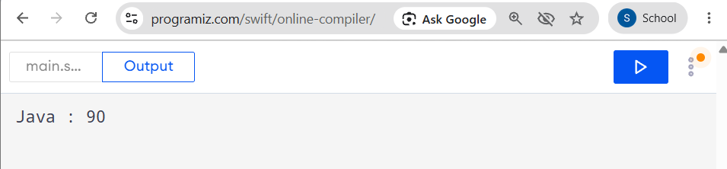
2)
Code:
var str:String = "swift is fun and swift is fast"
print("Length of string: \(str.count)")
var arr: [String] = str.split(separator: " ").map { String($0) }
var set:Set<String> = []
for i in 0..<arr.count {
set.insert(arr[i])
}
print("Length of set: \(set.count)")
var map: [String:Int]=[:]
for i in 0..<arr.count {
map[arr[i],default: 0]+=1
}

print("Frequency of wrds:")
for (key,value) in map {
print(key,value)
}
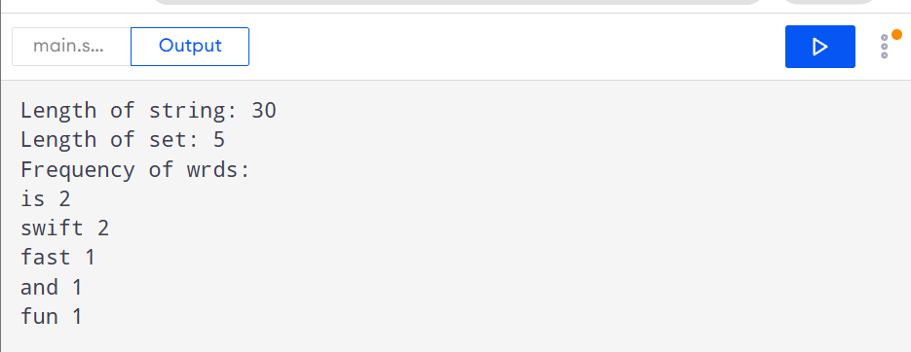
3)Code:
var swiftClub: [String] = ["Anu", "Ben", "Chitra",
"Dev"]
var uiClub: [String] = ["Chitra", "Dev", "Esha"]

var notboth: Set<String>=[]
for i in 0..<swiftClub.count {
if uiClub.contains(swiftClub[i]){
print(swiftClub[i])
}
else {
notboth.insert(swiftClub[i])
}
}

for name in notboth {
print(name)
}

for i in 0..<swiftClub.count {
print(swiftClub[i])
}
for i in 0..<uiClub.count {
print(uiClub[i])
}
var list: [Int] = [3, 1, 3, 2, 1,4]
var res: [Int] = []
for i in 0..<list.count {
if !res.contains(list[i]) {
res.append(list[i])
}
}
print(res)

