**WEEK_2_SOLUTIONS**

**EXERCISE 1 CONTROL STRUCTURES**

Scenario 1: The bank wants to apply a discount to loan interest rates for customers above 60 years old.

* + Question: Write a PL/SQL block that loops through all customers, checks their age, and if they are above 60, apply a 1% discount to their current loan interest rates.

Scenario 2: A customer can be promoted to VIP status based on their balance.

* + Question: Write a PL/SQL block that iterates through all customers and sets a flag IsVIP to TRUE for those with a balance over $10,000.

Scenario 3: The bank wants to send reminders to customers whose loans are due within the next 30 days.

* + Question: Write a PL/SQL block that fetches all loans due in the next 30 days and prints a reminder message for each customer.

**Step 1: Create Required Tables**

**Customers Table**

CREATE TABLE Customers (

CustomerID NUMBER PRIMARY KEY,

Name VARCHAR2(100),

Age NUMBER,

Balance NUMBER(10, 2),

LoanInterestRate NUMBER(5,2),

IsVIP VARCHAR2(5) DEFAULT 'FALSE'

);

**Loans Table**

CREATE TABLE Loans (

LoanID NUMBER PRIMARY KEY,

CustomerID NUMBER,

DueDate DATE,

FOREIGN KEY (CustomerID) REFERENCES Customers(CustomerID)

);

**OUTPUT**

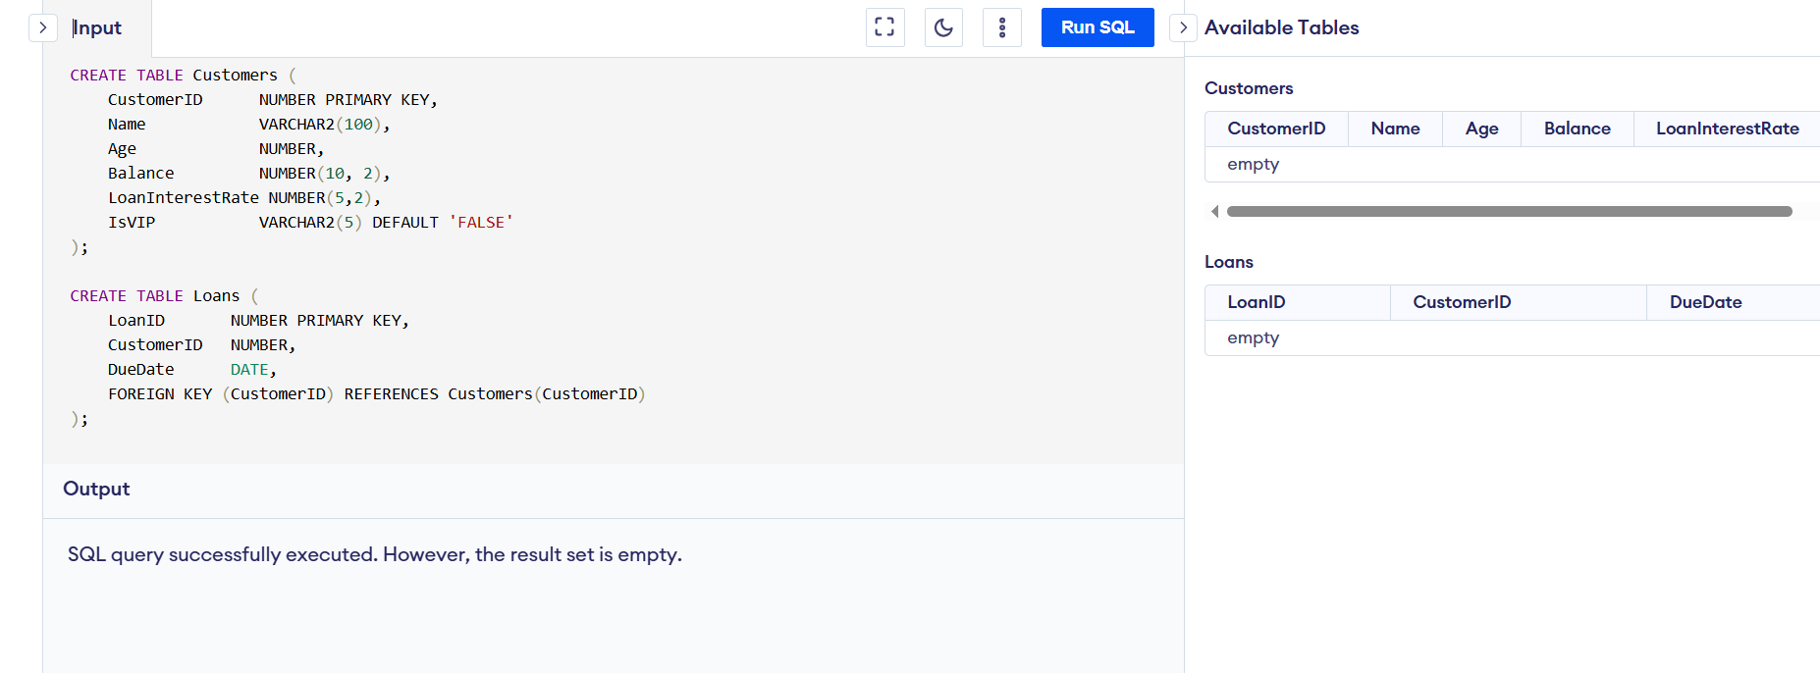

**Step 2: Insert Sample Data**

**➕ Insert into Customers**

INSERT INTO Customers VALUES (1, 'Ram Kumar', 65, 15000.00, 10.5, 'FALSE');

INSERT INTO Customers VALUES (2, 'Sneha P', 45, 8000.00, 9.0, 'FALSE');

INSERT INTO Customers VALUES (3, 'John', 62, 12000.00, 11.0, 'FALSE');

INSERT INTO Customers VALUES (4, 'Priya Ramesh', 35, 10500.00, 8.5, 'FALSE');

**➕ Insert into Loans**

INSERT INTO Loans VALUES (101, 1, DATE('now', '+15 days'));

INSERT INTO Loans VALUES (102, 2, DATE('now', '+40 days')); -- Not within 30 days

INSERT INTO Loans VALUES (103, 3, DATE('now', '+10 days'));

INSERT INTO Loans VALUES (104, 4, DATE('now', '+25 days'));

**OUTPUT:**

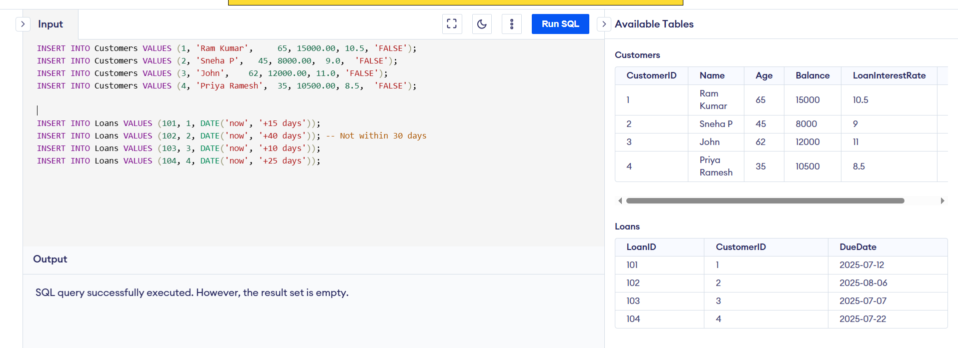

**Scenario 1: Apply Discount for Senior Customers**

**Problem**

If a customer is over 60 years old, reduce their current **loan interest rate** by 1%.

**PL/SQL Code**

UPDATE Customers

SET LoanInterestRate = LoanInterestRate - 1

WHERE Age > 60;

**OUTPUT:**

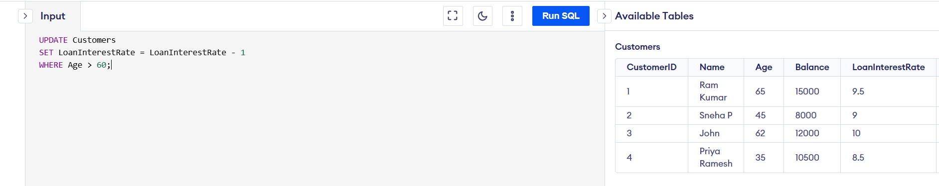

**Scenario 2: Promote Customers to VIP Based on Balance**

**Problem**

Mark customers with balance over $10,000 as **VIP** by setting IsVIP = TRUE.

**PL/SQL Code**

UPDATE Customers

SET IsVIP = 'TRUE'

WHERE Balance > 10000;

**OUTPUT:**

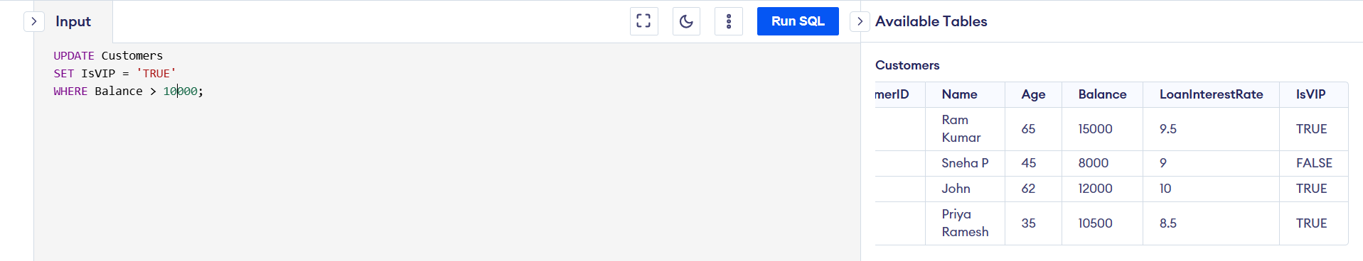

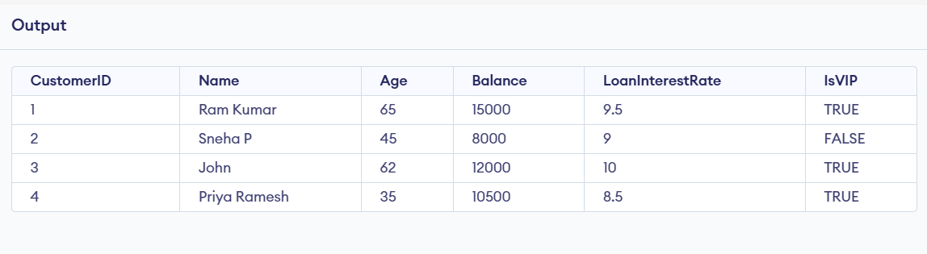

**Scenario 3: Loan Reminders for Due Loans**

**Problem**

Print reminders for loans that are due **within the next 30 days**.

**PL/SQL Code**

SELECT LoanID, CustomerID, DueDate

FROM Loans

WHERE DueDate BETWEEN DATE('now') AND DATE('now', '+30 days');

**OUTPUT:**

