Lab program-1(Insurance database)

Person table:

create table person(

-> drive_id int(10),

-> name varchar(30),

-> address varchar(30),

-> primary key(drive_id));

Car table:

create table car(

-> reg_no varchar(20),

-> model varchar(20),

-> year int(10),

-> primary key(reg_no));

Accident:

create table accidentt(

-> rep_no int(10),

-> date date,

-> location varchar(30),

-> primary key(rep_no));

Owns:

create table owns(

-> drive_id int(10),

-> reg_no varchar(20),

-> primary key(drive_id),

-> foreign key(drive_id) references person(drive_id),

-> foreign key(reg_no) references car(reg_no));

Participated:

create table participated(

-> drive_id int(10),

-> reg_no varchar(20),

-> rep_no int(10),

-> damage_amt int,

-> primary key(drive_id),

-> foreign key(drive_id) references person(drive_id),

-> foreign key(reg_no) references car(reg_no),

-> foreign key(rep_no) references accident(rep_no));

->Select * from person;

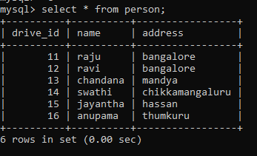

->Select * from car;

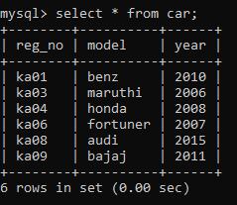

->Select * from accident;

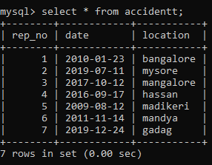

->Select * from owns;

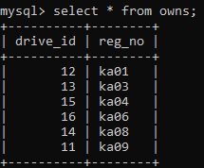

->Select * from participated;

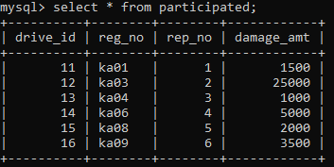

Query-1;

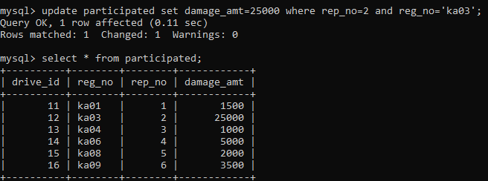

Query-2:

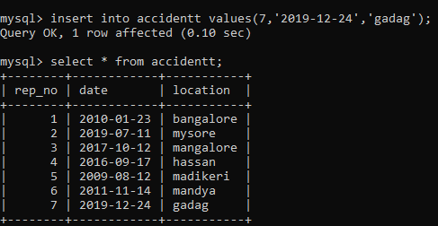

Query-3:

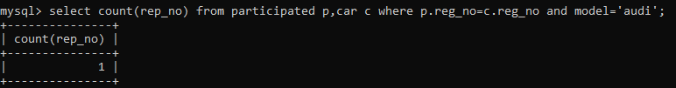

Query-4:

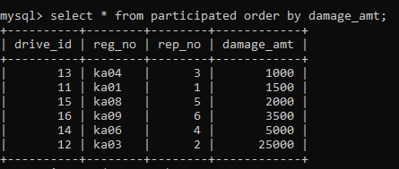

Query-5:

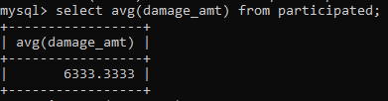

Query-6:

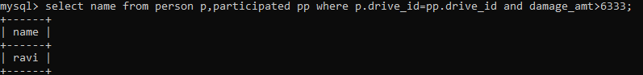

Query-7:

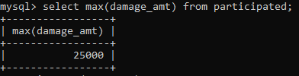

Lab program-2(Bank Database)

Branch;

Create table branch(

Branch_name varchar(30),

Branch_city varchar(30),

Assets varchar(30),

Primary key(branch_name));

Accounts;

Create table accounts(

Acc_no int,

Branch_name varchar(30),

Balance int,

Primary key(acc_no));

Loan;

create table loan(

-> loan_num int,

-> branch_name varchar(30),

-> amt int,

-> primary key(loan_num)

-> foreign key(branch_name) references branch(branch_name));

Customer:

create table customer(

-> cust_name varchar(30),

-> cust_street varchar(30),

-> cust_city varchar(30),

-> primary key (cust_name));

Depositer:

create table depositer(

-> cust_name varchar(30),

-> acc_no int,

-> primary key(cust_name,acc_no),

-> foreign key(cust_name) references customer(cust_name),

-> foreign key(acc_no) references accounts(acc_no));

->Select * from branch;

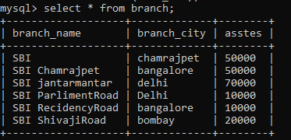

Select * from customer;

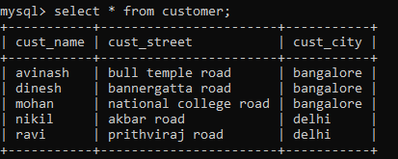

Select * from loan;

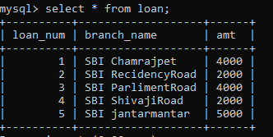

Select * from depositer;

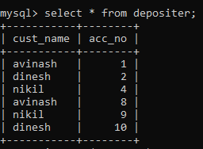

Select * from accounts;

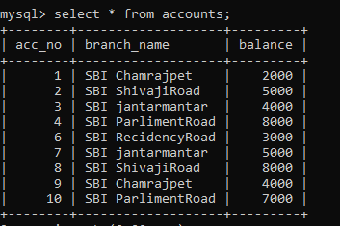

Lab program-03(Supplier database)

Supplier :

create table supplier(

-> sid int,

-> sname varchar(30),

-> address varchar (30),

-> primary key(sid));

Parts:

create table parts (

-> pid int,

-> pname varchar(30),

-> color varchar(20),

-> primary key(pid));

Catalog:

create table catalog(

-> sid int,

-> pid int,

-> cost real,

-> primary key(sid,pid),

-> foreign key(sid) references supplier(sid),

-> foreign key(pid) references parts(pid));

->Select * from supplier;

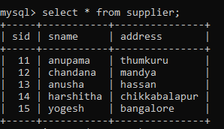

->Select * from parts;

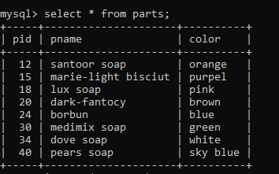

->Select * from catalog;

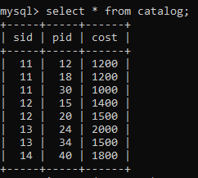

->Query-1

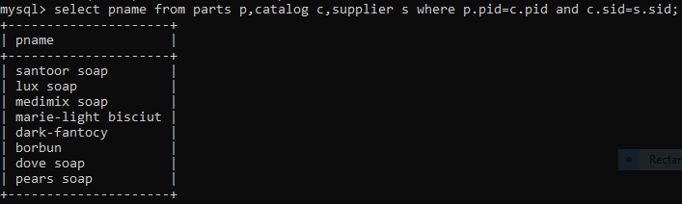

->Query-2

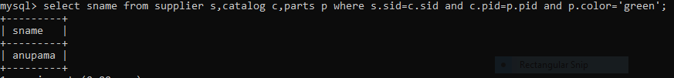

->Query-3

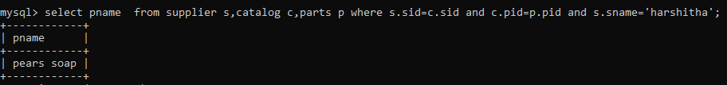

->Query-4

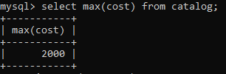

->Query-5

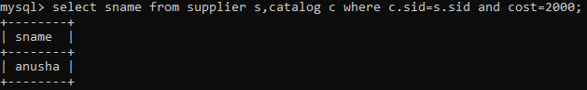

Lab program-04(Student faculty database)

Student:

create table student(

-> snum int,

-> sname varchar(30),

-> major varchar(10),

-> level varchar(10),

-> age int,

-> primary key(snum));

Faculty:

create table faculty(

-> fid int,

-> fname varchar(30),

-> dep_id int,

-> primary key(fid));

Class:

create table class(

-> cname varchar(10),

-> meets_at time,

-> room int,

-> fid int,

-> primary key(cname),

-> foreign key(fid) references faculty(fid));

Enrolled:

ctreate table enrolled(

-> snum int,

-> cname varchar(10),

-> primary key(snum,cname),

-> foreign key(snum) references student(snum),

-> foreign key(cname) references class(cname));

->Select * from student;

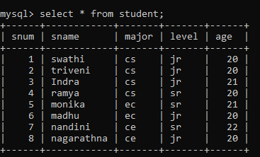

->Select * from faculty;

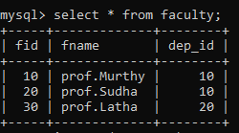

->Select * from class;

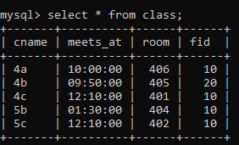

->Select * from enrolled;

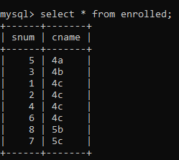

->Query1;

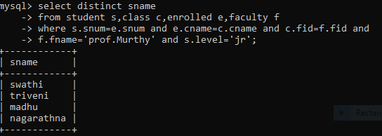

->Query2;

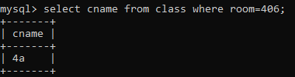

->query3;

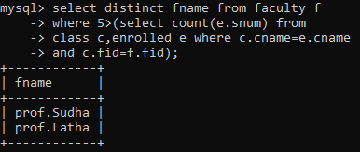

->query4;

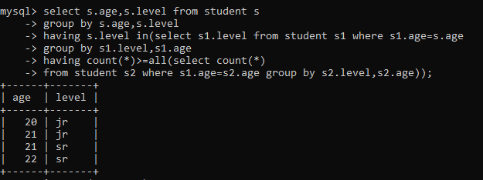

Lab program-05(Movie database)

Actor:

create table actor(

-> act_id int,

-> act_name varchar(30),

-> act_gender varchar(10),

-> primary key(act_id));

Director:

create table director(

-> dir_id int,

-> dir_name varchar(30),

-> dir_phone int,

-> primary key(dir_id));

Movies:

create table movies(

-> mov_id int,

-> mov_title varchar(20),

-> mov_year int,

-> mov_lang varchar(20),

-> dir_id int,

-> primary key(mov_id),

-> foreign key(dir_id) references director(dir_id));

Movie_cast:

create table movie_cast(

-> act_id int,

-> mov_id int,

-> role varchar(15),

-> primary key(act_id,mov_id),

-> foreign key(act_id) references actor(act_id),

-> foreign key(mov_id) references movies(mov_id));

Rating:

create table rating(

-> mov_id int,

-> rev_stars int,

-> primary key(mov_id),

-> foreign key(mov_id) references movies(mov_id));

->Select * from actor;

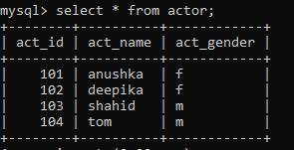

->Select * from director;

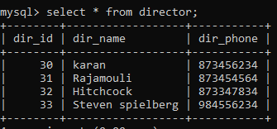

->Select * from movies;

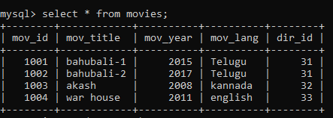

->Select * from movie_cast;

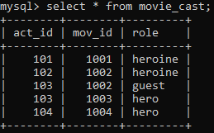

->Select * from rating;

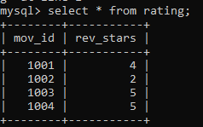

->Query-1

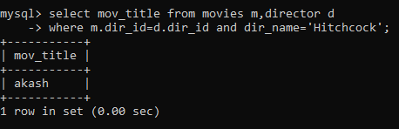

->Query-2

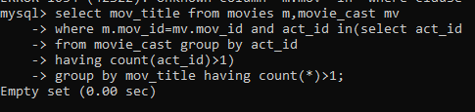

->Query-3

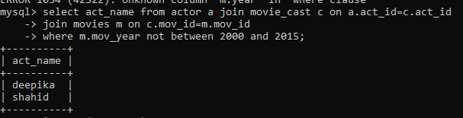

->Query-4

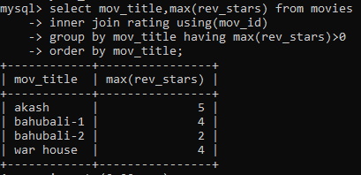

->query-5

