**SWATHY KRISHNA P R**

**RMCA B**

**ROLL NO: 31**

**EXPERIMENT 2**

**1**.

public class complex{

double a, b;

complex(double r, double i){

this.a = r;

this.b = i;

}

public static complex sum(complex c1, complex c2)

{

complex temp = new complex(0, 0);

temp.a = c1.a + c2.a;

temp.b = c1.b+ c2.b;

return temp;

}

public static void main(String args[]) {

complex c1 = new complex(12, 5);

complex c2 = new complex(8, 4.5);

complex temp = sum(c1, c2);

System.out.printf("\nSum = "+ temp.a+" + "+ temp.b +"i");

}

}

**OUTPUT**

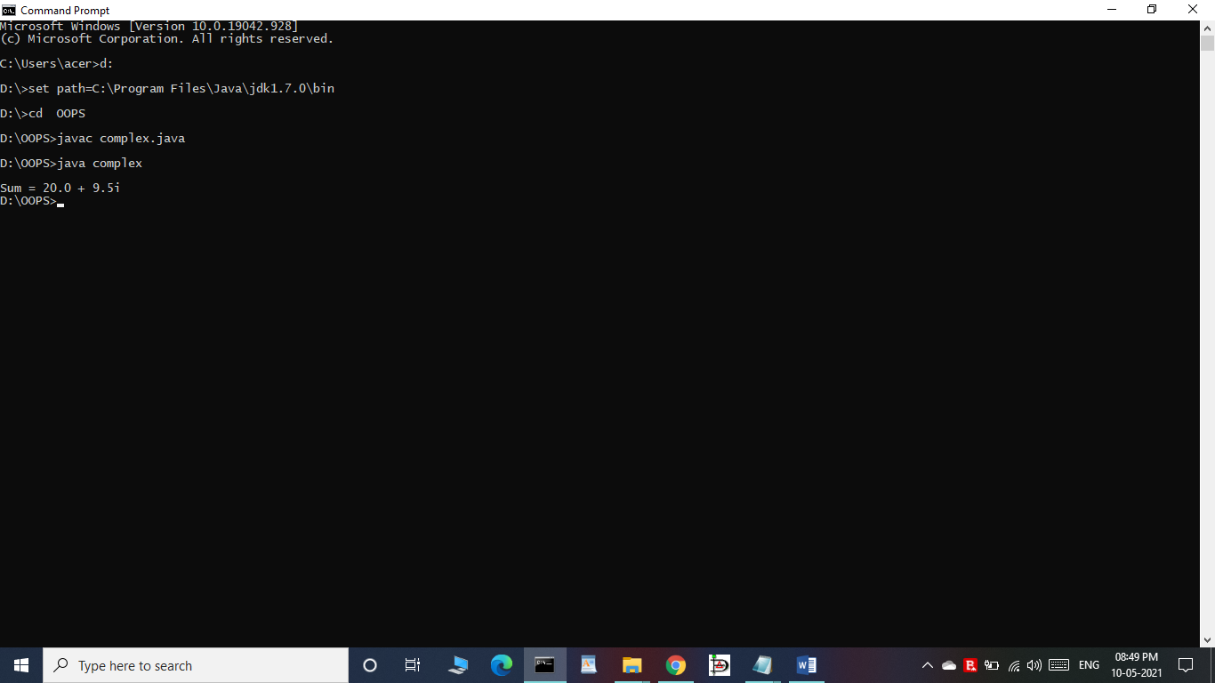

**2.**

public class product {

int pcode;

String pname;

int price;

public static void main(String[] args) {

int smallest;

product p1 = new product();

product p2 = new product();

product p3 = new product();

p1.pcode=1001;

p1.pname="RAM";

p1.price=7000;

p2.pcode=1002;

p2.pname="Processor";

p2.price=37000;

p3.pcode=1001;

p3.pname="SSD";

p3.price=16700;

if(p1.price<p2.price) {

if(p3.price<p1.price) {

smallest = p3.price;

} else {

smallest = p1.price;

}

} else {

if(p2.price<p3.price) {

smallest = p2.price;

} else {

smallest = p3.price;

}

}

System.out.println(smallest + " is the cheapest");

}

}

**OUTPUT**

