**Co1-2-Read 2 matrices from the console and perform matrix addition**

import java.util.*;

class matrixadd{

public static void main(String[] args)

{

int row,col,i,j;

Scanner sc=new Scanner(System.in);

System .out.print("enter the no of rows:");

row=sc.nextInt();

System .out.print("enter the no of columns:");

col=sc.nextInt();

int mat1[][]=new int[row][col];

int mat2[][]=new int[row][col];

int mat3[][]=new int[row][col];

System.out.print("enter the elements of matrix1 :");

for(i=0;i<row;i++)

{

for(j=0;j<col;j++)

{

mat1[i][j]=sc.nextInt();

}

System.out.println();

}

System.out.print("enter the elements of matrix2 :");

for(i=0;i<row;i++)

{

for(j=0;j<col;j++)

{

mat2[i][j]=sc.nextInt();

}

System.out.println();

}

for(i=0;i<row;i++)

{

for(j=0;j<col;j++)

{

mat3[i][j]=mat1[i][j]+mat2[i][j];

}

}

System.out.print("sum of matrix :");

for(i=0;i<row;i++)

{

for(j=0;j<col;j++)

{

System.out.print(mat3[i][j]+"\t");

}

System.out.println();

}

}

}

**OUTPUT**

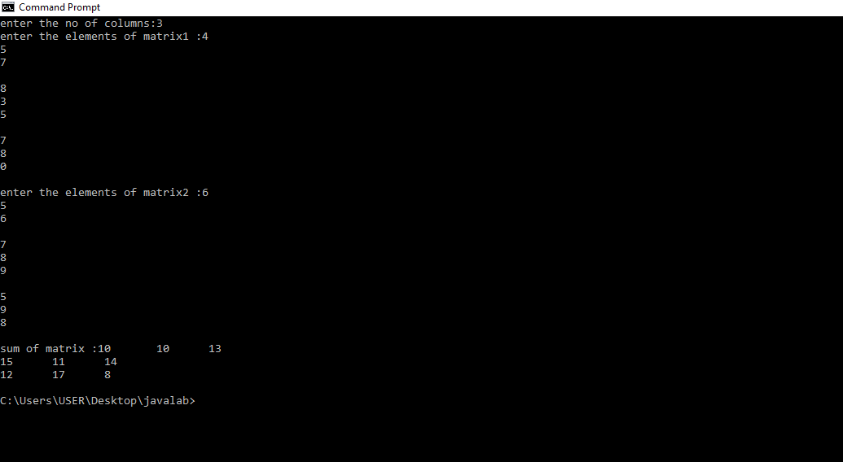

**C01-4-Read a matrix from the console and check whether it is symmetric or not**

**CODE**

import java.util.Scanner;

public class Symmetric

{

public static void main(String[] args)

{

Scanner sc = new Scanner(System.in);

System.out.println("Enter the no. of rows : ");

int rows = sc.nextInt();

System.out.println("Enter the no. of columns : ");

int cols = sc.nextInt();

int matrix[][] = new int[rows][cols];

System.out.println("Enter the elements :");

for (int i = 0; i < rows; i++)

{

for (int j = 0; j < cols; j++)

{

matrix[i][j] = sc.nextInt();

}

}

System.out.println("Printing the input matrix :");

for (int i = 0; i < rows; i++)

{

for (int j = 0; j < cols; j++)

{

System.out.print(matrix[i][j]+"\t");

}

System.out.println();

}

if(rows != cols)

{

System.out.println("The given matrix is not a square matrix, so it can't be symmetric.");

}

else

{

boolean symmetric = true;

for (int i = 0; i < rows; i++)

{

for (int j = 0; j < cols; j++)

{

if(matrix[i][j] != matrix[j][i])

{

symmetric = false;

break;

}

}

}

if(symmetric)

{

System.out.println("The given matrix is symmetric...");

}

else

{

System.out.println("The given matrix is not symmetric...");

}

}

sc.close();

}

}

**Output**

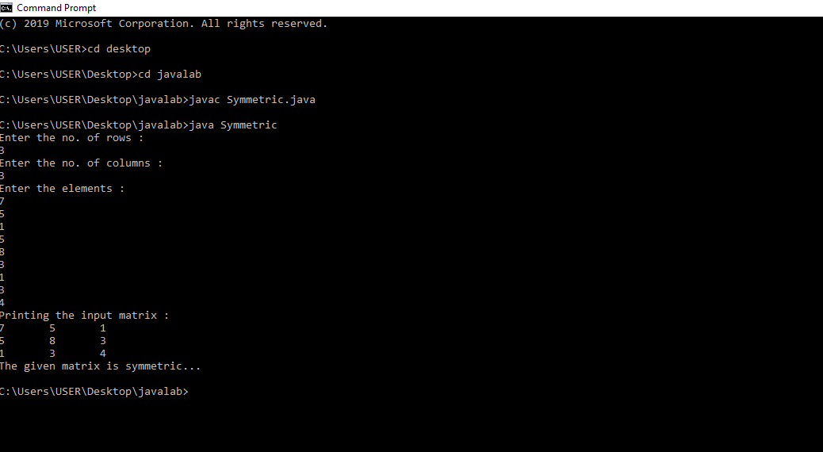

**C01-5-Create CPU with attribute price. Create inner class Processor (no. of cores, manufacturer) and static nested class RAM (memory, manufacturer). Create an object of CPU and print information of Processor and RAM.**

**CODE**

class CPU {

double price=27000;

class Processor{

double cores=8;

String manufacturer="Intel";

}

protected class RAM{

double memory=16;

String manufacturer="OWC";

}

}

public class Main2 {

public static void main(String[] args) {

CPU cpu = new CPU();

CPU.Processor processor = cpu.new Processor();

CPU.RAM ram = cpu.new RAM();

System.out.println("CPU price = " + cpu.price);

System.out.println("Processor cores = " + processor.cores);

System.out.println("Processor manufacturer = " + processor.manufacturer);

System.out.println("RAM memory = " + ram.memory);

System.out.println("RAM manufacturer = " + ram.manufacturer);

}

}

