**1)**

interface student

{

void stresullt();

}

interface sports

{

void spresult();

}

class result implements student,sports{

public void spresult()

{

String hundred="First";

String twohundred="Second";

String fivehundred="First";

String relay="Second";

System.out.println("Sports Result");

System.out.println("Hundred Meter:"+hundred);

System.out.println("Two Hundred Meter:"+twohundred);

System.out.println("Five Hundred Meter:"+fivehundred);

System.out.println("Relay:"+relay);

}

public void stresullt()

{

int physics=30;

int chemistry=40;

int maths=45;

int english=50;

int computer=50;

System.out.println("Marks");

System.out.println("Physics:"+physics);

System.out.println("Chemistry:"+chemistry);

System.out.println("Mathematics:"+maths);

System.out.println("English:"+english);

System.out.println("Computer:"+computer);

}

public static void main(String[] args)

{

result r = new result();

r.stresullt();

r.spresult();

}

}

**Output**

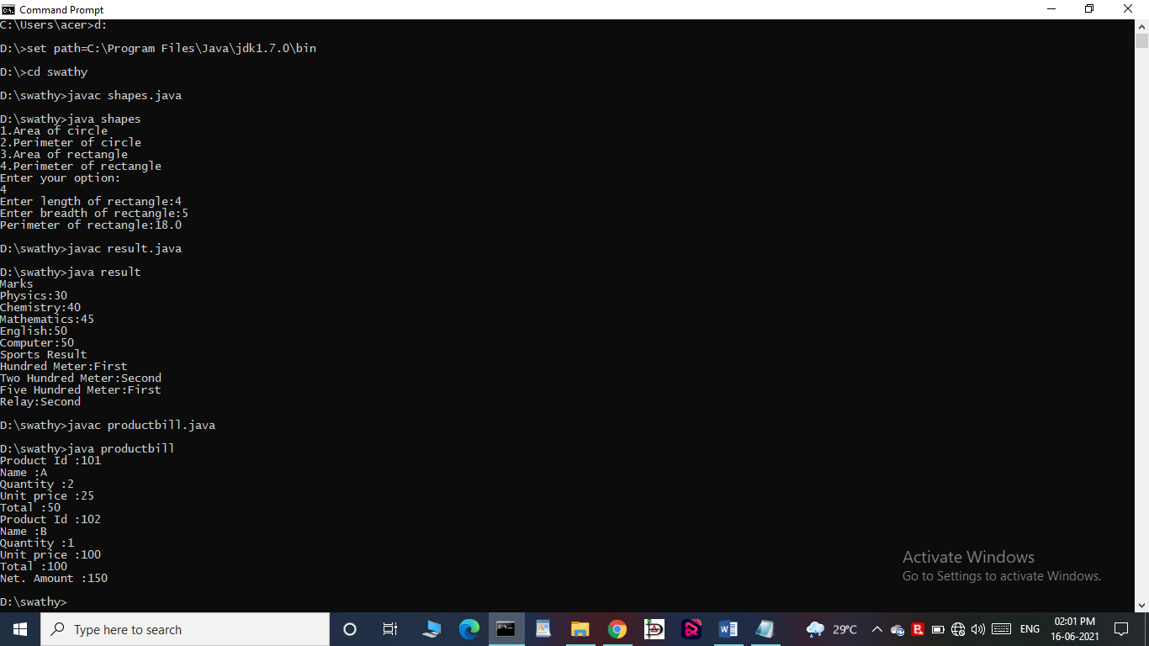

**2)**

import java.util.Scanner;

interface Shape

{

void input();

void area();

void perimeter();

}

class Circle implements Shape

{

int r = 0;

double pi = 3.14, ar = 0,per=0;

public void input()

{ Scanner s = new Scanner(System.in);

System.out.print("Enter radius of circle:");

r= s.nextInt();

}

public void area()

{

ar = pi * r * r;

System.out.println("Area of circle:"+ar);

}

public void perimeter()

{

per = 2 * pi * r;

System.out.println("Perimeter of circle:"+per);

}

}

class Rectangle implements Shape

{

int l = 0, b = 0;

double ar,per;

public void input()

{ Scanner s = new Scanner(System.in);

System.out.print("Enter length of rectangle:");

l = s.nextInt();

System.out.print("Enter breadth of rectangle:");

b = s.nextInt();

}

public void area()

{

ar = l * b;

System.out.println("Area of rectangle:"+ar);

}

public void perimeter()

{

per = 2 * (l + b);

System.out.println("Perimeter of rectangle:"+per);

}

}

public class shapes

{

public static void main(String[] args)

{ int n;

Scanner s = new Scanner(System.in);

Rectangle obj1 = new Rectangle();

Circle obj2 = new Circle();

System.out.println("1.Area of circle");

System.out.println("2.Perimeter of circle");

System.out.println("3.Area of rectangle");

System.out.println("4.Perimeter of rectangle");

System.out.println("Enter your option:");

n= s.nextInt();

switch(n) {

case 1:

obj2.input();

obj2.area();

break;

case 2:

obj2.input();

obj2.perimeter();

break;

case 3:

obj1.input();

obj1.area();

break;

case 4:

obj1.input();

obj1.perimeter();

break;

default:

System.out.println("Invalid option");

}

}

}

**Output**



**3)**

interface bill

{

int productdetails();

}

class product1 implements bill{

int id = 101,quantity= 2,unit=25,total=0;

String name="A";

public int productdetails()

{

total = quantity * unit;

System.out.println("Product Id :"+id);

System.out.println("Name :"+name);

System.out.println("Quantity :"+quantity);

System.out.println("Unit price :"+unit);

System.out.println("Total :"+total);

return(total);

}

}

class product2 implements bill{

int id = 102,quantity= 1,unit=100,total=0;

String name="B";

public int productdetails()

{

total = quantity * unit;

System.out.println("Product Id :"+id);

System.out.println("Name :"+name);

System.out.println("Quantity :"+quantity);

System.out.println("Unit price :"+unit);

System.out.println("Total :"+total);

return(total);

}

}

public class productbill

{

public static void main(String[] args)

{

product1 p1 = new product1();

product2 p2 = new product2();

int t1= p1.productdetails();

int t2= p2.productdetails();

int t3=t1+t2;

System.out.println("Net. Amount :"+t3);

}

}

**Output**

