**1. Navigation**

**MainActivity.java**

package com.example.sample;

import androidx.annotation.NonNull;

import androidx.appcompat.app.ActionBarDrawerToggle;

import androidx.appcompat.app.AppCompatActivity;

import androidx.drawerlayout.widget.DrawerLayout;

import android.os.Bundle;

import android.view.MenuItem;

public class MainActivity extends AppCompatActivity {

DrawerLayout drawerLayout;

ActionBarDrawerToggle actionBarDrawerToggle;

@Override

protected void onCreate(Bundle savedInstanceState) {

super.onCreate(savedInstanceState);

setContentView(R.layout.activity_main);

drawerLayout=findViewById(R.id.drawerLayout);

actionBarDrawerToggle=new ActionBarDrawerToggle(this,drawerLayout,R.string.nav_open,R.string.nav_close);

drawerLayout.addDrawerListener(actionBarDrawerToggle);

actionBarDrawerToggle.syncState();

getSupportActionBar().setDisplayHomeAsUpEnabled(true);

}

@Override

public boolean onOptionsItemSelected(@NonNull MenuItem item) {

if(actionBarDrawerToggle.onOptionsItemSelected(item))

{

return true;

}

return super.onOptionsItemSelected(item);

}

}

**Activity_main.xml**

<?xml version="1.0" encoding="utf-8"?>

<androidx.drawerlayout.widget.DrawerLayout xmlns:android="http://schemas.android.com/apk/res/android"

xmlns:app="http://schemas.android.com/apk/res-auto"

xmlns:tools="http://schemas.android.com/tools"

android:layout_width="match_parent"

android:layout_height="match_parent"

android:id="@+id/drawerLayout"

tools:context=".MainActivity">

<LinearLayout

android:layout_width="match_parent"

android:layout_height="wrap_content"

android:orientation="vertical">

<TextView

android:layout_width="wrap_content"

android:layout_height="wrap_content"

android:text="NavigationDrawer"

android:textSize="20dp"

android:layout_gravity="center"/>

</LinearLayout>

<com.google.android.material.navigation.NavigationView

android:layout_width="wrap_content"

android:layout_height="match_parent"

android:layout_gravity="start"

app:menu="@menu/navigation_menu"/>

</androidx.drawerlayout.widget.DrawerLayout>

**Navigation_menu.xml**

<?xml version="1.0" encoding="utf-8"?>

<menu xmlns:android="http://schemas.android.com/apk/res/android">

<item

android:id="@+id/ac"

android:title="My Account"

android:icon="@drawable/img" />

<item

android:id="@+id/se"

android:title="My Settings"

android:icon="@drawable/img_2" />

<item

android:id="@+id/lg"

android:title="Logout"

android:icon="@drawable/img_4" />

</menu>

**String.xml**

<resources>

<string name="app_name">Sample</string>

<string name="nav_open">Open</string>

<string name="nav_close">Close</string>

</resources>

**OUTPUT**

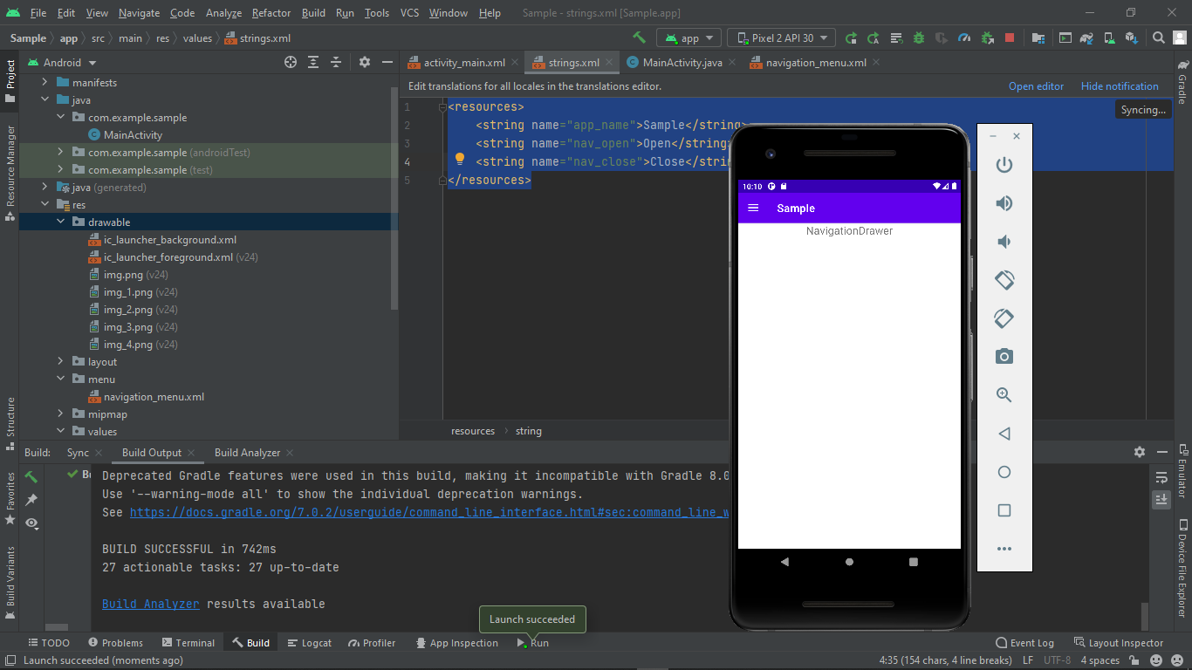 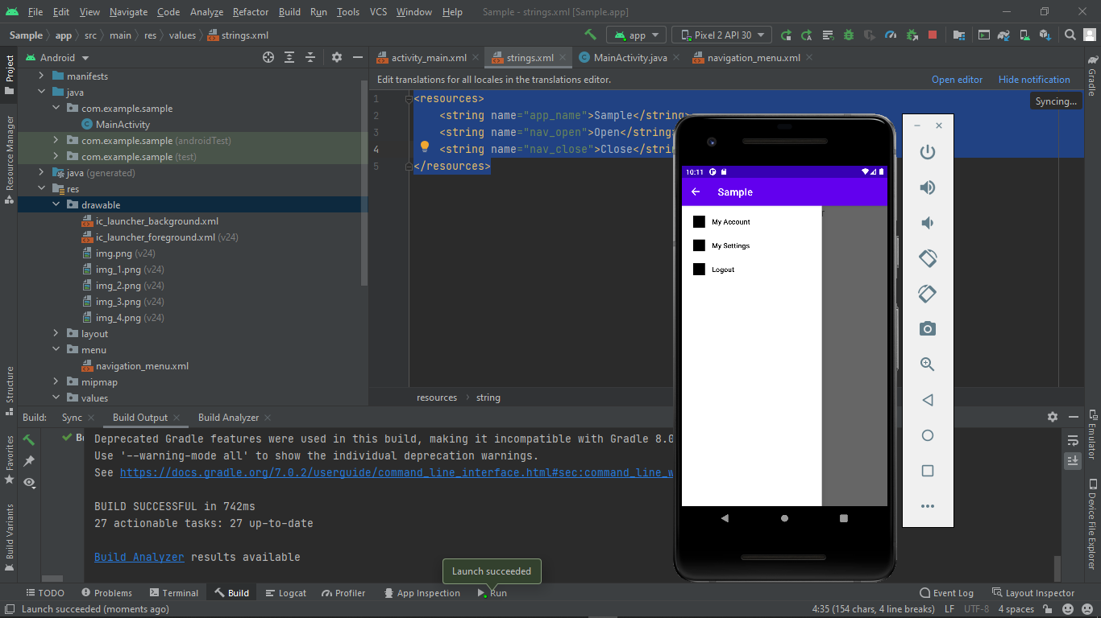

**2. Spinner**

**MainActivity.java**

package com.example.spinner;

import androidx.appcompat.app.AppCompatActivity;

import android.content.Context;

import android.os.Bundle;

import android.view.View;

import android.widget.AdapterView;

import android.widget.ArrayAdapter;

import android.widget.Spinner;

import android.widget.Toast;

public class MainActivity extends AppCompatActivity implements AdapterView.OnItemSelectedListener {

String[] course={"BTECH","BCA","MCA","CIVIL","CSS"};

@Override

protected void onCreate(Bundle savedInstanceState) {

super.onCreate(savedInstanceState);

setContentView(R.layout.activity_main);

Spinner spin=(Spinner) findViewById(R.id.spinner);

spin.setOnItemSelectedListener(this);

ArrayAdapter a =new ArrayAdapter(this,android.R.layout.simple_spinner_item,course);

a.setDropDownViewResource(android.R.layout.simple_spinner_dropdown_item);

spin.setAdapter(a);

}

@Override

public void onItemSelected(AdapterView<?> arg0, View arg1, int position, long id) {

Toast.makeText(getApplicationContext(),course[position], Toast.LENGTH_SHORT).show();

}

@Override

public void onNothingSelected(AdapterView<?> arg1) {

}

}

**Activity_main.xml**

<?xml version="1.0" encoding="utf-8"?>

<androidx.constraintlayout.widget.ConstraintLayout xmlns:android="http://schemas.android.com/apk/res/android"

xmlns:app="http://schemas.android.com/apk/res-auto"

xmlns:tools="http://schemas.android.com/tools"

android:layout_width="match_parent"

android:layout_height="match_parent"

tools:context=".MainActivity">

<Spinner

android:id="@+id/spinner"

android:layout_width="149dp"

android:layout_height="40dp"

android:layout_marginStart="8dp"

android:layout_marginEnd="8dp"

android:layout_marginBottom="8dp"

app:layout_constraintBottom_toBottomOf="parent"

app:layout_constraintEnd_toEndOf="parent"

app:layout_constraintStart_toStartOf="parent"

app:layout_constraintTop_toTopOf="parent"

app:layout_constraintVertical_bias="0.409" />

</androidx.constraintlayout.widget.ConstraintLayout>

**OUTPUT**

