**1. Write a program to create alertbox and popup messages**

**Menu.xml**

<?xml version="1.0" encoding="utf-8"?>

<menu xmlns:android="http://schemas.android.com/apk/res/android">

<item android:id="@+id/item1" android:title="AlertDialog" android:icon="@drawable/ic_launcher_background"/>

<item android:id="@+id/item2" android:title="Popup"/>

</menu>

**MainActivity.java**

package com.example.alertdialog;

import androidx.appcompat.app.AppCompatActivity;

import android.app.AlertDialog;

import android.content.DialogInterface;

import android.os.Bundle;

import android.view.Menu;

import android.view.MenuItem;

import android.view.View;

import android.widget.Button;

import android.widget.EditText;

import android.widget.TextView;

import android.widget.Toast;

public class MainActivity extends AppCompatActivity {

AlertDialog.Builder builder;

AlertDialog alertDialog;

EditText e1,e2;

Button b;

TextView t;

@Override

public boolean onCreateOptionsMenu(Menu menu) {

// Inflate the menu; this adds items to the action bar if it is present.

getMenuInflater().inflate(R.menu.menu, menu);

return true;

}

@Override

public boolean onOptionsItemSelected(MenuItem item){

switch (item.getItemId()){

case R.id.item1:

builder=new AlertDialog.Builder(MainActivity.this);

builder.setMessage("Do You Want To Close?").setTitle("AlertDialog").setPositiveButton("Ok", new DialogInterface.OnClickListener() {

@Override

public void onClick(DialogInterface dialog, int which) {

finish();

}

}).setNegativeButton("Cancel", new DialogInterface.OnClickListener() {

@Override

public void onClick(DialogInterface dialog, int which) {

dialog.dismiss();

}

});

alertDialog= builder.create();

alertDialog.show();

return true;

case R.id.item2:

builder = new AlertDialog.Builder(MainActivity.this);

View popupView=getLayoutInflater().inflate(R.layout.popup,null);

builder.setView(popupView);

alertDialog= builder.create();

alertDialog.show();

Toast.makeText(getApplicationContext(), "Help", Toast.LENGTH_SHORT).show();

return true;

default:

return super.onOptionsItemSelected(item);

}

}

@Override

protected void onCreate(Bundle savedInstanceState) {

super.onCreate(savedInstanceState);

setContentView(R.layout.activity_main);

}

}

**Popup.xml**

<?xml version="1.0" encoding="utf-8"?>

<LinearLayout xmlns:android="http://schemas.android.com/apk/res/android"

xmlns:app="http://schemas.android.com/apk/res-auto"

android:layout_width="match_parent"

android:layout_height="match_parent"

android:orientation="vertical">

<ImageView

android:id="@+id/imageView2"

android:layout_width="wrap_content"

android:layout_height="200dp"

android:layout_weight="1"

app:srcCompat="@drawable/ic_launcher_background" />

<TextView

android:layout_width="wrap_content"

android:layout_height="wrap_content"

android:text="Mickey"

android:textSize="25dp"

android:textStyle="bold"/>

</LinearLayout>

**ActivityMain.xml**

<?xml version="1.0" encoding="utf-8"?>

<androidx.constraintlayout.widget.ConstraintLayout xmlns:android="http://schemas.android.com/apk/res/android"

xmlns:app="http://schemas.android.com/apk/res-auto"

xmlns:tools="http://schemas.android.com/tools"

android:layout_width="match_parent"

android:layout_height="match_parent"

android:orientation="vertical"

tools:context=".MainActivity">

<TextView

android:id="@+id/textView"

android:layout_width="409dp"

android:layout_height="70dp"

android:text="AlertDialog"

android:textSize="20dp"

android:textStyle="bold"

android:textAlignment="center"

app:layout_constraintBottom_toBottomOf="parent"

app:layout_constraintEnd_toEndOf="parent"

app:layout_constraintHorizontal_bias="0.5"

app:layout_constraintStart_toStartOf="parent"

app:layout_constraintTop_toTopOf="parent" />

</androidx.constraintlayout.widget.ConstraintLayout>

**OUTPUT**

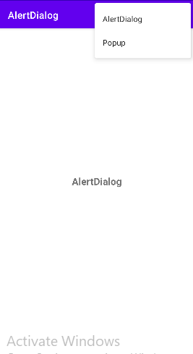 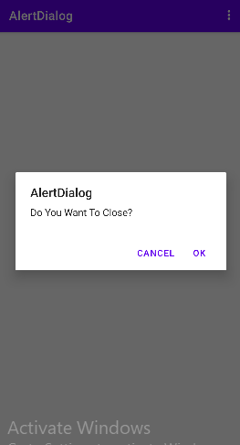

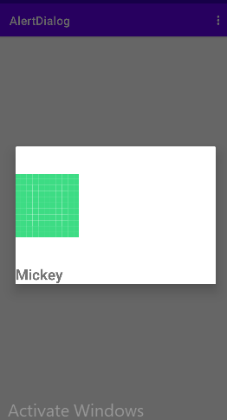

**2. Develop an app to store values of one activity using shared preferences and print on another page**

**activity_main.xml**

<?xml version="1.0" encoding="utf-8"?>

<androidx.constraintlayout.widget.ConstraintLayout xmlns:android="http://schemas.android.com/apk/res/android"

xmlns:app="http://schemas.android.com/apk/res-auto"

xmlns:tools="http://schemas.android.com/tools"

android:layout_width="match_parent"

android:layout_height="match_parent"

tools:context=".MainActivity">

<Button

android:id="@+id/btn"

android:layout_width="wrap_content"

android:layout_height="wrap_content"

android:text="Button"

app:layout_constraintBottom_toBottomOf="parent"

app:layout_constraintEnd_toEndOf="parent"

app:layout_constraintHorizontal_bias="0.444"

app:layout_constraintStart_toStartOf="parent"

app:layout_constraintTop_toTopOf="parent"

app:layout_constraintVertical_bias="0.513" />

<TextView

android:id="@+id/textView2"

android:layout_width="wrap_content"

android:layout_height="wrap_content"

android:text="TextView"

app:layout_constraintBottom_toBottomOf="parent"

app:layout_constraintEnd_toEndOf="parent"

app:layout_constraintHorizontal_bias="0.473"

app:layout_constraintStart_toStartOf="parent"

app:layout_constraintTop_toTopOf="parent"

app:layout_constraintVertical_bias="0.411" />

<EditText

android:id="@+id/et"

android:layout_width="wrap_content"

android:layout_height="wrap_content"

android:ems="10"

android:inputType="textPersonName"

android:text="Name"

app:layout_constraintBottom_toBottomOf="parent"

app:layout_constraintEnd_toEndOf="parent"

app:layout_constraintHorizontal_bias="0.557"

app:layout_constraintStart_toStartOf="parent"

app:layout_constraintTop_toTopOf="parent"

app:layout_constraintVertical_bias="0.313" />

</androidx.constraintlayout.widget.ConstraintLayout>

**MainActivity.java**

package com.example.myapplication50;

import androidx.appcompat.app.AppCompatActivity;

import android.content.Intent;

import android.content.SharedPreferences;

import android.os.Bundle;

import android.view.View;

import android.widget.Button;

import android.widget.EditText;

public class MainActivity extends AppCompatActivity {

EditText e;

Button b;

@Override

protected void onCreate(Bundle savedInstanceState) {

super.onCreate(savedInstanceState);

setContentView(R.layout.activity_main);

EditText e =findViewById(R.id.et);

Button b=findViewById(R.id.btn);

SharedPreferences sp =getSharedPreferences("Shared",MODE_PRIVATE);

b.setOnClickListener(new View.OnClickListener() {

@Override

public void onClick(View v) {

String val =e.getText().toString();

sp.edit().putString("abc",val).commit();

Intent i =new Intent(MainActivity.this,MainActivity2.class);

startActivity(i);

}

});

}

}

**MainActivity2.java**

package com.example.myapplication50;

import androidx.appcompat.app.AppCompatActivity;

import android.content.SharedPreferences;

import android.os.Bundle;

import android.widget.TextView;

public class MainActivity2 extends AppCompatActivity {

TextView tt;

@Override

protected void onCreate(Bundle savedInstanceState) {

super.onCreate(savedInstanceState);

setContentView(R.layout.activity_main2);

SharedPreferences sp= getSharedPreferences("Share",MODE_PRIVATE);

TextView tt=findViewById(R.id.tvw);

String se =sp.getString("abc","No data found");

tt.setText(se);

**}**

**}**

Activity_main2.xml

<?xml version="1.0" encoding="utf-8"?>

<androidx.constraintlayout.widget.ConstraintLayout xmlns:android="http://schemas.android.com/apk/res/android"

xmlns:app="http://schemas.android.com/apk/res-auto"

xmlns:tools="http://schemas.android.com/tools"

android:layout_width="match_parent"

android:layout_height="match_parent"

tools:context=".MainActivity2">

<TextView

android:id="@+id/tvw"

android:layout_width="wrap_content"

android:layout_height="wrap_content"

android:text="TextView"

app:layout_constraintBottom_toBottomOf="parent"

app:layout_constraintEnd_toEndOf="parent"

app:layout_constraintStart_toStartOf="parent"

app:layout_constraintTop_toTopOf="parent" />

</androidx.constraintlayout.widget.ConstraintLayout>

**OUTPUT**

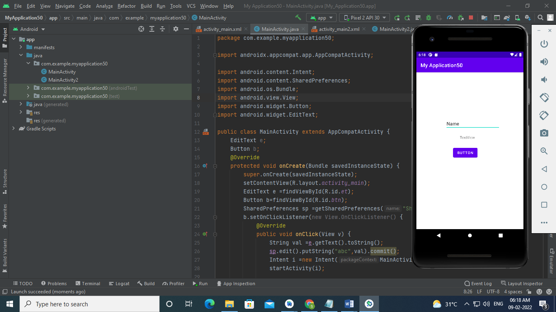 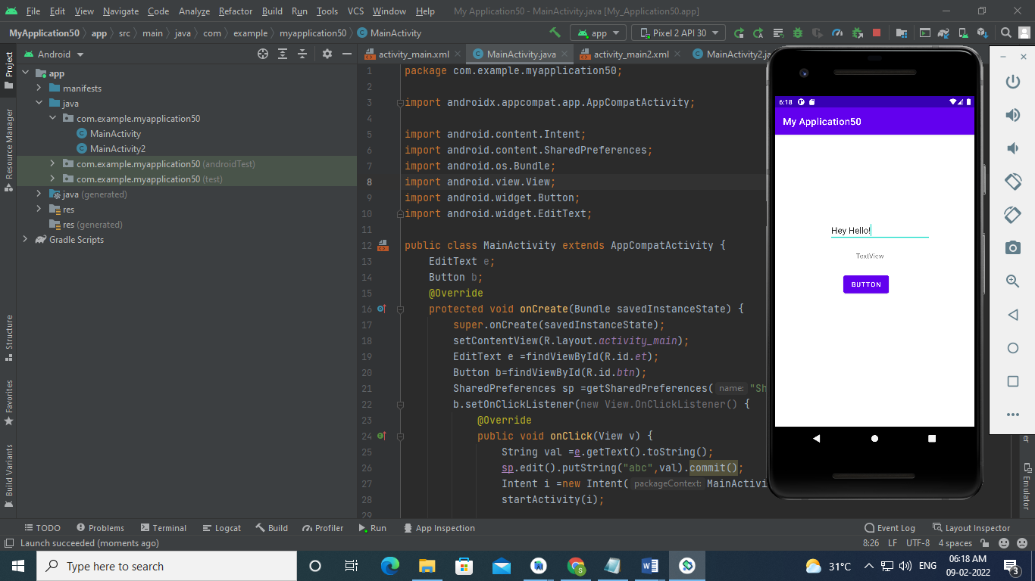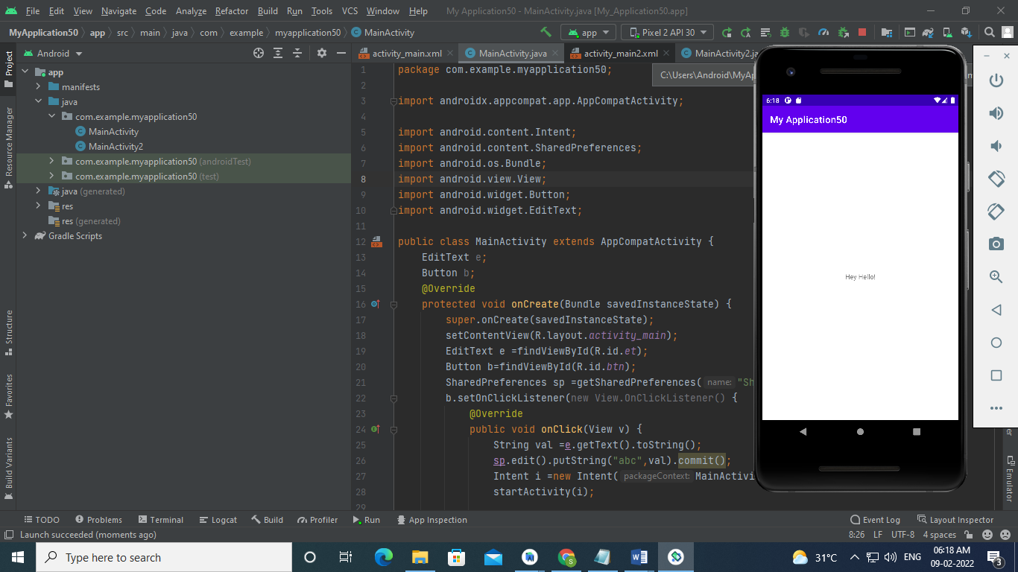

**3. Develop an application that toggle image using frame layout**

**MainActivity.java**

package com.example.myapp50;

import androidx.appcompat.app.AppCompatActivity;

import android.os.Bundle;

import android.view.View;

import android.widget.ImageView;

public class MainActivity extends AppCompatActivity {

@Override

protected void onCreate(Bundle savedInstanceState) {

super.onCreate(savedInstanceState);

setContentView(R.layout.activity_main);

ImageView iv1=findViewById(R.id.iv1);

ImageView iv2=findViewById(R.id.iv2);

iv1.setOnClickListener(new View.OnClickListener() {

@Override

public void onClick(View v) {

iv2.bringToFront();

}

});

iv2.setOnClickListener(new View.OnClickListener() {

@Override

public void onClick(View v) {

iv1.bringToFront();

}

});

}

}

**Activity_main.xml**

<FrameLayout xmlns:android="http://schemas.android.com/apk/res/android"

android:orientation="vertical"

android:layout_width="match_parent"

android:layout_height="match_parent">

<ImageView

android:id="@+id/iv1"

android:src = "@drawable/img_1"

android:layout_width="match_parent"

android:layout_height="match_parent"

android:scaleType="fitXY" />

<ImageView

android:id="@+id/iv2"

android:src = "@drawable/img"

android:layout_width="match_parent"

android:layout_height="match_parent"

android:scaleType="fitXY" />

</FrameLayout>

**OUTPUT**

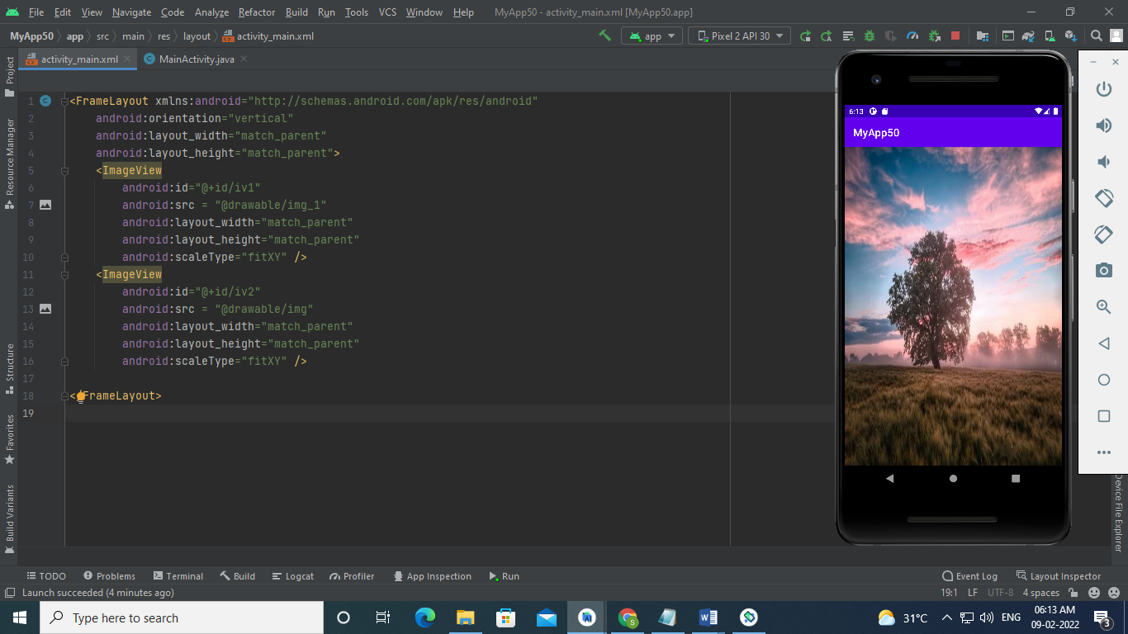 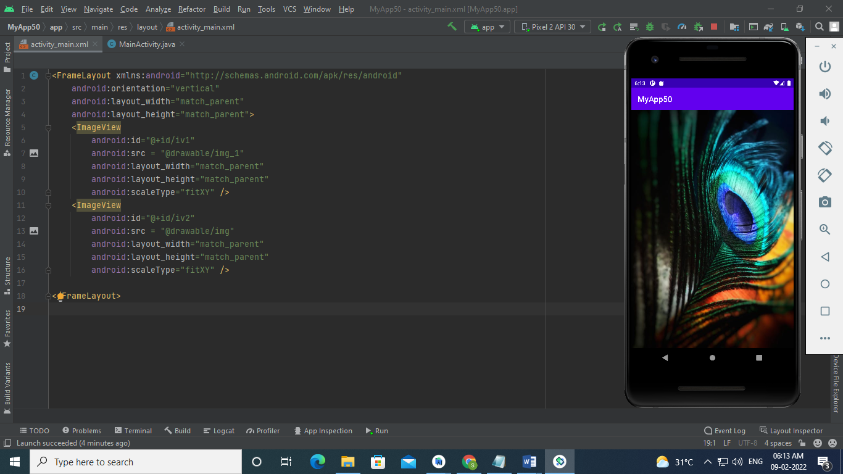

**4. Create an app to switch framents on button click**

**Fragment**

<?xml version="1.0" encoding="utf-8"?>

<LinearLayout xmlns:android="http://schemas.android.com/apk/res/android"

xmlns:app="http://schemas.android.com/apk/res-auto"

xmlns:tools="http://schemas.android.com/tools"

android:layout_width="match_parent"

android:layout_height="match_parent"

android:orientation="vertical"

tools:context=".MainActivity">

<FrameLayout

android:id="@+id/frameLayout"

android:layout_width="match_parent"

android:layout_height="0dp"

android:layout_weight="4" />

<RelativeLayout

android:layout_width="match_parent"

android:layout_height="0dp"

android:layout_weight="1">

<Button

android:id="@+id/button1"

android:layout_width="wrap_content"

android:layout_height="wrap_content"

android:layout_alignParentStart="true"

android:layout_marginStart="30dp"

android:layout_marginBottom="30dp"

android:text="Button" />

<Button

android:id="@+id/button2"

android:layout_width="wrap_content"

android:layout_height="wrap_content"

android:layout_alignParentStart="true"

android:layout_alignParentRight="true"

android:layout_marginStart="217dp"

android:layout_marginRight="100dp"

android:layout_marginBottom="30dp"

android:text="Button" />

</RelativeLayout>

</LinearLayout>

**Mainactivity.java**

package com.example.nav;

import androidx.appcompat.app.AppCompatActivity;

import androidx.fragment.app.Fragment;

import androidx.fragment.app.FragmentManager;

import androidx.fragment.app.FragmentTransaction;

import android.os.Bundle;

import android.view.View;

import android.widget.Button;

public class MainActivity extends AppCompatActivity {

Button btt,btt2;

@Override

protected void onCreate(Bundle savedInstanceState) {

super.onCreate(savedInstanceState);

setContentView(R.layout.activity_main);

btt=findViewById(R.id.button1);

btt2=findViewById(R.id.button2);

btt.setOnClickListener(new View.OnClickListener() {

@Override

public void onClick(View v) {

replaceFragment(new fragment1());

}

});

btt2.setOnClickListener(new View.OnClickListener() {

@Override

public void onClick(View v) {

replaceFragment(new fragment2());

}

});

}

private void replaceFragment(Fragment fragment){

FragmentManager fragmentManager=getSupportFragmentManager();

FragmentTransaction fragmentTransaction=fragmentManager.beginTransaction();

fragmentTransaction.replace(R.id.frameLayout,fragment);

fragmentTransaction.commit();

}

}

**Fragment_fragment2.xml**

<?xml version="1.0" encoding="utf-8"?>

<RelativeLayout xmlns:android="http://schemas.android.com/apk/res/android"

xmlns:tools="http://schemas.android.com/tools"

android:layout_width="match_parent"

android:layout_height="match_parent"

tools:context=".fragment2">

<!-- TODO: Update blank fragment layout -->

<TextView

android:layout_width="wrap_content"

android:layout_height="wrap_content"

android:layout_centerInParent="true"

android:textSize="30dp"

android:text="Fragment 2" />

</RelativeLayout>

**Fragment_fragment1.xml**

<?xml version="1.0" encoding="utf-8"?>

<RelativeLayout xmlns:android="http://schemas.android.com/apk/res/android"

xmlns:tools="http://schemas.android.com/tools"

android:layout_width="match_parent"

android:layout_height="match_parent"

tools:context=".fragment1">

<!-- TODO: Update blank fragment layout -->

<TextView

android:layout_width="wrap_content"

android:layout_height="wrap_content"

android:layout_centerInParent="true"

android:textSize="30dp"

android:text="Fragment 1" />

</RelativeLayout>

**Fragment2.java**

package com.example.nav;

import android.os.Bundle;

import androidx.fragment.app.Fragment;

import android.view.LayoutInflater;

import android.view.View;

import android.view.ViewGroup;

public class fragment2 extends Fragment {

public View onCreateView(LayoutInflater inflater, ViewGroup container,

Bundle savedInstanceState) {

// Inflate the layout for this fragment

return inflater.inflate(R.layout.fragment_fragment2, container, false);

}

**Fragment1.java**

package com.example.nav;

import android.os.Bundle;

import androidx.fragment.app.Fragment;

import android.view.LayoutInflater;

import android.view.View;

import android.view.ViewGroup;

public class fragment1 extends Fragment {

@Override

public View onCreateView(LayoutInflater inflater, ViewGroup container,

Bundle savedInstanceState) {

// Inflate the layout for this fragment

return inflater.inflate(R.layout.fragment_fragment1, container, false);

}

}

**OUTPUT**

