Interview Questions on SQL are based on following two tables, Employee Table and Employee Incentive Table.

**Table Name : Employee EMP_ID As PRIMARY KEY**

|  |  |  |  |  |  |  |  |
| --- | --- | --- | --- | --- | --- | --- | --- |
| EMPLOYEE_ID | FIRST_NAME | LAST_NAME | SALARY | JOINING_DATE | DEPARTMENT | | |
| 1 | Venkatesh | S | 100000 | 08/28/2015 | | BANKING | | |
| 2 | Ragavi | P | 75000 | 08/28/2015 | | | BUSINESS | |
| 3 | Gopinath | C | 50000 | 03/02/2016 | | | PHARMA | |
| 4 | Dinesh | G | 50000 | 03/02/2016 | | | INSURANCE | |
| 5 | Saibabu | E | 40000 | 07/08/2017 | | | SOFTWARE | |
| 6 | Hasan | S | 29000 | 07/08/2017 | | | MANUFACTURING | |
| 7 | Divya | P | 33000 | 07/08/2017 | | | HEALTHCARE | |
| 8 | Aravindan | R | 40000 | 07/08/2017 | | | HEALTHCARE | |
| 9 | Sathish | MD | 45000 | 03/02/2016 | | | AUTOMOBILE | |
| 10 | Prasanth | PKP | 34000 | 03/02/2016 | | | INSURANCE | |
| 11 | Vijay | R | 25684 | 03/02/2016 | | | BUSINESS | |
| 12 | Sivakumar | K | 54789 | 03/02/2016 | | | SOFTWARE | |

**Table Name : Incentives**

|  |  |  |
| --- | --- | --- |
| **EMPLOYEE_REF_ID** | **INCENTIVE_DATE** | **INCENTIVE_AMOUNT** |
| 1 | 01-FEB-16 | 5000 |
| 2 | 01-FEB-16 | 3000 |
| 3 | 01-FEB-17 | 4000 |
| 1 | 01-JAN-17 | 4500 |
| 2 | 01-JAN-17 | 3500 |

**SQL Queries Interview Questions and Answers on "SQL Select" - Examples**

1. **Get all employee details from the employee table**

[SELECT](http://localhost/phpmyadmin/url.php?url=https://dev.mysql.com/doc/refman/5.5/en/select.html) * FROM emplyee2

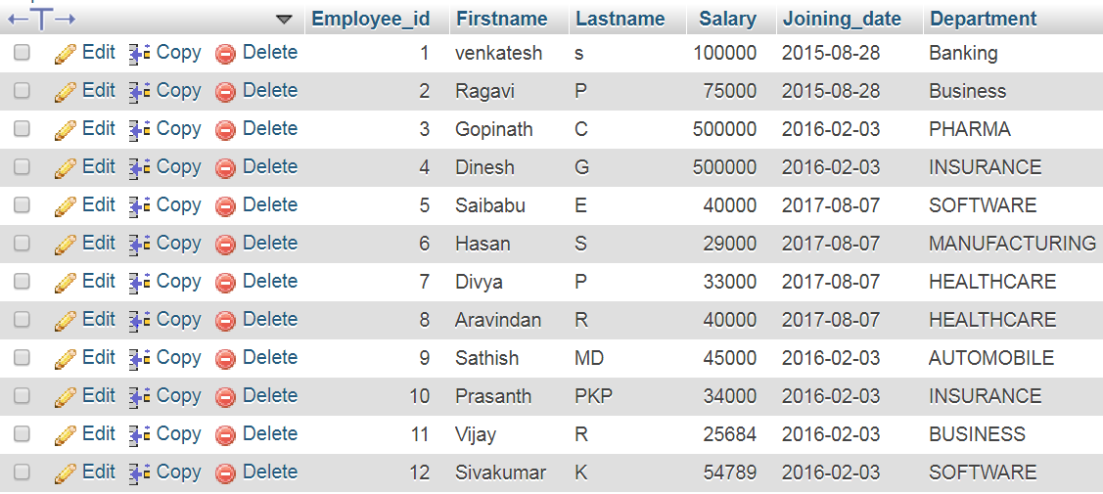

1. **Get First_Name,Last_Name from employee table**

[SELECT](http://localhost/phpmyadmin/url.php?url=https://dev.mysql.com/doc/refman/5.5/en/select.html) Firstname,Lastname FROM emplyee2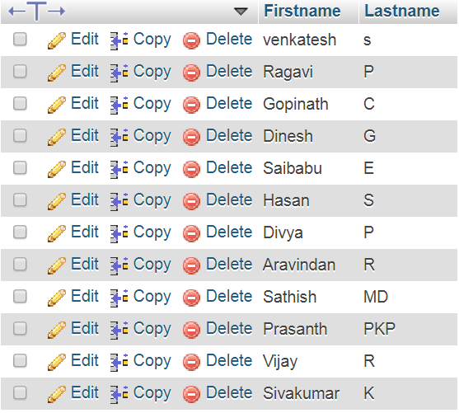

1. **Get First_Name from employee table using alias name “Employee Name”**
2. [SELECT](http://localhost/phpmyadmin/url.php?url=https://dev.mysql.com/doc/refman/5.5/en/select.html) Firstname as Employee_Name FROM emplyee2
3. 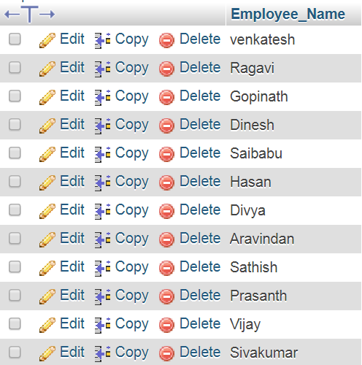

4. **Get First_Name from employee table in upper case**

[SELECT](http://localhost/phpmyadmin/url.php?url=https://dev.mysql.com/doc/refman/5.5/en/select.html) upper(Firstname) FROM emplyee2

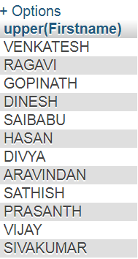

1. **Get First_Name from employee table in lower case**

[SELECT](http://localhost/phpmyadmin/url.php?url=https://dev.mysql.com/doc/refman/5.5/en/select.html) lower(Firstname) FROM emplyee2

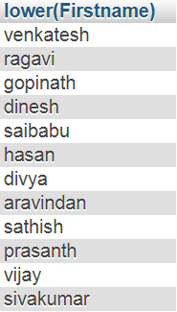

1. **Get unique DEPARTMENT from employee table**

[SELECT](http://localhost/phpmyadmin/url.php?url=https://dev.mysql.com/doc/refman/5.5/en/select.html) distinct(Department) FROM emplyee2

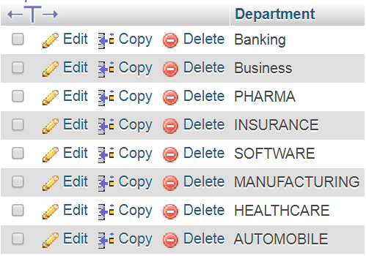

1. **Select first 3 characters of FIRST_NAME from EMPLOYEE**

[SELECT](http://localhost/phpmyadmin/url.php?url=https://dev.mysql.com/doc/refman/5.5/en/select.html) substring(Firstname,1,3) FROM emplyee2

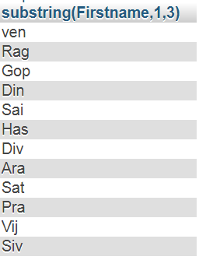

8. **Get position of 'a' in name 'ragavi' from employee table**

[SELECT](http://localhost/phpmyadmin/url.php?url=https://dev.mysql.com/doc/refman/5.5/en/select.html) INSTR (Firstname,'a') FROM emplyee2 WHERE Firstname='Ragavi'



9. **Get FIRST_NAME from employee table after removing white spaces from right side**

[SELECT](http://localhost/phpmyadmin/url.php?url=https://dev.mysql.com/doc/refman/5.5/en/select.html) rtrim(Firstname) FROM emplyee2

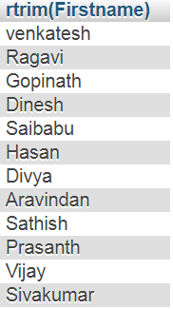

1. **Get FIRST_NAME from employee table after removing white spaces from left side**

[SELECT](http://localhost/phpmyadmin/url.php?url=https://dev.mysql.com/doc/refman/5.5/en/select.html) ltrim(Firstname) FROM emplyee2

1. **Get length of FIRST_NAME from employee table**

[SELECT](http://localhost/phpmyadmin/url.php?url=https://dev.mysql.com/doc/refman/5.5/en/select.html) LENGTH (Firstname) FROM emplyee2

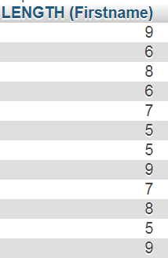

1. **Get First_Name from employee table after replacing 'a' with '$'**

[SELECT](http://localhost/phpmyadmin/url.php?url=https://dev.mysql.com/doc/refman/5.5/en/select.html) [REPLACE](http://localhost/phpmyadmin/url.php?url=https://dev.mysql.com/doc/refman/5.5/en/replace.html) (Firstname,'o','$') FROM emplyee2

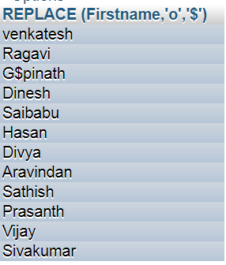

1. **Get First_Name and Last_Name as single column from employee table separated by a '_'**

[SELECT](http://localhost/phpmyadmin/url.php?url=https://dev.mysql.com/doc/refman/5.5/en/select.html) concat(Firstname,'_',Lastname) FROM emplyee2

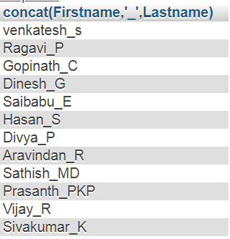

1. **Get FIRST_NAME ,Joining year,Joining Month and Joining Date from employee table**

[SELECT](http://localhost/phpmyadmin/url.php?url=https://dev.mysql.com/doc/refman/5.5/en/select.html) [year](http://localhost/phpmyadmin/url.php?url=https://dev.mysql.com/doc/refman/5.5/en/date-and-time-types.html)(Joining_date),month(Joining_date),[date](http://localhost/phpmyadmin/url.php?url=https://dev.mysql.com/doc/refman/5.5/en/date-and-time-types.html)(Joining_date) FROM emplyee2

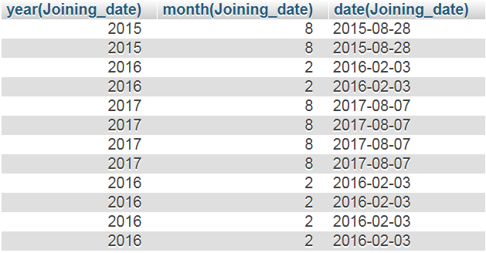

**Database SQL Queries Interview Questions and answers on "SQL Order By"**

1. **Get all employee details from the employee table order by First_Name Ascending**
2. [SELECT](http://localhost/phpmyadmin/url.php?url=https://dev.mysql.com/doc/refman/5.5/en/select.html) * FROM emplyee2 order by Firstname ASC
3. 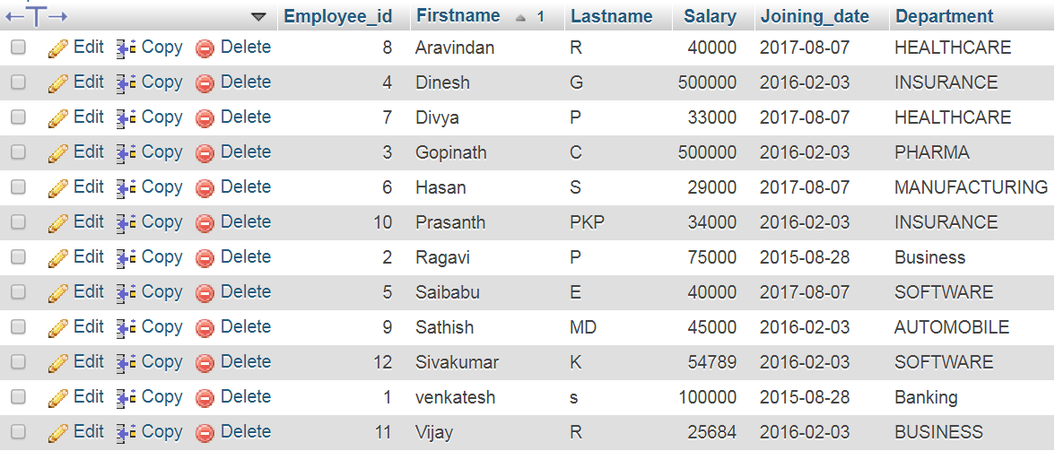

**16. Get all employee details from the employee table order by First_Name descending**

[SELECT](http://localhost/phpmyadmin/url.php?url=https://dev.mysql.com/doc/refman/5.5/en/select.html) * FROM emplyee2 order by Firstname desc

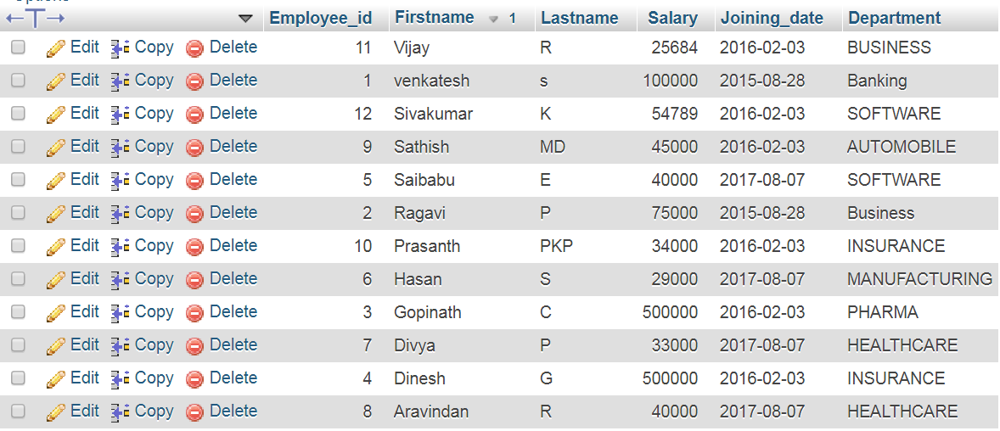

**17. Get all employee details from the employee table order by First_Name Ascending and Salary descending**

[SELECT](http://localhost/phpmyadmin/url.php?url=https://dev.mysql.com/doc/refman/5.5/en/select.html) * FROM emplyee2 order by Firstname asc,Salary desc

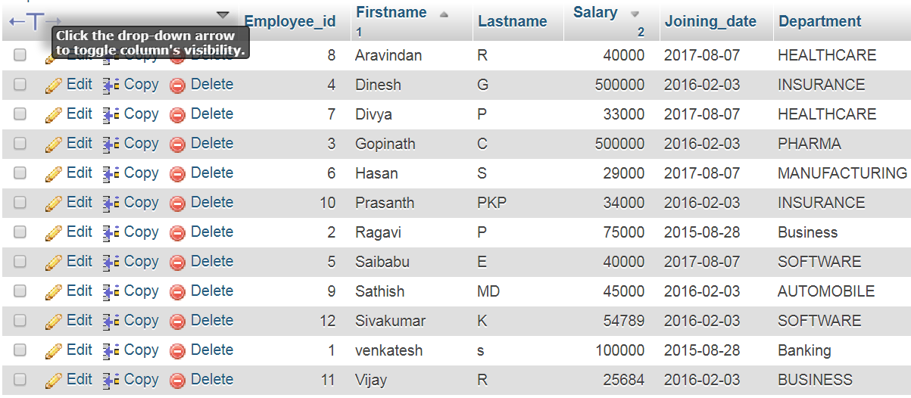

**SQL Queries Interview Questions and Answers on "SQL Where Condition" - Examples**

1. **Get employee details from employee table whose employee name is “Dinesh”**

[SELECT](http://localhost/phpmyadmin/url.php?url=https://dev.mysql.com/doc/refman/5.5/en/select.html) * FROM emplyee2 WHERE Firstname='Dinesh'



1. **Get employee details from employee table whose employee name are “Dinesh” and “Roy”**

[SELECT](http://localhost/phpmyadmin/url.php?url=https://dev.mysql.com/doc/refman/5.5/en/select.html) * FROM emplyee2 WHERE Firstname [in](http://localhost/phpmyadmin/url.php?url=https://dev.mysql.com/doc/refman/5.5/en/comparison-operators.html#function_in)('Dinesh','Roy')



1. **Get employee details from employee table whose employee name are not “Dinesh” and “Roy”**

[SELECT](http://localhost/phpmyadmin/url.php?url=https://dev.mysql.com/doc/refman/5.5/en/select.html) * FROM emplyee2 WHERE Firstname [not](http://localhost/phpmyadmin/url.php?url=https://dev.mysql.com/doc/refman/5.5/en/logical-operators.html#operator_not) [in](http://localhost/phpmyadmin/url.php?url=https://dev.mysql.com/doc/refman/5.5/en/comparison-operators.html#function_in)('Dinesh','Roy')

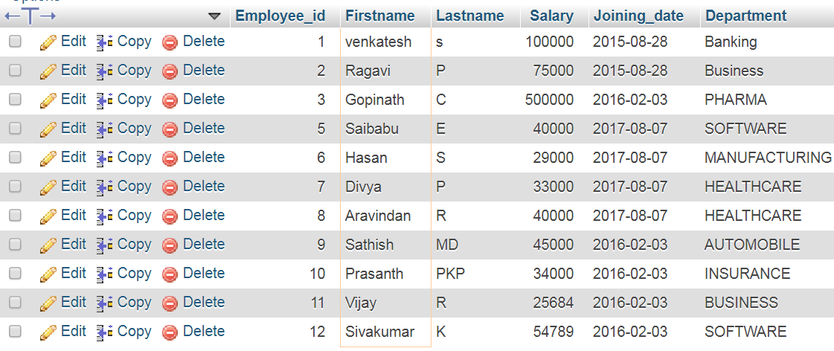

**SQL Queries Interview Questions and Answers on "SQL Wild Card Search" - Examples**

1. **Get employee details from employee table whose first name starts with 's'**

[SELECT](http://localhost/phpmyadmin/url.php?url=https://dev.mysql.com/doc/refman/5.5/en/select.html) * FROM emplyee2 WHERE Firstname [like](http://localhost/phpmyadmin/url.php?url=https://dev.mysql.com/doc/refman/5.5/en/string-comparison-functions.html#operator_like) 's%'

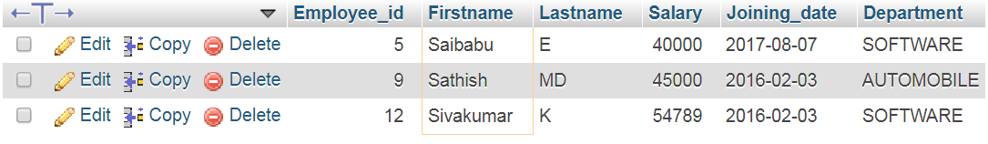

1. **Get employee details from employee table whose first name contains 'v'**

[SELECT](http://localhost/phpmyadmin/url.php?url=https://dev.mysql.com/doc/refman/5.5/en/select.html) * FROM emplyee2 WHERE Firstname [like](http://localhost/phpmyadmin/url.php?url=https://dev.mysql.com/doc/refman/5.5/en/string-comparison-functions.html#operator_like) '%v%'

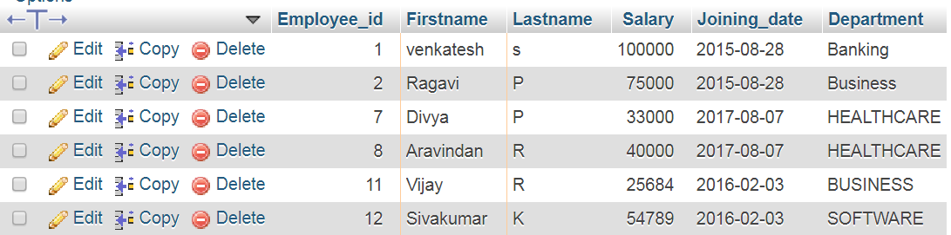

1. **Get employee details from employee table whose first name ends with 'n'**

[SELECT](http://localhost/phpmyadmin/url.php?url=https://dev.mysql.com/doc/refman/5.5/en/select.html) * FROM emplyee2 WHERE Firstname [like](http://localhost/phpmyadmin/url.php?url=https://dev.mysql.com/doc/refman/5.5/en/string-comparison-functions.html#operator_like) '%n'

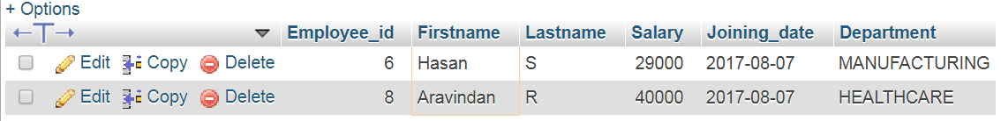

**SQL Queries Interview Questions and Answers on "SQL Pattern Matching" - Examples**

1. **Get employee details from employee table whose first name ends with 'n' and name contains 5 letters**

[SELECT](http://localhost/phpmyadmin/url.php?url=https://dev.mysql.com/doc/refman/5.5/en/select.html) * FROM emplyee2 WHERE Firstname [like](http://localhost/phpmyadmin/url.php?url=https://dev.mysql.com/doc/refman/5.5/en/string-comparison-functions.html#operator_like) '____n'



**25. Get employee details from employee table whose first name starts with 'D' and name contains 5 letters**

[SELECT](http://localhost/phpmyadmin/url.php?url=https://dev.mysql.com/doc/refman/5.5/en/select.html) * FROM emplyee2 WHERE Firstname [like](http://localhost/phpmyadmin/url.php?url=https://dev.mysql.com/doc/refman/5.5/en/string-comparison-functions.html#operator_like) 'D____'



1. **Get employee details from employee table who’s Salary greater than 60000**

[SELECT](http://localhost/phpmyadmin/url.php?url=https://dev.mysql.com/doc/refman/5.5/en/select.html) * FROM emplyee2 WHERE (Salary>60000)

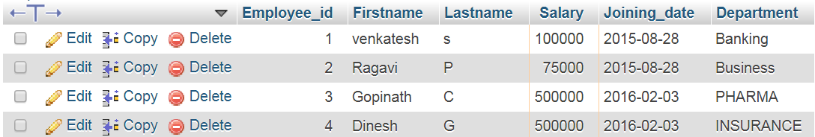

1. **Get employee details from employee table who’s Salary less than 80000**

[SELECT](http://localhost/phpmyadmin/url.php?url=https://dev.mysql.com/doc/refman/5.5/en/select.html) * FROM emplyee2 WHERE (Salary<80000)

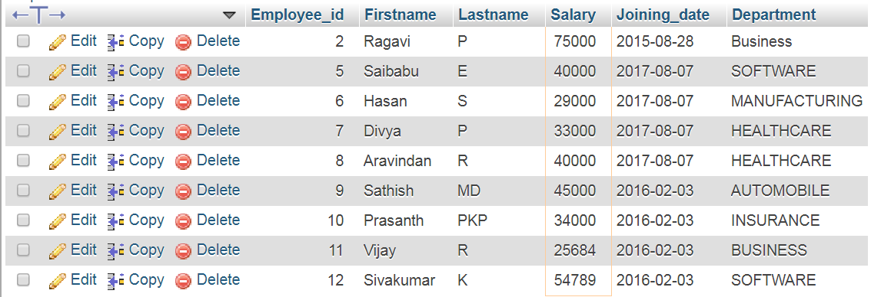

1. **Get employee details from employee table who’s Salary between 50000 and 80000**

[SELECT](http://localhost/phpmyadmin/url.php?url=https://dev.mysql.com/doc/refman/5.5/en/select.html) * FROM emplyee2 WHERE Salary BETWEEN 50000 [and](http://localhost/phpmyadmin/url.php?url=https://dev.mysql.com/doc/refman/5.5/en/logical-operators.html#operator_and) 80000

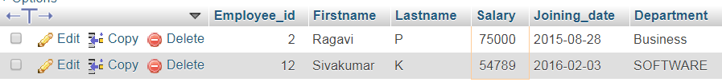

1. **Get employee details from employee table whose name is venkatesh and ragavi**

[SELECT](http://localhost/phpmyadmin/url.php?url=https://dev.mysql.com/doc/refman/5.5/en/select.html) * FROM `emplyee2` WHERE Firstname [in](http://localhost/phpmyadmin/url.php?url=https://dev.mysql.com/doc/refman/5.5/en/comparison-operators.html#function_in) ('Venkatesh','Ragavi')

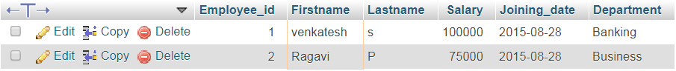

**SQL Queries Interview Questions and Answers on "SQL DATE Functions" - Examples**

1. **Get employee details from employee table whose joining year is “2015”**

[SELECT](http://localhost/phpmyadmin/url.php?url=https://dev.mysql.com/doc/refman/5.5/en/select.html) * FROM emplyee2 WHERE [year](http://localhost/phpmyadmin/url.php?url=https://dev.mysql.com/doc/refman/5.5/en/date-and-time-types.html)(Joining_date)='2015'

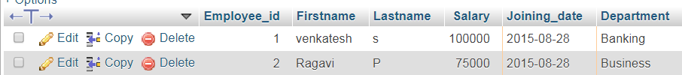

1. **Get employee details from employee table whose joining month is “February”**

[SELECT](http://localhost/phpmyadmin/url.php?url=https://dev.mysql.com/doc/refman/5.5/en/select.html) * FROM emplyee2 WHERE month(Joining_date)='02'

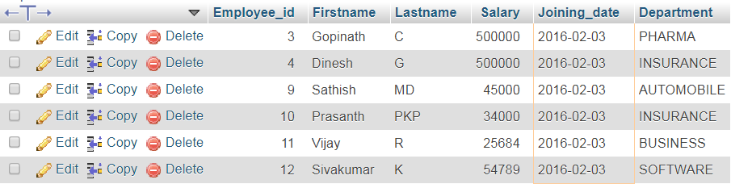

1. **Get employee details from employee table who joined before January 1st 2017**

[SELECT](http://localhost/phpmyadmin/url.php?url=https://dev.mysql.com/doc/refman/5.5/en/select.html) * FROM emplyee2 WHERE Joining_date <'2017-01-01'

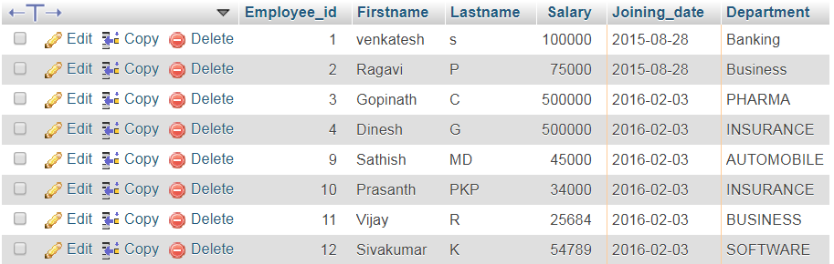

1. **Get employee details from employee table who joined after January 31st 2016**

[SELECT](http://localhost/phpmyadmin/url.php?url=https://dev.mysql.com/doc/refman/5.5/en/select.html) * FROM emplyee2 WHERE Joining_date >'2016-01-31'

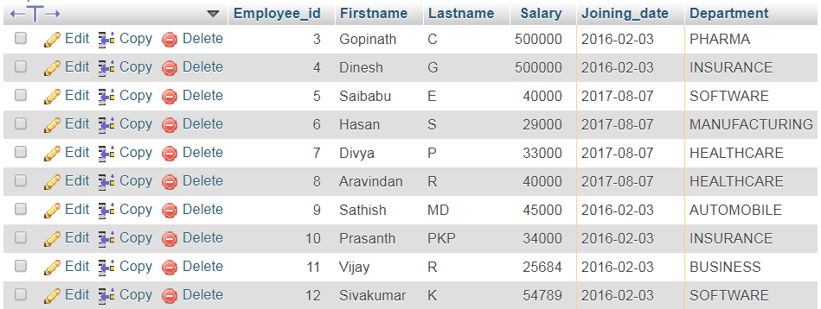

1. **Get Joining Date and Time from employee table**

**36. Get Joining Date,Time including milliseconds from employee table**

**37. Get difference between JOINING_DATE and INCENTIVE_DATE from employee and incentives table**

[SELECT](http://localhost/phpmyadmin/url.php?url=https://dev.mysql.com/doc/refman/5.5/en/select.html) Firstname,Incentive_date,Joining_date from emplyee2 a inner join incentives B on A.Employee_id=B.Employer_Id

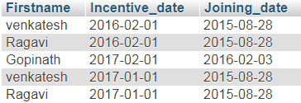

**38. Get database date**

[SELECT](http://localhost/phpmyadmin/url.php?url=https://dev.mysql.com/doc/refman/5.5/en/select.html) now()



**SQL Queries Interview Questions and Answers on "SQL Escape Characters" - Examples**

**39. Get names of employees from employee table who has '%' in Last_Name. Tip : Escape character for special characters in a query.**

[Select](http://localhost/phpmyadmin/url.php?url=https://dev.mysql.com/doc/refman/5.5/en/select.html) Firstname FROM emplyee2 WHERE Lastname [LIKE](http://localhost/phpmyadmin/url.php?url=https://dev.mysql.com/doc/refman/5.5/en/string-comparison-functions.html#operator_like) '%\%%'



**40. Get Last Name from employee table after replacing special character with white space**

[SELECT](http://localhost/phpmyadmin/url.php?url=https://dev.mysql.com/doc/refman/5.5/en/select.html) [REPLACE](http://localhost/phpmyadmin/url.php?url=https://dev.mysql.com/doc/refman/5.5/en/replace.html) (Lastname,'%',' ')from emplyee2

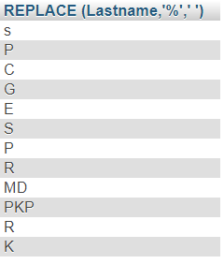

**SQL Queries Interview Questions and Answers on "SQL Group By Functions" - Examples**

**41. Get department,total salary with respect to a department from employee table.**

[SELECT](http://localhost/phpmyadmin/url.php?url=https://dev.mysql.com/doc/refman/5.5/en/select.html) Department,[SUM](http://localhost/phpmyadmin/url.php?url=https://dev.mysql.com/doc/refman/5.5/en/group-by-functions.html#function_sum)(Salary) TOTAL_SALARY FROM emplyee2 GROUP BY Department

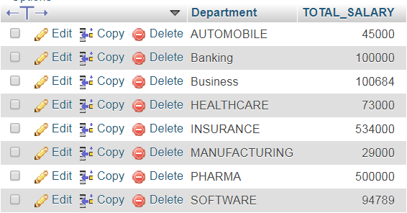

**42. Get department,total salary with respect to a department from employee table order by total salary descending**

[SELECT](http://localhost/phpmyadmin/url.php?url=https://dev.mysql.com/doc/refman/5.5/en/select.html) Department,[SUM](http://localhost/phpmyadmin/url.php?url=https://dev.mysql.com/doc/refman/5.5/en/group-by-functions.html#function_sum)(Salary) TOTAL_SALARY FROM emplyee2 GROUP BY Department ORDER BY TOTAL_SALARY DESC

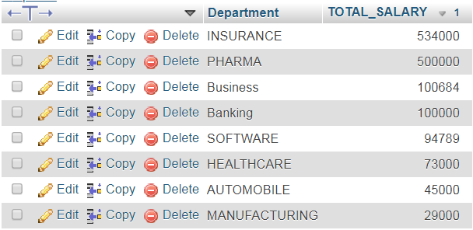

**SQL Queries Interview Questions and Answers on "SQL Mathematical Operations using Group By" - Examples**

**43. Get department,no of employees in a department,total salary with respect to a department from employee table order by total salary descending**

[SELECT](http://localhost/phpmyadmin/url.php?url=https://dev.mysql.com/doc/refman/5.5/en/select.html) Department,[COUNT](http://localhost/phpmyadmin/url.php?url=https://dev.mysql.com/doc/refman/5.5/en/group-by-functions.html#function_count)(Firstname),[SUM](http://localhost/phpmyadmin/url.php?url=https://dev.mysql.com/doc/refman/5.5/en/group-by-functions.html#function_sum)(Salary) TOTAL_SALARY FROM emplyee2 GROUP BY Department ORDER BY TOTAL_SALARY DESC

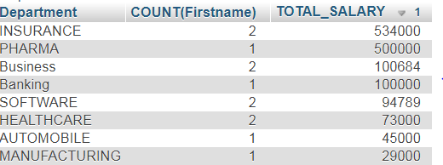

**44. Get department wise average salary from employee table order by salary ascending**

[SELECT](http://localhost/phpmyadmin/url.php?url=https://dev.mysql.com/doc/refman/5.5/en/select.html) Department,[AVG](http://localhost/phpmyadmin/url.php?url=https://dev.mysql.com/doc/refman/5.5/en/group-by-functions.html#function_avg)(Salary) AVGSalary FROM emplyee2 GROUP BY Department ORDER BY AVGSalary ASC

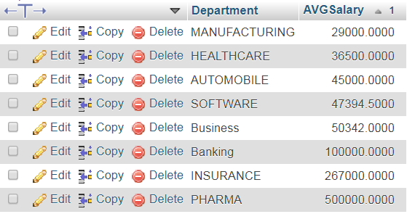

**45. Get department wise maximum salary from employee table order by salary ascending**

[SELECT](http://localhost/phpmyadmin/url.php?url=https://dev.mysql.com/doc/refman/5.5/en/select.html) DEPARTMENT,[MAX](http://localhost/phpmyadmin/url.php?url=https://dev.mysql.com/doc/refman/5.5/en/group-by-functions.html#function_max)(Salary) MAXSalary FROM emplyee2 GROUP BY Department ORDER BY MAXSalary ASC

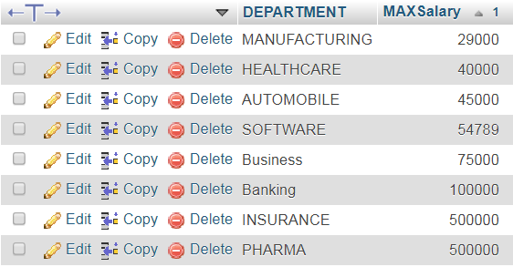

**46. Get department wise minimum salary from employee table order by salary ascending**

[SELECT](http://localhost/phpmyadmin/url.php?url=https://dev.mysql.com/doc/refman/5.5/en/select.html) DEPARTMENT,[MIN](http://localhost/phpmyadmin/url.php?url=https://dev.mysql.com/doc/refman/5.5/en/group-by-functions.html#function_min)(Salary) MINSalary FROM emplyee2 GROUP BY Department ORDER BY MINSalary ASC

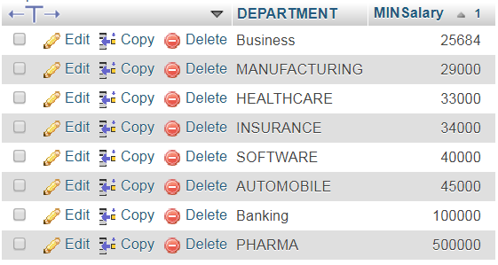

**47. Select no of employees joined with respect to year and month from employee table**

[SELECT](http://localhost/phpmyadmin/url.php?url=https://dev.mysql.com/doc/refman/5.5/en/select.html) [year](http://localhost/phpmyadmin/url.php?url=https://dev.mysql.com/doc/refman/5.5/en/date-and-time-types.html)(Joining_date) JOIN_YEAR, month(Joining_date) JOIN_MONTH,[COUNT](http://localhost/phpmyadmin/url.php?url=https://dev.mysql.com/doc/refman/5.5/en/group-by-functions.html#function_count)(*) TOTAL_EMP FROM emplyee2 GROUP BY [year](http://localhost/phpmyadmin/url.php?url=https://dev.mysql.com/doc/refman/5.5/en/date-and-time-types.html)(Joining_date),month(Joining_date)

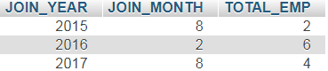

**48. Select department,total salary with respect to a department from employee table where total salary greater than 800000 order by Total_Salary descending**

[SELECT](http://localhost/phpmyadmin/url.php?url=https://dev.mysql.com/doc/refman/5.5/en/select.html) Department,[SUM](http://localhost/phpmyadmin/url.php?url=https://dev.mysql.com/doc/refman/5.5/en/group-by-functions.html#function_sum)(Salary) TOTAL_SALARY FROM emplyee2 GROUP BY Department HAVING [SUM](http://localhost/phpmyadmin/url.php?url=https://dev.mysql.com/doc/refman/5.5/en/group-by-functions.html#function_sum)(Salary) >80000 ORDER BY TOTAL_SALARY DESC

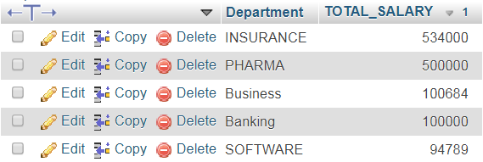

**SQL Queries Interview Questions and Answers on "SQL Joins" - Examples**

**49. Select first_name, incentive amount from employee and incentives table for those employees who have incentives**

[SELECT](http://localhost/phpmyadmin/url.php?url=https://dev.mysql.com/doc/refman/5.5/en/select.html) Firstname,Incentive_amoubt FROM emplyee2 a INNER join incentives B on A.Employee_id=B.Employer_Id

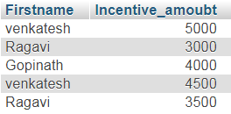

**50. Select first_name, incentive amount from employee and incentives table for those employees who have incentives and incentive amount greater than 3000**

[Select](http://localhost/phpmyadmin/url.php?url=https://dev.mysql.com/doc/refman/5.5/en/select.html) Firstname,incentive_amoubt from emplyee2 a inner join incentives B on A.Employee_id = B.Employer_Id [and](http://localhost/phpmyadmin/url.php?url=https://dev.mysql.com/doc/refman/5.5/en/logical-operators.html#operator_and) incentive_amoubt > 3000

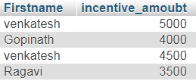

**51. Select first_name, incentive amount from employee and incentives table for all employes even if they didn't get incentives**

[Select](http://localhost/phpmyadmin/url.php?url=https://dev.mysql.com/doc/refman/5.5/en/select.html) Firstname,Incentive_amoubt from emplyee2 a [left](http://localhost/phpmyadmin/url.php?url=https://dev.mysql.com/doc/refman/5.5/en/string-functions.html#function_left) join incentives B on A.Employee_id = B.Employer_Id

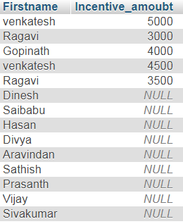

**52. Select first_name, incentive amount from employee and incentives table for all employees even if they didn't get incentives and set incentive amount as 0 for those employees who didn't get incentives.**

[Select](http://localhost/phpmyadmin/url.php?url=https://dev.mysql.com/doc/refman/5.5/en/select.html) Firstname,IFNULL(incentive_amoubt,0) from emplyee2 a [left](http://localhost/phpmyadmin/url.php?url=https://dev.mysql.com/doc/refman/5.5/en/string-functions.html#function_left) join incentives B on A.Employee_id = B.Employer_Id

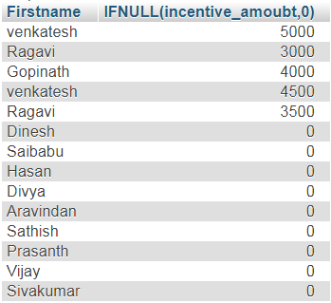

**53. Select first_name, incentive amount from employee and incentives table for all employees who got incentives using left join**

[Select](http://localhost/phpmyadmin/url.php?url=https://dev.mysql.com/doc/refman/5.5/en/select.html) Firstname, ifnull(incentive_amoubt,0) from emplyee2 a [left](http://localhost/phpmyadmin/url.php?url=https://dev.mysql.com/doc/refman/5.5/en/string-functions.html#function_left) join incentives B on A.Employee_id = B.Employer_Id

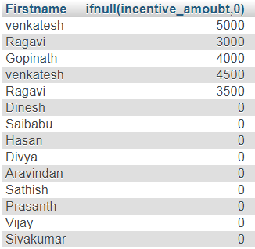

**54. Select max incentive with respect to employee from employee and incentives table using sub query**

**Advanced SQL Queries Interview Questions and Answers on "Top N Salary" – Examples**

[select](http://localhost/phpmyadmin/url.php?url=https://dev.mysql.com/doc/refman/5.5/en/select.html) Department,([select](http://localhost/phpmyadmin/url.php?url=https://dev.mysql.com/doc/refman/5.5/en/select.html) nvl([max](http://localhost/phpmyadmin/url.php?url=https://dev.mysql.com/doc/refman/5.5/en/group-by-functions.html#function_max)(Incentive_amoubt),0) from incentives where employer_id = Employee_id) Max_incentive from emplyee2

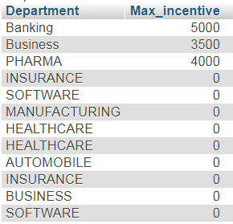

**55. Select TOP 2 salary from employee table**

[select](http://localhost/phpmyadmin/url.php?url=https://dev.mysql.com/doc/refman/5.5/en/select.html) * from emplyee2 order by Salary desc limit 2

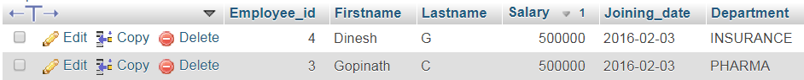

**56. Select TOP N salary from employee table**

[select](http://localhost/phpmyadmin/url.php?url=https://dev.mysql.com/doc/refman/5.5/en/select.html) * from emplyee2 order by Salary desc limit 5

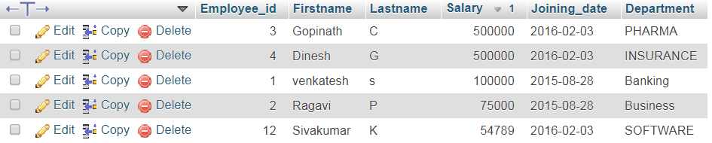

**57. Select 2nd Highest salary from employee table**

[select](http://localhost/phpmyadmin/url.php?url=https://dev.mysql.com/doc/refman/5.5/en/select.html) [min](http://localhost/phpmyadmin/url.php?url=https://dev.mysql.com/doc/refman/5.5/en/group-by-functions.html#function_min)(Salary) second_minsalary from([SELECT](http://localhost/phpmyadmin/url.php?url=https://dev.mysql.com/doc/refman/5.5/en/select.html) * from emplyee2 order by Salary desc limit 2) a



**58. Select Nth Highest salary from employee table**

[select](http://localhost/phpmyadmin/url.php?url=https://dev.mysql.com/doc/refman/5.5/en/select.html) [min](http://localhost/phpmyadmin/url.php?url=https://dev.mysql.com/doc/refman/5.5/en/group-by-functions.html#function_min)(Salary) second_minsalary from([SELECT](http://localhost/phpmyadmin/url.php?url=https://dev.mysql.com/doc/refman/5.5/en/select.html) * from emplyee2 order by Salary desc limit 5) a



**SQL Queries Interview Questions and Answers on "SQL Union" - Examples**

**59. Select First_Name,LAST_NAME from employee table as separate rows**

[SELECT](http://localhost/phpmyadmin/url.php?url=https://dev.mysql.com/doc/refman/5.5/en/select.html) Firstname from emplyee2 UNION [SELECT](http://localhost/phpmyadmin/url.php?url=https://dev.mysql.com/doc/refman/5.5/en/select.html) Lastname from emplyee2

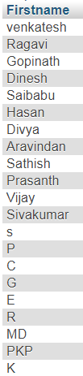 **60. What is the difference between UNION and UNION ALL ?**

**"Advanced SQL Queries Interview Questions and Answers"**

**61. Select employee details from employee table if data exists in incentive table ?**

[SELECT](http://localhost/phpmyadmin/url.php?url=https://dev.mysql.com/doc/refman/5.5/en/select.html) * FROM emplyee2 where EXISTS ([select](http://localhost/phpmyadmin/url.php?url=https://dev.mysql.com/doc/refman/5.5/en/select.html) * from incentives)

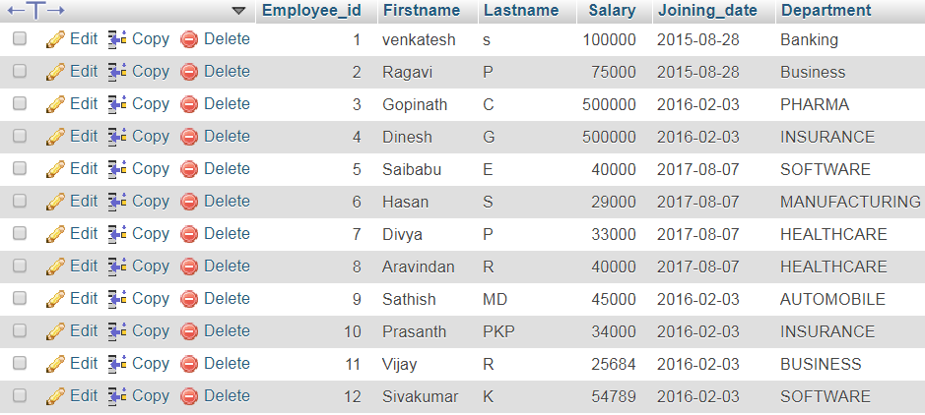

**62. How to fetch data that are common in two query results ?**

**63. Get Employee ID's of those employees who didn't receive incentives without using sub query ?**

**64. Select 20 % of salary from venkat , 10% of Salary for gopi and for other 15 % of salary from employee table**

**65. Select Banking as 'Bank Dept', Insurance as 'Insurance Dept' and Services as 'Pharma Dept' from employee table**

**66. Delete employee data from employee table who got incentives in incentive table**

**67. Insert into employee table Last Name with " ' " (Single Quote - Special Character)**

**68. Select Last Name from employee table which contain only numbers**

**69. Write a query to rank employees based on their incentives for a month**

**70**. **Update incentive table where employee name is 'Dinesh'**