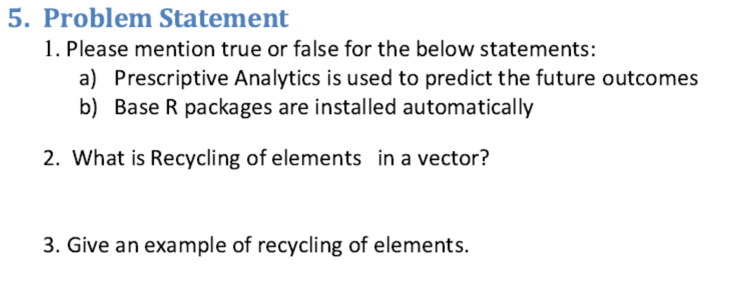

Solution:

1. A) True

B) False

1. Recycling occurs when R encounters two vectors of different lengths. R will automatically recycle the shorter one, until it is long enough to match the longer one.
2. Example of Recycling:

> c(1,2,4) + c(6,0,9,20,22)

[1] 7 2 13 21 24