PROJECT-NAME: FLIPKART

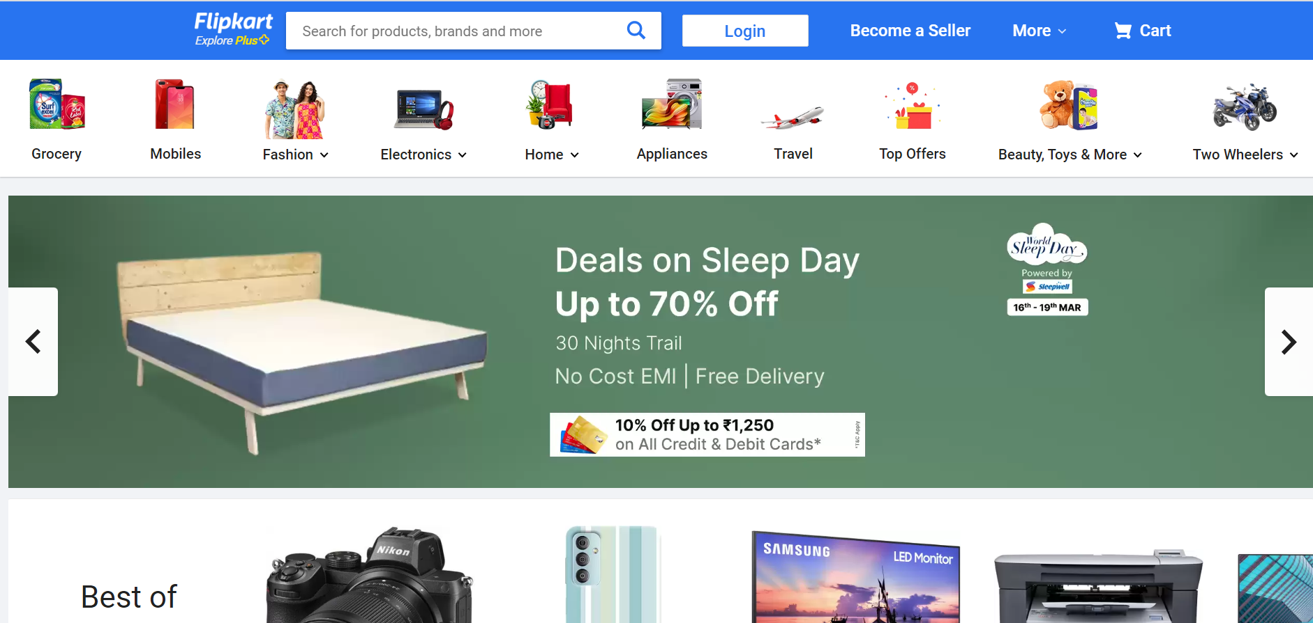

*OVERVIEW: The One-stop Shopping Destination.E-commerce is revolutionizing the way we all shop in India.

- HOME PAGE:
# Logo
# Search bar
# LogIn Option
# Option to become seller
# More option(Notification, customer support)
# Easy menu
# Slider
# Featured - (IMAGES)
# Trending - (IMAGES)
# Footer

- REGISTRATION FORM:
# E-MAIL ADDRESS
# D.O.B
# SHOPPING PREFERENCE

3. MAIN PAGE:

# FILTERS - ( BRANDS , COLOR , DISCOUNT RANGE , PRICE
COUNTRY OF ORIGIN , MATERIAL , FEATURES ,
FIT , OCCASION , PATTERN , RATING , SIZE ,
TYPE , SORT BY: )

# IMAGES OF THE CHOSEN PRODUCT WITH DETAILS LIKE -
( BRAND , PRODUCT NAME , PRICE , DISCOUNT% ( IF
ANY ) )

# ON CLICKING THE IMAGE - (MULTIPLE IMAGES OF THE
PRODUCT WILL APPEAR FROM DIFFERENT ANGLES ,
ZOOM IN , ZOOM OUT

# PRODUCT DESCRIPTION - BRAND , PRODUCT NAME ,
PRICE , DISCOUNT% (IF ANY) , SIZE CHART ,
DELIVERY OPTIONS , PRODUCT
DETAILS , SIZE & FIT , MATERIAL & CARE ,
SPECIFICATIONS , RATINGS , CUSTOMER REVIEWS
WITH IMAGES (IF ANY )

# LOWER HALF OF THE PAGE - RELATED PRODUCTS

- PAYMENT PAGE:

# ADDRESS SELECTION
# PAYMENT METHOD - (PHONEPE , GOOGLE PAY , BHIM UPI ,
COD , CREDIT/DEBIT CARD , NET
- BANKING , EMI , PAYTM)

