README

Contents

Prerequisites 2

Build Solution 2

Implementation 3

# Prerequisites

* Visual Studio 2017
* SQL Server 2017
* Google Map API Key

# Build Solution

* Visual Studio Version: Microsoft Visual Studio Professional 2017
* To Run the solution, follow below Steps:
* Open Solution file in Visual Studio
* Right click on solution and clean solution
* Rebuild the solution
* Run or Press F5
* Configure web api project on IIS

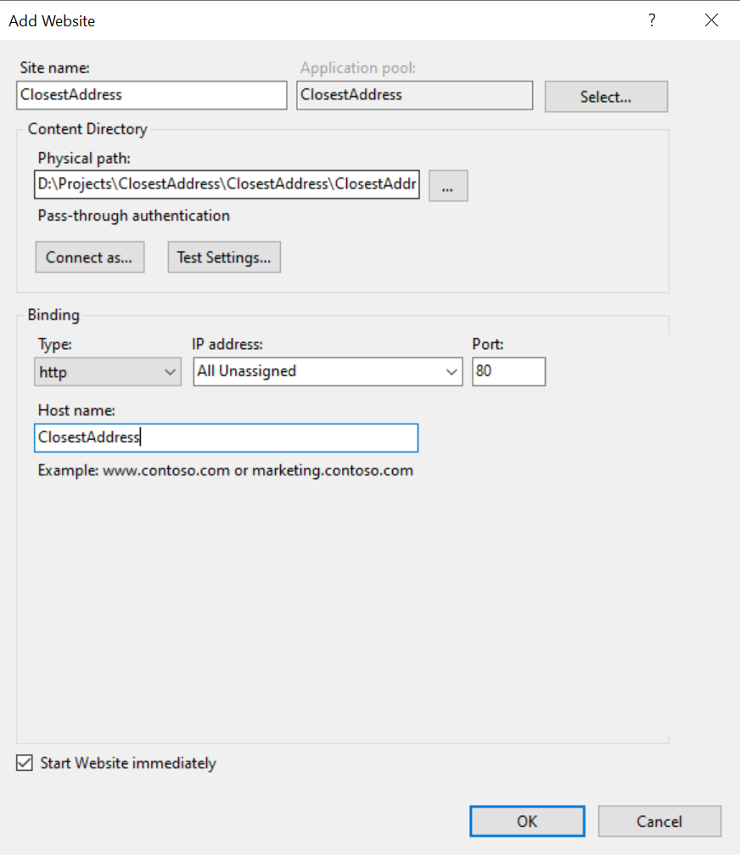

# Implementation

## **Google Map API**

* Calculated Distance between two addresses using Google Map API.
* Google Map API is available in Web.config so it can be config later as well

## **Log4Net**

* Log4Net has been used for to log errors

## **Cache**

* Cache has been implemented on **ClosestAddress.Cache proect**

## **Constants**

* Constants has been implemented on **ClosestAddress.Constants** project so we can define all constants there.

## **Unit Test**

* All unit test is available on **ClosestAddress.Tests** project

## **Web API**

* Web API is available on this project **ClosestAddress.WebApi** which has been configured on IIS

## **MVVM**

* Vue.JS has been implemented for two-way binding

## **Responsive Design**

* Bootstrap has been used as UI framework
* Page is responsive as well