**Assignment 4**

**Submitted by,**

**Swati Verma**

**MT19073**

For this assignment we are supposed to build a small natural language interface that will provide inputs to our career advisory system developed in prolog.

**Assumption: The user will provide one of the given option in its answer.**

I have created a python file which asks question to the user and gives option. The user gives the answer in the form of string.

**Preprocessing steps done for the input strings are as follows:**

1. Input string is converted into lower case.
2. All the punctuation marks like, !, @, #, . , &, etc. are removed from the given string using string library.
3. All the words in the string are tokenized and split on the basis of space.
4. Lemmatization is done which converts the words into their root words in a meaningful way.

**Here I am giving various career options like:**

* Master in Science (MS).
* Masters in Technology (MTech).
* Masters in Business Administration (MBA).
* IT jobs like Software Developer, Data Analyst, and System Designer.
* Government jobs like working in the public sector or teaching jobs.
* A career in defence.
* Traveling related options like Journalist, Event Planner, Travel Advisor, Photographer,

etc.

* Other career options like Graphic Designer, Interior Designer, Fashion Designer.

**Different parameters considered are:**

* Physical or Mental work.
* Aptitude marks.
* Technical or non-technical person.
* Done coding or not.
* Exams given - GRE, CAT, GATE, None.
* Business oriented.
* Leadership skill.
* Risk taker.
* Creative and innovative.
* Traveller or non-traveller.

**Screenshots :**

1. **Python interface:**

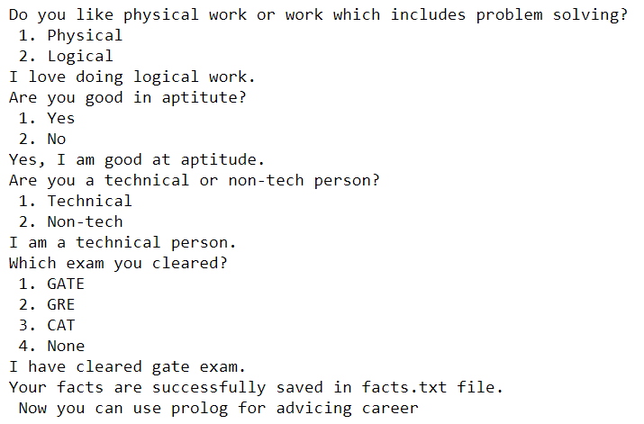

**Facts created in txt file:**

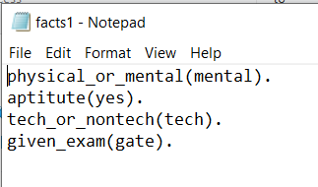

**Prolog output for above file:**

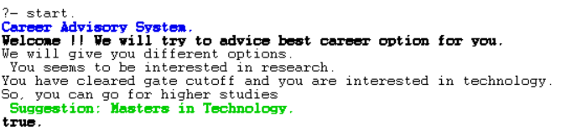

1. **Python interface:**

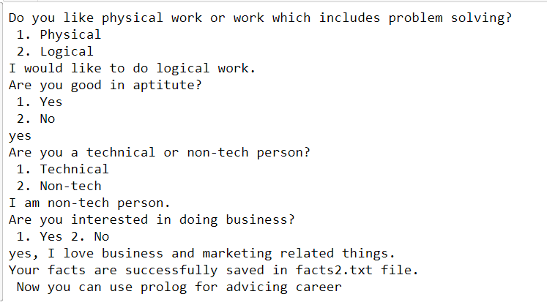

**Fact file created:**

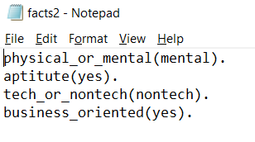

**Prolog output:**

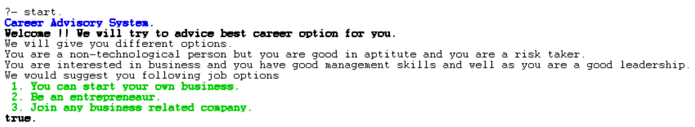

1. **Python interface:**

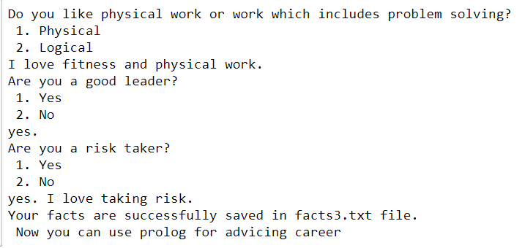

**Fact file created:**

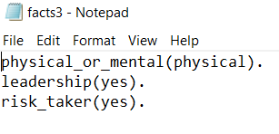

**Prolog output:**

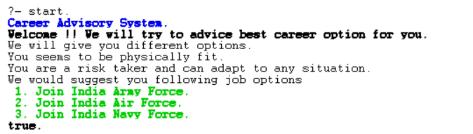

1. **Python interface:**

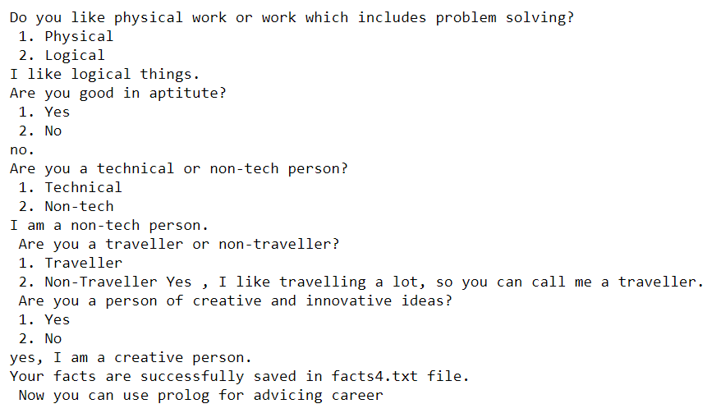

**Facts created:**

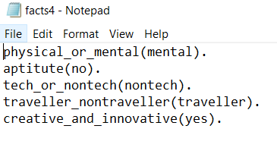

**Prolog output:**

