
- High Level Design (HLD)

High Level Design (HLD)

SER: Speech Emotion

Recognition

Revision Number: 1.0

Last date of revision: 02/06/2021

Vasanth P
Swati Sinha
Maitry Sinha


Vehicle Detection 1

- High Level Design (HLD)

Document Version Control

Date Issued | Version | Description | Author
18th August 2021 | 1.0 | First Version of Complete HLD | Vasanth P

Vehicle Detection 2

- High Level Design (HLD)

Contents

Document Version Control .................................................................................................... |  |  | 2
Abstract................................................................................................................................. |  |  | 4
1 | Introduction .................................................................................................................... |  | 5
 | 1.1 | Vehicle Detection…………………................................................................. | 5
 | 1.2 | Dataset.................................................................................................................... | 5
2 | General Description ....................................................................................................... |  | 6
 | 2.1 | Product Perspective ................................................................................................ | 6
 | 2.2 | Tools used .............................................................................................................. | 6
 | 2.3 | Constraints ............................................................................................................. | 6
 | 2.4 | Assumptions ........................................................................................................... | 6
3 | Design Details ................................................................................................................ |  | 7
 | 3.1 | Functional Architecture ........................................................................................... | 7
 | 3.2 | Database Design .................................................................................................... | 7
 | 3.3 | Web Application Architecture .................................................................................. | 8
 | 3.4 | Event log ................................................................................................................. | 8
 | 3.5 | Error Handling ......................................................................................................... | 9
 | 3.6 | Help ........................................................................................................................ | 9
 | 3.7 | Performance ........................................................................................................... | 9
 | 3.8 | Security ................................................................................................................... | 9
 | 3.9 | Reusability .............................................................................................................. | 9
 | 3.10 | Application compatibility .......................................................................................... | 9
 | 3.11 | Resource utilization ................................................................................................. | 9
 | 3.12 | Deployment............................................................................................................. | 9

Vehicle Detection 3

- High Level Design (HLD)

Abstract

More than two decades machine learning techniques have been applied in multidisciplinary fields in order to find more accurate, efficient and effective solutions. In that specifically deep learning is a growing multi-layer neural network learning algorithm in the field of machine learning in recent years. This research tries to detect vehicles. SSD along with mobile detection is used for the detection task. Python programming language have been utilized as the development language for this model. For the evaluation purpose multiple techniques are used in order to compare and identify the more accurate model. The primary goal of this project is to develop a system in which the system should be able to detect the vehicles automatically.

Vehicle Detection 4

- High Level Design (HLD)

- Introduction

  - Vehicle Detection

Vehicles in this world is now increasing day by day. Without vehicles most of the people don’t travel for their specific work be it personal or professional work. Now as it is increasing day by day there are some problems happening like all are to avoid traffic like moving in the wrong side of the road, running over time limit, overtaking and many more. So here we are doing an AI application which will detect the the vehicle and this AI can be applied in all sorts of the problem discussed above

  - Datasets

The datasets used task is COCO dataset:

The MS COCO (Microsoft Common Objects in Context) dataset is a large-scale object detection, segmentation, key-point detection, and captioning dataset. The dataset consists of 328K images.

Splits: The first version of MS COCO dataset was released in 2014. It contains 164K images split into training (83K), validation (41K) and test (41K) sets. In 2015 additional test set of 81K images was released, including all the previous test images and 40K new images.

Annotations: The dataset has annotations for
- object detection: bounding boxes and per-instance segmentation masks with 80 object categories,
- captioning: natural language descriptions of the images (see MS COCO Captions),
- keypoints detection: containing more than 200,000 images and 250,000 person instances labeled with keypoints (17 possible keypoints, such as left eye, nose, right hip, right ankle),
- stuff image segmentation – per-pixel segmentation masks with 91 stuff categories, such as grass, wall, sky (see MS COCO Stuff),
- panoptic: full scene segmentation, with 80 thing categories (such as person, bicycle, elephant) and a subset of 91 stuff categories (grass, sky, road),
- dense pose: more than 39,000 images and 56,000 person instances labeled with DensePose annotations – each labeled person is annotated with an instance id and a mapping between image pixels that belong to that person body and a template 3D model. The annotations are publicly available only for training and validation images.

Vehicle Detection 5

- High Level Design (HLD)

- General Description

2.1 Product Perspective

The Vehicle Detection system is a web application which will detect the type of vehicles from the image which is being uploaded into the application and gives you a detection by giving a bounding box for the vehicle. The Speech Emotion Recognition system designed will have many components. Most of these components will be programmed, while others will be implementations of open-source packages. The user interface will be using HTML/CSS to display the pages, Flask for deploying models and running the server.

2.2 Tools used



Front End(UI) | HTML, CSS
Back End | Flask
Libraries | Tensorflow, Keras, Numpy, OpenCV
Other Tools | VS Code, Pycharm – IDE, Postman-Monitoring API requests, Git – Version Control
Deployment Cloud | AWS

2.3 Constraints

The Vehicle detection system must be user friendly, as automated as possible and users should not be required to know any of the workings. Need to build a UI which is very compelling and enhancing user’s experience. The app built needs to be very robust such that it can handle large number of API requests

2.4 Assumptions

The main objective of the project is to detect vehicle from the images uploaded. It is also assumed that all aspects of this project have the ability to work together in the way the designer is expecting.

Vehicle Detection 6

- High Level Design (HLD)

3 Design Details

3.1 Functional Architecture
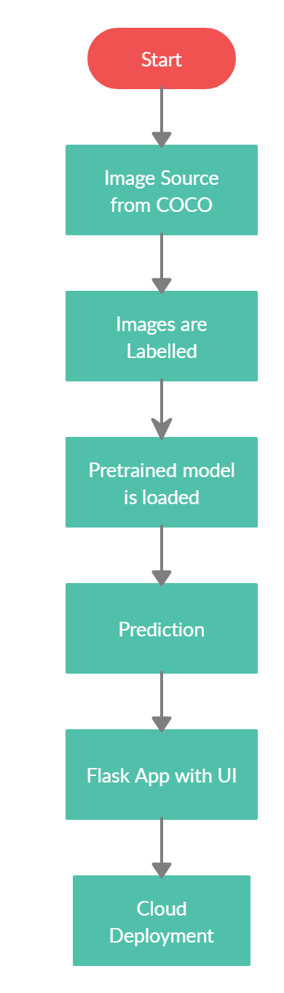

Figure 1: Functional Architecture of Vehicle Detection

We used the image source as coco dataset and used pretrained SSD model as our model. Here once the image is got is decoded and then sent to the model. The pretrained model is set with all parameters ready. The class names are extracted and are assigned to images as labels. Then the model is validated with the data. Once the model is validated the predictions are checked from unseen data such a way to get input from user dynamically. Once the predictions are looked to be fine a flask app is developed along with a UI. And then this whole folder is dockerized and is pushed into the cloud

Vehicle Detection 7

- High Level Design (HLD)

3.2 Web Application Architecture

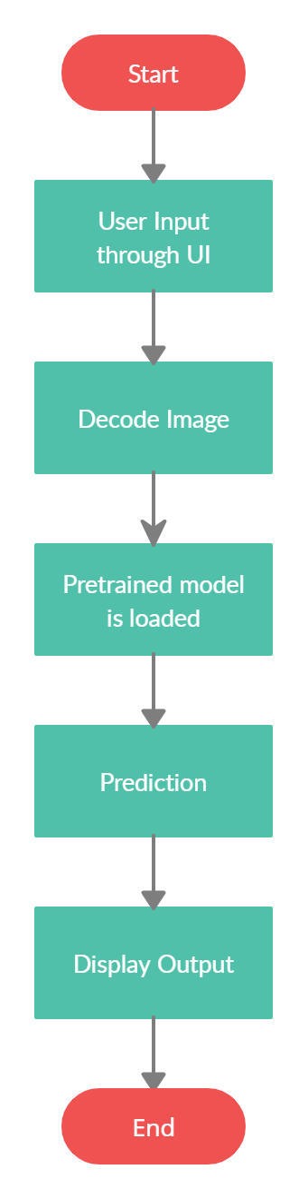

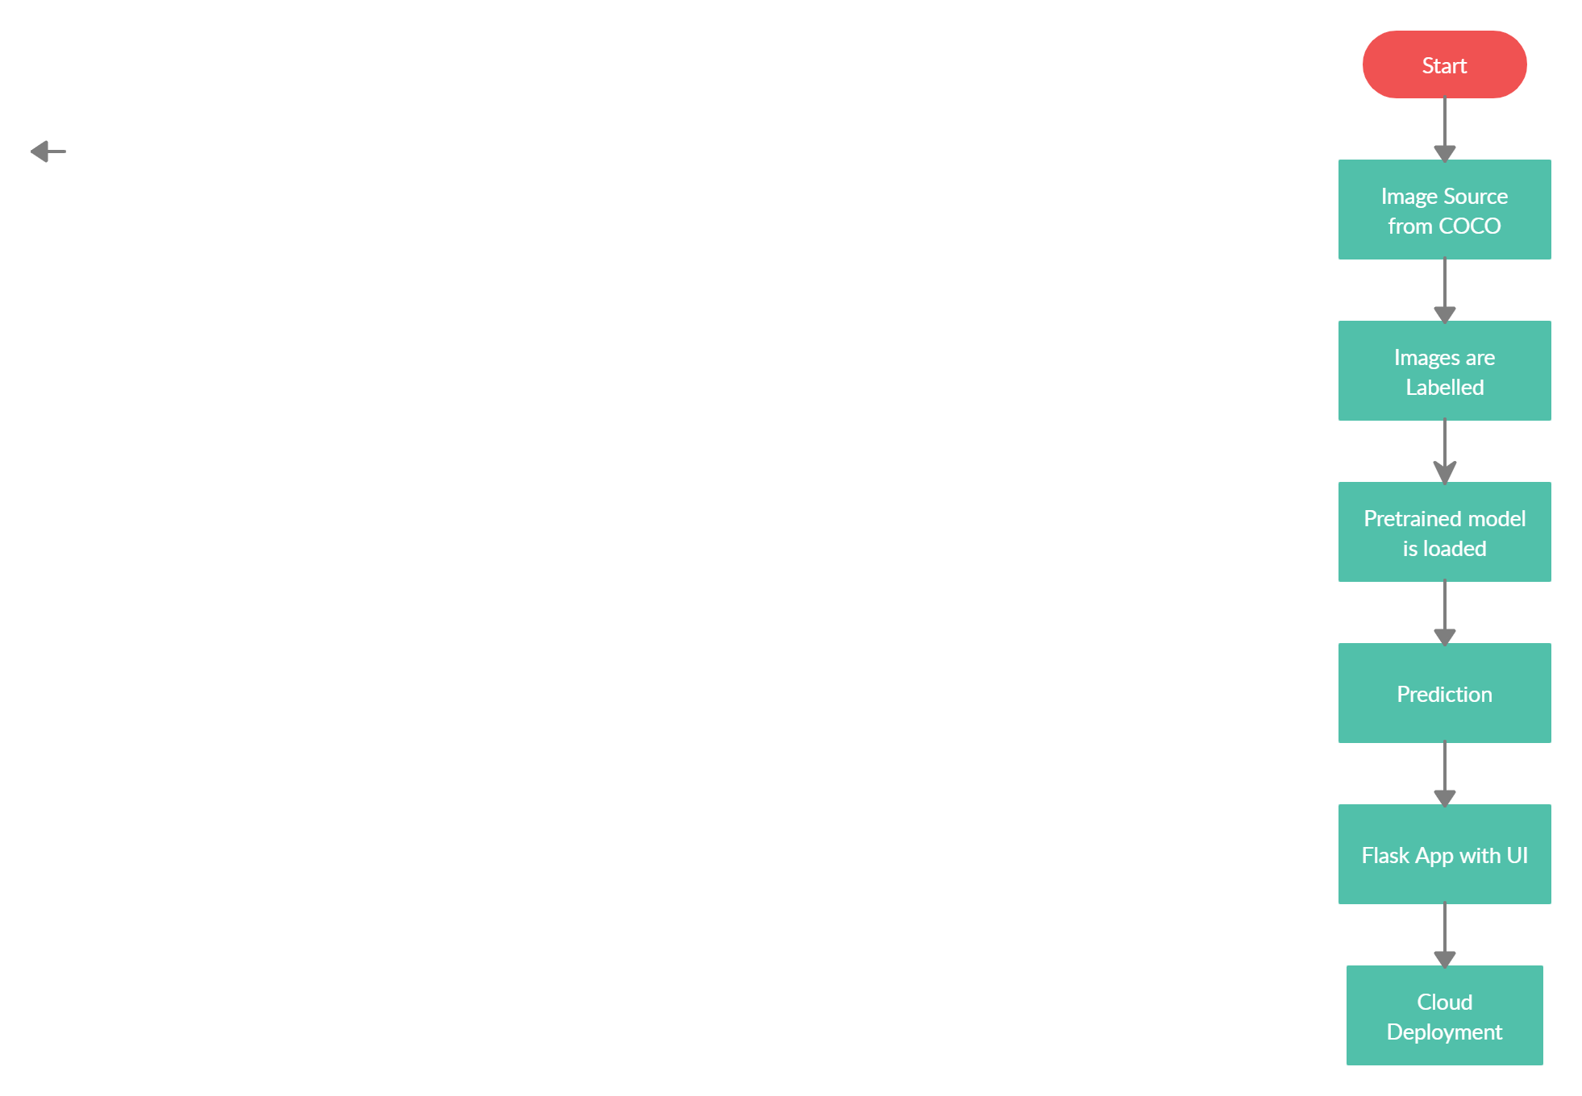Figure 2: Web application architecture

The front end of the program is a web application which comprises of just a single page. There is place for upload of the image. The users can upload their images in that place. Once the image is uploaded it is decoded and the decoded image goes to our model for prediction. Once the model runs and predicts the class of the vehicle, the output is displayed in the output screen.

3.3 Event log

The system should log every event so that the user will know what process is running internally.

Initial Step-By-Step Description:

- The System identifies at what step logging required

- The System should be able to log each and every system flow.

- System should not hang even after using so many loggings. Logging just because we can easily debug issues so logging is mandatory to do.

Vehicle Detection 8
- High Level Design (HLD)

3.4 Error Handling

Should errors be encountered, an explanation will be displayed as to what went wrong. An error will be defined as anything that falls outside the normal and intended usage.

3.5 Help

Help will come in the form of all the documentation created prior to coding which explain the uses of the system.

3.6 Performance

Vehicle detection system is used for many applications as discussed before, so it should be as accurate as possible. So that it will not mislead the user. Also, model retraining is very important to improve the performance because in the real-time data might vary from the trained data.

3.7 Security

Security is not the prime focus now

3.8 Reusability

The code written and the components should have the ability to be reused with no problems.

3.9 Application compatibility

The different components for this project will be using Python as an interface between them. Each component will have its own task to perform, and it is the job of the Python to ensure proper transfer of information.

3.10 Resource utilization

When any task is performed, it will likely use all the processing power available until that function is finished

3.11 Deployment



Vehicle Detection 9

