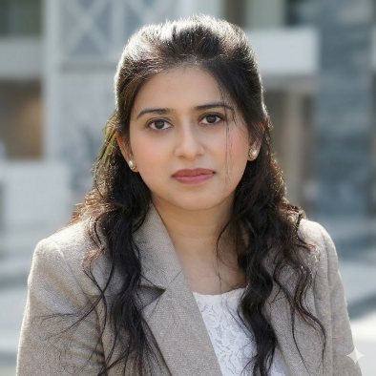
CORE COMPETENCY
- Structural Proteomics| Cross-linking mass-spectrometry| High resolution LC-MS/MS| HPLC| Orbitrap Fusion Lumos Mass spectrometer| SDS-PAGE| Cross-functional collaboration| Pharmaceutical quality control| Method development

Contact
(+420) 608693396
swatibanerjee060@gmail.com
Prague, Czech Republic, EU
in linkedin.com/in/swati-banerjee-cz

swati banerjee, M.Sc.

RESEARCH SCIENTIST

SUMMARY

- 10 years of combined experience in pharmaceutical quality control and mass spectrometry based structural proteomic research across leading research institute, CRO and government regulatory laboratory including junior analyst mentorships.
- Experienced in developing high-resolution LC-MS/MS workflows for protein interaction studies in complex biological systems, leading to 2 recent peer-reviewed scientific publications .
- Extensive hands-on experience in HPLC method development contributing to the analysis of high volume of complex pharmaceutical samples under national drug surveillance programs.
- Confident scientific communicator with experience presenting research findings at in-house seminars and 5 scientific conferences, including 1 international conference.

Work authorization: Czech Republic (Permanent resident)

PROFESSIONAL EXPERIENCE

Doctoral fellow – Structural proteomics, IOCB↗, Czech Republic| 2019 – 2025
- Developed high-resolution LC-MS/MS methods for protein interaction analysis of 7+ diverse protein systems by protein cross-linking - mass spectrometry.
- Led the analytical evaluation & validation of a novel in-house developed water-soluble, MS-cleavable cross-linker, resulting in first-author peer-reviewed publication.
- Characterized complex protein structure by mapping residue-level interaction interfaces and conformational changes by XL-MS.

Analytical Chemist - Quality Control, Central Drugs Laboratory↗, India| 2015 – 2019
- Led high-throughput HPLC and compendial analysis per USP/EP/IP standards across diverse dosage forms—including solids, injectables, and suspensions—to detect counterfeit medicines and resolve court-referred disputes in an ISO 17025 environment.

Professional development | 2013 – 2015
- Dedicated period to secure the national-level NET qualification and deliver independent academic mentorship in core chemical/biological sciences.

Research chemist, Chemgen Pharma International Pvt. Ltd. ↗, India| 2011 – 2013
- Developed over 300 novel therapeutic scaffolds using multi-step organic synthesis, utilizing LC-MS and NMR for structural characterization to deliver highly pure intermediates for bioactivity evaluation under strict CRO timelines.

EDUCATION
- PhD in Analytical Chemistry (Thesis writing), IOCB ↗ & Charles University↗, Prague 2019 - present
- MSc in Chemistry, WBSU, India 2008 - 2010
- Certifications: Certified in Quality Pharmaceutical industry (GHP, GLP and GMP).

key instrumentation & SOFTWARE skills

Instrumentation
- Liquid Chromatography: HPLC/UHPLC (Perkin-elmer Flexar): assay, impurity profiling, method development
- Mass Spectrometry: HR-LC-MS/MS (Orbitrap Fusion Lumos - Dionex Ultimate 3000 RSLC nano, Bruker MALDI-TOF/TOF Ultraflextreme: protein and small molecule characterization
- Pharmaceutical QC: dissolution (Veego Scientific), disintegration (Labindia DT), UV-Vis (Shimadzu 1800), Karl Fischer titration
- Protein Analysis: bottom-up proteomics, SDS-PAGE, In-gel/In-solution protein digestion, Protein cross-linking – sample preparation, Mass-spectrometric complex data analysis and interpretation, use of cleavable & non-cleavable cross-linkers

Software skills
- TotalChrom| XCalibur| Merox| plink| pymol| Proteome Discoverer| MS convert | XiView | Chimera | Python (basic)| MS Office

LANGUAGE SKILLS
English (professional proficiency), Hindi & Bengali (Native), Czech (beginner level)

Achievements
- Achieved 97th percentile in all India exam (CSIR-UGC NET lectureship, 2014).

