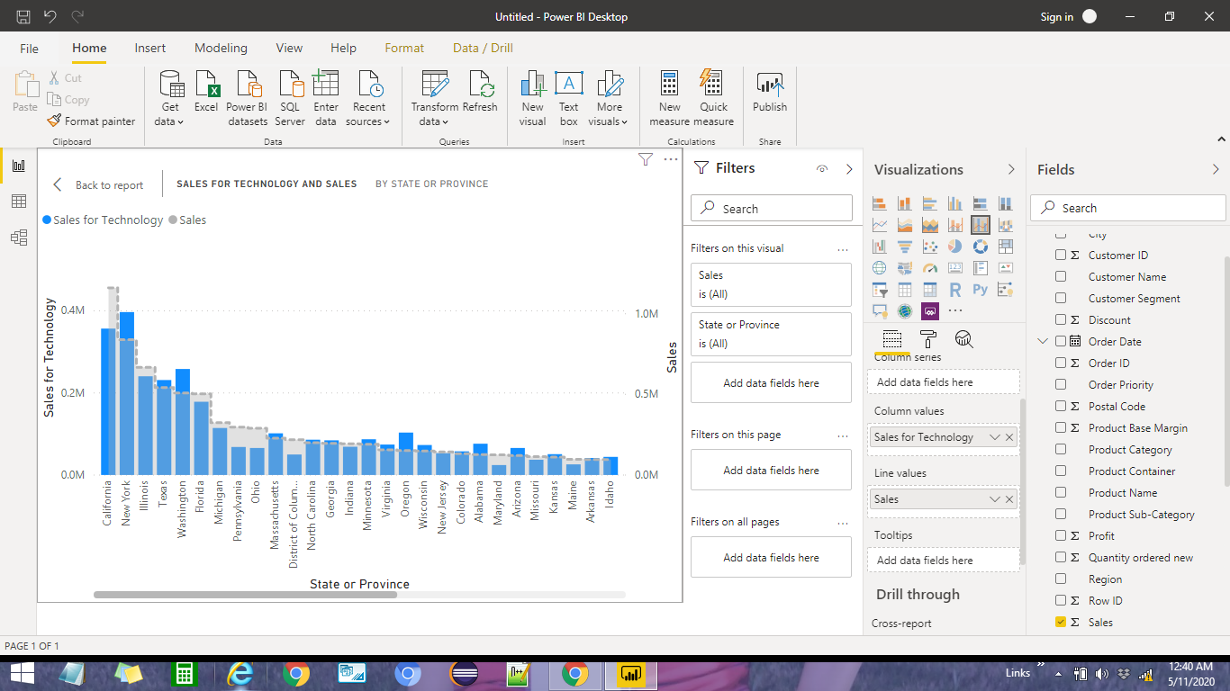

According to graph,
California state has the highest sales in terms Technology.

