# **Term Project Selected paper – Swati Mishra CS 580**

The Paper I have chosen is – ‘American Association of Clinical Endocrinology Consensus Statement: Comprehensive Type 2 Diabetes Management Algorithm - 2023 Update’. This paper has many algorithms for different situations, and I have selected 2 that are a continuation of each other.

1. Glucose-centric algorithm for glycemic control (Algorithm Fig 7)
2. Algorithm for adding or intensifying insulin (Algorithm Fig 8)

I am adding screenshots of both algorithms from the paper.

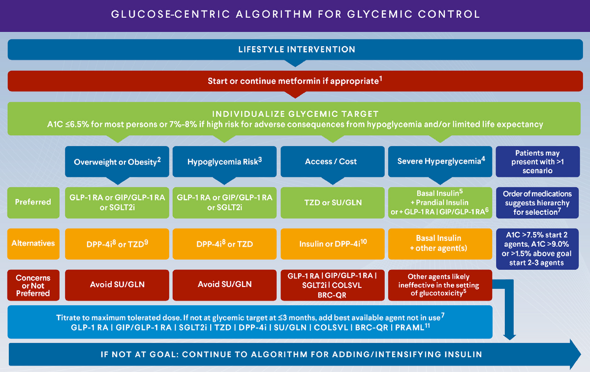

Paper reference –

Samson, S. L., Vellanki, P., Blonde, L., Christofides, E. A., Galindo, R. J., Hirsch, I. B., Isaacs, S., Izuora, K., Wang, C. C. L., Twining, C. L., Umpiérrez, G. E., & Valencia, W. M. (2023). American Association of Clinical Endocrinology Consensus Statement: Comprehensive Type 2 Diabetes Management Algorithm – 2023 Update. *Endocrine Practice*, *29*(5), 305–340. <https://doi.org/10.1016/j.eprac.2023.02.001>