STRESS TEST REVIEW APPLICATION
Full Workflow, Architecture & Project Creation Specification
Manager / Claude Project Creation Document • MVP starts with Stress Test 0 and expands to ST0–ST5
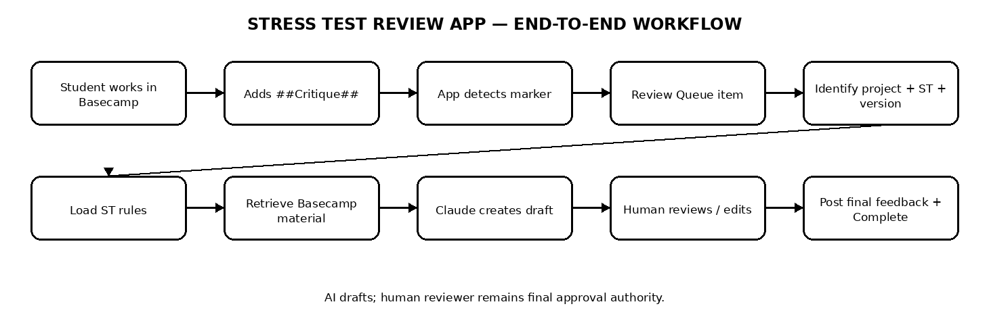
Figure 1. End-to-end workflow from Basecamp submission to human-approved feedback.

Executive Summary
The application is a single Stress Test Review platform. Students continue working in Basecamp. A normalized ##Critique## marker becomes the machine trigger. The application creates a review item, identifies the project and Stress Test, identifies the exact submission/version, loads the correct rule module, retrieves the required Basecamp material, generates an AI draft review, and presents it to a human critiquer. Only the human reviewer can finalize the review. Final feedback is posted back to Basecamp and the completed review becomes structured historical knowledge for future retrieval.

1. Business Objectives
- Reduce manual effort required to review Stress Tests while keeping human approval as the final control.
- Apply the correct rules consistently for each Stress Test instead of asking AI for generic critique.
- Create one central Review Queue for all projects and all Stress Tests.
- Preserve every submission/version, AI finding, reviewer edit, final feedback, and decision for audit and learning.
- Retrieve only a small set of relevant historical cases instead of sending the entire historical database to Claude.
- Start with ST0 and allow ST1–ST5 to be added as configurable modules without rebuilding the application.

2. Complete Student-to-Reviewer Journey
Step | Process | Requirement
1 | Student works in Basecamp | Student creates or updates the Stress Test submission in the existing Basecamp project.
2 | Student adds ##Critique## | Marker indicates the current submission/version is ready for review.
3 | Application detects marker | Application monitors Basecamp activity and identifies a valid normalized critique marker.
4 | Review Queue item is created | Create Pending review tied to the exact submission/version.
5 | Project + Stress Test identified | Determine project, student, Stress Test, version and reviewer; never guess if ambiguous.
6 | Correct rules loaded | Load only the rule module for the identified Stress Test.
7 | Submission retrieved | Retrieve written content, comments, screenshots, attachments, files and relevant links required for review.
8 | AI reviews against rules | Claude evaluates the current submission against the loaded rules only.
9 | Draft feedback generated | Return rule ID, status, severity, evidence, reason, suggested feedback and confidence.
10 | Human reviewer reviews | Reviewer can approve, edit, reject or add findings. Human review is mandatory.
11 | Final feedback posted | Post only approved final feedback to the correct Basecamp location.
12 | Review becomes Completed | Completed means human review and final feedback are complete.

3. One Application, Six Stress Test Modules
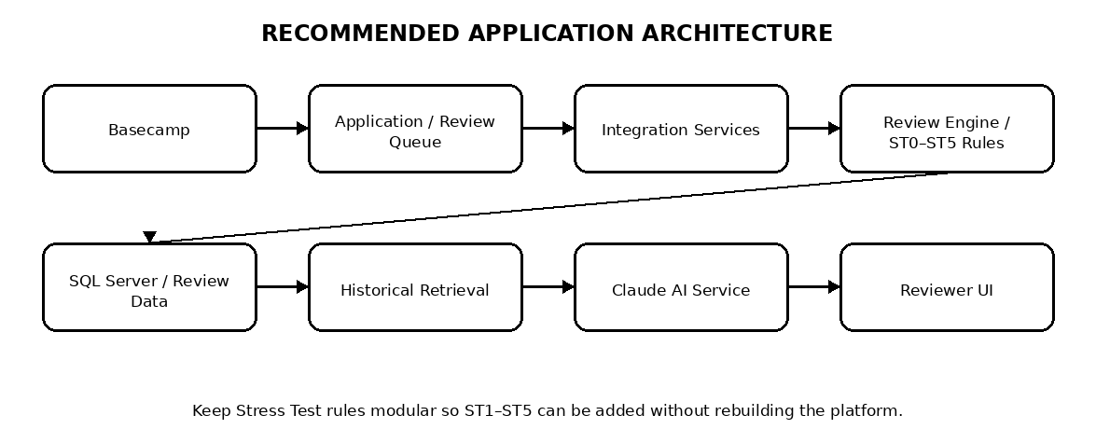
Module | Role | MVP status
Review Queue | Central list of submissions awaiting/undergoing review | Build first
ST0 | Dataset, source, collection, problems, artifacts; structural validation | Build first
ST1 | Data preparation / modeling rules | Future
ST2 | Dashboard / KPI rules | Future
ST3 | Insights / analysis rules | Future
ST4 | Reporting / strategy rules | Future
ST5 | Final presentation / evaluation rules | Future
History / Learning | Searchable completed reviews and reviewer decisions | Design now; expand over time
The common platform owns Basecamp integration, marker detection, queue management, submission retrieval, reviewer workflow, audit history, and historical retrieval. Each Stress Test module owns its rules, validation logic, required artifacts, review stages and feedback guidance.

4. Critique Marker Detection and Version Handling

4.1 Authoritative detection approach
The new application should read the underlying Basecamp comment data directly rather than relying solely on the existing proc_AllStressTestData procedure. The current procedure uses exact LIKE matching for ##Critique##, ##FeedbackGiven## and ##Approved## and therefore should not be treated as the authoritative detector for reasonable marker variations.
- Recognize reasonable case/spacing variations: ##Critique##, ## Critique##, ##Critique ##, ## Critique ##.
- Do not trigger on plain Critique, #Critique, ##Review##, or ordinary prose containing the word critique.
- Normalize the marker before evaluating it.
- Use MessageId to identify the overall Basecamp thread.
- Use CommentId to identify the exact submission/comment version.
- Do not use IsSubmitted as the submission/version identifier.
- A new critique marker on a later version creates a new review while preserving the previous review.
Data element | Use
MessageId | Overall Basecamp message/thread identity
CommentId | Exact comment/submission/version identity
Critique marker | Machine trigger for a review
IsSubmitted | Not a reliable version identifier
Previous review | Preserve for history and revision context

5. Existing SQL Server Procedure and New Application
Component | Current / intended role | Decision
proc_AllStressTestData | Existing Critique List/intake support | Keep; not authoritative for new marker detection
Basecamp_MessageBoards_MessageComments | Underlying comment records | Primary source for app marker/version detection
ADF_BasecampStressTestCritiquer | Critiquer assignment/history | Use where appropriate
Basecamp API | Full review material and eventual feedback posting | Required
The existing procedure can continue supporting the current Critique List. The new application should add its own normalization and review-intake layer rather than forcing all new behavior into the existing procedure.

6. Review Material Retrieval
- SQL Server identifies the candidate review and provides stored references/context.
- Basecamp retrieves the actual material needed for review.
- Review material can include written submission, images/screenshots, attachments/files and relevant links.
- Review engine must support multimodal input when a Stress Test requires visual evidence.
- If project, Stress Test or submission cannot be identified confidently, move the case to manual resolution rather than guessing.
- If Basecamp content cannot be retrieved, preserve the queue item and expose the integration error.

7. Stress Test Rule Architecture
Official Stress Test rules should be versioned configuration, not hard-coded into generic AI prompts. The platform loads the rule module that matches the identified Stress Test.
Rule-module content | Purpose
Stress Test scope | Defines what AI is and is not allowed to evaluate
Rule IDs | Stable identifiers such as ST0-001
Requirement definitions | Requirement to validate
Validation logic | How evidence is interpreted
Required artifacts | Screenshots, files, links, etc.
Review stages | Order in which checks execute
Severity guidance | Required Fix / Needs Attention / Improvement
Feedback guidance | Expected concise/actionable wording
Advisory rules | Non-blocking guidance where applicable
Rule version | Allows historical reviews to be interpreted against rules active at that time
Recommended organization: keep this Master Project Specification separate from individual Stress Test rule specifications. For Claude project creation, upload the Master Specification plus the rule document(s) for the modules being implemented.

8. ST0 Module — Scope
ST0 is structural validation only. It should not evaluate modeling quality, forecasting quality, dataset realism, strategic quality, feature engineering, algorithm selection or other later-stage analytical concerns. Final approval remains manual.

9. ST0 Review Sequence
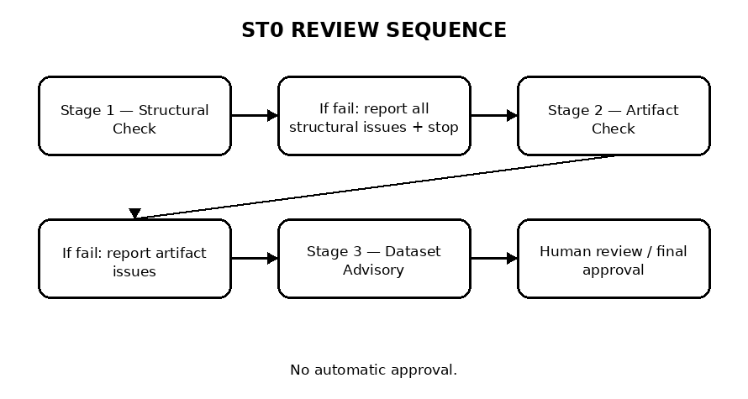
- Stage 1 — Structural Check.
- Stage 2 — Artifact Check.
- Stage 3 — Dataset Advisory.
- If Stage 1 fails, list all Stage 1 structural issues together and stop. Do not mix Stage 2 issues into the blocking result.
- Only after Stage 1 passes should Stage 2 run.
- The dataset advisory must not create a structural failure.
- The application must never auto-approve a submission.

10. ST0 Rule Summary
Rule ID | Requirement | Expected result
ST0-001 | Dataset description is present | PASS / Required Fix
ST0-002 | At least one valid public dataset source link | PASS / Required Fix
ST0-003 | Data collection explanation is present and separate from dataset description | PASS / Needs Attention
ST0-004 | Dataset screenshot shows headers and preview rows | PASS / Required Fix
ST0-005 | Dataset file(s) are present in final submission | PASS / Required Fix
ST0-006 | 8–10 Data Science problems are provided | PASS / Required Fix
ST0-007 | Each problem contains all required fields | PASS / Required Fix
ST0-008 | Exactly one selected problem is clearly identified | PASS / Required Fix
This table is a summary only. The detailed ST0 Rules & Validation Specification should be maintained separately and used by the review engine.

11. ST0 Problem Completeness
Each of the 8–10 structured Data Science problems must contain:
- Problem
- Solution
- Model Type/s
- Algorithm
- Independent Variable/s
- Dependent Variable
- Target Audience
- Future Capability/ies
Topic headers and descriptive text before a problem are allowed. Detection should be based on required section presence and meaning, not exact heading wording. Minor capitalization, punctuation, singular/plural, numbering and wording variations should not cause failure.

12. ST0 Dataset Advisory — Power BI Readiness
This is advisory context, not a blocking structural rule. Prefer datasets with multiple meaningful categorical dimensions, several numerical columns and at least one date/time field. Numeric identifiers such as Store_ID, Dept_ID and Product_ID are weak dimensions. A dataset with no categorical dimensions, or only one, may limit meaningful dashboard analysis.

13. AI Finding Structure and Feedback Style
Field | Purpose
rule_id | Connect finding to official Stress Test rule
status | PASS / FAIL / ADVISORY
severity | Required Fix / Needs Attention / Improvement
evidence | Specific evidence in current submission
reason | Why evidence passes/fails rule
suggested_feedback | Concise, specific, actionable feedback
confidence | AI confidence
historical_support | Optional relevant prior cases
Prioritize blocking and unclear issues. The AI must not invent requirements, substitute another Stress Test's rules or make final approval decisions.

14. Historical Retrieval — Fast Path
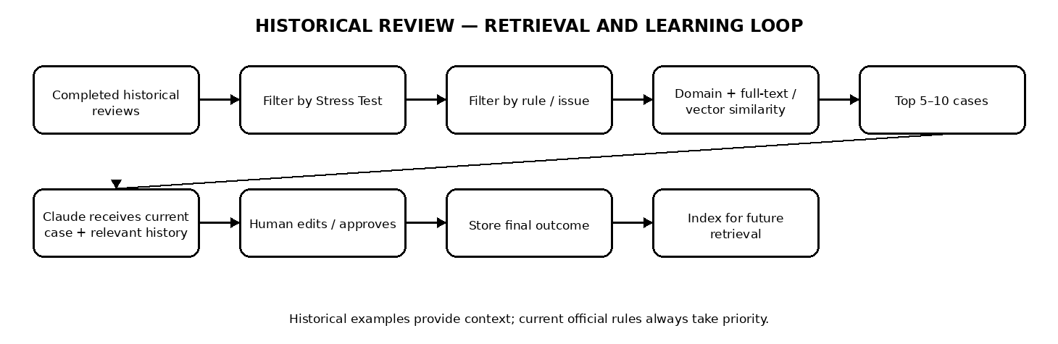
Retrieval layer | Purpose | Example
1. SQL filters | Reduce search space | Stress Test = ST0 AND review = Completed
2. Rule matching | Find same requirement/issue | rule_id = ST0-004
3. Domain/objective matching | Find similar project context | Retail / e-commerce / similar objective
4. Full-text search | Find related wording/concepts | SQL Server Full-Text Search
5. Vector similarity | Find semantic matches | Embedding similarity; optional/advanced
6. Top-k selection | Send only useful examples | Top 5–10 cases
Claude should receive the current case plus a small, relevant set of historical cases. It should never receive every project and every Stress Test.

15. How New Reviews Become Historical Knowledge
- No manual AI retraining is required after every review.
- When a review is completed, store final feedback, reviewer edits, rule IDs, findings and decision.
- Index the completed case for future retrieval.
- A future submission can retrieve the completed case when relevant.
- Historical examples never override official current Stress Test rules.

16. Technical Architecture
Layer | Responsibility
Frontend web application | Review Queue, Review Detail, AI Findings, Feedback Editor, History
Backend application/API | Queue processing, orchestration, Basecamp integration, rule engine, Claude calls, reviewer APIs
Integration services | Basecamp API/OAuth/webhooks and Claude/AI access
Review engine | ST0–ST5 rule loading, validation, finding generation, historical retrieval, prompting
SQL Server | System of record for reviews, versions, rules, findings, history, reviewer decisions and audit
Background worker | Webhook processing, submission retrieval, AI review and historical indexing
Logging/monitoring | API errors, processing failures, latency and integration health
Authentication/SSO | Reviewer access and identity
Secret management | API keys, OAuth secrets and DB credentials; never hard-code

17. Technology / Tools Required
Component | Required? | Purpose / notes
Microsoft SQL Server | Yes — already available | Primary application database and system of record
Basecamp API | Yes | Read projects/submissions/comments/attachments as permitted and post final feedback
Basecamp OAuth 2.0 | Yes | Authenticate application access
Basecamp webhooks | Recommended | Near-real-time relevant activity notification
Claude API / approved Claude route | Yes if Claude selected | AI review and structured draft feedback
Anthropic credentials or AWS/Bedrock credentials | One of these | Approved enterprise Claude access
SQL Server Full-Text Search | Recommended | Initial historical retrieval
Embedding model/service | Optional for MVP; recommended later | Semantic historical retrieval
Vector search | Optional | Evaluate approved SQL Server 2025 or dedicated vector layer
Backend application/API | Yes | Orchestration and review services
Frontend web application | Yes | Reviewer experience
Background job/worker | Recommended | Asynchronous processing
Logging/monitoring | Yes | Operational visibility
Authentication / SSO | Recommended | Reviewer identity and access

18. Credentials and Security
Credential | Source | Use
Anthropic API key | Anthropic / organization | Direct Claude API
AWS credentials / IAM role + Bedrock access | AWS / organization | Claude through Bedrock
Basecamp OAuth client ID / secret | Basecamp app registration | OAuth authorization
Basecamp authorization/token information | Authorized Basecamp user | Basecamp API
SQL Server service account / connection credentials | Internal IT / DBA | Database access
Embedding API credential | Chosen provider | Only if vector retrieval is implemented
Application secret / SSO configuration | Internal security team | Reviewer authentication/session security
Keep secrets in an approved secret manager or protected environment configuration. Never place API keys in source code, browser JavaScript, plain-text SQL tables or documents shared with reviewers.

19. Database Design
Table / entity | Purpose
stress_test_reviews | One review instance per project/submission/version; status, reviewer, timestamps, final feedback
stress_test_rules | Versioned ST0–ST5 rule definitions and validation guidance
review_findings | AI findings with rule ID, status, severity, evidence, reason, confidence and reviewer decision
submissions / submission_versions | Exact Basecamp submission/version reviewed
projects | Basecamp project identity and metadata
historical_reviews | Searchable completed reviews / normalized historical context
reviewer_edits | What the human changed, rejected, approved or added
review_audit_log | Who did what, when and against which version
integration_events | Incoming webhook/API events and processing status

20. Review Queue
Visible field | Meaning
COE | Center / organizational context
Critique List / Project | Project and Stress Test submission requiring review
Last Submitted | Most recent submission/version timestamp
Critiquer | Assigned human reviewer
Status | Pending / In Review / Feedback Generated / Completed internally; Pending/Completed may remain visible
Action | Open review / Continue / Complete

21. Review Detail Screen
- Submission summary: project, student, Stress Test, submission version and trigger timestamp.
- Current submission content and required artifacts.
- AI findings grouped by Required Fix, Needs Attention and Improvement.
- Evidence and rule ID for every finding.
- Relevant historical examples used by AI.
- Editable final feedback area.
- Approve / Edit / Reject / Add Finding controls.
- Audit/history showing AI draft and final human version.

22. Status Model
Status | Meaning
Pending | ##Critique## detected and review created
In Review | Reviewer has opened/started the case
Feedback Generated | AI draft exists
Completed | Human reviewer finalized review and final feedback was posted/stored
Completed must never mean 'AI finished.' It means human review is finished and final feedback has been accepted/delivered.

23. Error Handling
Condition | Required behavior
Project cannot be identified | Manual resolution; do not critique
Stress Test number cannot be identified | Manual resolution; do not guess
Submission cannot be retrieved | Preserve queue item and show integration error
Unsupported Stress Test | Do not apply another module's rules
Duplicate critique event | Idempotency check prevents duplicate review records
New critique on later version | Create new review/version and preserve previous review
Claude/API failure | Retry safely; retain queue item and error state
Basecamp posting failure | Do not mark Completed until final feedback delivery is resolved

24. Security, Audit and Governance
- Use least-privilege access for Basecamp and SQL Server.
- Keep API credentials outside source code.
- Record the exact submission/version reviewed.
- Preserve original AI output before human edits.
- Store final human feedback separately from AI feedback.
- Record reviewer identity and completion timestamp.
- Version Stress Test rules so old reviews can be interpreted against the rules active at that time.
- Define retention/access policies for student submissions and reviewer history.
- Prevent AI from directly changing final review status or posting final feedback without human approval.

25. Implementation Phases
Phase | Scope | Outcome
1 | Basecamp connection + critique detection + Review Queue | Real submission can enter system
2 | ST0 rule engine + validation | Application identifies structural ST0 issues
3 | Claude integration + structured findings | AI generates draft ST0 feedback
4 | Human workflow + Basecamp posting | End-to-end ST0 review operational
5 | Historical retrieval | Relevant prior reviews surfaced automatically
6 | Learning / reviewer decision analytics | Reviewer edits and decisions improve future retrieval/prompting
7 | ST1–ST5 modules | Additional Stress Tests added without rebuilding core platform

26. MVP Acceptance Criteria
- ##Critique## creates exactly one review record per submission version.
- Correctly identifies ST0 and loads only ST0 rules.
- Detects all required missing structural items.
- Identifies exact problem number/field when a required field is missing.
- Runs Stage 1 before Stage 2, then advisory checks.
- Dataset advisory does not become a structural failure.
- AI feedback is concise, specific and actionable.
- Human reviewer can approve, edit, reject or add feedback.
- Review is marked Completed only after human review.
- New critique on a new version creates a new review while preserving previous history.
- AI never final-approves a submission.
- Historical retrieval never overrides current Stress Test rules.

27. Development Inputs Required Before Coding
- Confirm exact Basecamp environment and projects/COEs the application must access.
- Register Basecamp integration and obtain OAuth credentials.
- Confirm webhook availability and exact trigger strategy.
- Confirm installed SQL Server version and Full-Text Search availability.
- Confirm whether SQL Server 2025 vector functionality is available/approved.
- Obtain approved Claude access path: direct Anthropic API or Amazon Bedrock/AWS.
- Confirm security requirements for student data, API calls, logging and retention.
- Define reviewer authentication/SSO requirements.
- Provide representative historical ST0 reviews for retrieval testing.
- Confirm exact Basecamp location for final feedback posting.
- Define reviewer assignment/reassignment permissions and completion permissions.

28. Recommended Document Set for Claude Project Creation
Document | Purpose | When used
01 — Master Project Specification | Architecture, workflow, database, UI, integrations, security and acceptance criteria | Always
02 — ST0 Rules & Validation Specification | Detailed official ST0 scope, rules, stages, validation logic and feedback guidance | ST0 implementation
03 — ST1 Rules & Validation Specification | Official ST1 rules | When ST1 is implemented
04 — ST2 Rules & Validation Specification | Official ST2 rules | When ST2 is implemented
05 — ST3 Rules & Validation Specification | Official ST3 rules | When ST3 is implemented
06 — ST4 Rules & Validation Specification | Official ST4 rules | When ST4 is implemented
07 — ST5 Rules & Validation Specification | Official ST5 rules | When ST5 is implemented
Historical Review Data / Examples | Approved completed cases for retrieval/testing | As needed
This separation is intentional. The Master Specification tells Claude how to build the platform. The Stress Test rule documents tell Claude what each module must validate. A rule change can therefore be made without rewriting the core architecture specification.

29. Recommended MVP Technology Decision
Keep Microsoft SQL Server as the system of record. Use a backend service for integrations and orchestration, a web frontend for reviewers, Claude through the approved enterprise route, and SQL Server Full-Text Search as the initial historical retrieval mechanism. If the installed SQL Server environment supports approved vector functionality, evaluate native vector storage/search; otherwise add a dedicated vector layer only when semantic retrieval is proven necessary.

30. Bottom Line
The proposed platform is a controlled review system, not an AI bot sitting on top of Basecamp. Basecamp supplies the submission. The application identifies the correct Stress Test and rules. Historical retrieval supplies relevant precedent. Claude creates a draft. A human reviewer makes the final decision. Final feedback is posted to Basecamp. The completed review becomes structured historical knowledge for the next case.
Prepared as a detailed project-creation specification for implementation in Claude.

