SONAR sensor data analysis

(Author : Swati V. Shirke)

Chapter 1: Analysis of SONAR sensor characteristics

Sensor used : HCSR04

Ranging Distance :2cm – 400 cm

For Distance 100 cm :

Readings Line graph for the same readings 

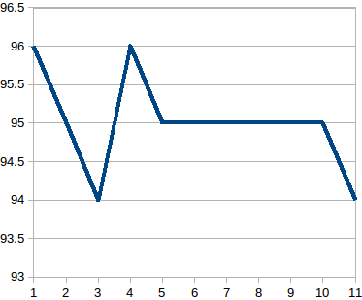

Note : Here 5 readings used with average filter are also sufficient to find the correct distacne.

For Distance = 200cm :

Readings Grapg for the same readings



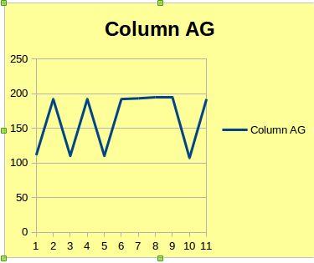

Note : Here readings varry from 100 to 200 range so averaging data can not give us correct result.

But Median filter can be used as maximum time we are getting correct reading.

If we take only 5 readings here then,

Readings Graph for the same

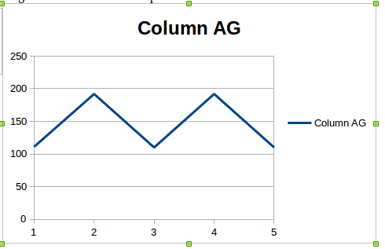

Note : Here averaging data will give wrong result.

Conclusion : So we can conclude follwing things for this sensor

1. For distacne < 100cm it gives good result with even averaging filter.

2. For distacne > 100 cm , we should go with median filter.

Chapter 2 : Implementation of Median Filter windowsize = 5

Before applying Median filter where object is present at 200cm

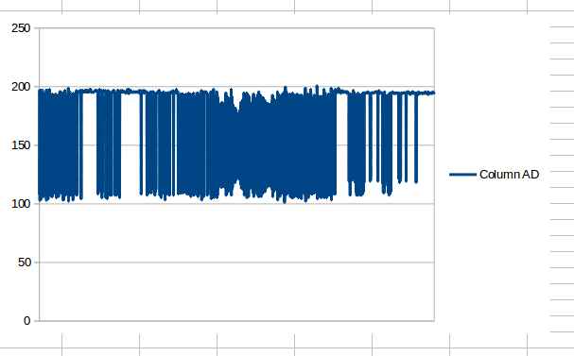

After applying Median filter with window size N=5, where object is present at distacne D= 200cm.

