S3: (Simple Storage Service)
Amazon Simple Storage Service (Amazon S3) is an object storage service that offers industry-leading scalability, data availability, security, and performance.
You can store Big File, Small files, Media content, source code etc.
Whenever we are going to store any file or any kind of data file then that particular file is going to be store as an object not as an file.

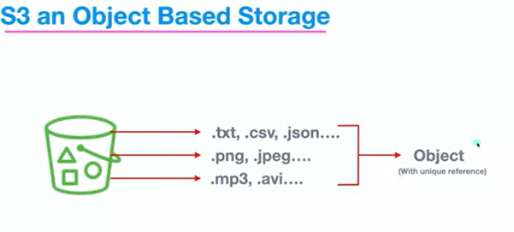

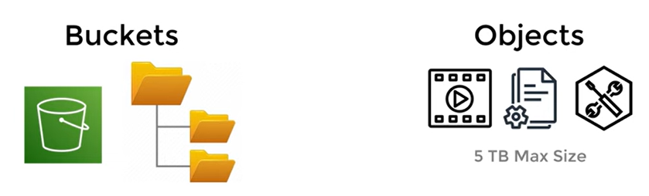
Even we can control access to a certain object within your S3 bucket. You provide read write update permission.
Bucket will be region specified.
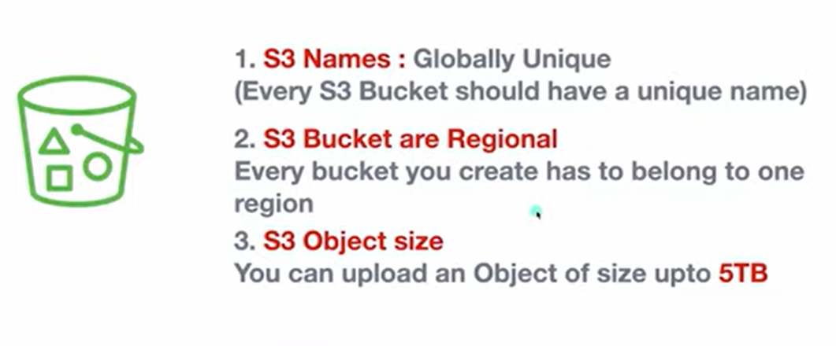
How it works:
Amazon S3 stores data as objects within buckets. An object is a file and any metadata that describes the file. A bucket is a container for objects. To store your data in Amazon S3, you first create a bucket and specify a bucket name and AWS Region. Then, you upload your data to that bucket as objects in Amazon S3. Each object has a key (or key name), which is the unique identifier for the object within the bucket.
S3 provides features that you can configure to support your specific use case. For example, you can use S3 Versioning to keep multiple versions of an object in the same bucket, which allows you to restore objects that are accidentally deleted or overwritten. Buckets and the objects in them are private and can only be accessed with explicitly granted access permissions. You can use bucket policies, AWS Identity and Access Management (IAM) policies, S3 Access Points, and access control lists (ACLs) to manage access.

- Search s3 in AWS Console
- Create Bucket
- Bucket name (unique)
- Bucket versioning – disable
- Bucket key – enable
- Create bucket
- Click on bucket
- Upload – files & folder – add files -select any file -upload

Benefits:
Scalability: You can store virtually any amount of data with S3 all the way to exabytes with unmatched performance. S3 is fully elastic, automatically growing and shrinking as you add and remove data. There’s no need to provision storage, and you pay only for what you use.
Durability and availability:
Amazon S3 provides the most durable storage in the cloud and industry leading availability. Based on its unique architecture, S3 is designed to provide 99.999999999% (11 nines) data durability and 99.99% availability by default, backed by the strongest SLAs in the cloud.

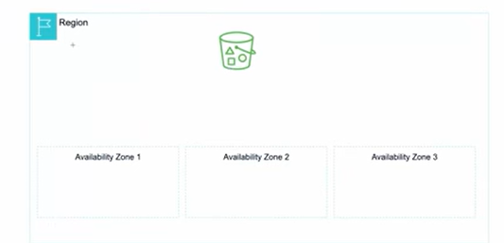
Security and data protection:
Protect your data with unmatched security, data protection, compliance, and access control capabilities. S3 is secure, private, and encrypted by default, and also supports numerous auditing capabilities to monitor access requests to your S3 resources.
Lowest price and highest performance:
S3 delivers multiple storage classes with the best price performance for any workload and automated data lifecycle management, so you can store massive amounts of frequently, infrequently, or rarely accessed data in a cost-efficient way. S3 delivers the resiliency, flexibility, latency, and throughput, to ensure storage never limits performance.

Use cases:
  - Data backup and restore
  - Application data storage
  - Static website hosting
  - Data archiving
  - Media content storage and distribution
  - Data lake for analytics

S3 Storage Classes:
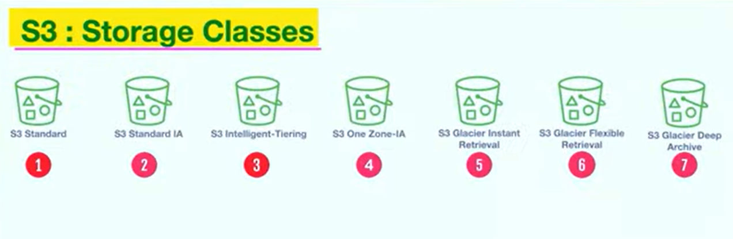

S3 Standard:
- Default
- Highly durable
- Ideal for frequent access
- Low latency (fast response time)
S3 Standard IA (Infrequent access):
- Cost effective
- Suitable for infrequent access
- Supports high availability
S3 Intelligent -Tiering:
- Move data between two access tiers
- Optimize costs based on usage patterns
S3 One Zone – IA:
- Low Cost
- Suitable for infrequent access
- Single availability zone
- Reduced Durability

S3 Glacier instant retrieval:
- Low cost
- Suitable for archival data
- Retrieval in milliseconds

S3 Glacier Flexible retrieval:
- Low cost for archival
- Flexible Retrieval options – mins to hrs

S3 Glacier deep archive:
- Lowest cost storage
- Retrieval within 12 hours

