Practical - 1
Practical Title: Project Initiation, Requirement Analysis, Sitemap, Wireframe, and GitHub Setup

Problem Definition: Initiate the semester-long StudentHub portal by identifying the problem scope, user roles, key modules, navigation flow, and minimum 10 pages. Create a sitemap, low-fidelity wireframe, project folder structure, README file, and GitHub repository.

Theory

What is URL and parts of URL?
Answer:
URL(Uniform Resource Locator) is the unique address used to locate and access resources on internet. Parts of URL are protocol, subdomain, domain name and path.
For example:
If the website is https://www.studenthub.com/login.html then https is protocol, www is subdomain, studenthub.com is domain name and /login.html is path.

How does HTML file process in web browser?
Answer:
When a user enters a website URL, the web browser requests the HTML file from the web server. The browser receives the HTML file, reads and interprets its code, loads any linked CSS and JavaScript files, and then Senders the content to display the webpage on the screen.

3. How will page navigation flow managed among all HTML pages?
Answer:
Page navigation is managed using hyperlinks created with the <a> (anchor) tag. Each HTML page is linked to other pages, allowing users to move from one page to another by clicking the links.

4. How will GitHub commits be maintained after each practical?
Answer:
After completing each practical, the updated files are saved, committed with a meaningful commit message, and pushed to the GitHub repository. This maintains a record of all changes and progress for each practical.

Implementation/ Output/Result

Evidence of Work (Screenshots):

- Figure 1.1: Wirefream Of Login Page:
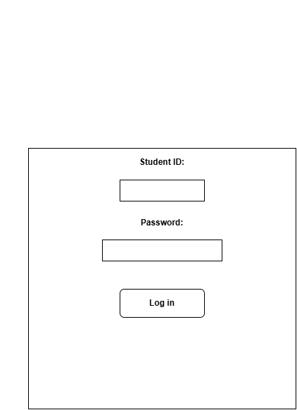

- Figure 1.2: Wirefream Of DashBoard:

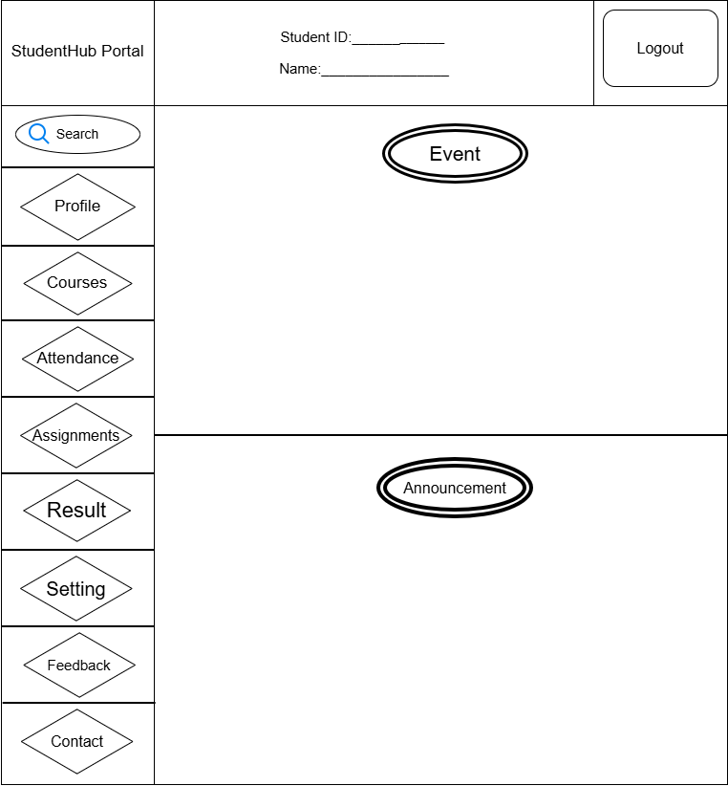
- Figure 1.3: Wirefream Of Profile
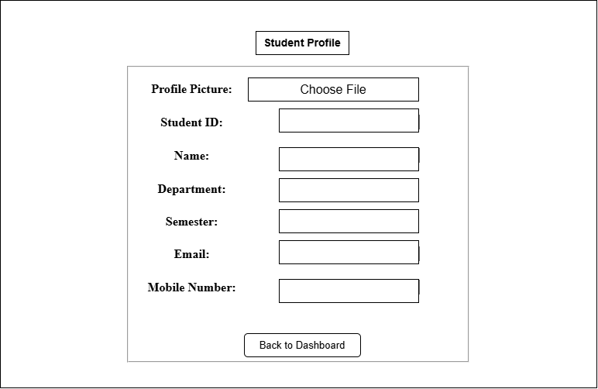
- Figure 1.4: Wirefream Of Courses
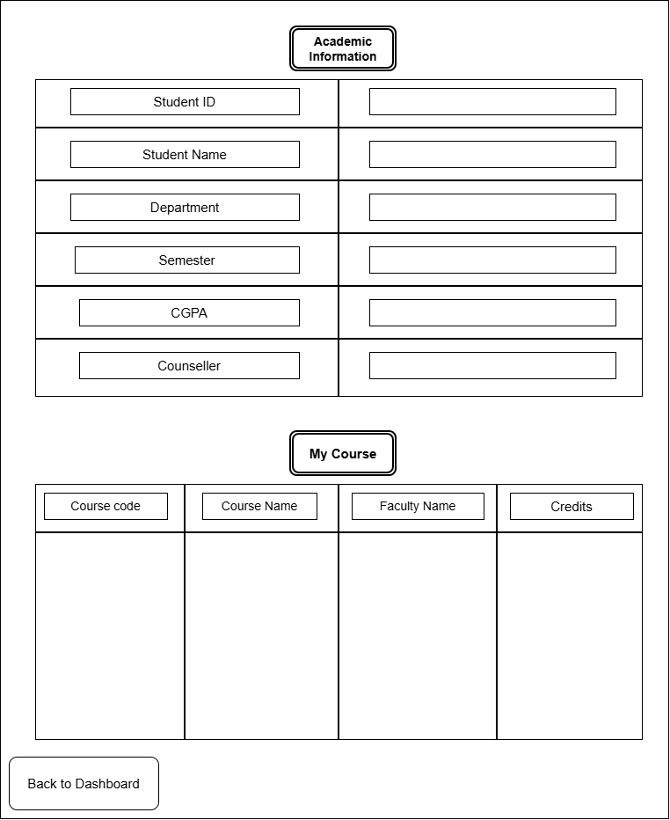

- Figure 1.5 : Wirefream Of Attendance
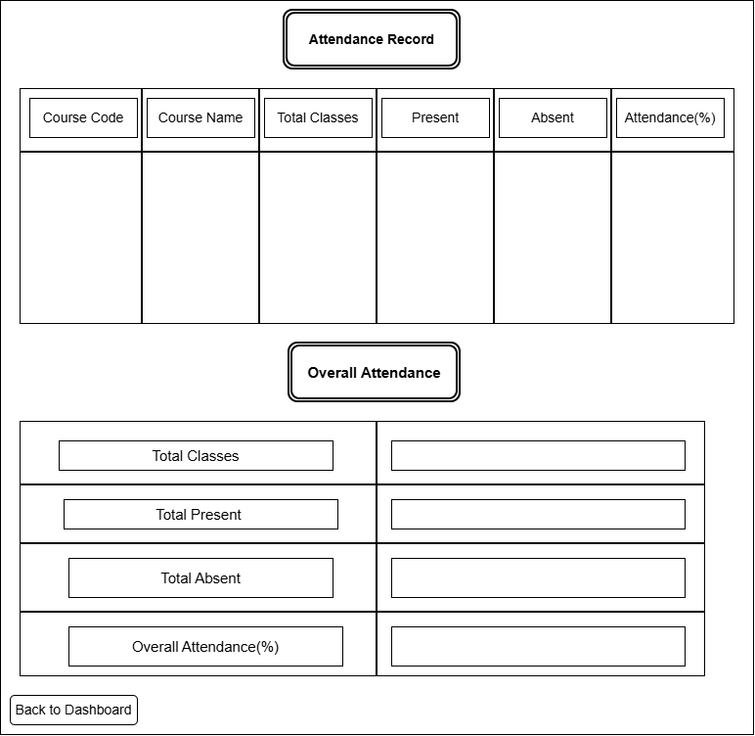

- Figure 1.6: Wirefream Of Assignment
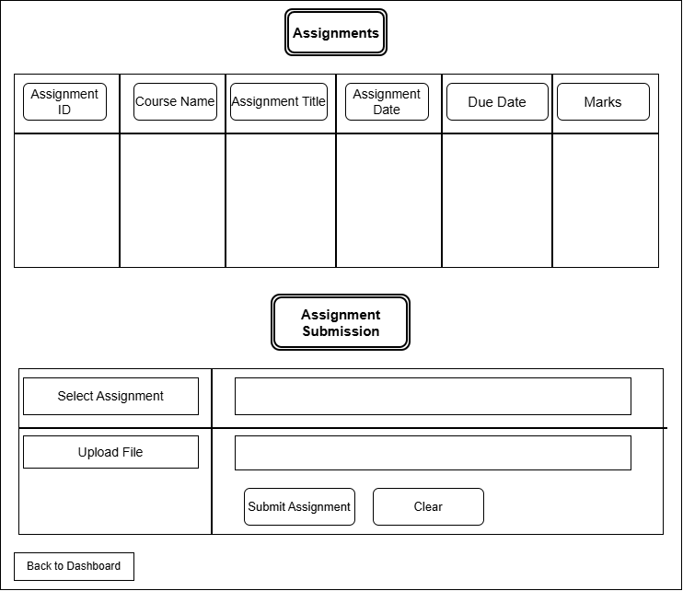
- Figure 1.7: Wirefream Of Result
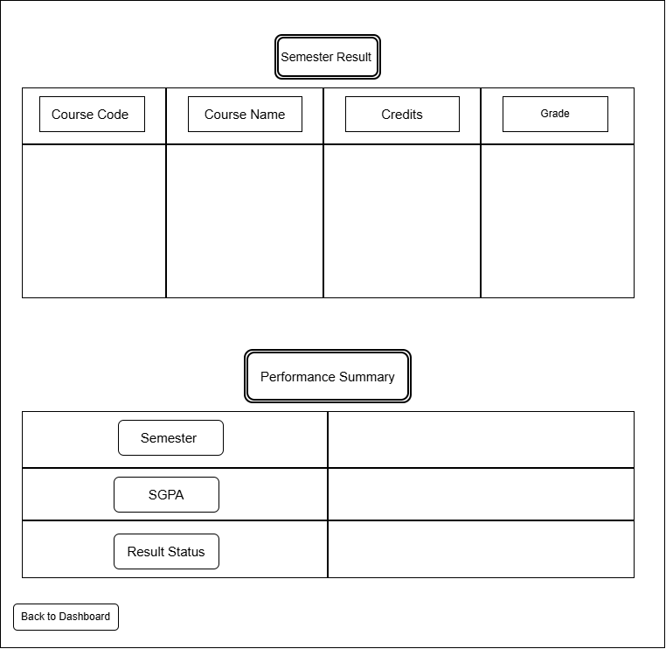

- Figure 1.8:Wirefream Of Setting
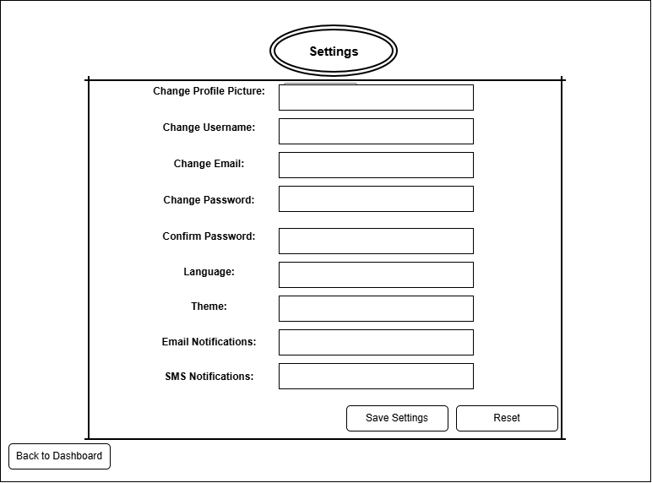
- Figure 1.9 Wirefream Of Feedback
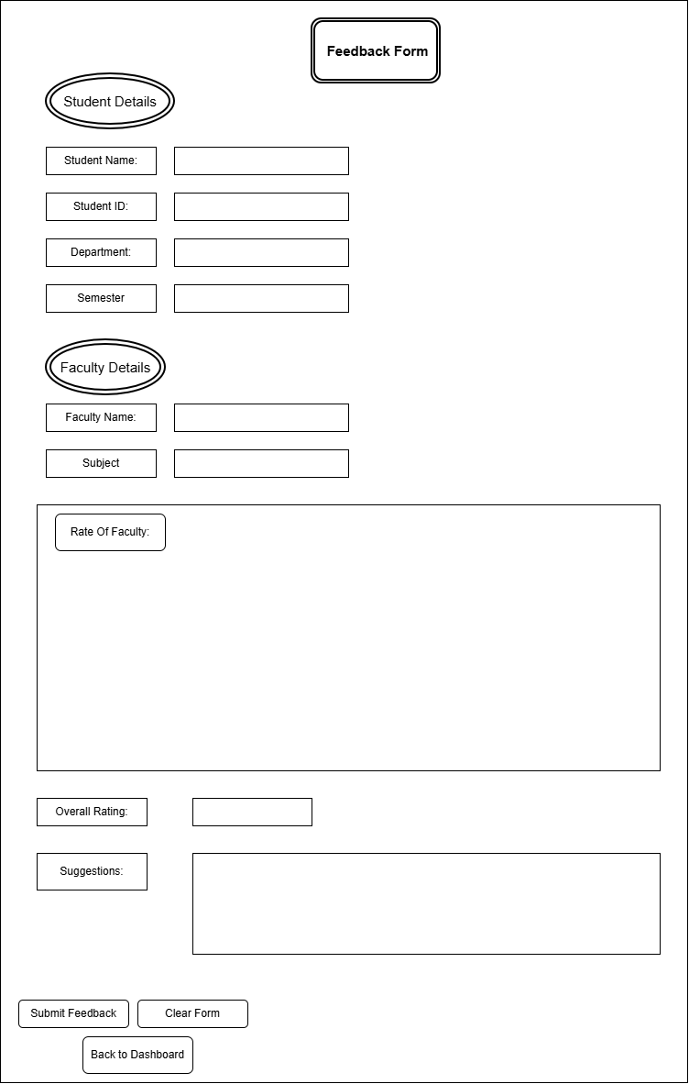
- Figure 2.0 Wirefream Of Contact
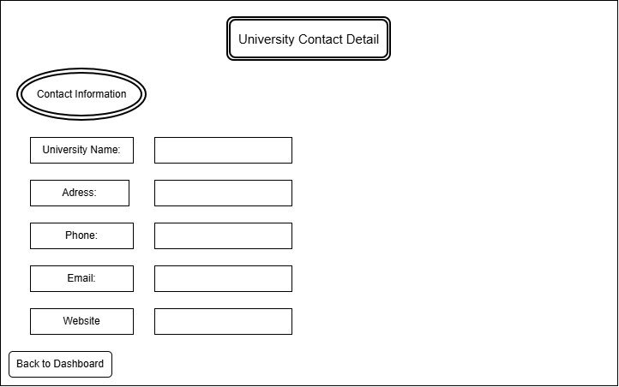

GitHub Repository Link:
https://github.com/Swatibarasara01/WDF.git

Challenges Faced:

- Learning how to create a GitHub repository and upload project files.
- Understanding how to make commits and maintain project versions on GitHub.

Learning Outcomes:

How to analyze project requirements before starting development.

How to identify user roles and key modules of a website.

How to create a GitHub repository, upload files, and maintain commits.

Faculty Remarks:

