Practical - 13

Practical 13:PHP JSON API and AJAX/Fetch-Based CRUD without Page Reload

Problem Definition:Create simple PHP JSON API endpoints for events or students and consume them using Fetch API. Perform list, add, update, and delete operations asynchronously without full page reload.

Theory

- Do PHP endpoints return valid JSON responses?
Answer:Yes, the PHP endpoints return valid JSON responses. The API sends data and status messages in JSON format. The responses were tested successfully using the browser's Network tab.

- Are GET and POST requests handled properly?
Answer:Yes, GET and POST requests are handled properly. The GET method retrieves student records from the database, while the POST method adds new student records. Both operations were tested successfully.

- Are loading, success, and error states shown on the frontend?
Answer:Yes, the frontend displays appropriate messages for successful operations and errors. These messages help users understand whether the requested operation was completed or failed. Loading and response handling are managed through JavaScript.

- Is input validation performed before database operations?
Answer:Yes, input validation is performed before database operations. The API checks required fields, student names, email addresses, and student IDs before processing requests. Prepared statements are used to help prevent SQL injection attacks.

- Implementation/ Output/Result

- Evidence of Work(Screenshots)
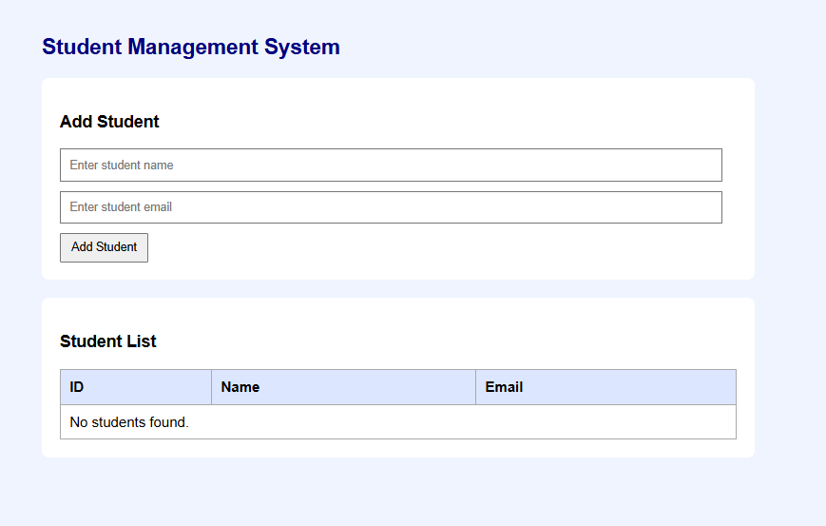
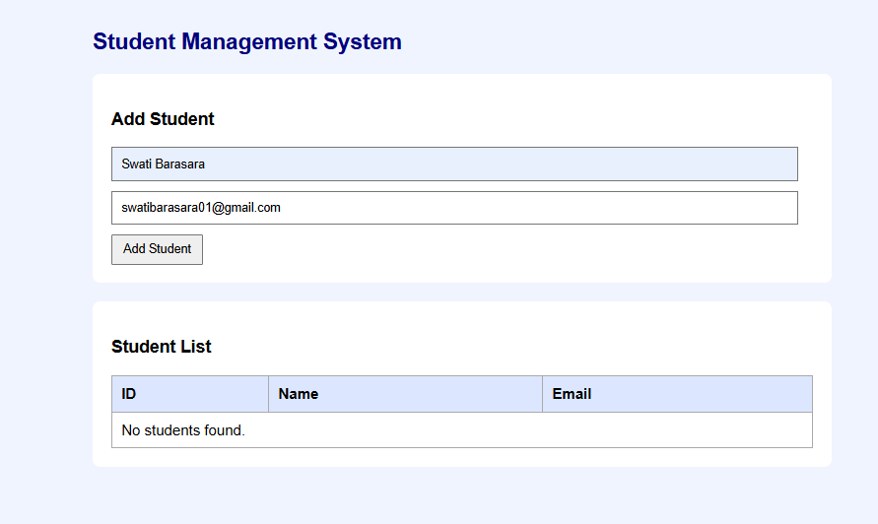

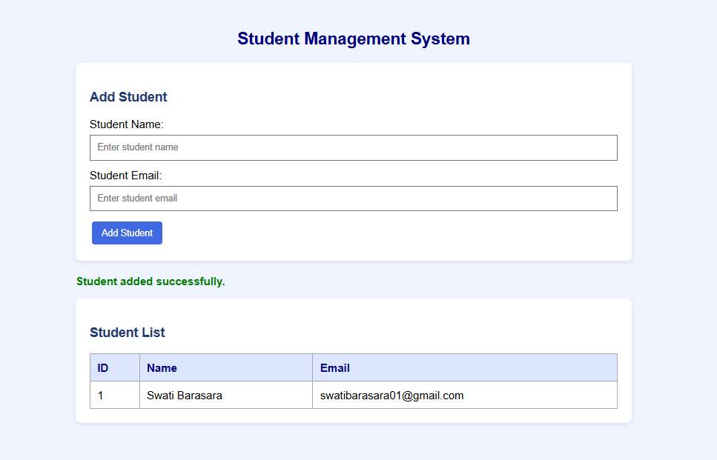

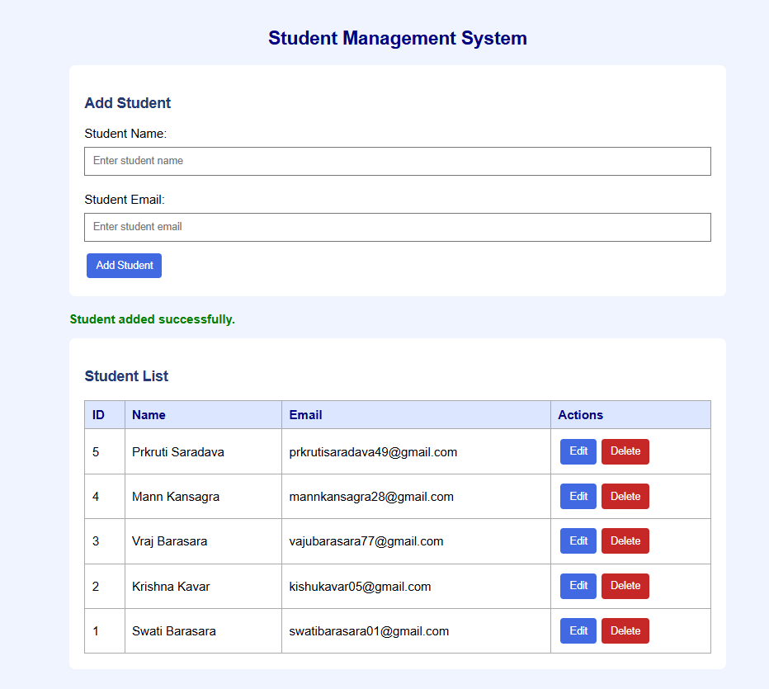
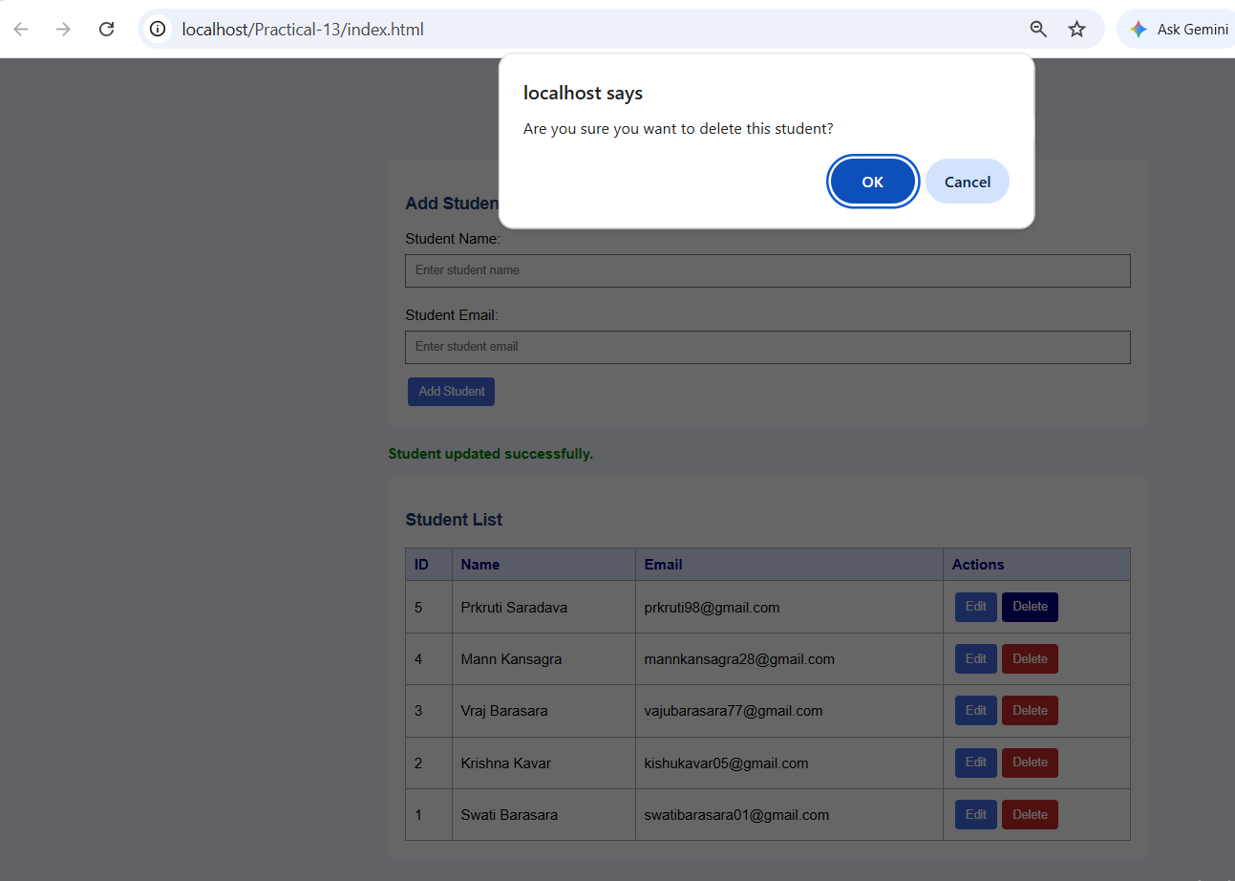

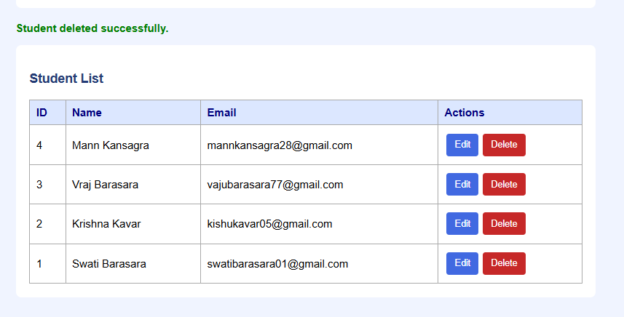

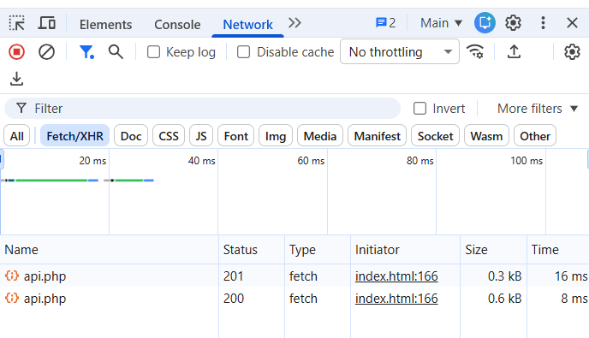
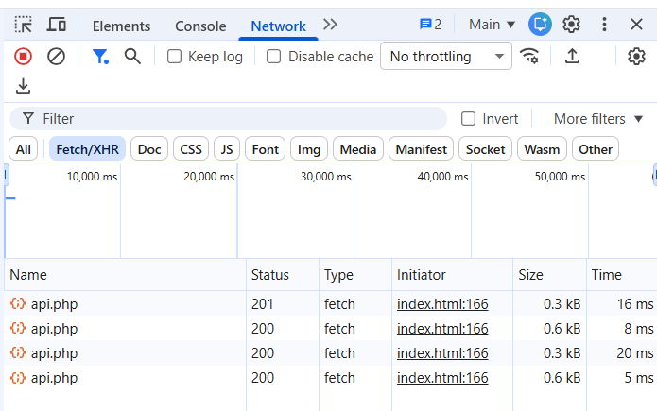

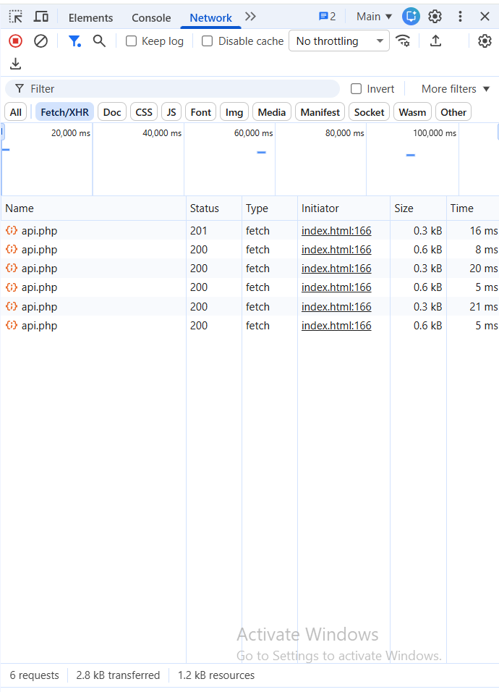
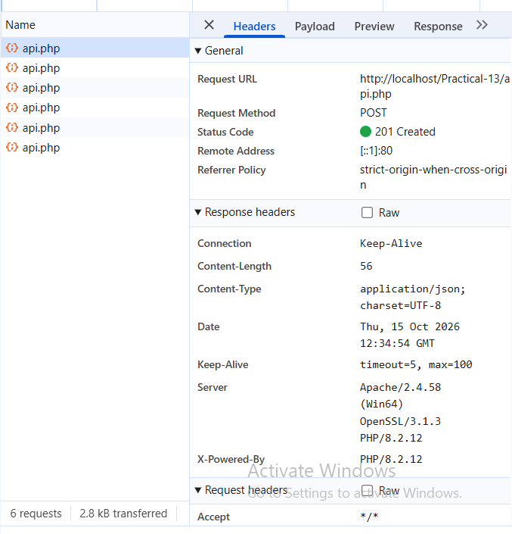
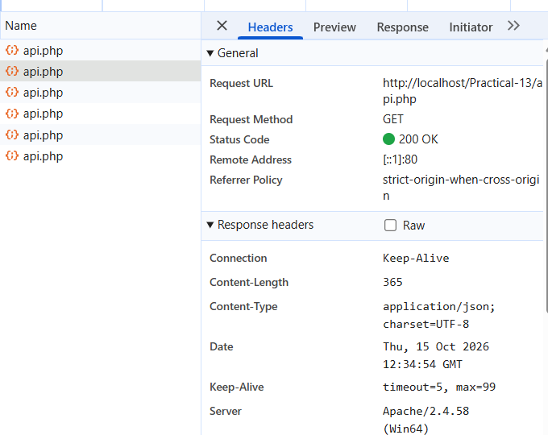
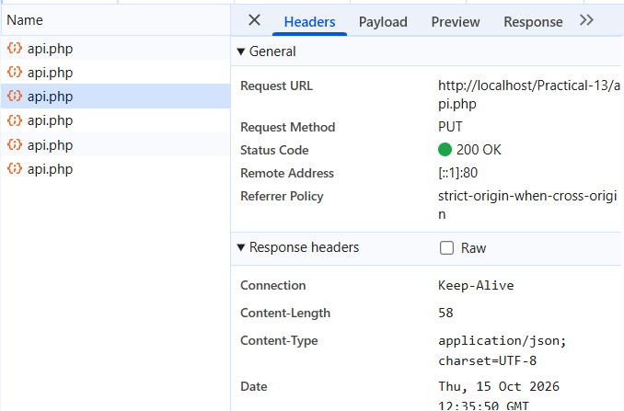

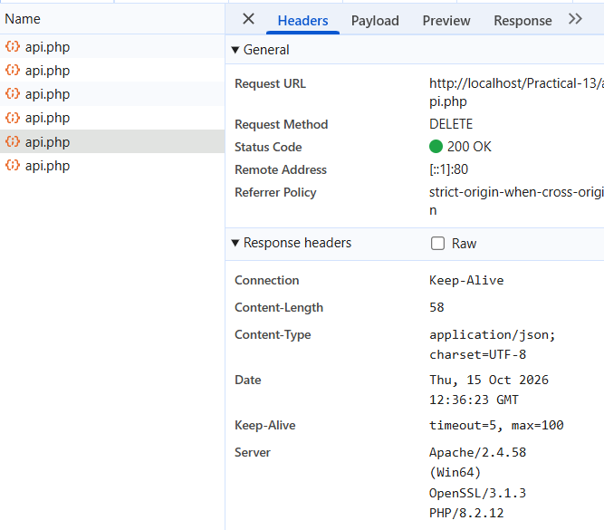

GitHub Repository Link:
https://github.com/Swatibarasara01/WDF/tree/main/Practical-13

Challenges Faced:
- Faced difficulties while connecting the PHP API to the MySQL database.
- Faced errors while implementing GET, POST, PUT, and DELETE requests.
- Faced difficulties in checking API responses and status codes using the browser's Network tab.
- Learned to troubleshoot errors and perform CRUD operations without reloading the webpage.

Learning Outcomes:
- Learned to create PHP JSON APIs and connect them to a MySQL database.
- Learned to perform CRUD operations using GET, POST, PUT, and DELETE methods.
- Learned to use the Fetch API to update data without reloading the webpage.
- Learned to handle JSON responses and display success and error messages.
- Learned to verify API requests and status codes using the browser's Network tab.

Faculty Remarks:

