Practical - 10
Practical 10:Secure Login/Logout with Sessions, Role-Based Access, Timeout, and Remember-Me Token
Problem Definition:Develop secure login and logout functionality using PHP sessions. Verify password using password_verify(), regenerate session ID after login, restrict dashboard access, implement role-based redirection, session timeout, and optional secure remember-me token.

Theory

- Are sessions started and destroyed securely?
Answer:Yes, sessions are started using session_start(). The session ID is regenerated after successful login using session_regenerate_id(true). During logout, session variables and the session cookie are cleared, and the session is destroyed.

- Is password_verify() used correctly?
Answer:Yes, password_verify() is used to compare the entered password with the hashed password stored in the database. This helps prevent storing passwords in plain text. The user can log in only when the password is correct.

- Is unauthorized dashboard access blocked?
Answer:Yes, unauthorized dashboard access is blocked using role-based access control. Only users with the admin role can access the Admin Dashboard, and only students can access the Student Dashboard. Unauthorized users receive an “Access Denied” message.

- Is session timeout implemented?
Answer:Yes, a session timeout of five minutes is implemented using the last activity timestamp. If the user remains inactive for more than five minutes, the session is destroyed and the user is redirected to the login page. The user must log in again unless a valid Remember-Me token restores the session.

- Are admin and student users redirected to appropriate dashboards?
Answer:Yes, users are redirected according to their roles after successful login. Admin users are redirected to admin.php, while student users are redirected to student.php. This ensures that each user accesses the appropriate dashboard.

- Implementation/ Output/Result

- Evidence of Work(Screenshots)
When a student tries to access the Admin Dashboard, the system displays “Access Denied: Admin only.” This happens because role-based access control allows only users with the admin role to access the Admin Dashboard.

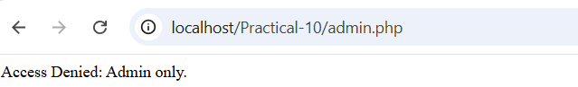

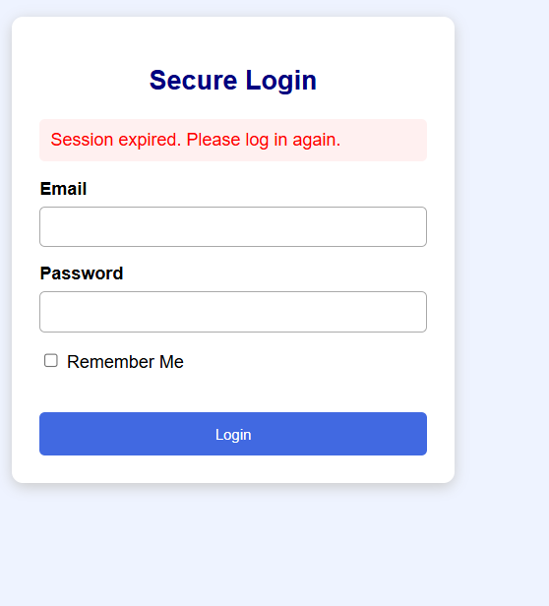

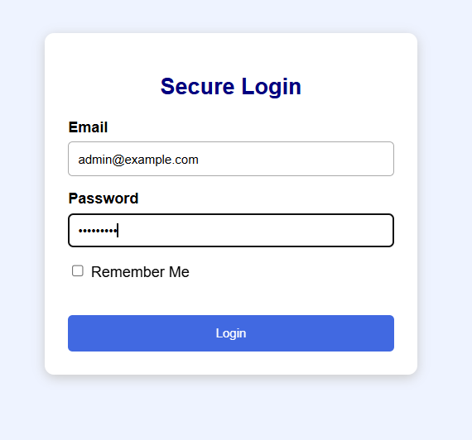
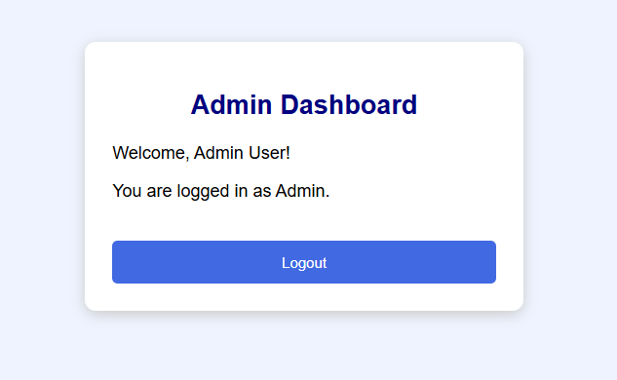

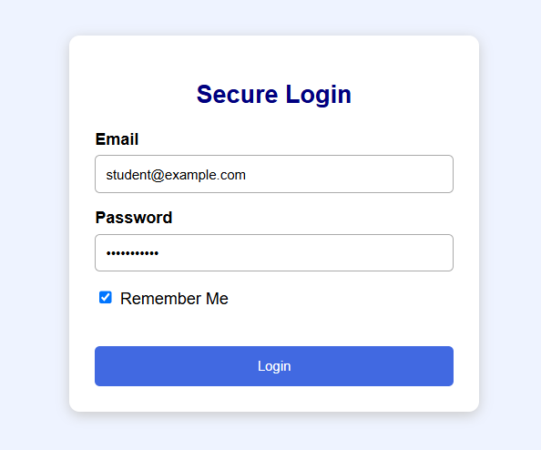
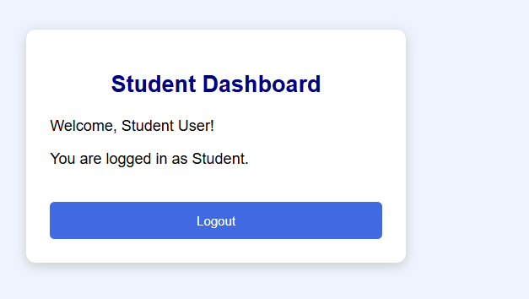

- After logout, remember me data row delete in database

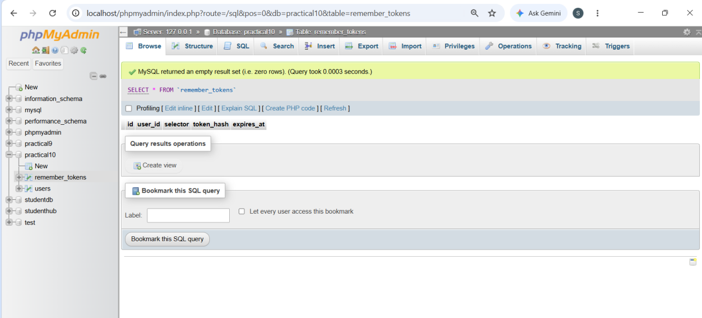

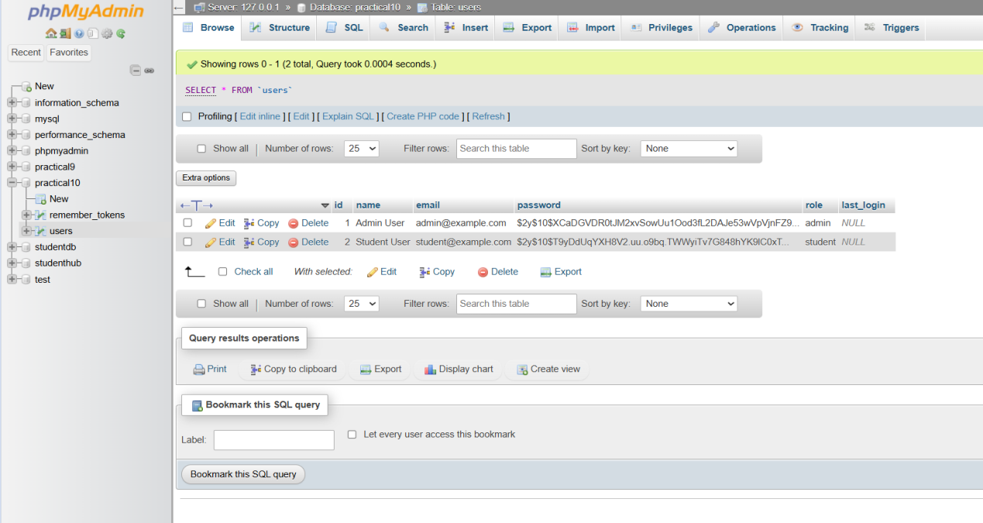
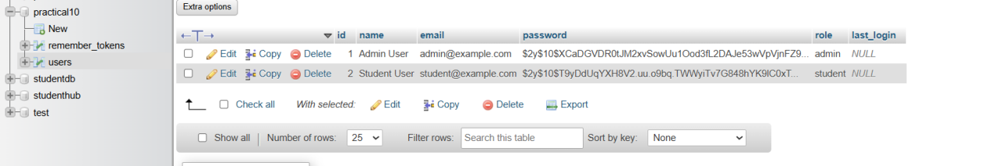

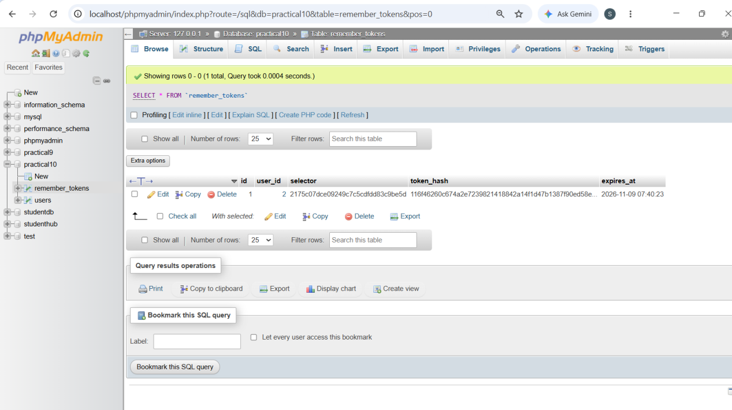

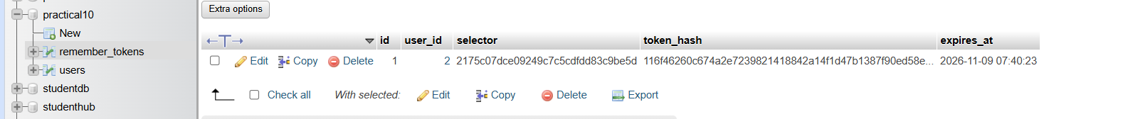

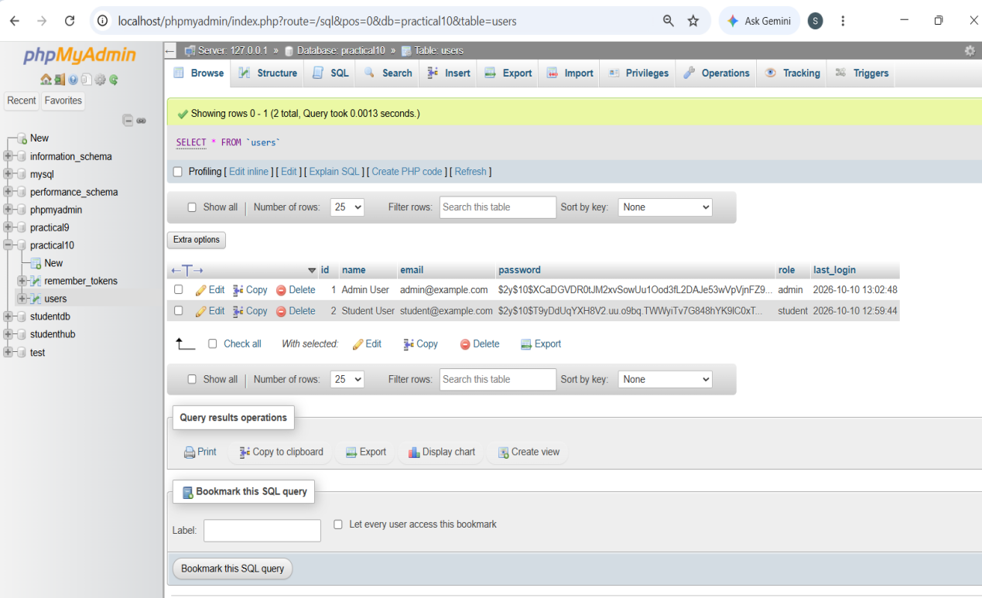
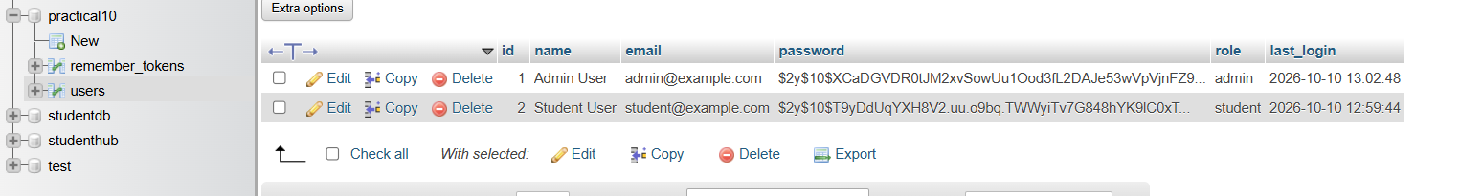

GitHub Repository Link:
https://github.com/Swatibarasara01/WDF/tree/main/Practical-10

Challenges Faced:
- The database connection error occurred because the MySQL server was stopped in XAMPP. As a result, the PHP login page could not establish a connection with the MySQL database. I resolved this issue by restarting the MySQL server in XAMPP.

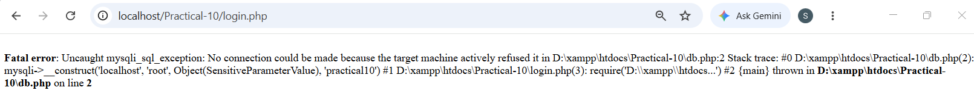

Learning Outcomes:
- Learned to implement secure login and logout functionality using PHP sessions.
- Learned to implement the Remember-Me feature using secure random tokens stored as hashes in the database.
- Learned to implement role-based access control for Admin and Student dashboards.
- Learned to verify passwords securely using password_verify() and regenerate session IDs after successful login.
- Learned to manage session timeouts and redirect users to the login page after session expiration.
- Learned to store and update the last login date and time of users in the MySQL database.
- Learned to prevent unauthorized dashboard access and securely destroy sessions and Remember-Me tokens during logout.

Faculty Remarks:

