Practical - 2
Practical Title: Semantic HTML5 Pages with Accessibility-Ready Structure

Problem Definition: Develop static HTML5 skeletons for at least 10 StudentHub pages such as Home, About, Register, Login, Dashboard, Events, Profile, Contact, Admin, FAQ, and Feedback. Use semantic tags and accessibility-friendly structure.

Theory

Are semantic tags such as header, nav, main, section, article, aside, and

footer used properly?
Answer:
Yes. Semantic HTML5 tags are used correctly to organize the webpage structure.
- <header> contains the website title or logo.
- <nav> contains navigation links.
- <main> contains the main content of the page.
- <section> groups related content.
- <article> represents an independent piece of content.
- <aside> contains additional or sidebar information.
- <footer> contains copyright, contact details, or other footer information.
Using these tags improves readability and accessibility.

Are form labels, headings, image alt text, and navigation links accessible?
Answer:
Yes. Accessibility is maintained by:
- Using proper <label> tags for all form inputs.
- Using headings (<h1> to <h6>) in the correct order.
- Adding alt text to all images so screen readers can describe them.
- Providing clear and meaningful navigation links that are easy to understand and use. This helps all users, including people with disabilities.

Is the page structure consistent across all pages?
Answer: Yes. All HTML pages follow the same layout and structure. Each page contains a common header, navigation menu, main content area, and footer. Consistent page structure provides a better user experience, makes navigation easier, and gives the website a professional appearance.

Implementation/ Output/Result

Evidence of Work (Screenshots)

Figure 1.1: Login Page of StudentHub Portal using HTML

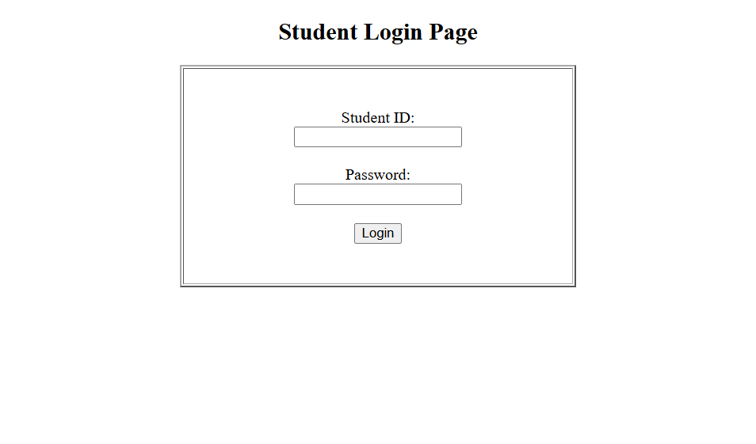
Figure 1.2: DashBoard Page of StudentHub Portal using HTML
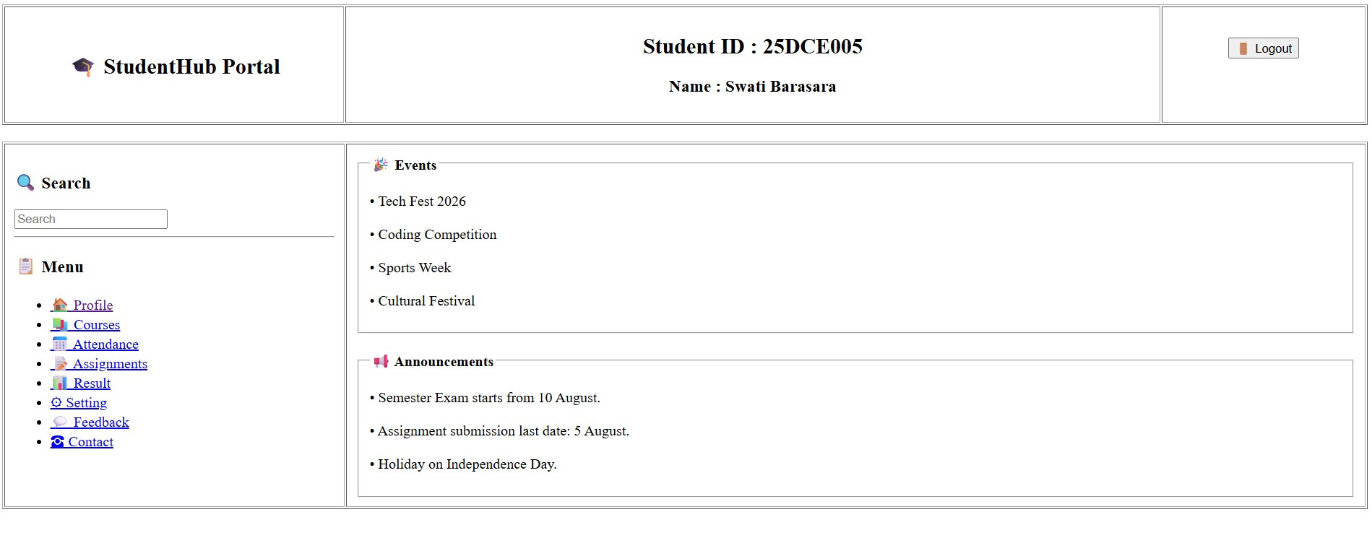
Figure 1.3: Profile Page of StudentHub Portal using HTML

Figure 1.4: Courses Page of StudentHub Portal using HTML
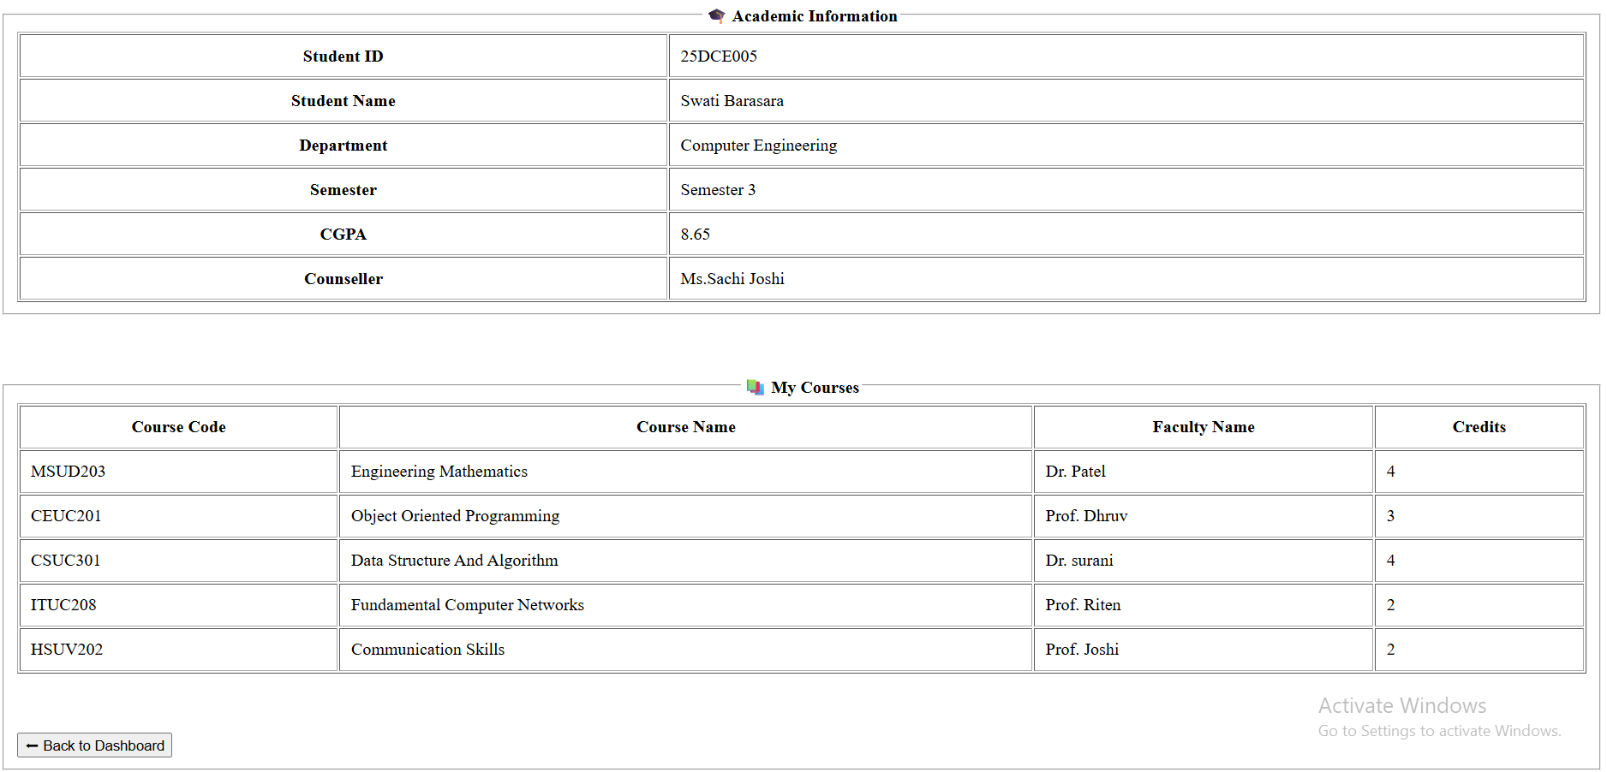
Figure 1.5: Attendance Page of StudentHub Portal using HTML
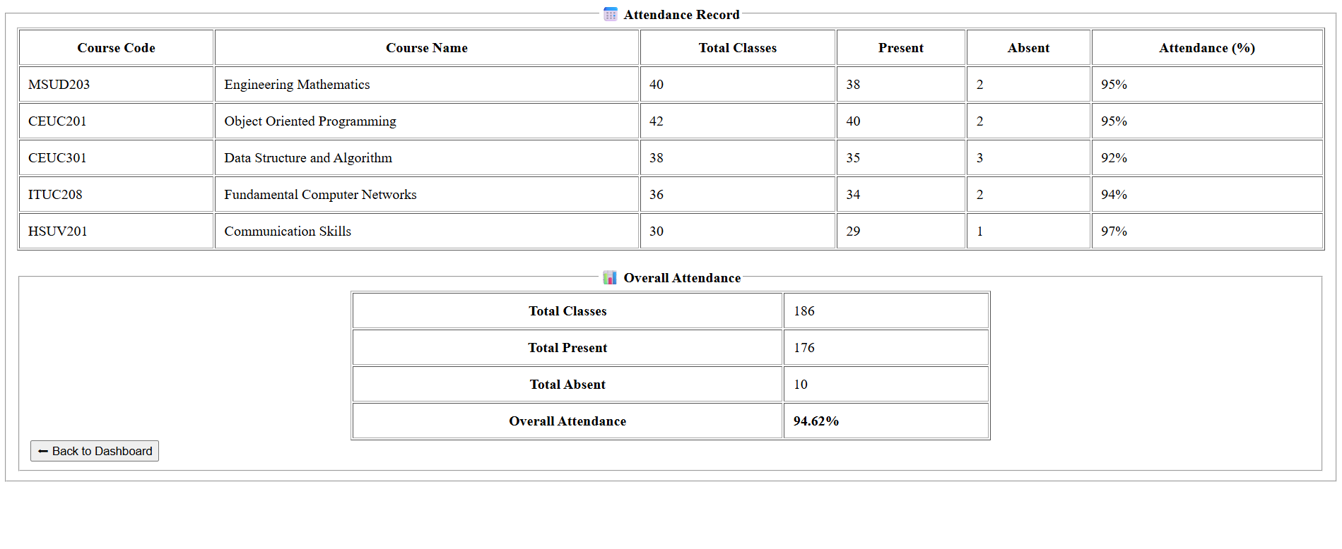
Figure 1.6: Assignment Page of StudentHub Portal using HTML
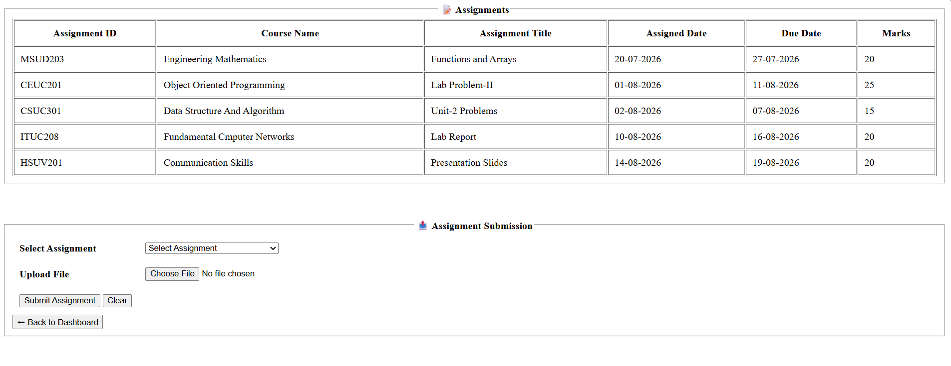
Figure 1.7: Result Page of StudentHub Portal using HTML
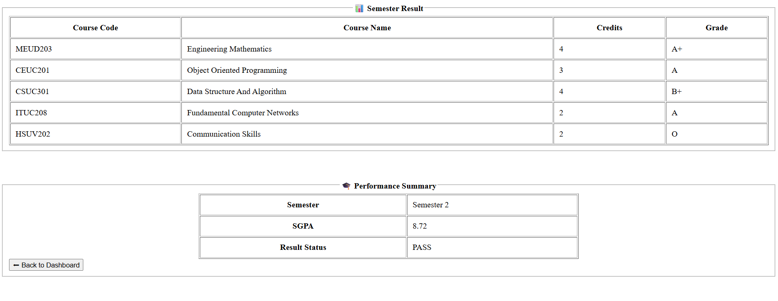
Figure 1.8: Setting Page of StudentHub Portal using HTML
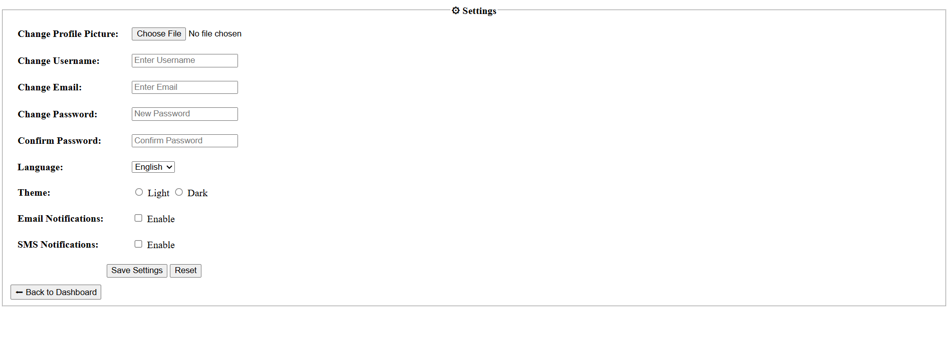

Figure 1.9: Feedback Form Page of StudentHub Portal using HTML

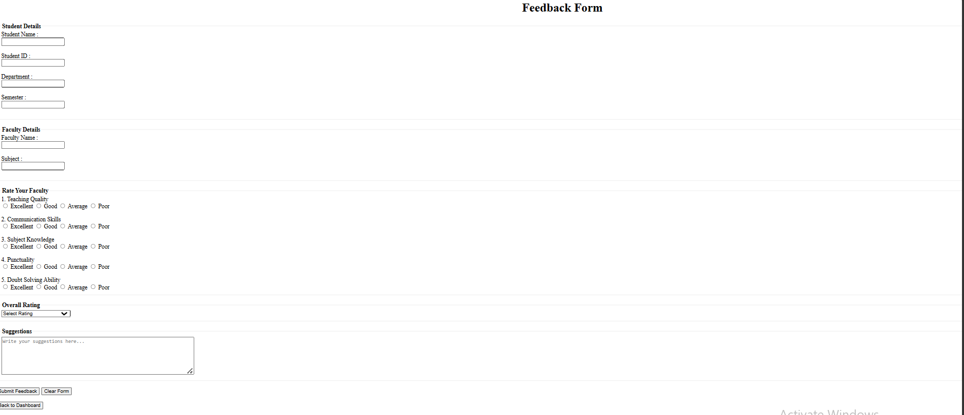
Figure 2.0: Contact Page of StudentHub Portal using HTML
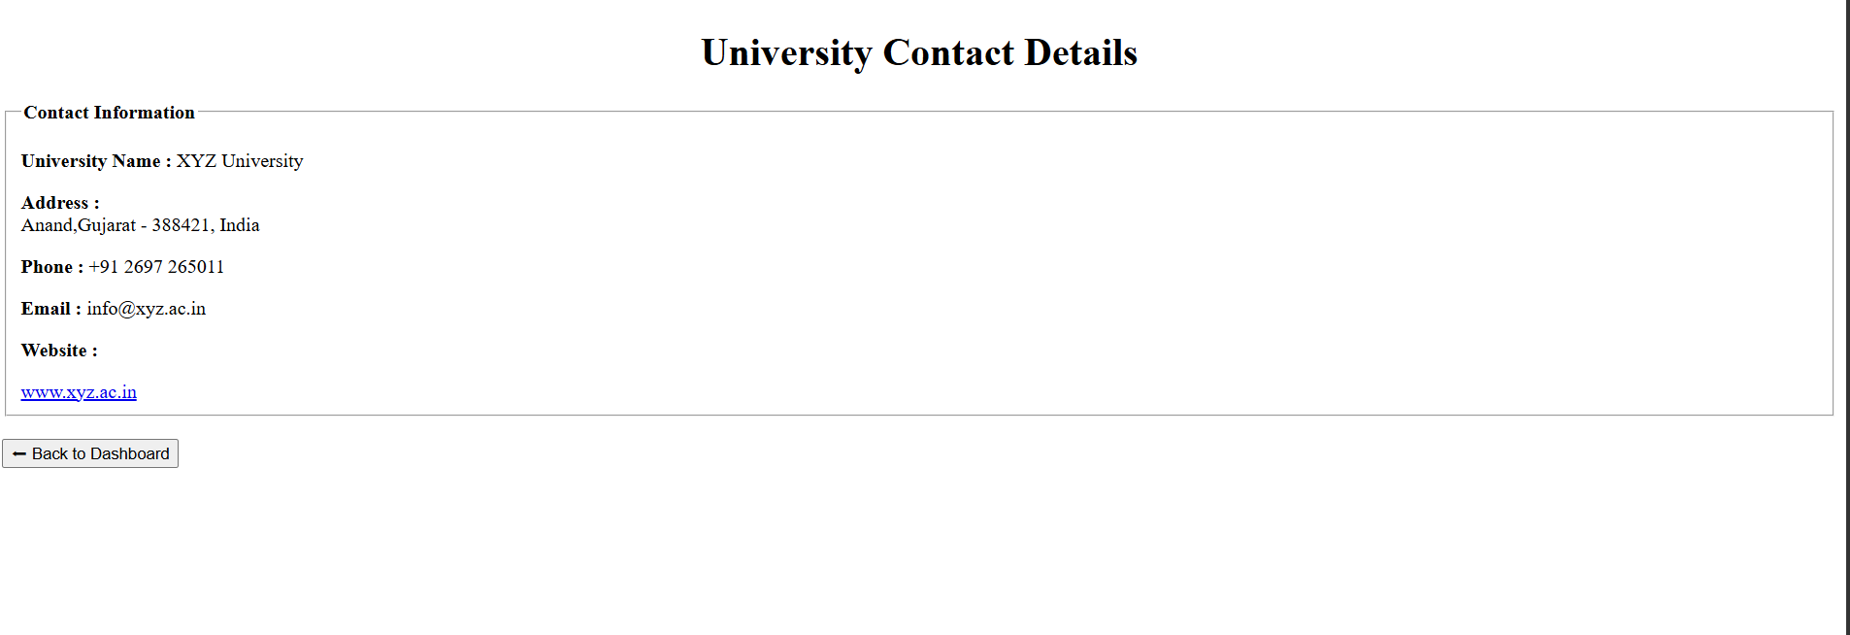

GitHub Repository Link:

https://github.com/Swatibarasara01/WDF.git

Challenges Faced:
- Maintaining a consistent layout and navigation across all HTML pages.
- Properly using semantic HTML5 tags such as <header>, <nav>, <main>, <section>, and <footer>.
- Ensuring accessibility by adding form labels, image alt text, and meaningful navigation links.
- Organizing content in a clear and user-friendly structure.
- Testing the pages in the browser to ensure proper display and navigation.

Learning Outcomes:

- Create semantic HTML5 pages using tags like <header>, <nav>, <main>, <section>, and <footer>.
- Design a consistent structure for multiple web pages.
- Link HTML pages using navigation menus and hyperlinks.
- Apply basic accessibility features such as labels, headings, and image alt text.
- Develop a clean, organized, and user-friendly StudentHub website.

Faculty Remarks:

