Practical - 6

Practical 6: Rendering External JSON Data using Fetch API, Search and Filter

Problem Definition:Display event lists, student profiles, notices, or FAQs from external JSON files using Fetch API. Implement dynamic rendering, search, filter, sorting, and pagination.

Theory

- How is JSON fetched, parsed, and rendered?
Answer:JSON data is fetched from the JSON file using JavaScript’s fetch() function. The response is then parsed using response.json() to convert the JSON data into a JavaScript object. Finally, the required data is rendered on the HTML page by accessing JSON properties and inserting them into HTML elements using JavaScript.

- Which array methods are used for search, filter, sort, and pagination?
Answer:
- Search: find() or findIndex() — used to find a particular element.
- Filter: filter() — used to get elements that satisfy a condition.
- Sort: sort() — used to arrange elements in ascending or descending order.
- Pagination: slice() — used to display only a specific portion of an array at a time.

- How are loading and error states handled?
Answer:Loading and error states are handled to give users proper information while fetching JSON data. A loading message can be shown while the data is being fetched. If the data is successfully loaded, it is displayed on the webpage, and if an error occurs, the .catch() method handles it and shows an error message.

- How is modularity maintained in JavaScript files?
Answer:Modularity is maintained by dividing JavaScript code into separate functions or modules, where each function performs a specific task. Common functions such as validation, JSON data loading, and DOM manipulation are kept separately so the code is easier to understand and maintain. This also allows the same JavaScript file or functions to be reused across multiple HTML pages.

- Implementation/ Output/Result

- Evidence of Work(Screenshots)
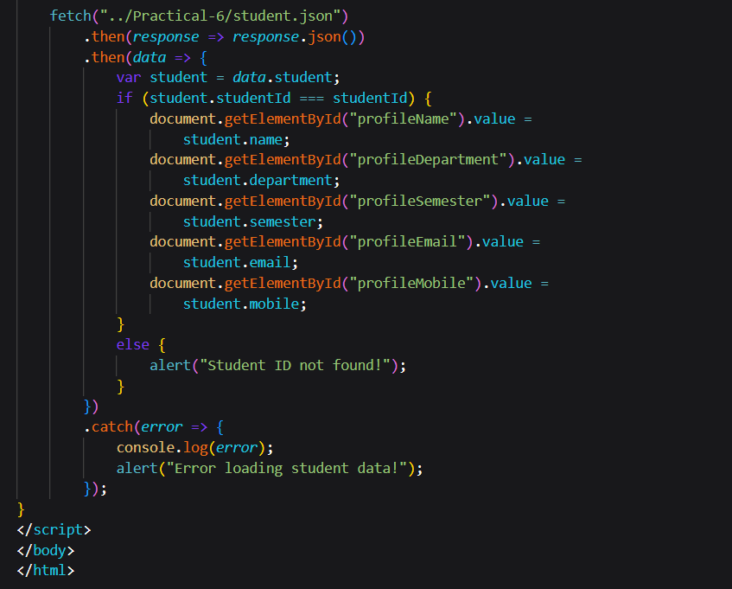

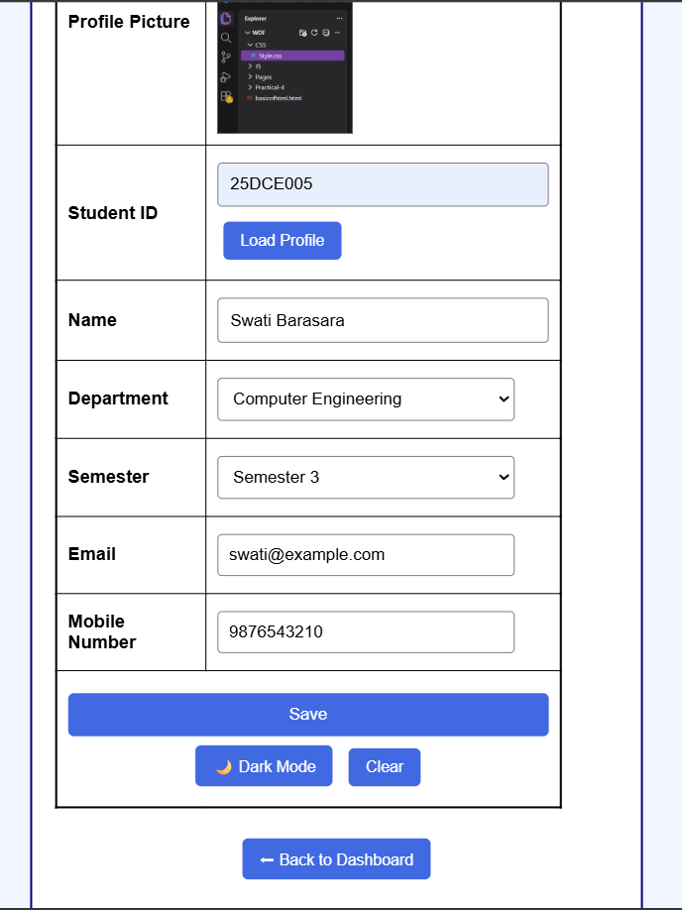

GitHub Repository Link:
https://github.com/Swatibarasara01/WDF/blob/main/Practical6
/student.json

https://github.com/Swatibarasara01/WDF/tree/main/Practical-6

Challenges Faced:
- Understanding how to fetch JSON data using JavaScript and display it on HTML pages.
- Maintaining the correct JSON structure and accessing data using the proper keys such as student, courses, etc.
- Connecting the JSON file with different HTML pages using the correct file path.
- Understanding how JavaScript functions like fetch(), .then(), and .catch() work together.

Learning Outcomes:
- How to use JavaScript fetch() to retrieve data from a JSON file.
- How to convert JSON response into JavaScript objects using response.json().
- How to access JSON data using properties such as data.student and data.courses.
- How to use error handling with .catch() when JSON data cannot be loaded.
- How JSON can make a website more dynamic, organized, and easier to maintain.

Faculty Remarks:

