Practical - 3
Practical Title: Responsive UI Design using CSS Grid, Flexbox, and Bootstrap/Tailwind

Problem Definition: Design responsive layouts for Home, About, Registration, Dashboard, and Events pages using CSS Grid and Flexbox. Optional to use CSS framework such as Bootstrap or Tailwind. Ensure mobile-first responsiveness.

Theory

How does the layout adapt for mobile, tablet, and desktop screens?
Answer:
- On mobile phones, the content is displayed in a single column so it is easy to read and scroll.
- On tablets, the content is arranged in two or more columns depending on the available space.
- On desktop computers, the layout uses multiple columns and a wider screen to display more content at the same time.
This is achieved using CSS Grid which help the webpage look good on all devices.

Which layout technique is used and why?
Answer: For this practical, CSS Grid is used.
- CSS Grid is used to create the overall page layout with rows and columns. It is suitable for dashboards and page sections.
- These techniques help create a clean, responsive, and user-friendly website.

Are typography, spacing, colors, and contrast readable?
Answer: Yes.
- Simple and clear fonts are used.
- Enough spacing is provided between headings, paragraphs, buttons, and images.
- Colors are chosen carefully to provide good contrast between the background and text.

- Is the framework used consistently without unnecessary inline CSS?
Answer: Yes.The website uses external CSS files and framework classes consistently.

Implementation/ Output/Result

Evidence of Work (Screenshots)

Figure 1.1: Login Page of StudentHub Portal using HTML & CSS
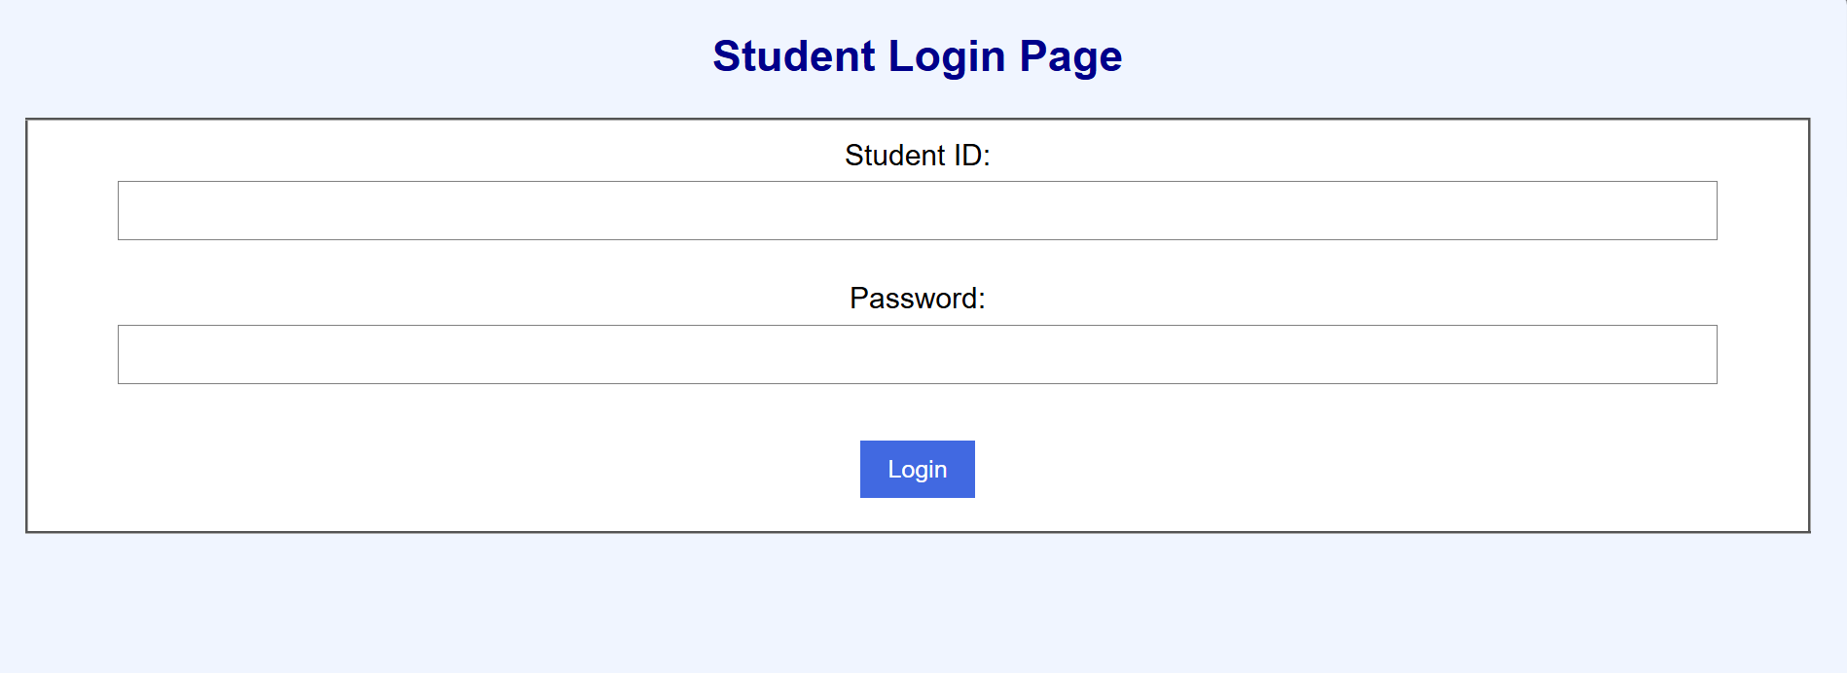

Figure 1.2: DashBoard Page of StudentHub Portal using HTML & CSS
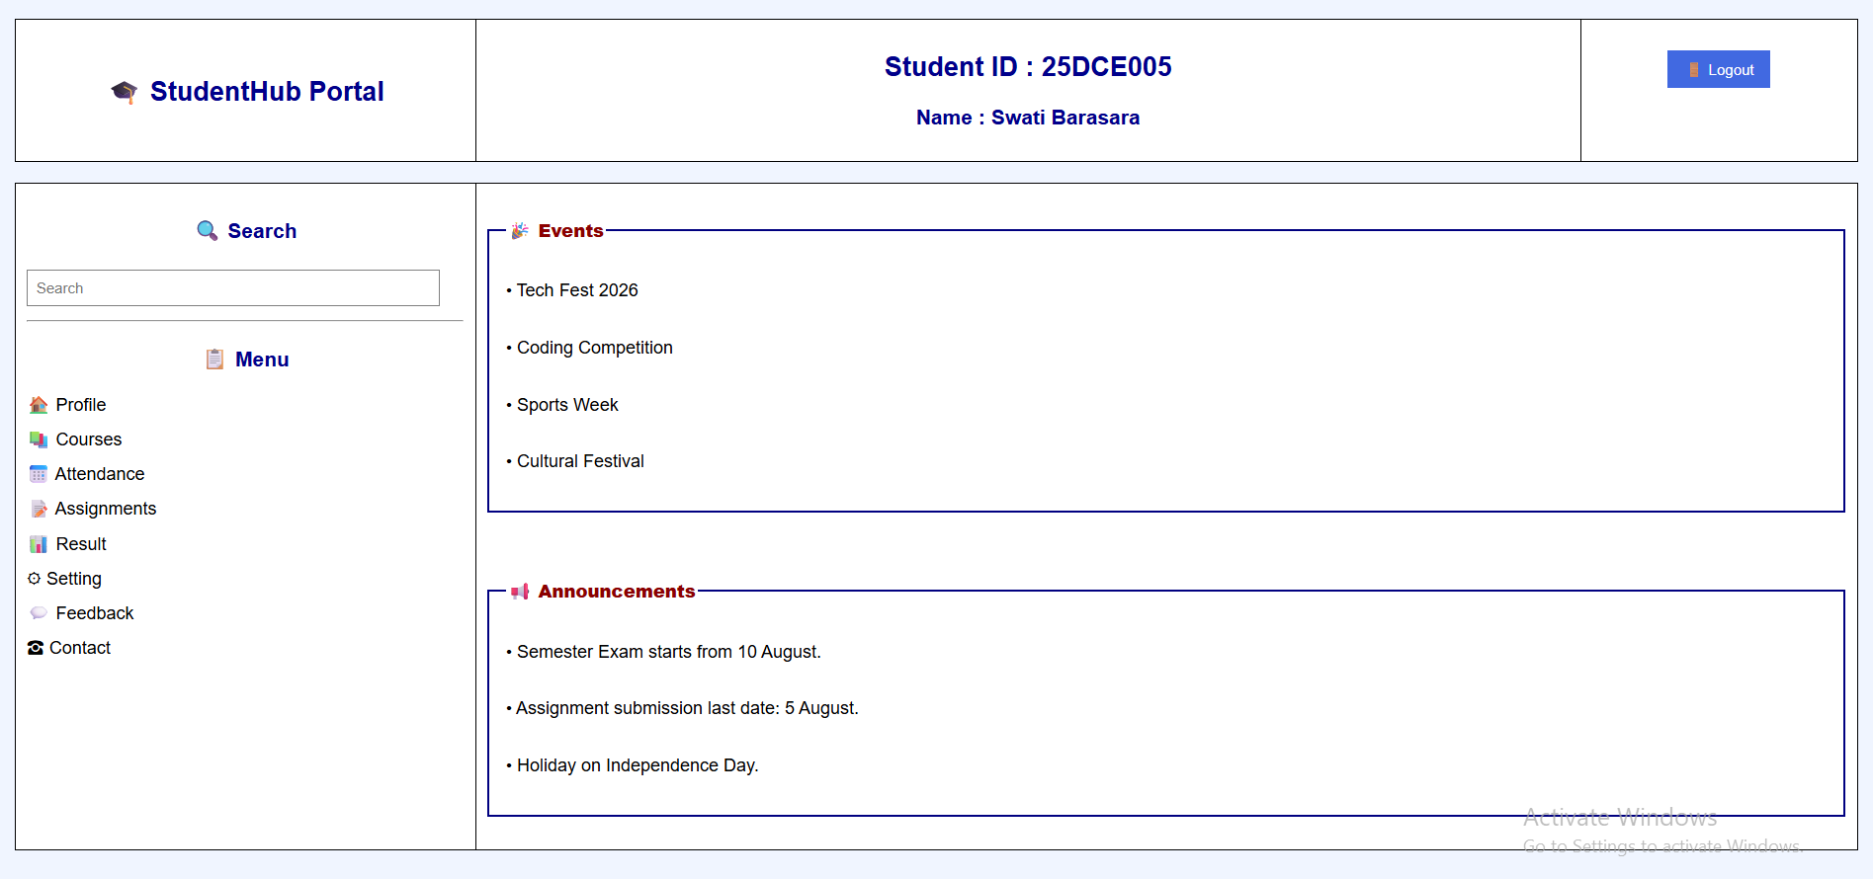

Figure 1.3: Profile Page of StudentHub Portal using HTML & CSS
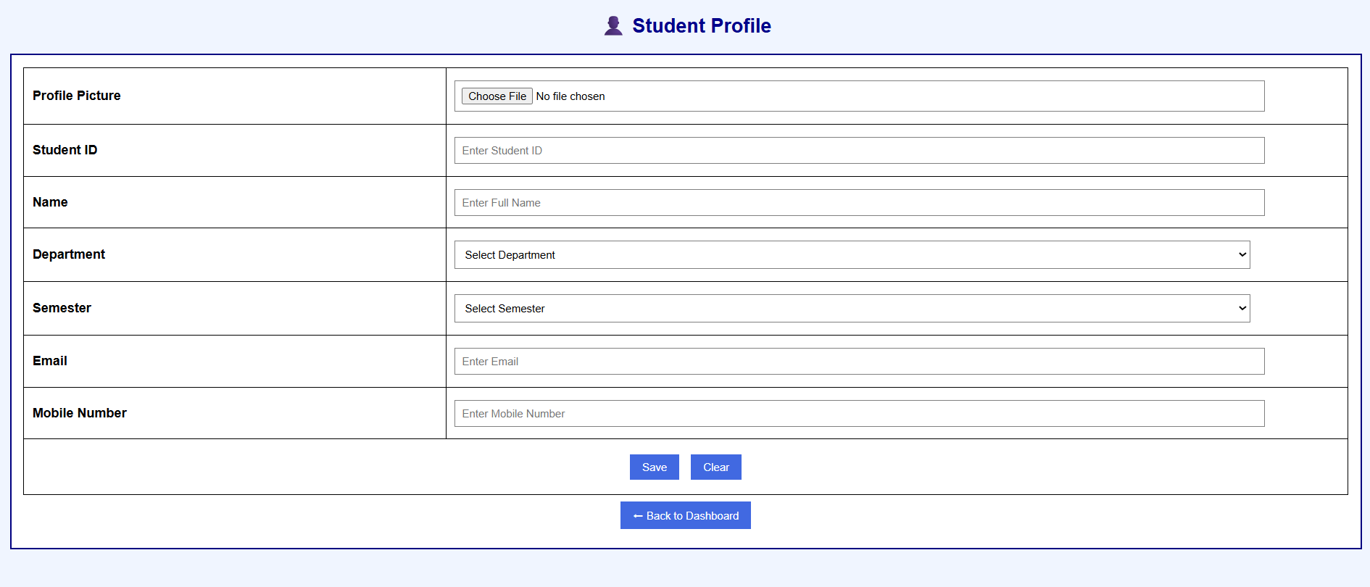
Figure 1.4: Courses Page of StudentHub Portal using HTML & CSS
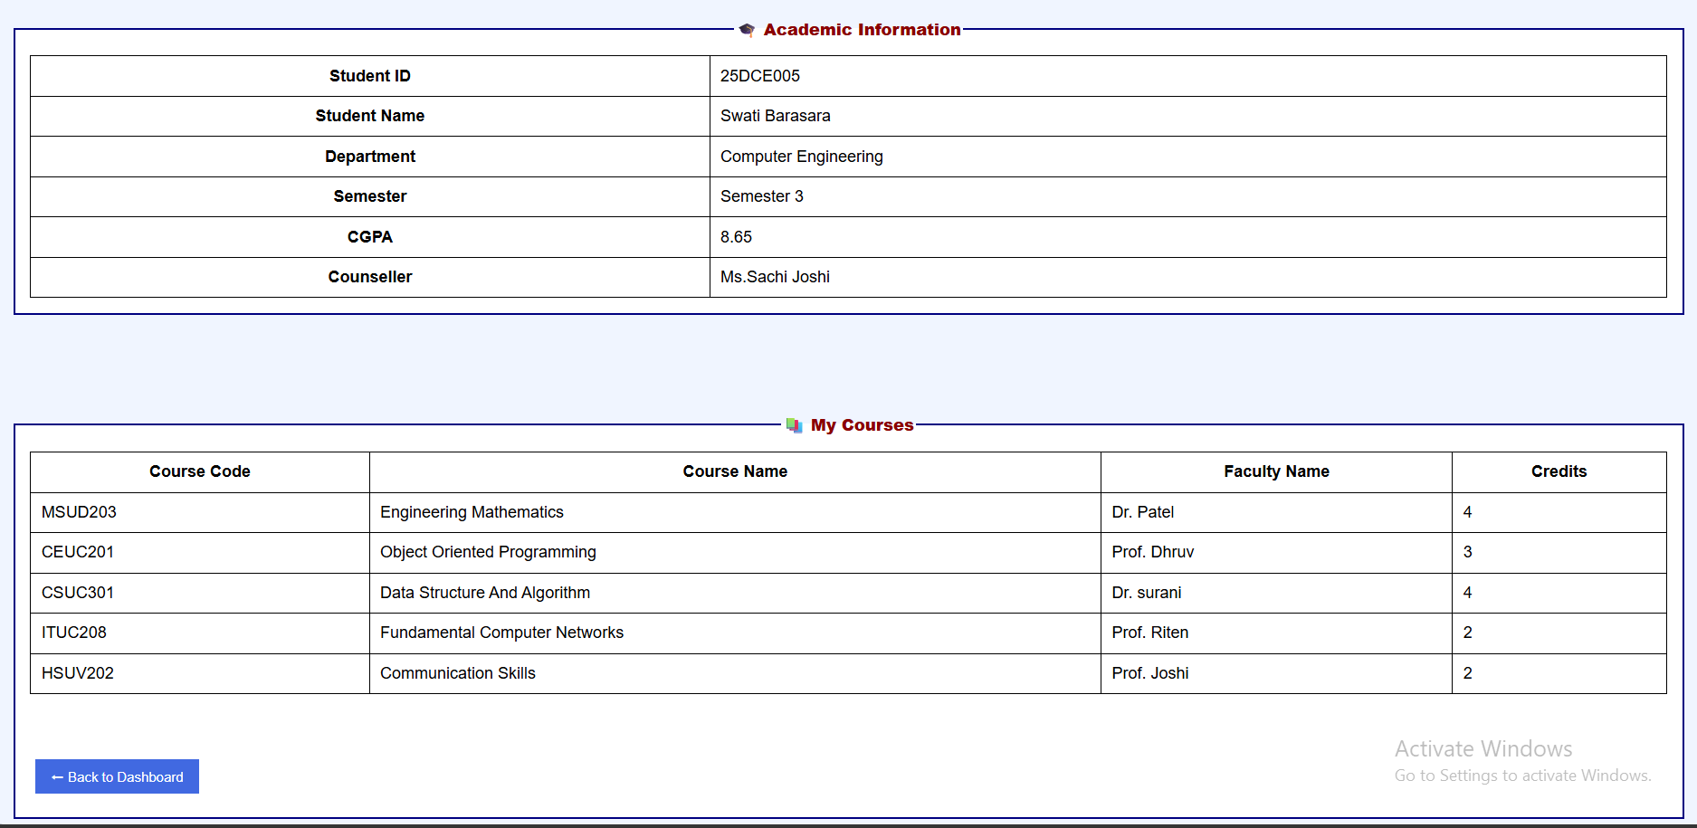
Figure 1.5: Attendance Page of StudentHub Portal using HTML & CSS
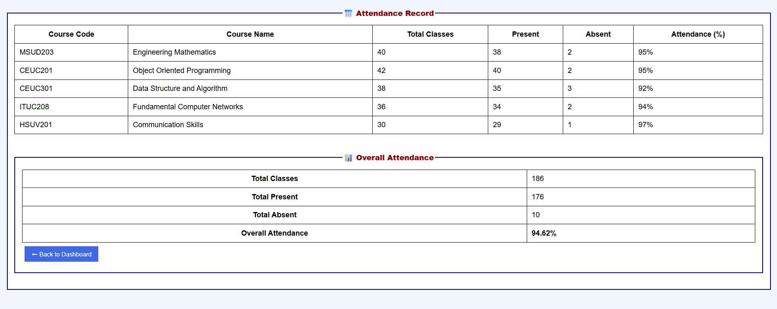
Figure 1.6: Assignment Page of StudentHub Portal using HTML & CSS
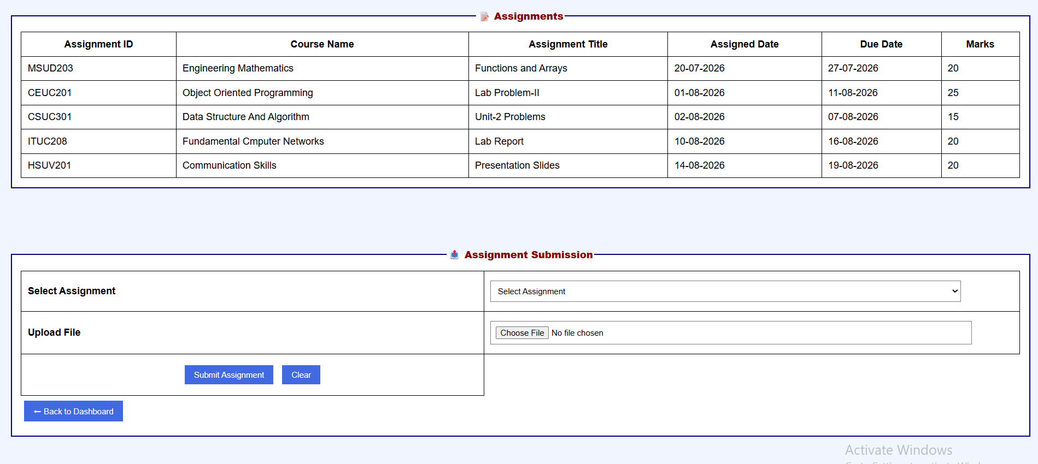
Figure 1.7: Result Page of StudentHub Portal using HTML & CSS
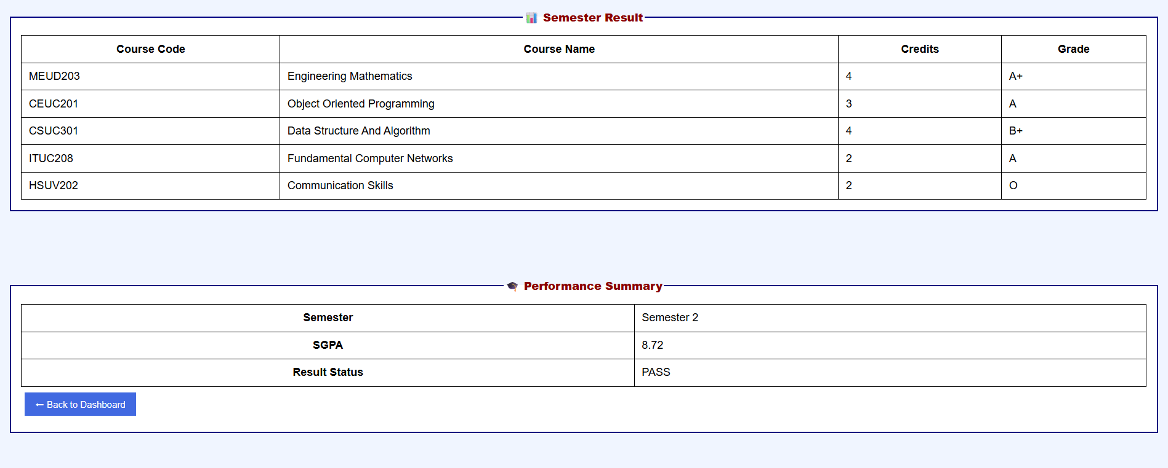
Figure 1.8: Setting Page of StudentHub Portal using HTML & CSS
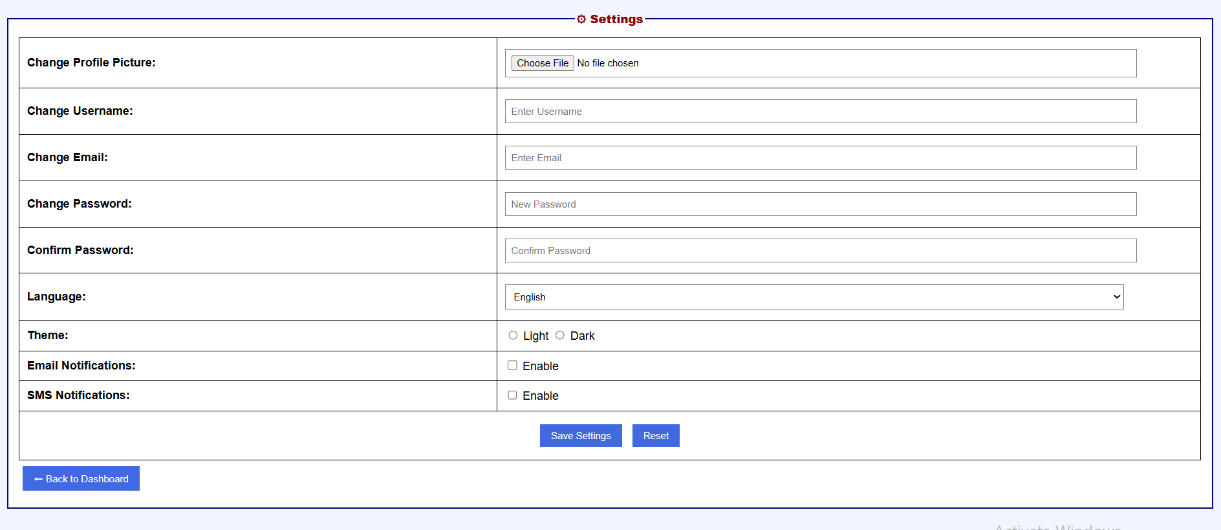
Figure 1.9: Feedback Page of StudentHub Portal using HTML & CSS
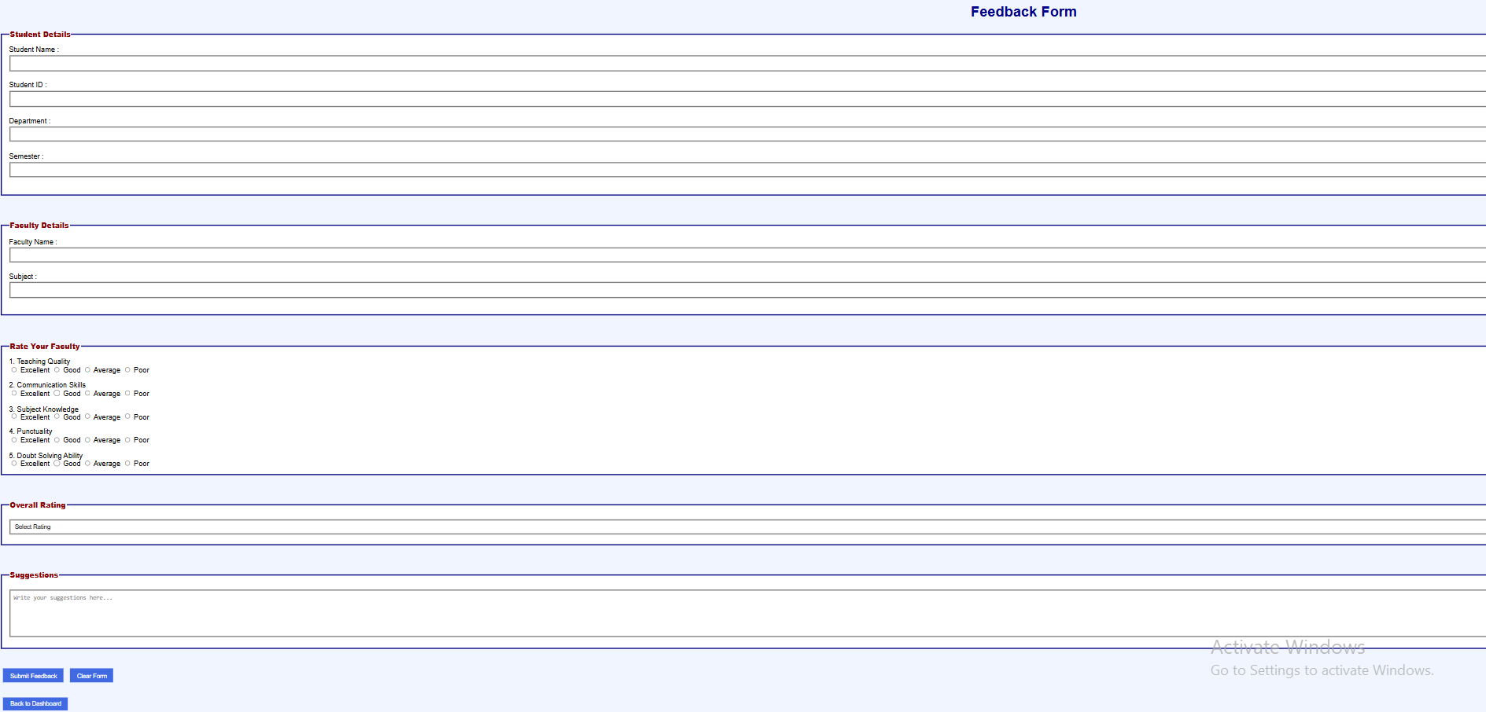
Figure 2.0: Contact Page of StudentHub Portal using HTML & CSS
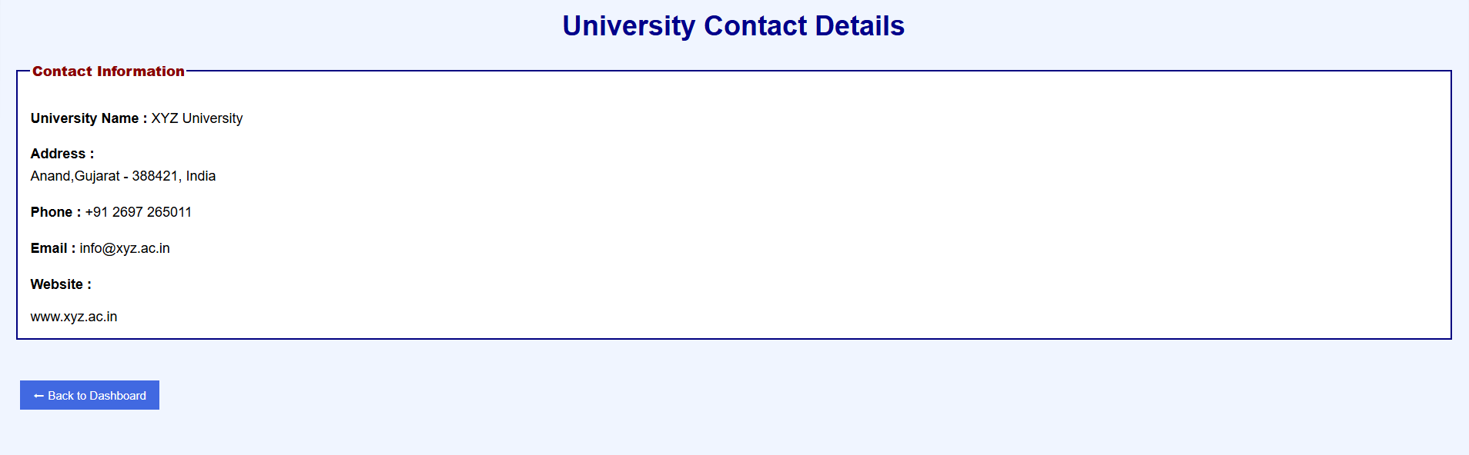

GitHub Repository Link:

https://github.com/Swatibarasara01/WDF.git

Challenges Faced:

- Maintaining consistent spacing and alignment across all pages.
- Arranging page elements properly without affecting the overall layout.
- Choosing suitable font sizes, colors, and contrast for better readability.

Learning Outcomes:

- Improve website readability using proper typography, spacing, and colors.
- The importance of writing clean, reusable, and organized external CSS.
- How to build a clean and user-friendly interface with proper spacing and alignment.
- How to improve website readability by choosing appropriate fonts, colors, and contrast.

Faculty Remarks:

