Practical - 9

Practical 9:Secure User Registration with Database Insert, Duplicate Email Check, and Password Hashing

Problem Definition:Implement secure user registration by inserting user details into MySQL using MYSQLi. Validate input on frontend and backend, check duplicate email/username, hash passwords using password_hash(), and display appropriate messages.

Theory

- Is password_hash() used before storing passwords?
Answer:Yes, password_hash() is used before storing passwords in the database. It converts the original password into a secure hashed value. This helps protect user passwords from being exposed. The hashed password is stored instead of the original password.

- Is duplicate email/username checked?
Answer:Yes, the system checks whether the email or username already exists in the database. If a duplicate is found, registration is rejected and an error message is displayed. This prevents multiple accounts from using the same email or username. Unique constraints are also applied to the database fields.

- Are frontend and backend validations consistent?
Answer:Yes, frontend and backend validations are used to check user inputs. JavaScript validates the password length and confirms that both passwords match. PHP performs additional validation for email, username, password, and required fields. This improves data accuracy and security.

- Implementation/ Output/Result

- Evidence of Work(Screenshots)
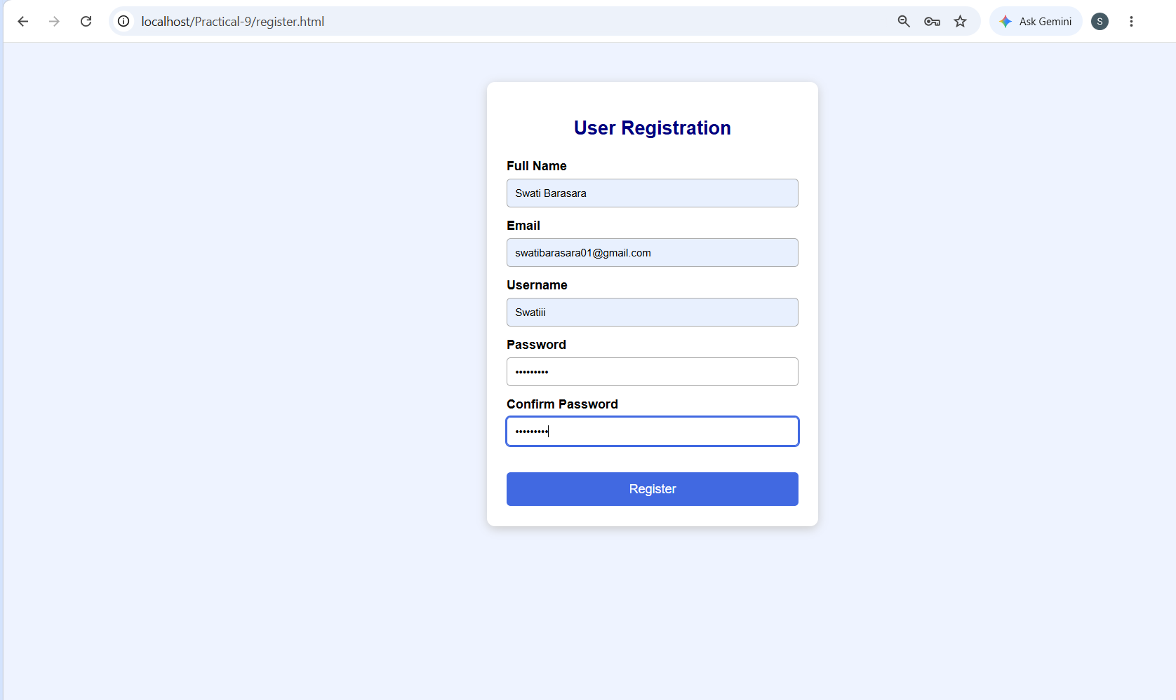
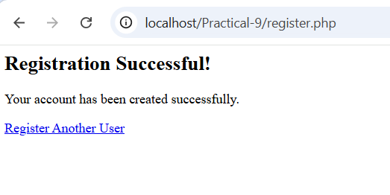

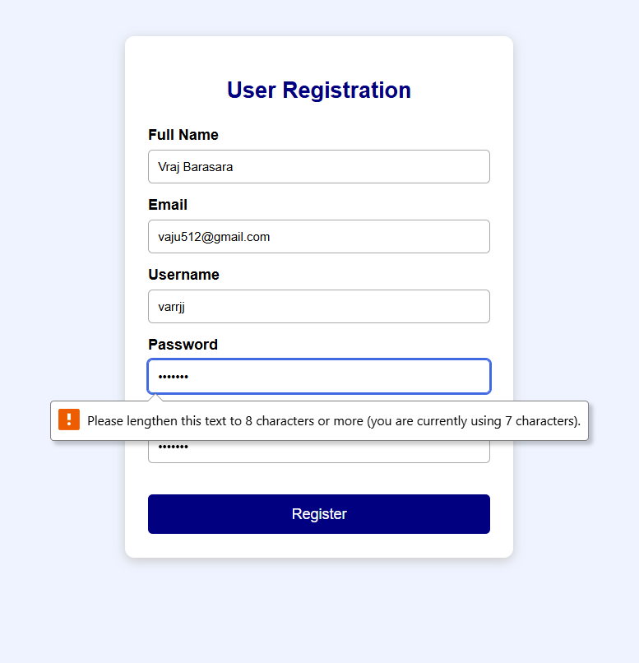
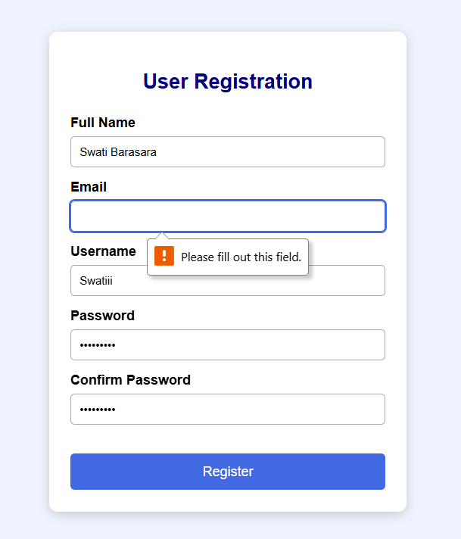

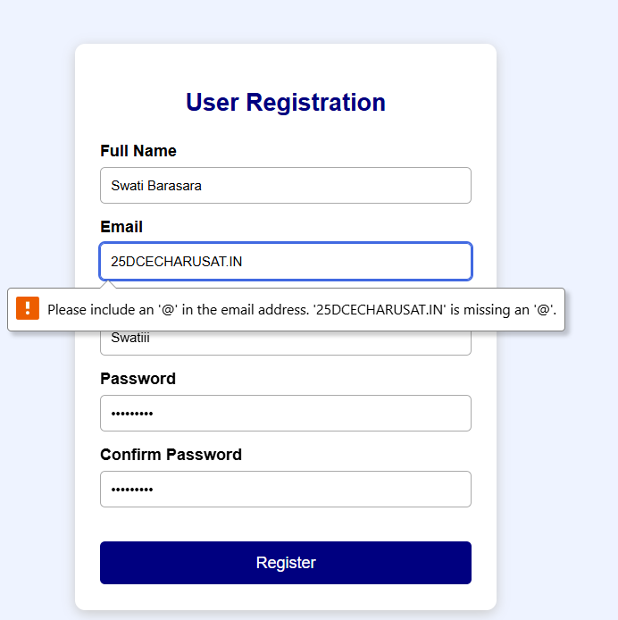
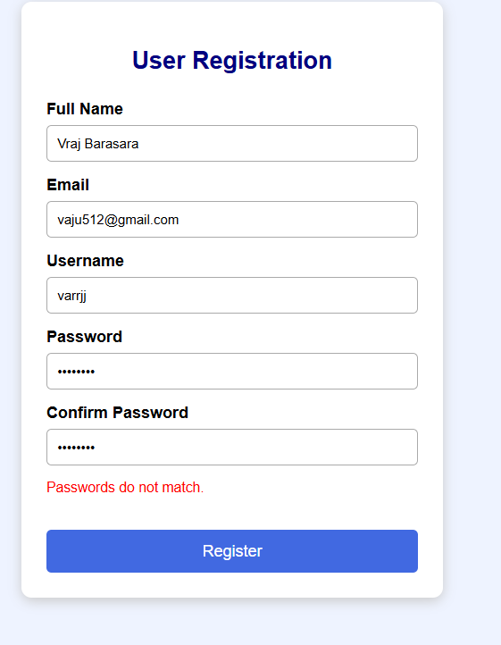

- If we add same data for second time

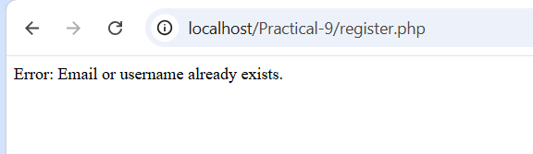

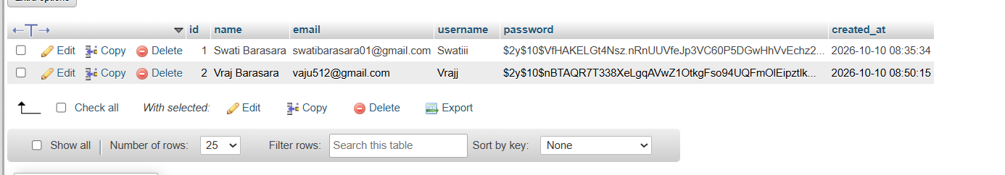
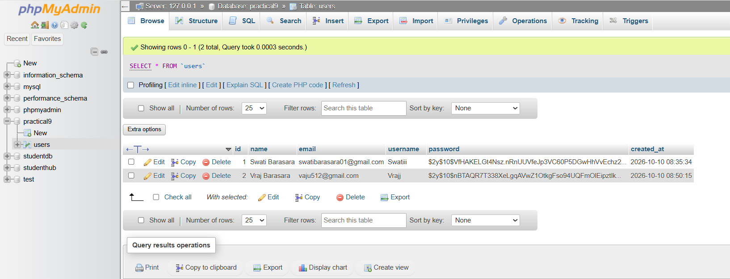

GitHub Repository Link:
https://github.com/Swatibarasara01/WDF/tree/main/Practical-9

Challenges Faced:
- The Database connection failed because MySQL service was not running in XAMPP. After Starting Apache and MySQL the issue was resolved.
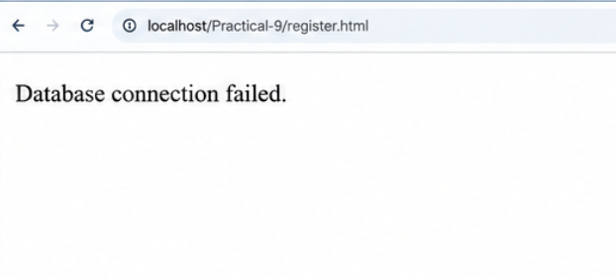

Learning Outcomes:
- Learned to create a secure user registration form using HTML, CSS, PHP, and MySQL.
- Learned to validate user inputs on both frontend and backend.
- Learned to check duplicate email addresses and usernames.
- Learned to store passwords securely using password_hash().
- Learned to test valid, invalid, and duplicate registration cases.
Faculty Remarks:

