Practical - 11

Practical 11:Student Management CRUD with Search and Filter

Problem Definition:Create a student management module to add, view, edit, delete, search and filter student records. All database operations must use MYSQLi statements and clear success/failure messages.

Theory

- Are SELECT, INSERT, UPDATE, and DELETE operations working?
Answer:Yes, all CRUD operations are working correctly. INSERT adds new student records, SELECT displays student details, UPDATE modifies existing records, and DELETE removes selected records from the database.

- Is search by name/email/course implemented?
Answer:Yes, the search feature is implemented using student name, email, and course. Users can search for specific student records by entering relevant keywords. The filter feature also allows users to display students according to their selected course.

- Are delete operations confirmed before execution?
Answer:Yes, a confirmation message appears before deleting a student record. The user must click OK to proceed with the deletion. This helps prevent accidental deletion of student records.

- Implementation/ Output/Result

- Evidence of Work(Screenshots)

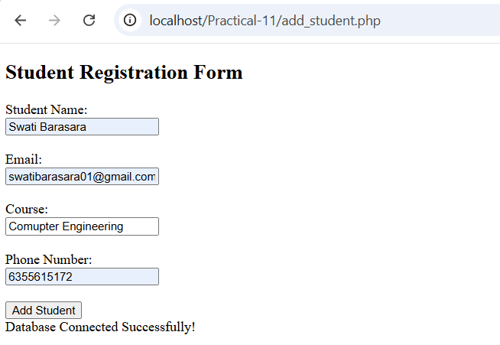
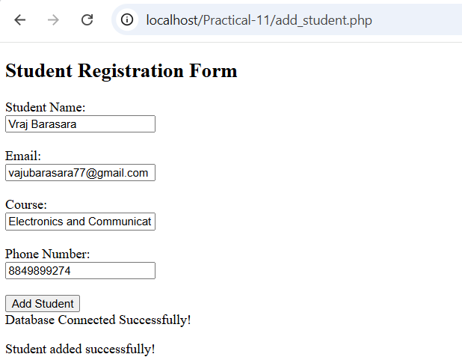

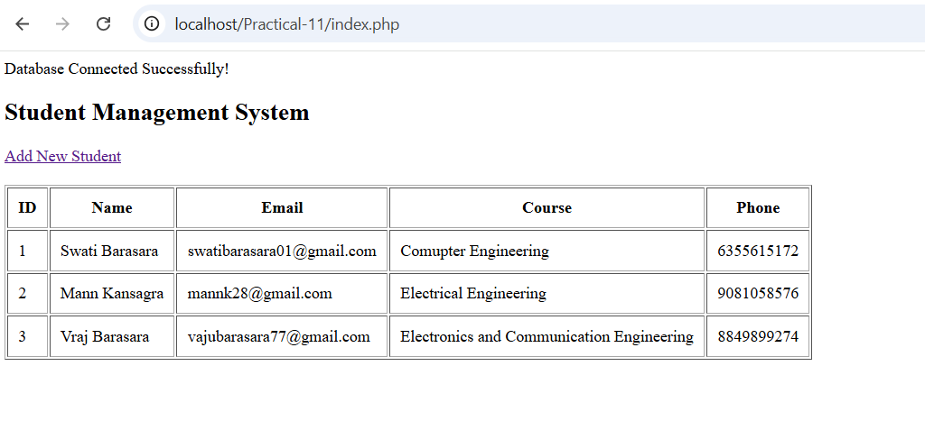
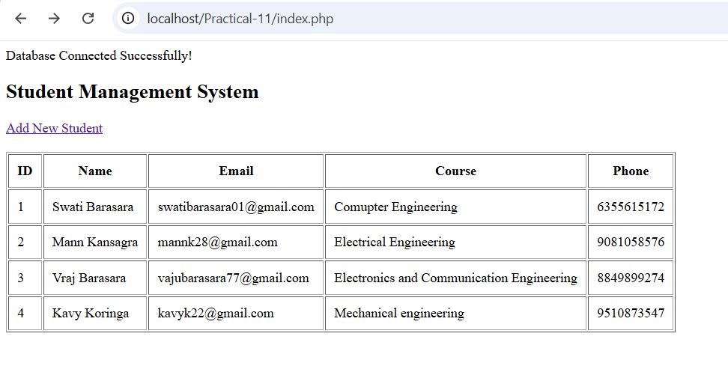
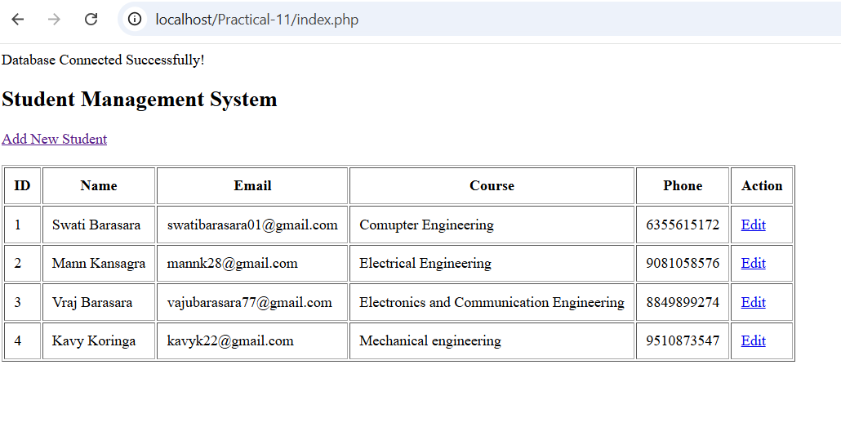

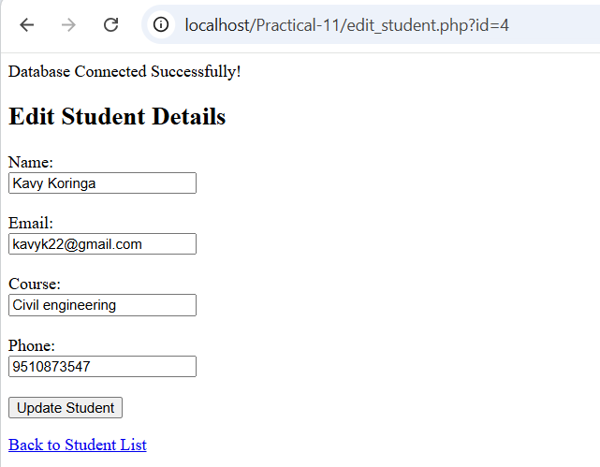

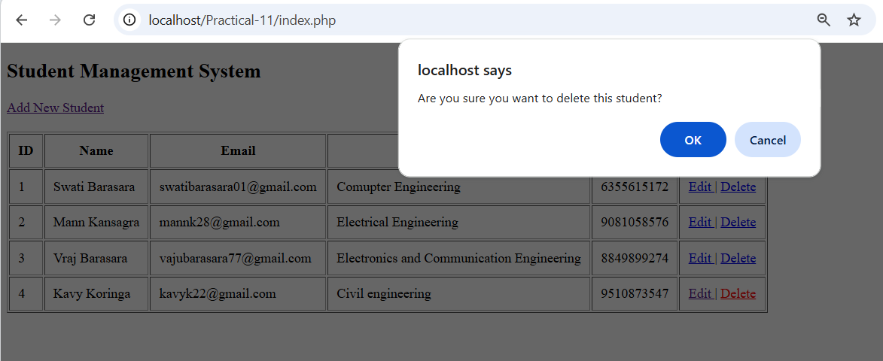
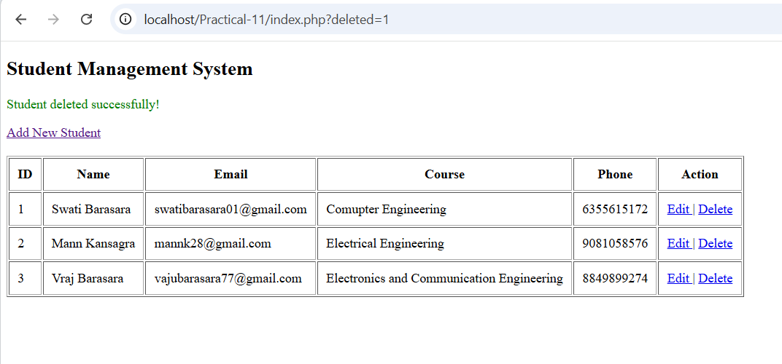

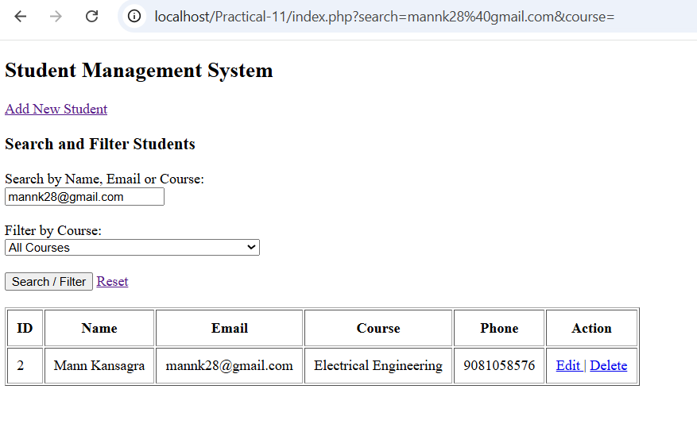

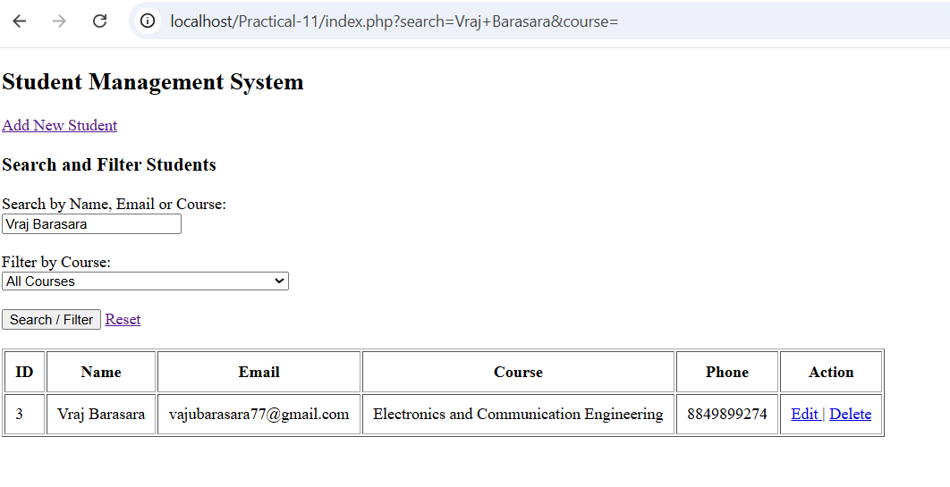
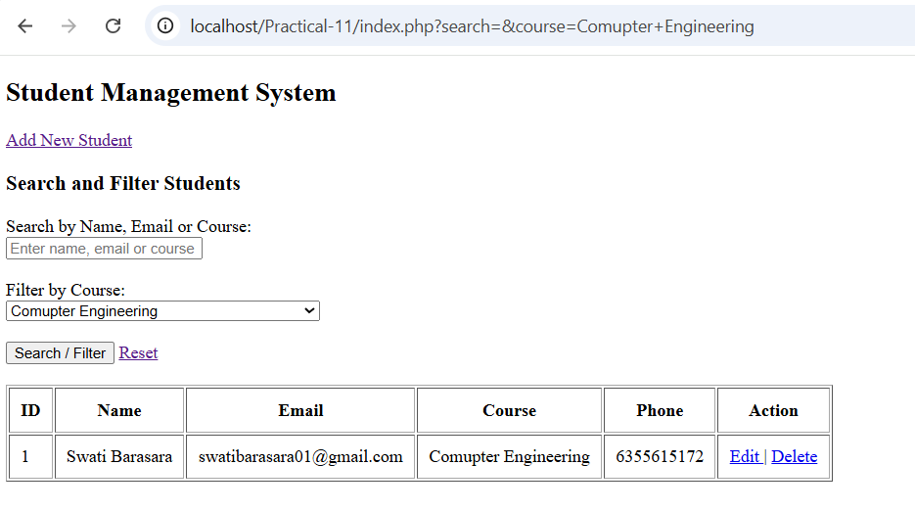

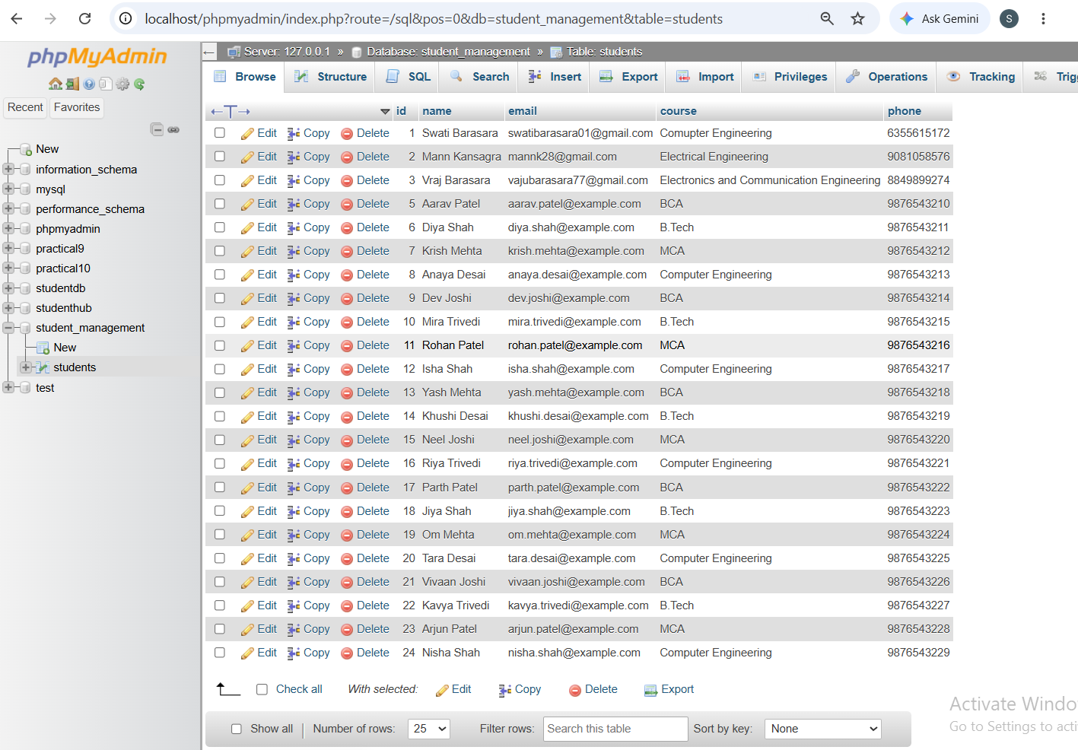
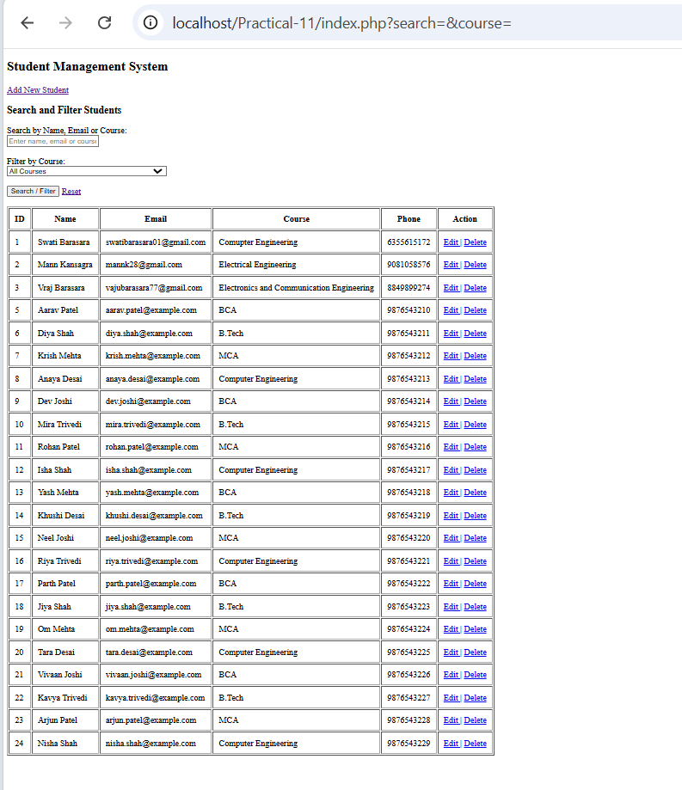

GitHub Repository Link:
https://github.com/Swatibarasara01/WDF/tree/main/Practical-11

Challenges Faced:
- Connecting PHP with the MySQL database correctly.
- Handling errors while inserting student records into the database.
- Updating student details using the correct student ID.
- Implementing search by name, email, and course.

Learning Outcomes:
- Learned how to connect PHP with a MySQL database using XAMPP.
- Learned how to perform CRUD operations such as Insert, Select, Update, and Delete on student records.
- Learned how to search student records by name, email, and course, and filter records by course.
- Learned how to display success and failure messages for database operations.
Faculty Remarks:

