Practical - 12

Practical 12:Event Management CRUD with Poster Upload and File Validation

Problem Definition:Develop event management functionality for admin users. Admin can add, view, update, delete, and upload event posters with file type and file size validation.

Theory

- Are add, update, and delete functionalities implemented correctly?
Answer:Yes, the add, update, and delete functionalities are implemented correctly. Users can add new events, edit existing event details, and delete selected events. The changes are reflected in the database.

- Is the UI linked with the database correctly?
Answer:Yes, the user interface is connected to the MySQL database using PHP. Event details are stored in the database and displayed on the webpage. Any changes made to the events are updated in the database.

- Are poster uploads validated for type and size?
Answer:Yes, poster uploads are validated for file type and size. Only JPG and PNG image files up to 2 MB are allowed. Invalid file types and oversized files are rejected to maintain security.

- Are success and failure messages displayed?
Answer:Yes, success and failure messages are displayed based on the operation performed. Users can identify whether an event was added, updated, or deleted successfully. If an error occurs, an appropriate message is displayed to help identify the problem.

- Implementation/ Output/Result

- Evidence of Work(Screenshots)
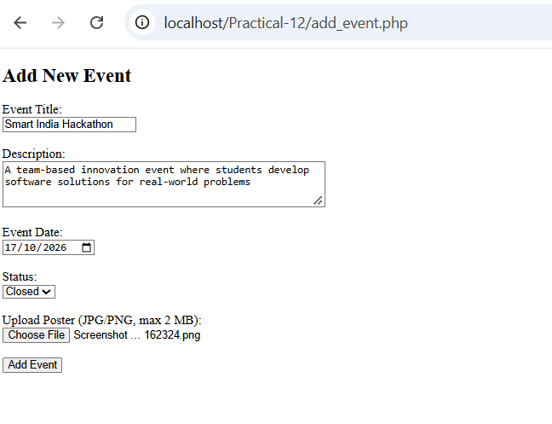
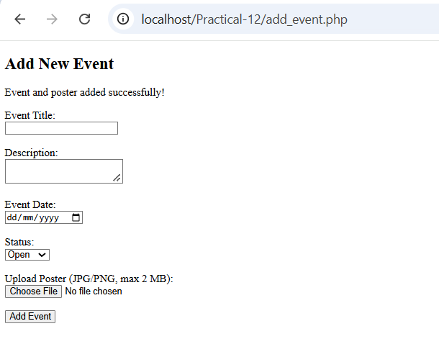

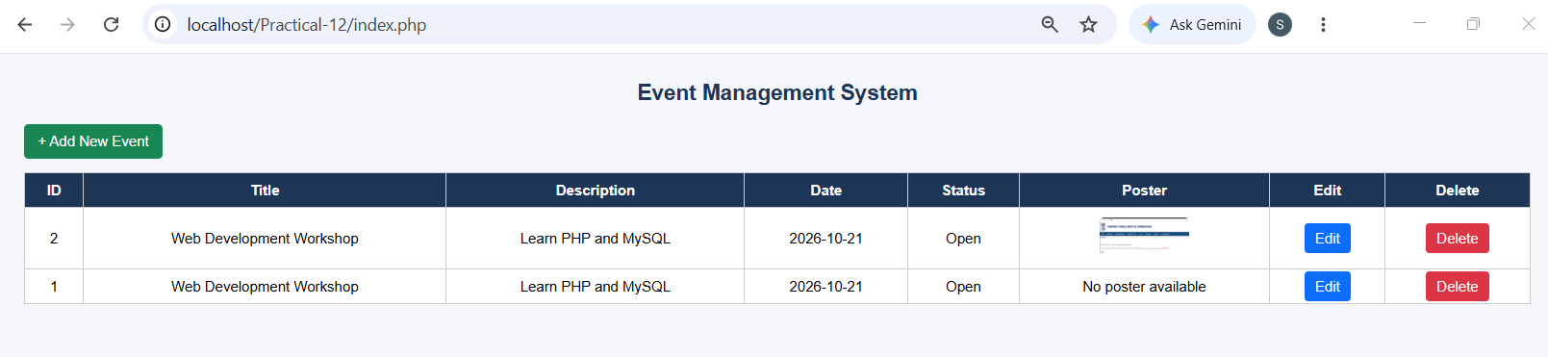

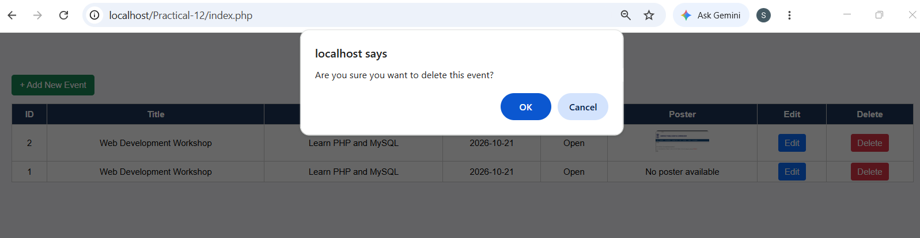
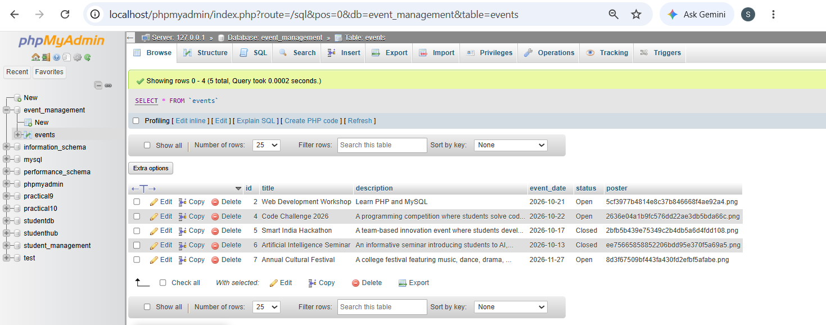

GitHub Repository Link:
https://github.com/Swatibarasara01/WDF/tree/main/Practical-12

Challenges Faced:
- Faced challenges while connecting PHP with the MySQL database and ensuring that event details were stored and displayed correctly.
- Faced difficulties implementing update and delete operations without affecting other event records.
- Faced challenges validating poster file types and sizes and storing uploaded images in the correct folder.

Learning Outcomes:
- Learned how to implement Create, Read, Update, and Delete (CRUD) operations using PHP and MySQL.
- Learned how to connect a PHP application to a MySQL database and display event details dynamically on a webpage.
- Learned how to upload event posters and validate file types and sizes for secure file handling.
- Learned how to display success and failure messages and handle errors during event management operations.

Faculty Remarks:

