Practical - 14

Practical 14:Admin Dashboard with Role-Based Access Control, Dynamic Menu, and Audit Log

Problem Definition:Develop an admin dashboard that displays user statistics, student count, event count and latest registrations. Restrict access to admin users only and show dynamic menu options based on role.

Theory

- Are dashboard values loaded dynamically from the database?
Answer:Yes, dashboard values are loaded dynamically from the database using SQL queries. The dashboard displays total users, students, events, and registrations.

- Is access restricted to admin users?
Answer:Yes, access is restricted using role-based access control. Only admin users can access the admin dashboard, while other users are denied access.

- Are role-based menus working?
Answer:Yes, menus are displayed according to the user's role. Admin users can access administrative options, while other roles have restricted menu access.

- Are important admin actions recorded in audit_logs?
Answer:Yes, important admin actions, such as login, are recorded in the audit logs. These records help track user activities and maintain security.

- Implementation/ Output/Result

- Evidence of Work(Screenshots)

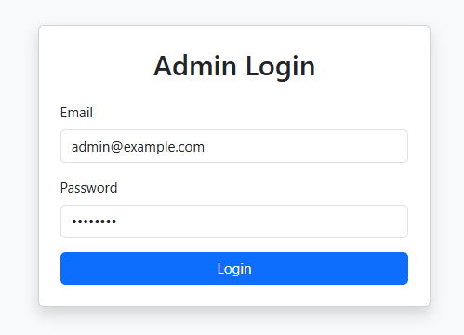
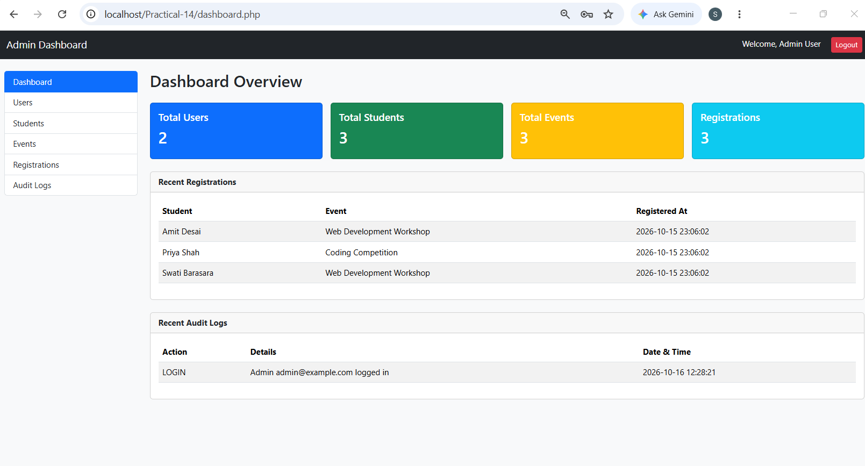

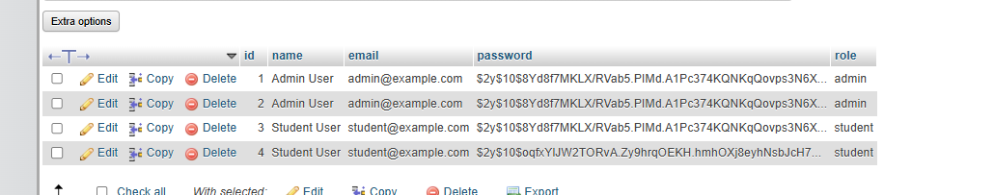

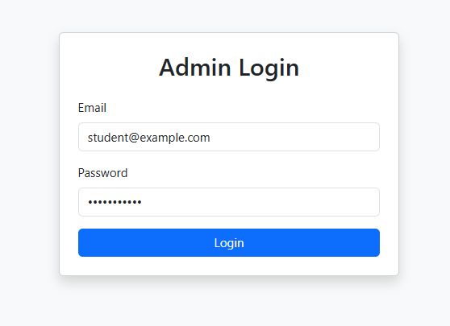

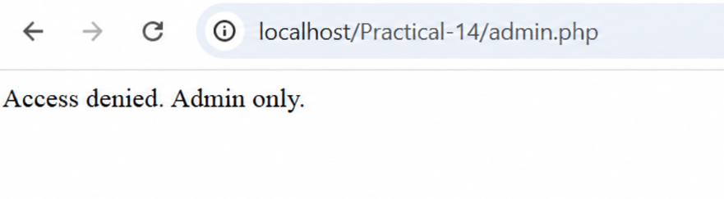

GitHub Repository Link:
https://github.com/Swatibarasara01/WDF/tree/main/Practical-14

Challenges Faced:

- Faced issues while validating admin login credentials and password hashes.
- Faced challenges in restricting dashboard access based on user roles.
- Faced issues while recording admin activities in the audit logs.
- Faced difficulties in displaying dynamic dashboard statistics and role-based menus.

Learning Outcomes:
- Learned to create an admin dashboard using PHP, MySQL, and Bootstrap.
- Learned to display dashboard statistics dynamically from the database.
- Learned to display dynamic menus according to user roles.
- Learned to record important admin activities in audit logs.
- Learned to manage secure login, sessions, and logout functionality.
Faculty Remarks:

