Practical - 4
Practical 4: JavaScript DOM Manipulation, Event Handling, and UI Interactivity

Problem Definition: Add dynamic UI components such as collapsible FAQ, modal popup, image/content slider, notification banner, hamburger menu, and light/dark theme switcher using JavaScript.

Theory

How are DOM elements selected and modified?

Answer: DOM elements are selected using methods such as getElementById(), querySelector(), and querySelectorAll(). After selecting the elements, JavaScript modifies their properties, styles, classes, and content dynamically. For example, our code uses document.getElementById("username") to select the Student ID input and changes its border when invalid input is entered. It also uses document.querySelectorAll("ul li") to select menu items and modify their display during searching.

- Are event listeners attached correctly?
Answer: Yes, event listeners are attached correctly using addEventListener(). In our JavaScript code, events such as input, click, mouseover, and mouseout are used. For example, the input event removes the red border while the user is typing, the click event changes between Dark Mode and Light Mode, and mouseover and mouseout are used to create a hover effect on menu items. These events make the website interactive.

- Is localStorage used for remembering theme choice?
Answer: Yes, localStorage is used to remember the user's selected theme. When the user selects Dark Mode, the code stores "dark" using localStorage.setItem("theme", "dark"). Similarly, Light Mode stores "light". When the page loads again, localStorage.getItem("theme") checks the saved preference and automatically applies the selected theme. Therefore, the user's theme choice is remembered even after refreshing the page.

- Does interactivity improve usability without breaking accessibility?
Answer: Yes, the JavaScript interactivity improves usability while keeping the interface simple and easy to use. Form validation gives immediate feedback when Student ID or Password is incorrect. The search function helps users quickly find menu items, and the Dark/Light Mode improves the viewing experience. The interactions use normal buttons, input fields, links, and text, so the basic structure of the website remains understandable and usable.

- Implementation/ Output/Result

Evidence of Work (Screenshots)

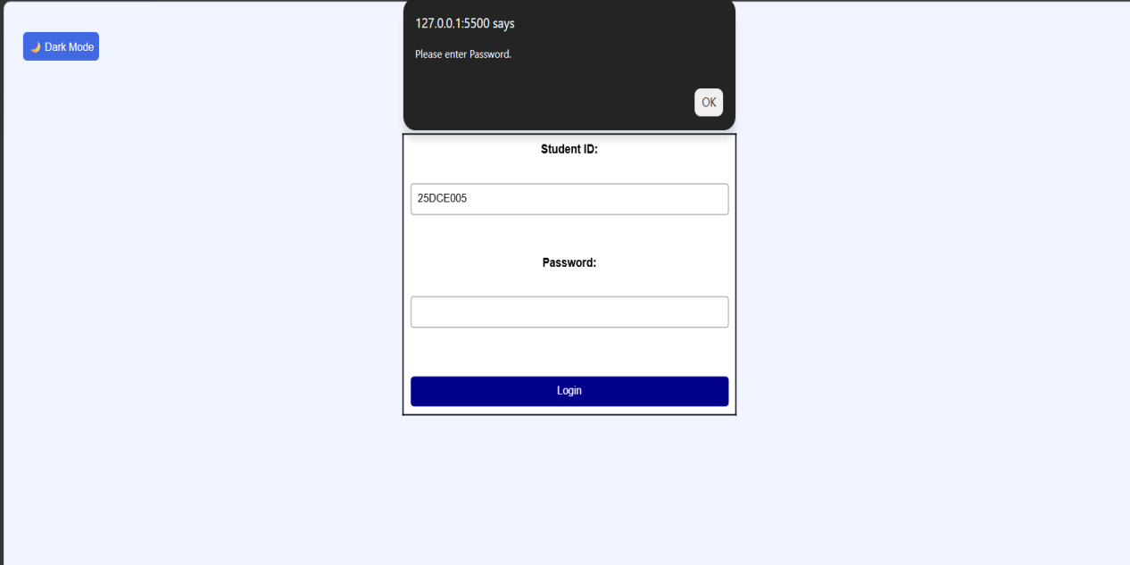

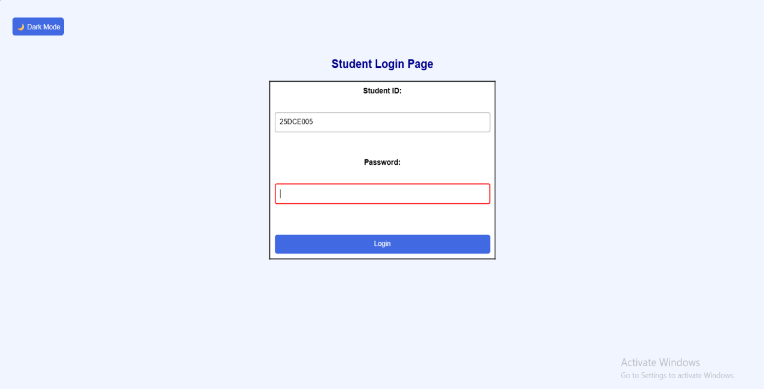

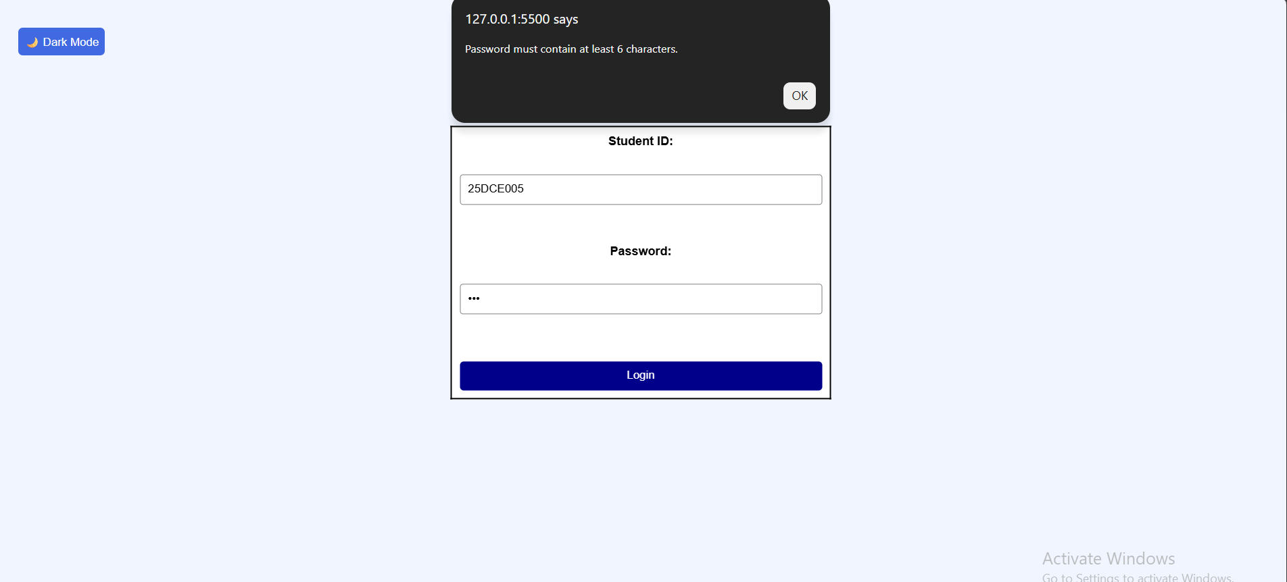

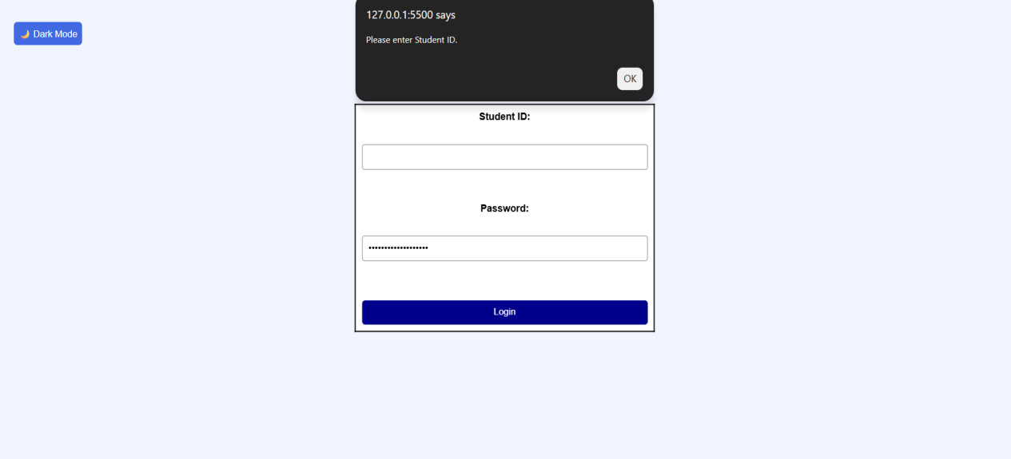



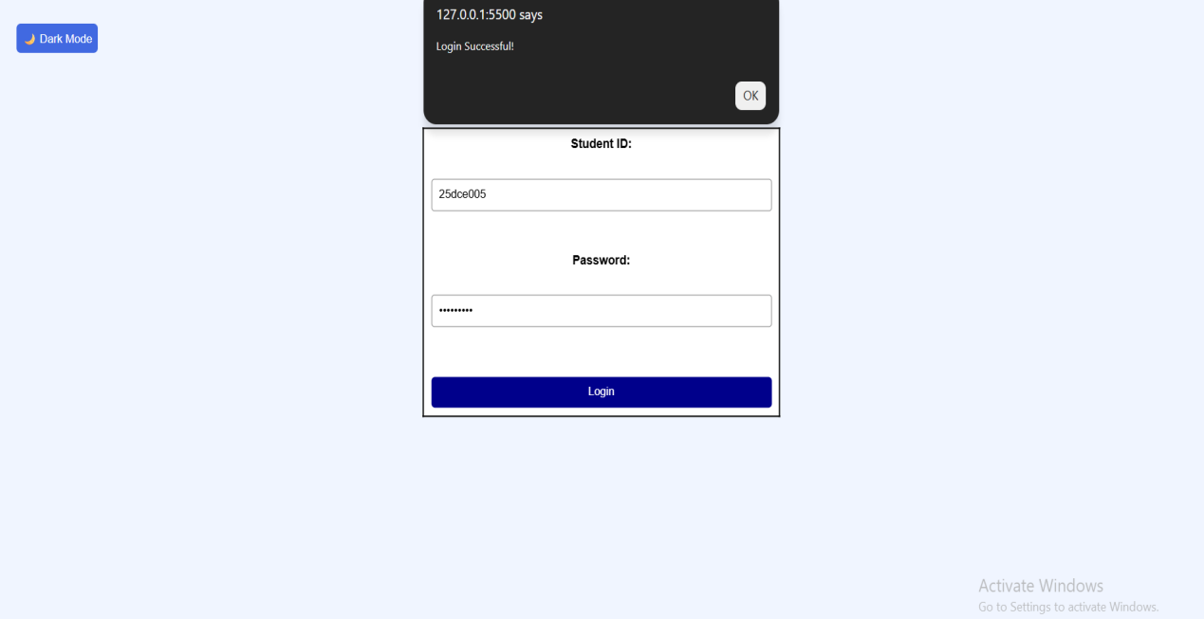

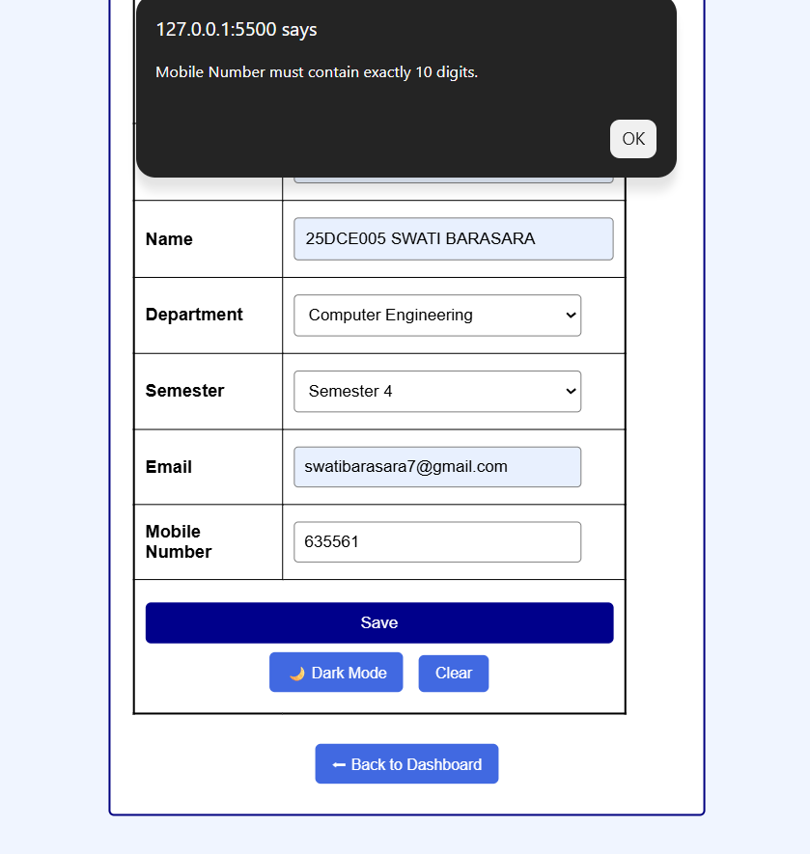

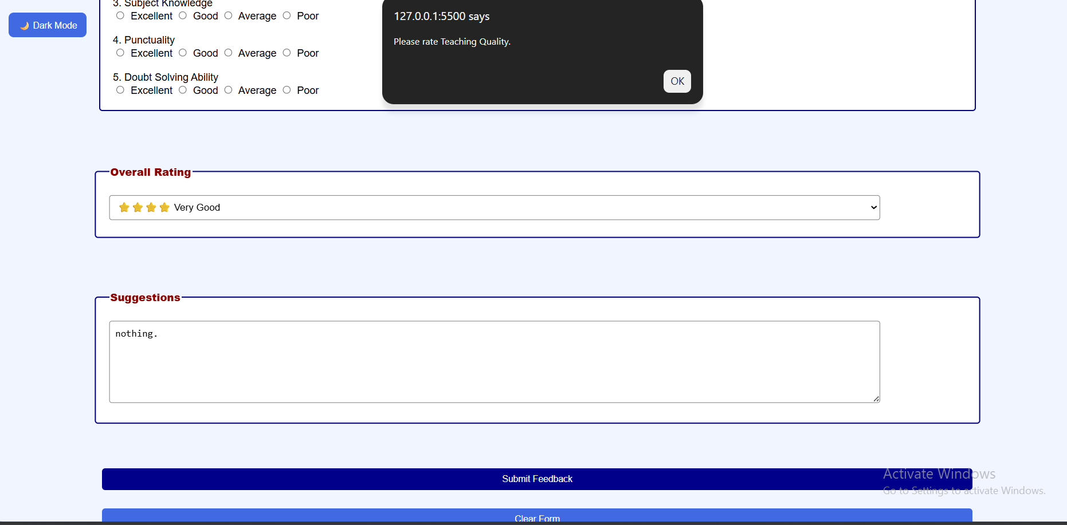

GitHub Repository Link:
https://github.com/Swatibarasara01/WDF.git

Challenges Faced:
- Handling different events such as click, input, mouseover, and mouseout.
- Applying basic UI effects without affecting the existing website design.

- Without entering Password we can assign dashboard pages

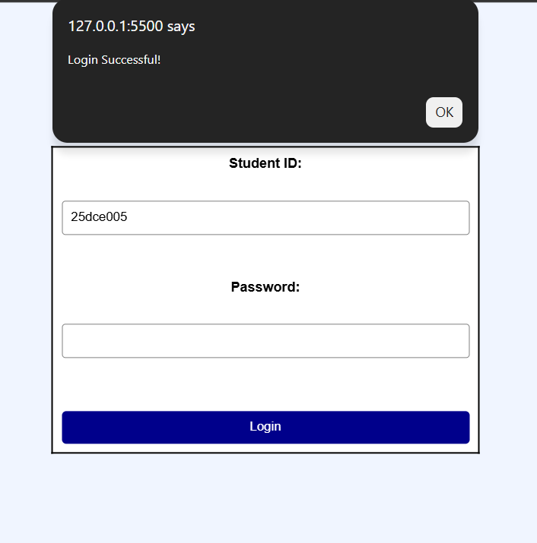

- Without entering Student-Id we can assign dashboard pages

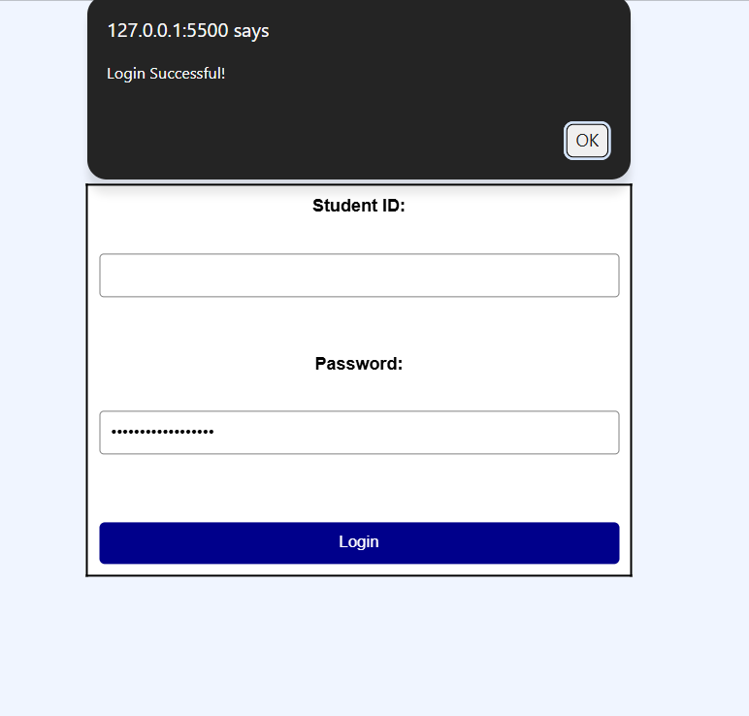

- The Dark Mode button was clickable, but the webpage did not switch to Dark Mode.
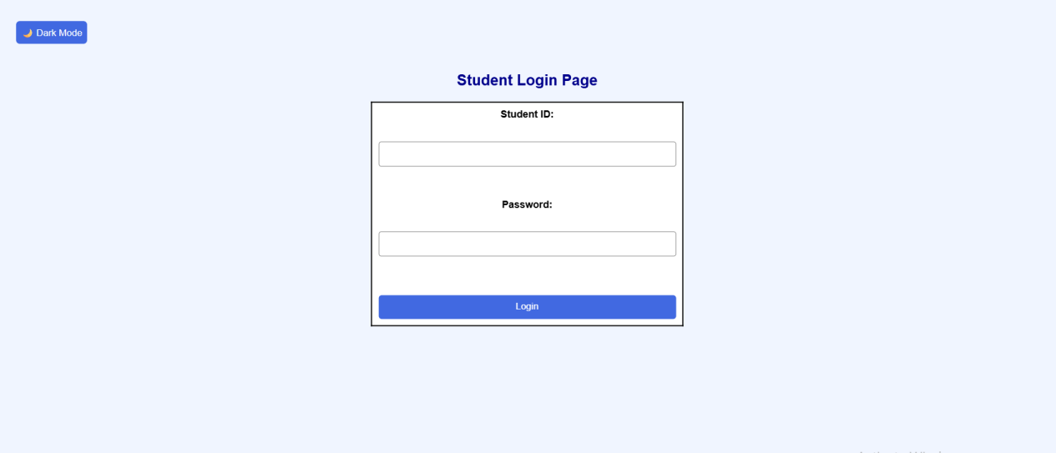

Learning Outcomes:
- Understanding of DOM manipulation using JavaScript.
- Knowledge of JavaScript event handling.
- Implementation of form validation and user input checking.
- Understanding of Dark Mode and Light Mode functionality.

Faculty Remarks:

