Practical - 5

Practical 5: Registration Form with Frontend Validation and User-Friendly Error Handling

Problem Definition: Create a student registration form with HTML5 input types and JavaScript validation for name, email, mobile number, password, confirm password, course, year, gender, and terms acceptance. Use Regular Expression for validations.

Theory

- Are correct input types and attributes used?

Answer:Yes. Appropriate HTML5 input types and attributes such as text, email, tel, password, radio button, checkbox, and select are used according to the requirements. JavaScript validation is also applied to check required fields and input formats. For example, Student ID, Email and Mobile Number are validated using Regular Expressions.

- Are validation errors displayed near the relevant fields?

Answer:Yes. When an invalid or empty value is entered, the corresponding field is highlighted with a red border, an error message is displayed, and the cursor is returned to that field. This helps the user identify and correct the error easily.

- Is password strength checked?

Answer:Yes, password strength is checked using JavaScript. The password is validated based on minimum length, uppercase letter, number, and special character. The password strength is displayed as Weak, Medium, or Strong while the user types the password. This helps users create a more secure password.

- Is the form accessible using keyboard and screen-reader-friendly labels?

Answer:The form can be made keyboard-friendly by using standard HTML form controls and proper <label> elements. The JavaScript also uses .focus() to move the cursor to the field containing an error, which improves keyboard usability.

- Implementation/ Output/Result

- Evidence of Work(Screenshots)

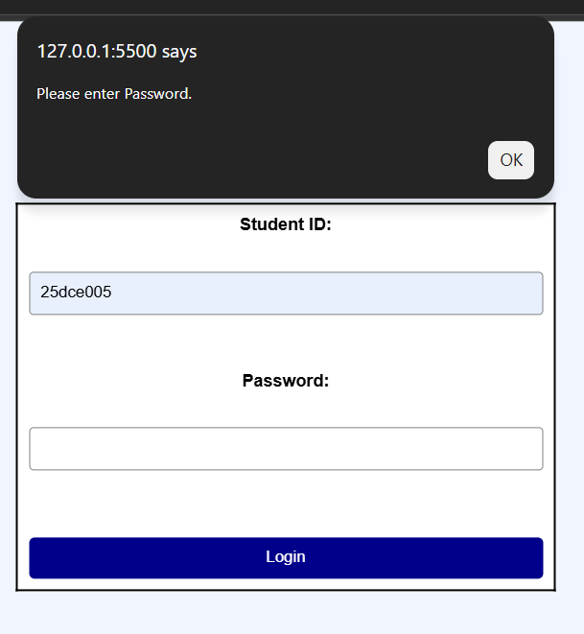

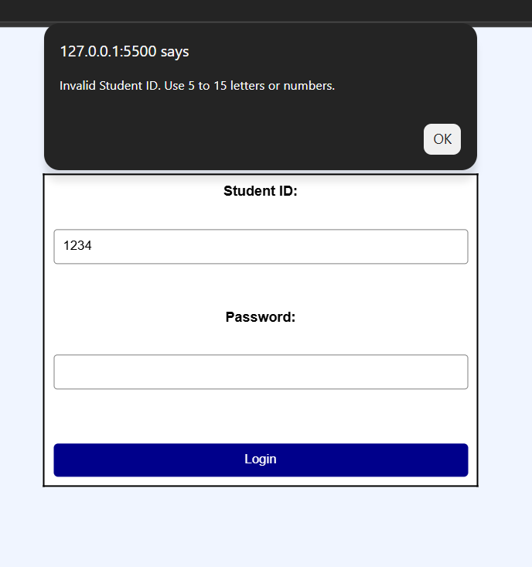
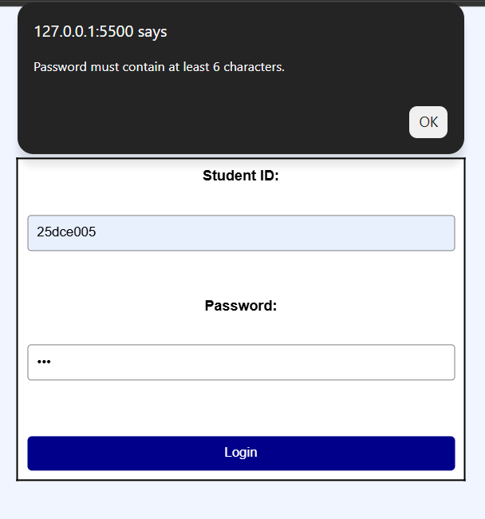

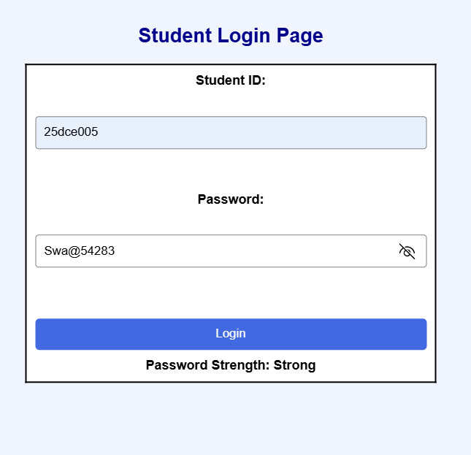
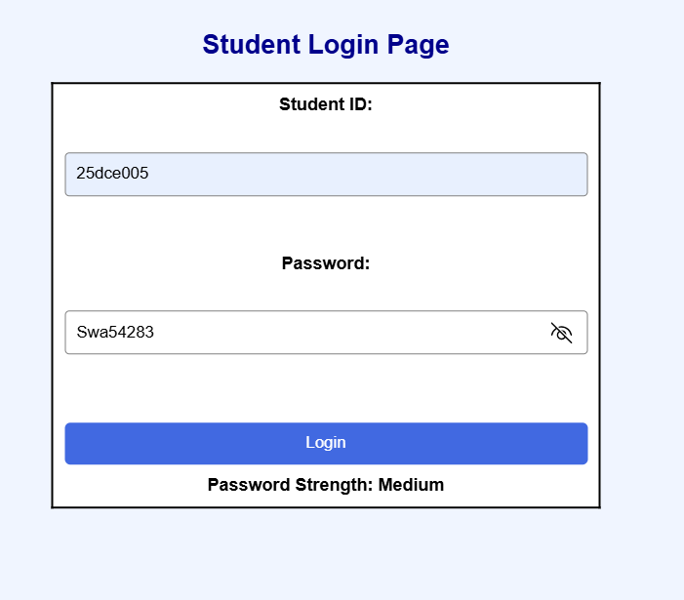

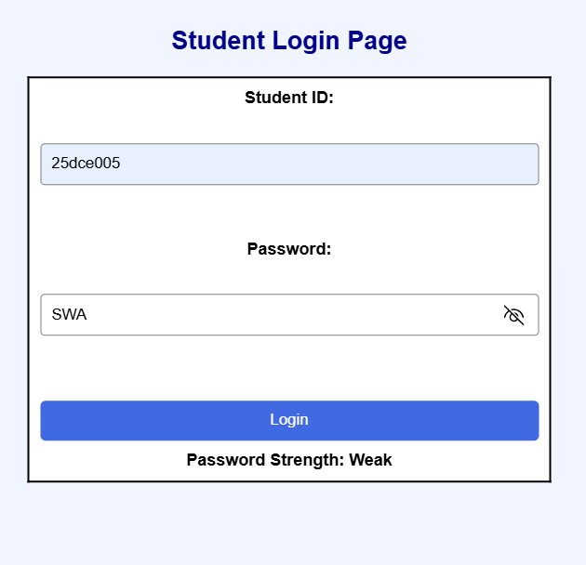
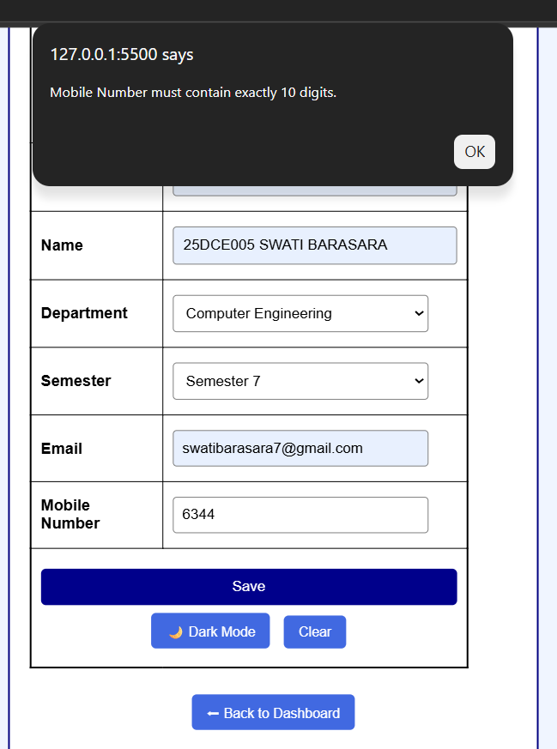

GitHub Repository Link:
https://github.com/Swatibarasara01/WDF/blob/main/Practical-5/Script.js

Challenges Faced:

- Without entering Student-Id we can assign dashboard pages

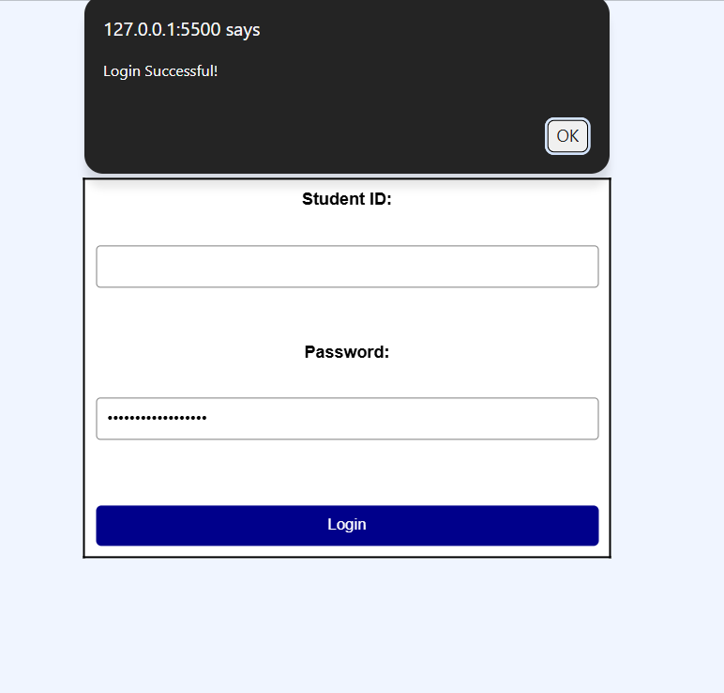
- Entering Invalid student-id we can assign dashboard page

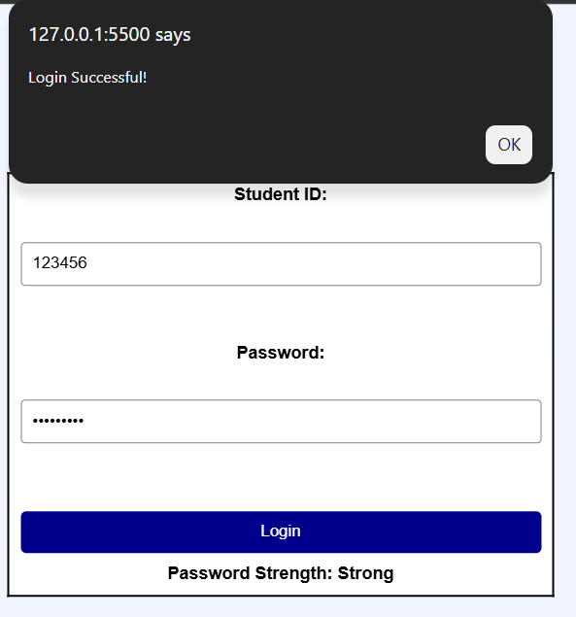

- The password shows as strong even when it does not contain a special character or a number.

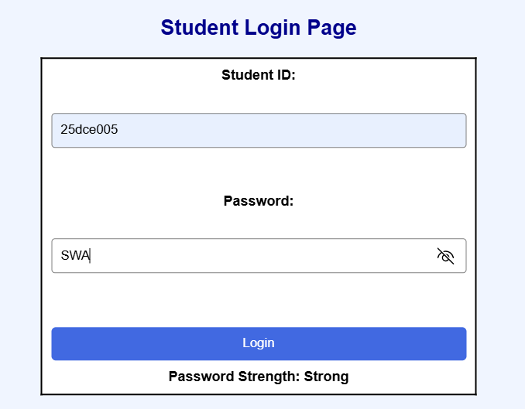

Learning Outcomes:
- Understand how to use Regular Expressions (Regex) for input validation.
- Learn to implement Password Strength as Weak, Medium and Strong.
- Learn to display error messages for invalid or empty inputs.
- Learn to validate Student ID, Password, Email and Mobile Number.

Faculty Remarks:

