Practical - 7

Practical 7:PHP Form Processing with Server-Side Validation and CSV/JSON File Storage

Problem Definition:Process submitted registration/contact form data using PHP. Validate and sanitize inputs on the server side and store records in CSV or JSON file format. Display success/error messages.

Theory

- Is the form submitted using POST?
Answer:Yes, the form uses the POST method to submit data to the PHP server. The submitted information is received using the $_POST variable. POST keeps the form data out of the URL and is suitable for sending form information.

- Are inputs validated and sanitized server side?
Answer:Yes, the input data is validated and sanitized on the server side using PHP. Required fields are checked to make sure they are not empty, and the email format is also verified. Functions such as trim() and htmlspecialchars() help clean and safely handle the input data.

- Is file writing handled safely?
Answer:Yes, file writing is handled using PHP file-handling functions such as fopen() and fputcsv(). The submitted data is stored in a structured CSV format. After writing the data, fclose() is used to properly close the file.

- Are success and error responses displayed clearly?
Answer:Yes, the PHP program displays clear success and error messages to the user. If the entered data is invalid, appropriate validation errors are displayed. If the data is successfully stored in the CSV file, a confirmation message is shown.

- Implementation/ Output/Result

- Evidence of Work(Screenshots)
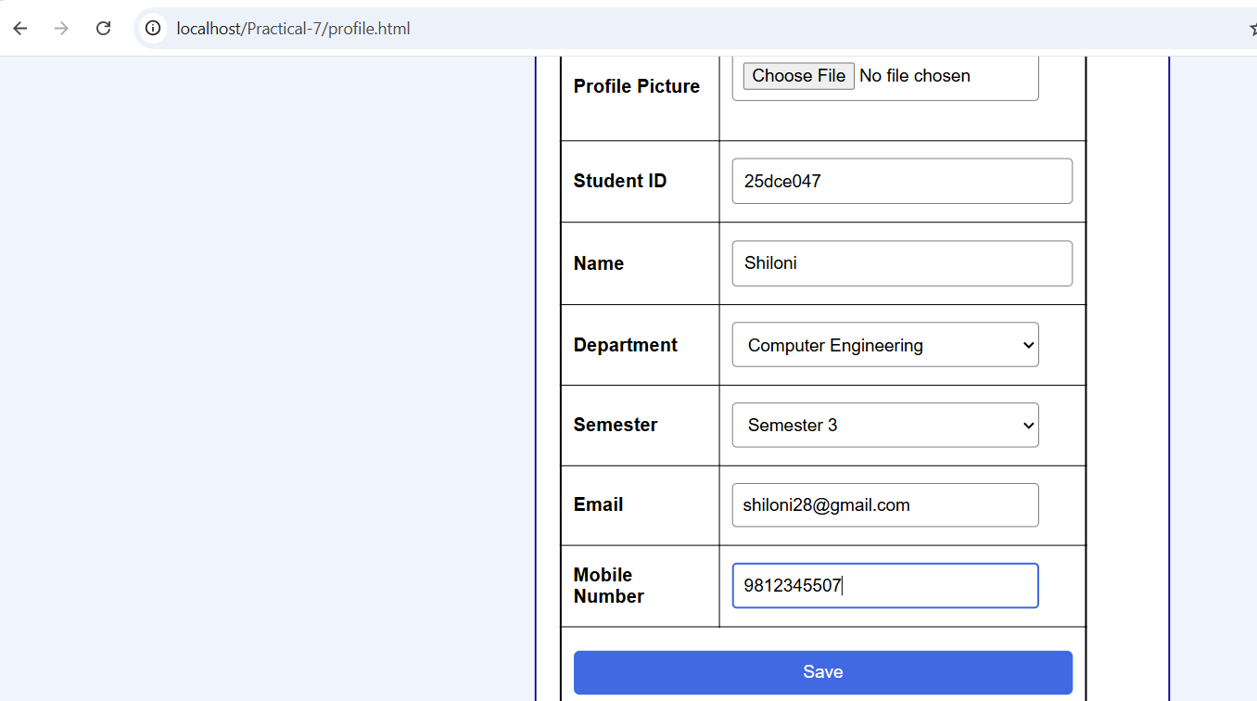
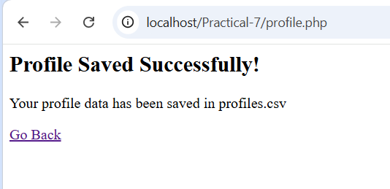

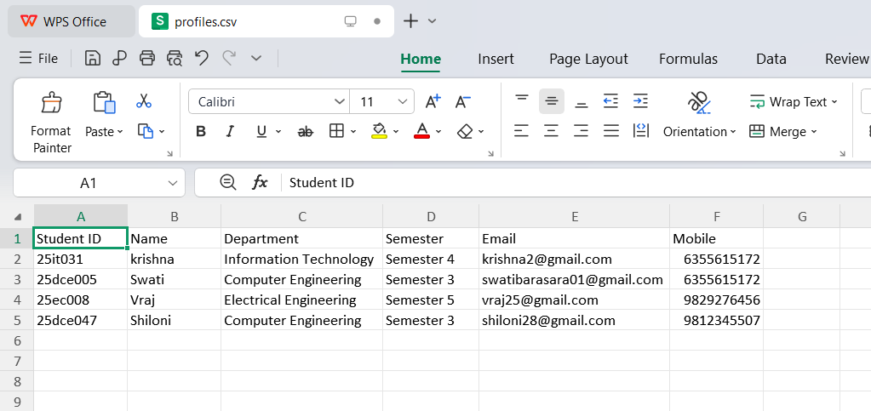

GitHub Repository Link:

https://github.com/Swatibarasara01/WDF/tree/main/Practical-7

Challenges Faced:
- I initially selected the wrong folder path, so the profile.php page could not be executed on localhost
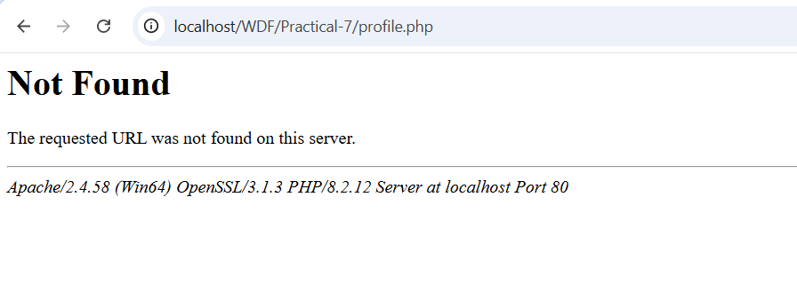

Learning Outcomes:
- Learned how to process HTML form data using PHP and POST.
- Learned about server-side validation and sanitization.
- Learned how to store form data in a CSV file using PHP.
- Learned how to use PHP file-handling functions like fopen(), fputcsv(), and fclose().
- Learned how to run and test a PHP application using XAMPP localhost.
Faculty Remarks:

