Practical - 8

Practical 8: MySQL Schema Design, ER Model, PDO Connectivity, and Prepared Statements

Problem Definition:Design the database for StudentHub with students, events and registrations. Create PHP database connection using MYSQL statements.

Theory

- Is the schema normalized properly?
Answer:Yes, the database is reasonably normalized because student, event, and registration information is stored in separate tables. This reduces data duplication and makes the database easier to manage and update.

- Are primary keys and foreign keys correctly defined?
Answer:Yes, each table has a primary key to uniquely identify its records. Foreign keys are used in the registrations table to establish relationships between students and events.

- Is the database connection handled securely?
Answer:Yes, the database connection is handled using PDO with exception handling. Prepared statements are also used for inserting data, which helps protect the application from SQL injection.

- Implementation/ Output/Result

- Evidence of Work(Screenshots)

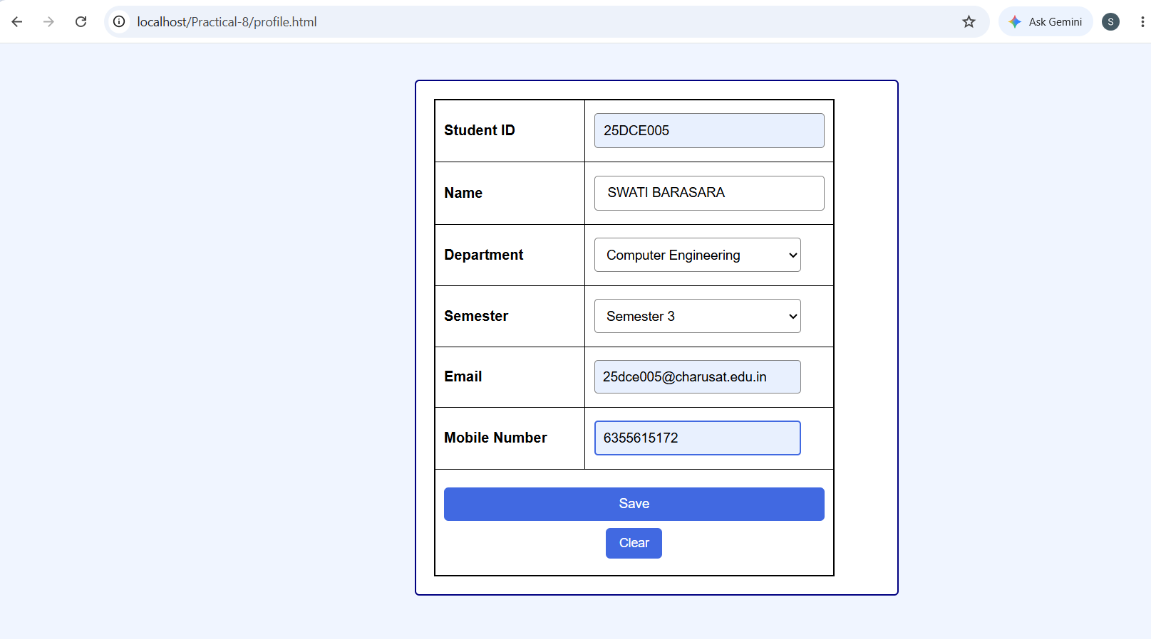
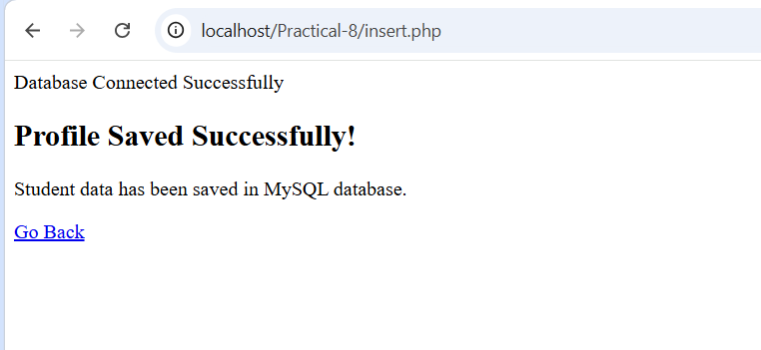

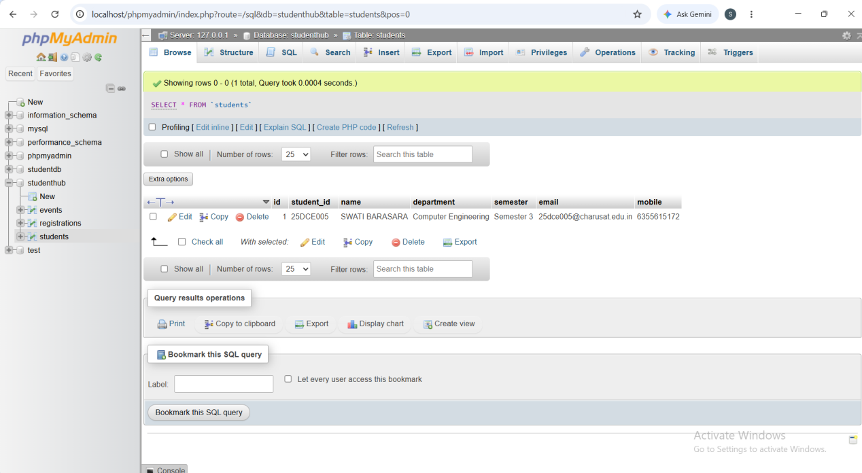

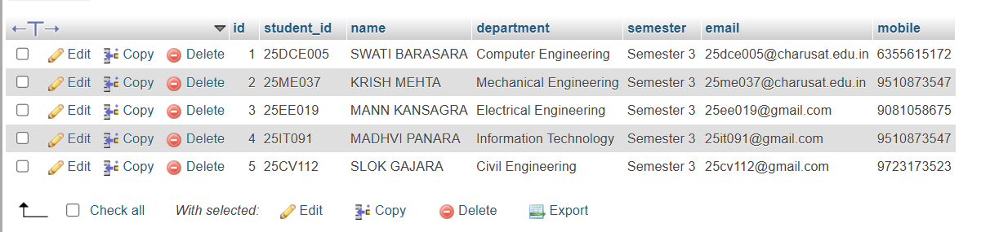

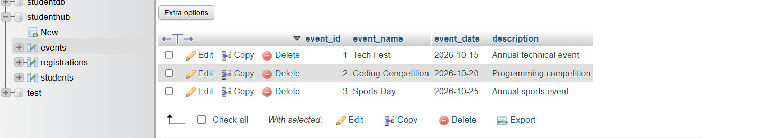
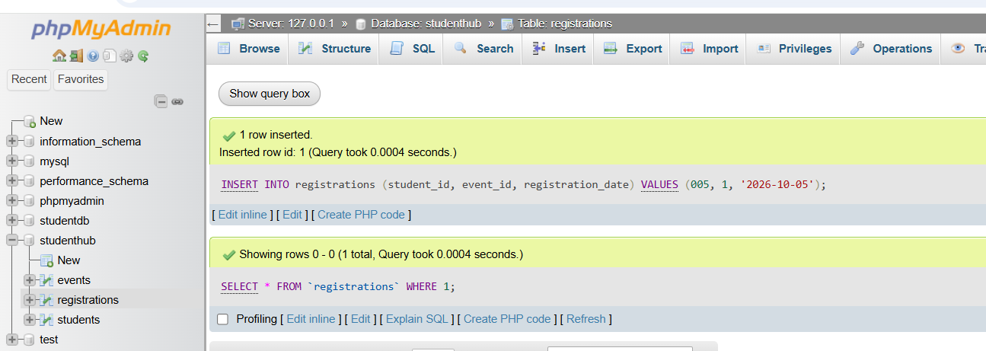

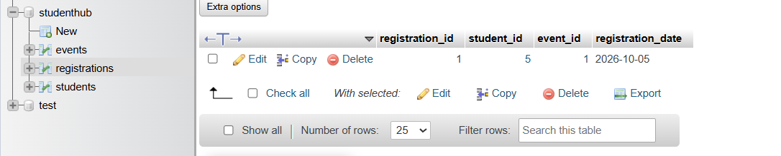

GitHub Repository Link:
https://github.com/Swatibarasara01/WDF/tree/main/Practical-8

Challenges Faced:
- The registration entry contains my Student ID 25DCE005, which includes both letters and numbers. However, the student_id field was defined to accept only integer values. Therefore, the database gives an error because the alphanumeric Student ID cannot be stored in an integer field.
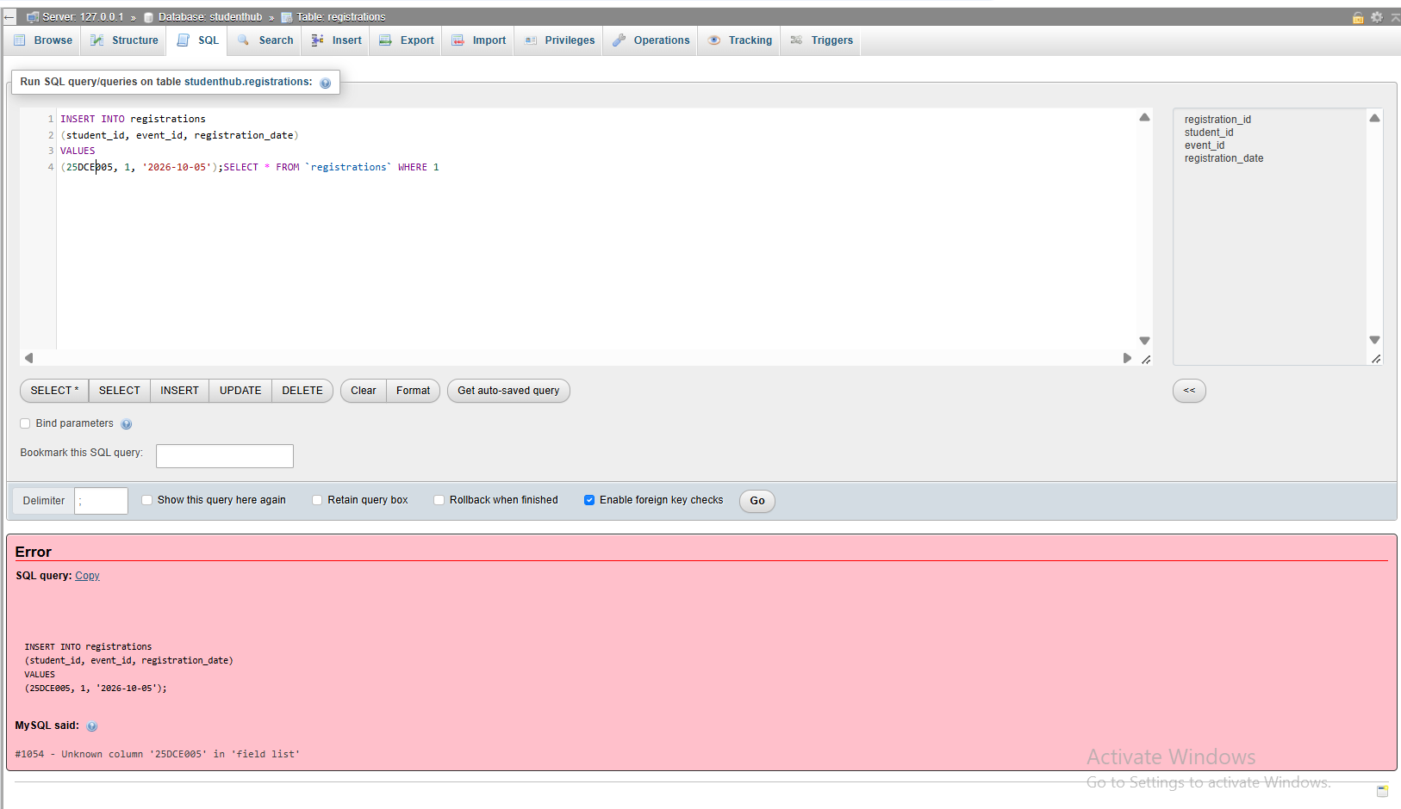

Learning Outcomes:
- Learned how to connect PHP with MySQL using PDO and handle database errors.
- Learned how to design and create a MySQL database with multiple related tables.
- Learned how to insert, manage, and export database data as an SQL dump.
- Learned to use prepared statements and validation for secure data insertion.

Faculty Remarks:

