**/*1. Create a database named library and a table named books with the following columns.*/**

id(Int, Primary key, Auto increment)

title(varchar(255))

author(varchar(100))

year(year)

genre(varchar(100))

create database library;

use library;

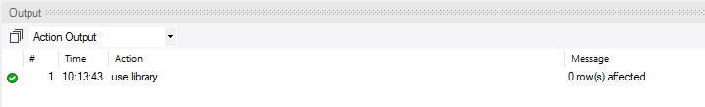

create table books(

id int primary key auto_increment,

title varchar(255),

author varchar(100),

year year,

genre varchar(100));

select*from books;

**/*2.Insert the following book records into the books table/*:**

"The Great Gatsby","F.Scott Fitzgerald",1925,"Fiction"

"Pride and Prejudice","Jane Austen",1913,"Romance"

"To kill a Mockingbird","Harper Lee",1960,"Fiction"

"1984","George Orwell",1949,"Dystopian"

"Moby Dick", "Herman Melville", 1951,"Adventure"

insert into books(id,title,author,year,genre)values

(1,"The Great Gatsby","F.Scott Fitzgerald",1925,"Fiction"),

(2,"Pride and Prejudice","Jane Austen",1913,"Romance"),

(3,"To kill a Mockingbird","Harper Lee",1960,"Fiction"),

(4,"1984","George Orwell",1949,"Dystopian"),

(5,"Moby Dick","Herman Melville",1951,"Adventure");

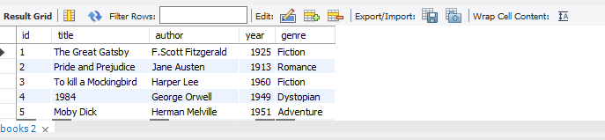

**/*3. Write a query to select all books where the title stars with the letter 'T'**

**using the LIKE operator./\***

select * from books where title LIKE "T%";

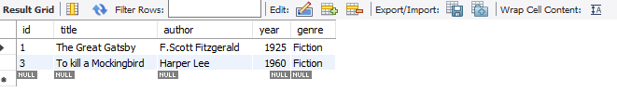

**/*4.Write a query to find all books where the author's last name ends with 'son'**

**using the like operator./\***

select * from books where author like "%son";

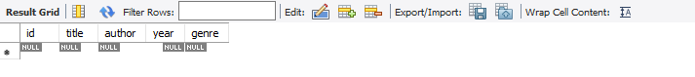

**/*5.Write a query to find all books where the title contains the word 'and' using**

**the like operator./\***

select * from books where title like "and%";

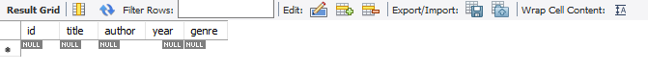

**/*6.Write a query to retreive all books where the title ends with the word 'bird'**

**using the like operator./\***

select * from books where title like "%bird";

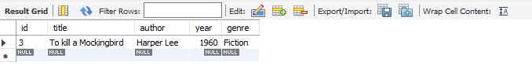

**/*7.Write a query to find all books where the title has exactly three characters**

**using the REGEXP operator./\***

select * from books where title REGEXP '[gpm]';

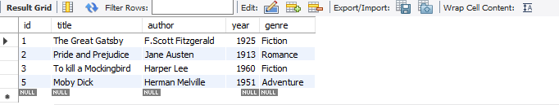

**/*8.Write a query to select all books where the title contains a number using the REGEXP**

**operator./\***

select * from books where title REGEXP '[0-9]'

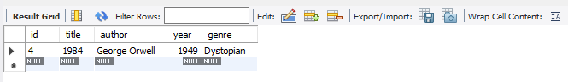

**/*9.Write a query to retreive all books where the author's name starts with any letter**

**between 'A' and 'J' using the REGEXP operator./\***

select * from books where author REGEXP '^[A-ja-j]';

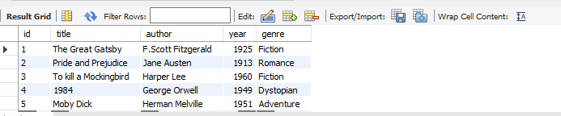

**/*10.Write a query to select all books where the genre is either 'Fiction' or 'Adventure' using the**

**REGEXP operator./\***

select * from books where genre REGEXP '^(fiction|Adventure)$';

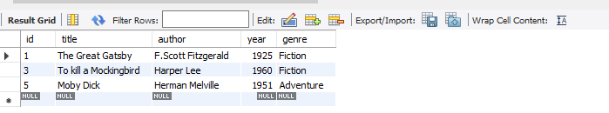

**/*11.Write a query to find all books where the title contains at least on uppercase letter using the**

**REGEXP operator./\***

select * from books where title REGEXP '[A-Z]';

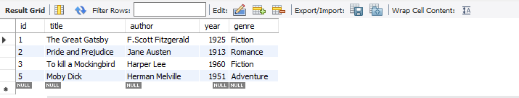

**/*12.Write a query to find all books where the year of publication is between 1800 and 1950 using the**

**LIKE operator./\***

select * from books where year like '18%';

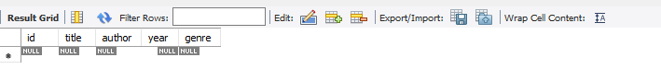

**\*13.Write a query to retreive all books where the author's name contains exactly two words using**

**the REGEXP operator./\***

select * from books where author REGEXP '^[A-Za-z]+\s[A-Za-z]+$';

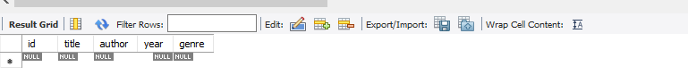

**/*14.Write query to find all books where the title starts with the letter 'P' and contains exactly**

**two words using the REGEXP operator./\***

select * from books where title REGEXP '^P[A-Za-z]*\s[A-Za-z]+$';

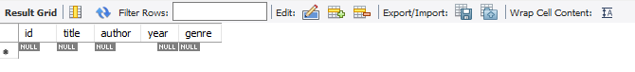

**/*15.Write a query to find all books where the title contains any special characters(e.g.,'!','@','#',etc.)**

**using the REGEXP operator./\***

select * from books where title REGEXP '[^a-zA-Z0-9\S]';

