**Statistic assignment**

**Q. 1):** **Plot a histogram,**

10, 13, 18, 22, 27, 32, 38, 40, 45, 51, 56, 57, 88, 90, 92, 94, 99

**Solution:**

**Create Histogram from given data:**

Let, X={10,13,18,22,27,32,38,40,45,51,56,57,88,90,92,94,99}

What kind of curve you get?

**Ans**:

We get bell curve in histogram in red line also called as Frequency polygon.

**Q5:**  **In left & right-skewed data, what is the relationship between mean, median & mode?**

**Draw the graph to represent the same**.

Ans: Comparing Positive, symmetrical and left skewed frequency distribution over mean, median and mode. (Empirical Relationship)

1. **Symmetrical Frequency Curve**

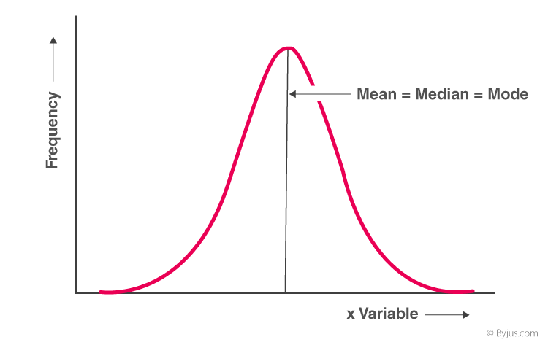

**Mean = median = mode**

1. **Positively Skewed Frequency Distribution**

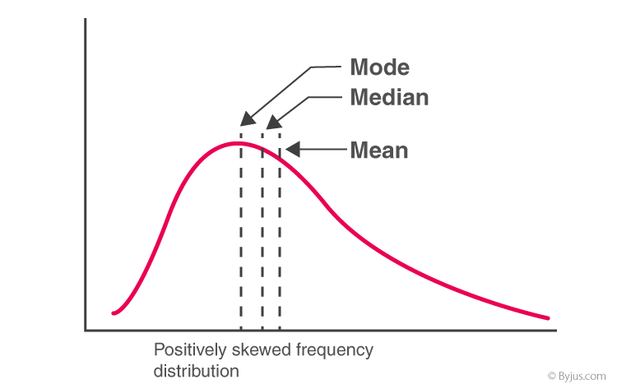

**Mean > median > mode**

1. **Negatively Skewed Frequency Distribution**

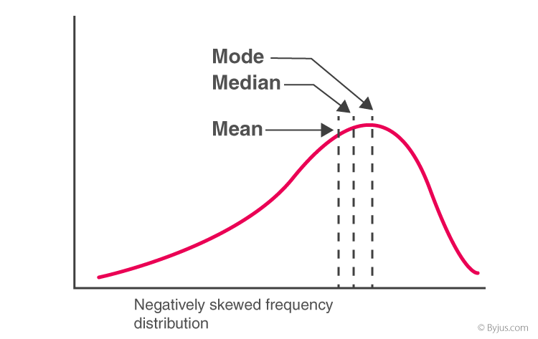

**Mode > median > mean**