**Statistic assignment**

**Assignment 1: (date: 19/06/2022)**

**Q1: Answer the following:**

1. What kind of variable is marital status?

Ans: Categorical

1. What kind of variable is Ganga river length?

Ans: Continuous

1. What kind of variable is Movie duration?

Ans: Continuous

1. What kind of variable is IQ?

Ans: Continuous

**Q2: Create Histogram from given data:**

Let, X={10,13,18,22,27,32,38,40,45,51,56,57,88,90,92,94,99}

What kind of curve you get?

**Ans**:

We get bell curve in histogram in red line also called as Frequency pylygon.

**Q3**: Why is sample variance is divided by (n-1)?

Ans:

**Assignment 2: (date: 25/06/2022)**

**Q1: Why is sample variance is divided by (n-1)?**

**Ans:**

In denominator we divided by (n-1) because the calculations for both sample standard deviation and sample variance are contains tittle bias (error). So we subtract 1 from sample size it means Bessel’s correction for correct this bias. **or**

(n-1) is also called degree of freedom (DOF) that is sample mean is supposed to be equal or closest to population mean. But we have to freedom to choose (n-1) to keep sample mean (x̄) =population mean (µ).

**Q2: Explain importance of Bell curve?**

**Ans:**  A bell curve is presents a normal distribution.

* **Gaussian function**, specific kind of function whose graph is a bell-shape curve.
* It is a type of graph that is used to visualize the distribution of set od chosen values across specific group that’s tends to have central, normal value as peak with low and high extremes tapering with symmetrical in both sides. It’s called **Gaussian distribution.**
* Bell curve useful for quickly visualizing data sets mean, median and mode. When distribution is normal the mean, median and mode are the same.

**Q3: Relationship between Mean, Median and Mode with Respect to right and left skewed .**

Ans: Comparing Positive, symmetrical and left skewed frequency distribution over mean, median and mode. (Empirical Relationship)

1. **Symmetrical Frequency Curve**

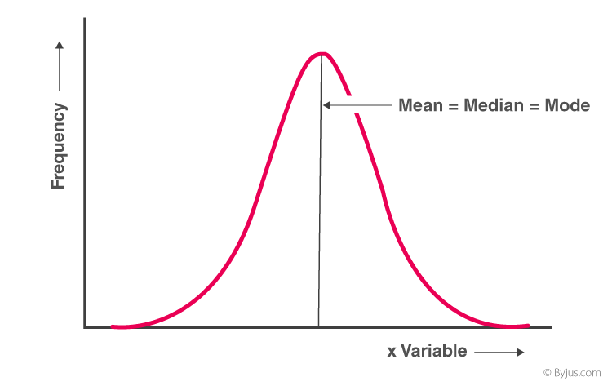

**Mean=median=mode**

1. **Positively Skewed Frequency Distribution**

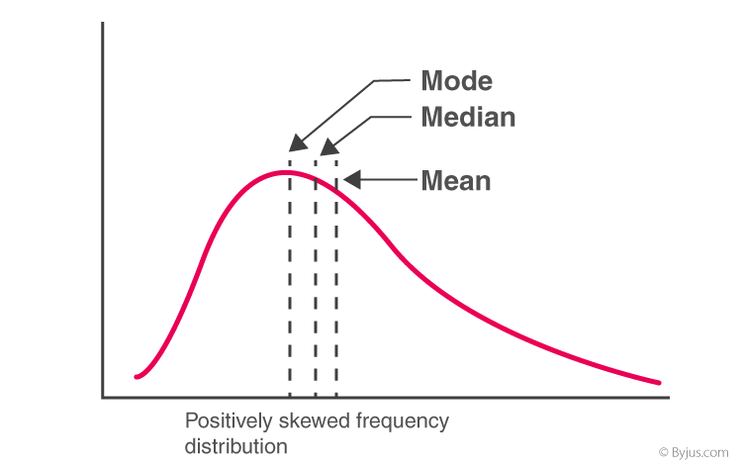

**Mean>median>mode**

1. **Negatively Skewed Frequency Distribution**

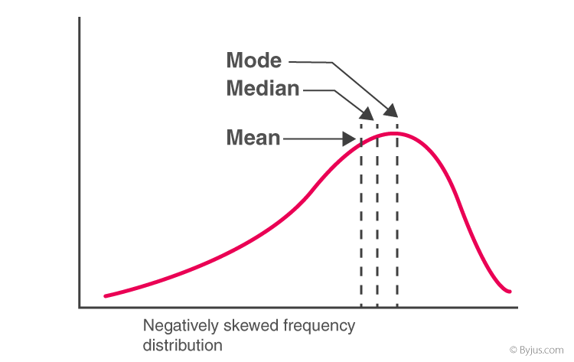

**mode>median>mean**