Name | Swati Kundu
Section | A4-B3
Roll no | 48
Subject | Daa

Practical 8

Aim: Implement Graph Colouring algorithm use Graph colouring concept.
Problem Statement:
A GSM is a cellular network with its entire geographical range divided into
hexadecimal cells. Each cell has a communication tower which connects with mobile
phones within cell. Assume this GSM network operates in different frequency
ranges. Allot frequencies to each cell such that no adjacent cells have same
frequency range.
Consider an undirected graph G = (V, E) shown in fig. Find the colour assigned to each node
using Backtracking method. Input is the adjacency matrix of a graph G(V, E), where V is the
number of Vertices and E is the number of edges.
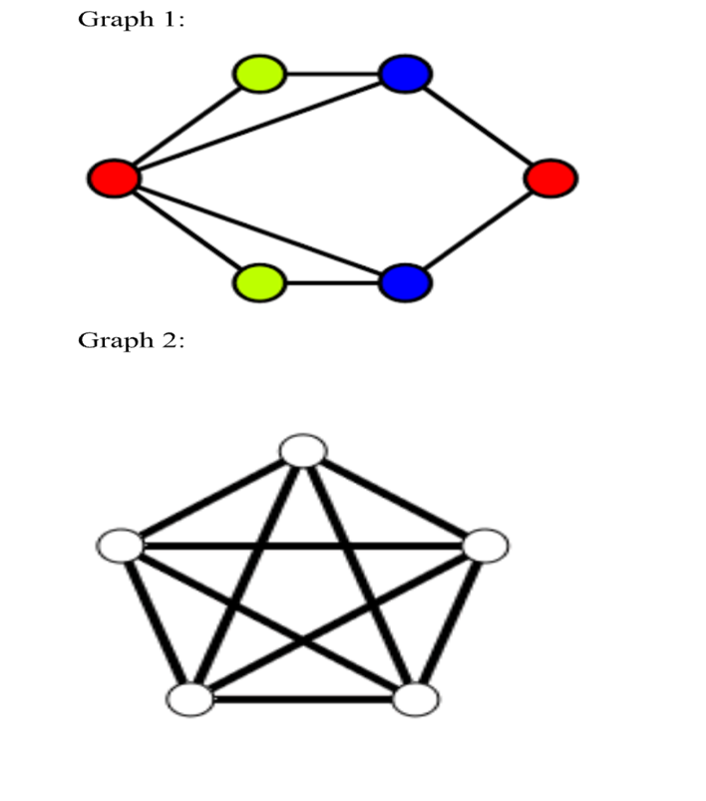

CODE :
#include <stdio.h>
#include <stdbool.h>

#define V 5

int graph[V][V]; // Adjacency matrix
int color[V];

bool isSafe(int v, int c) {
for (int i = 0; i < V; i++)
if (graph[v][i] && c == color[i])
return false;
return true;
}

bool graphColoringUtil(int m, int v) {
if (v == V)
return true;

for (int c = 1; c <= m; c++) {
if (isSafe(v, c)) {
color[v] = c;

if (graphColoringUtil(m, v + 1))
return true;

color[v] = 0; // backtrack
}
}
return false;
}

bool graphColoring(int m) {
for (int i = 0; i < V; i++)
color[i] = 0;

if (!graphColoringUtil(m, 0)) {
printf("Solution does not exist.\n");
return false;
}

printf("Solution Exists: Following are the assigned colors:\n");
for (int i = 0; i < V; i++)
printf("Vertex %d ---> Color %d\n", i + 1, color[i]);

return true;
}

int main() {
int m; // Number of colors

printf("Enter number of vertices: ");
scanf("%d", &m);
printf("Enter adjacency matrix (%dx%d):\n", V, V);
for (int i = 0; i < V; i++)
for (int j = 0; j < V; j++)
scanf("%d", &graph[i][j]);

int numColors;
printf("Enter number of available colors: ");
scanf("%d", &numColors);

graphColoring(numColors);

return 0;
}

OUTPUT:
