* **Practice: Commands in Solace CLI.**
* **Try the Queue creation using Solace CLI.**
* **Start Putty [Solace CLI]:**

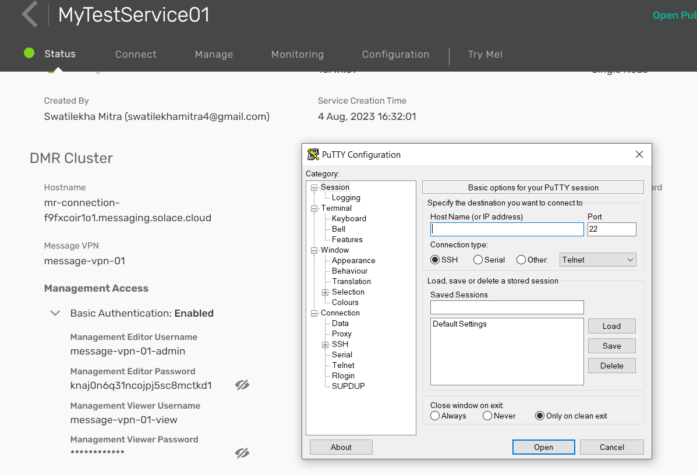

* **Check port number 22 is enabled or block...**

Manage --> Advanced Options --> Port Configuration --> edit --> Management.

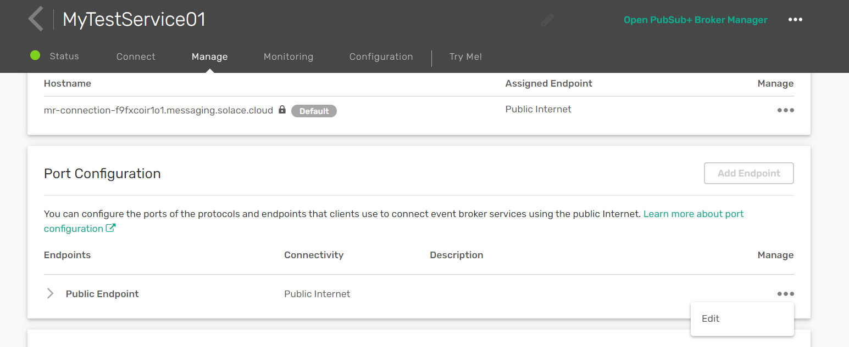

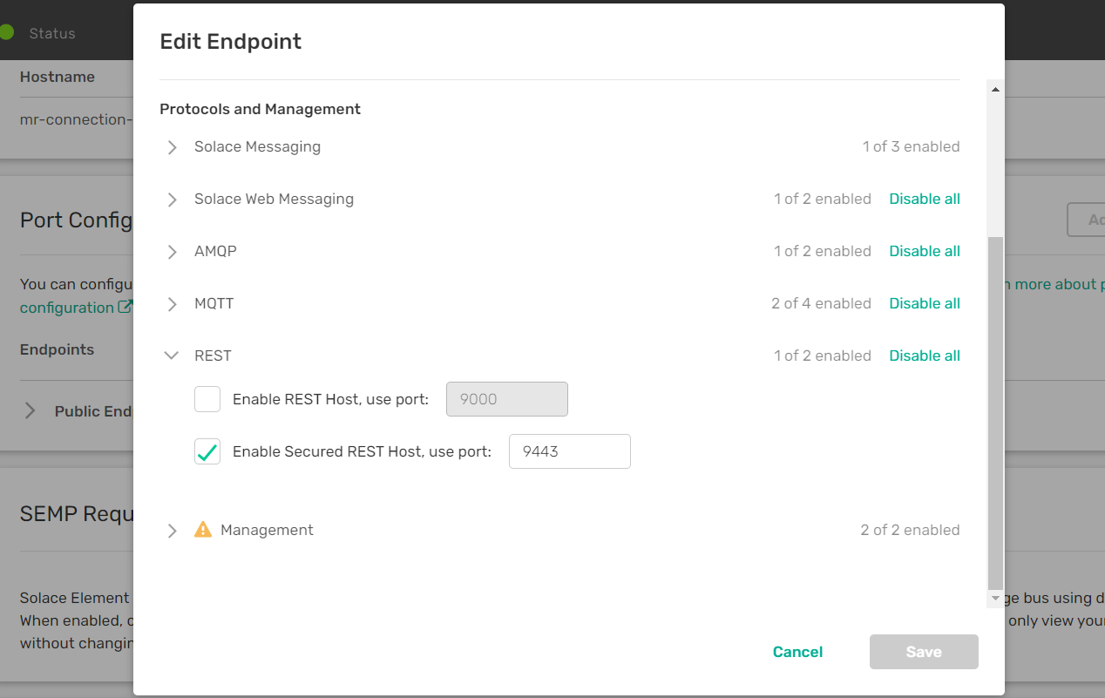

* **Enter Hostname and change some settings:**

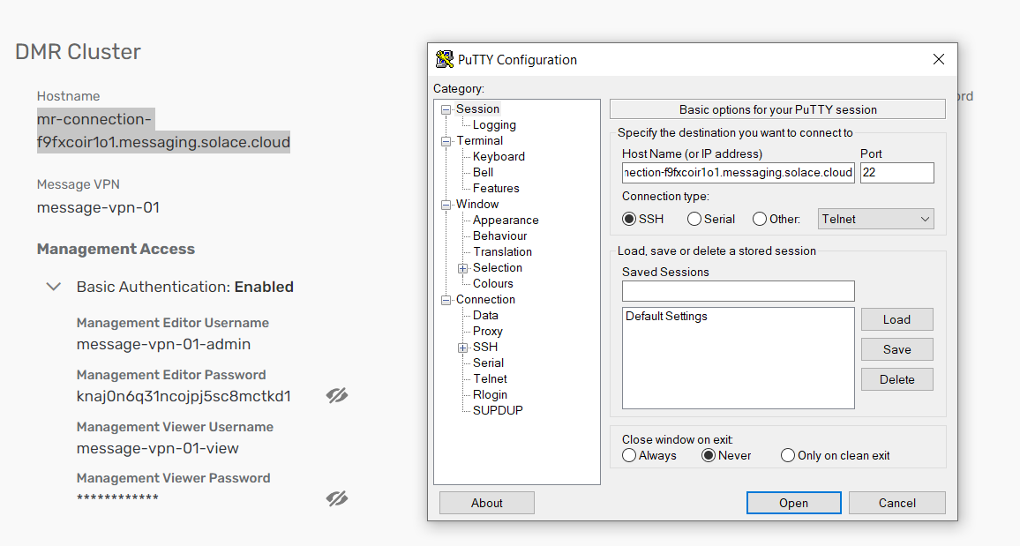

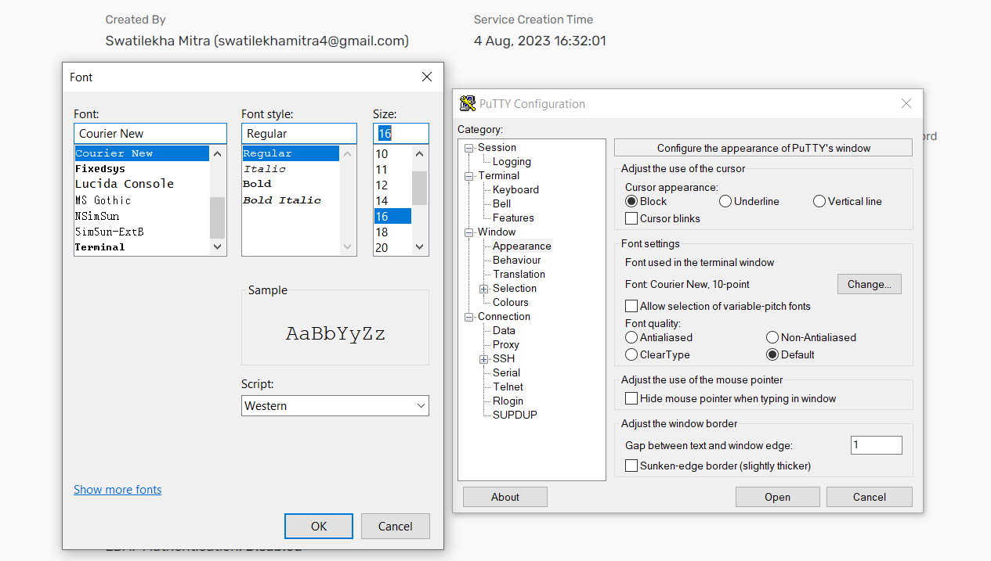

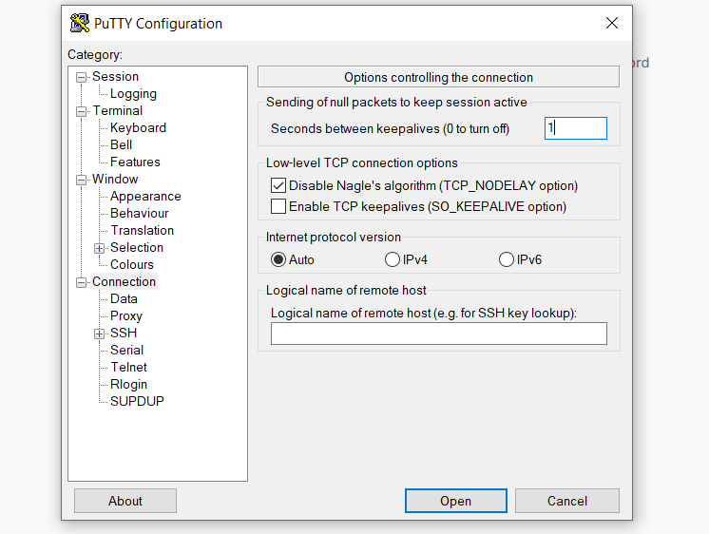

**Then, Open.**

* **Login with username and password:**

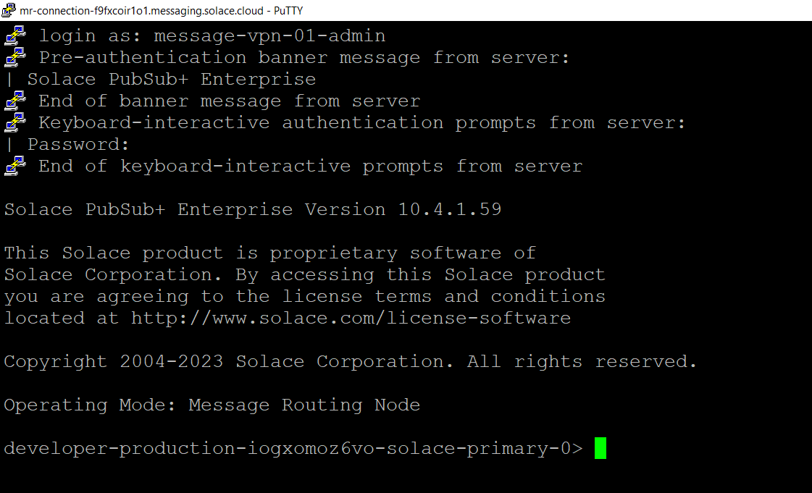

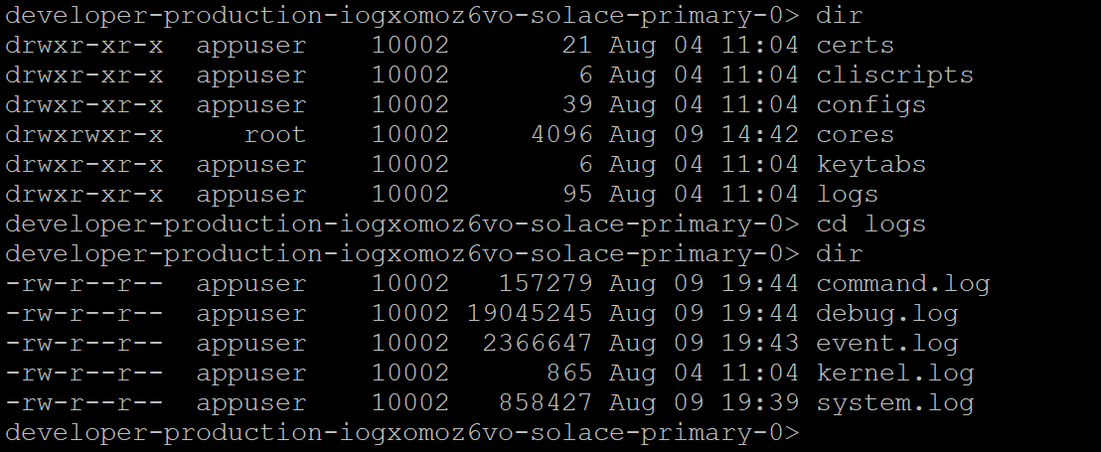

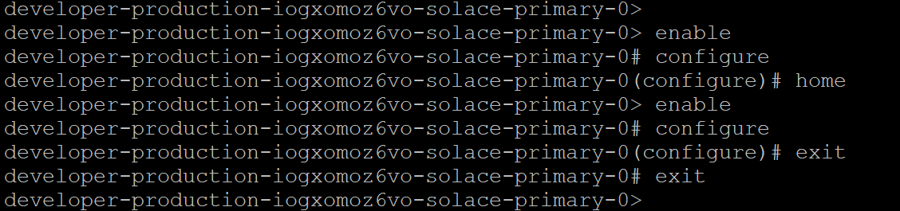

* **Create Queue with Subscription Topic:**

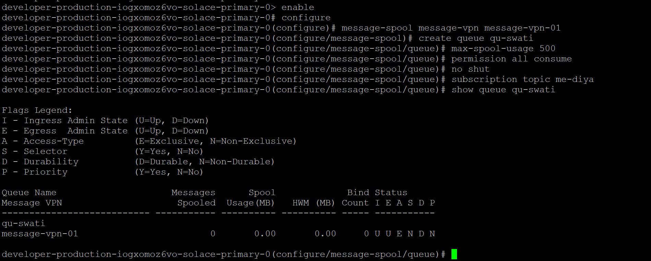

**Show The detail of Queue:**

**show queue qu-swati detail**

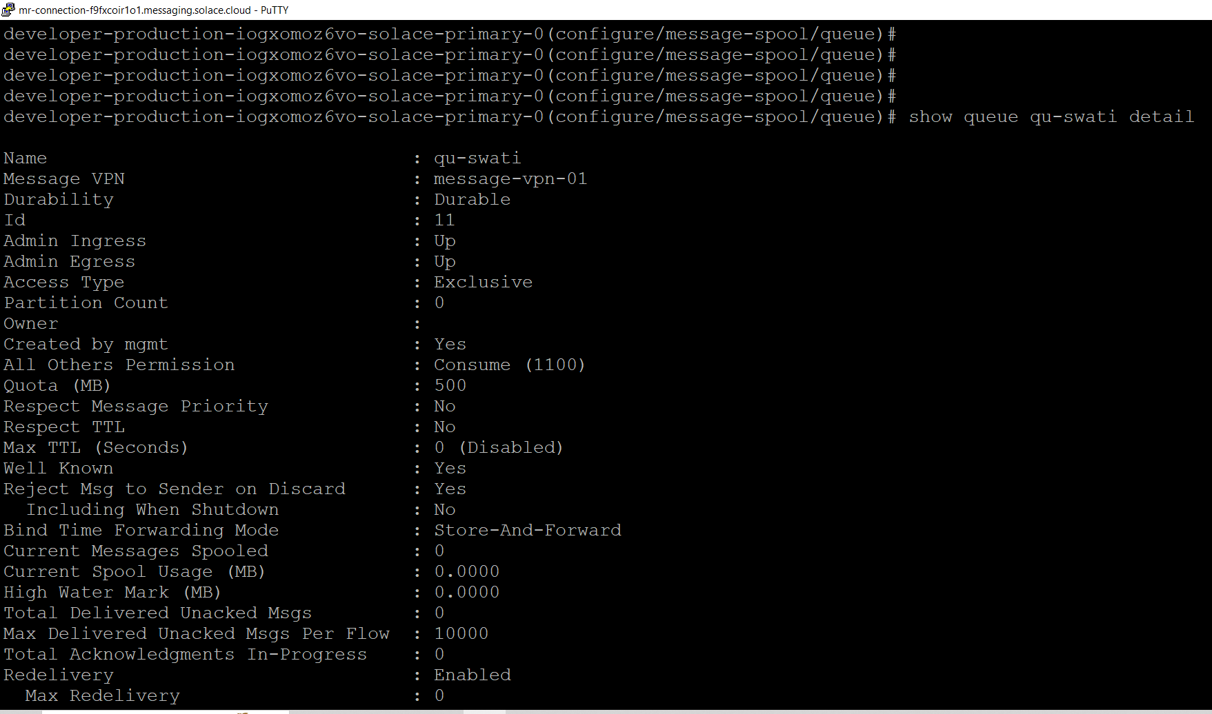

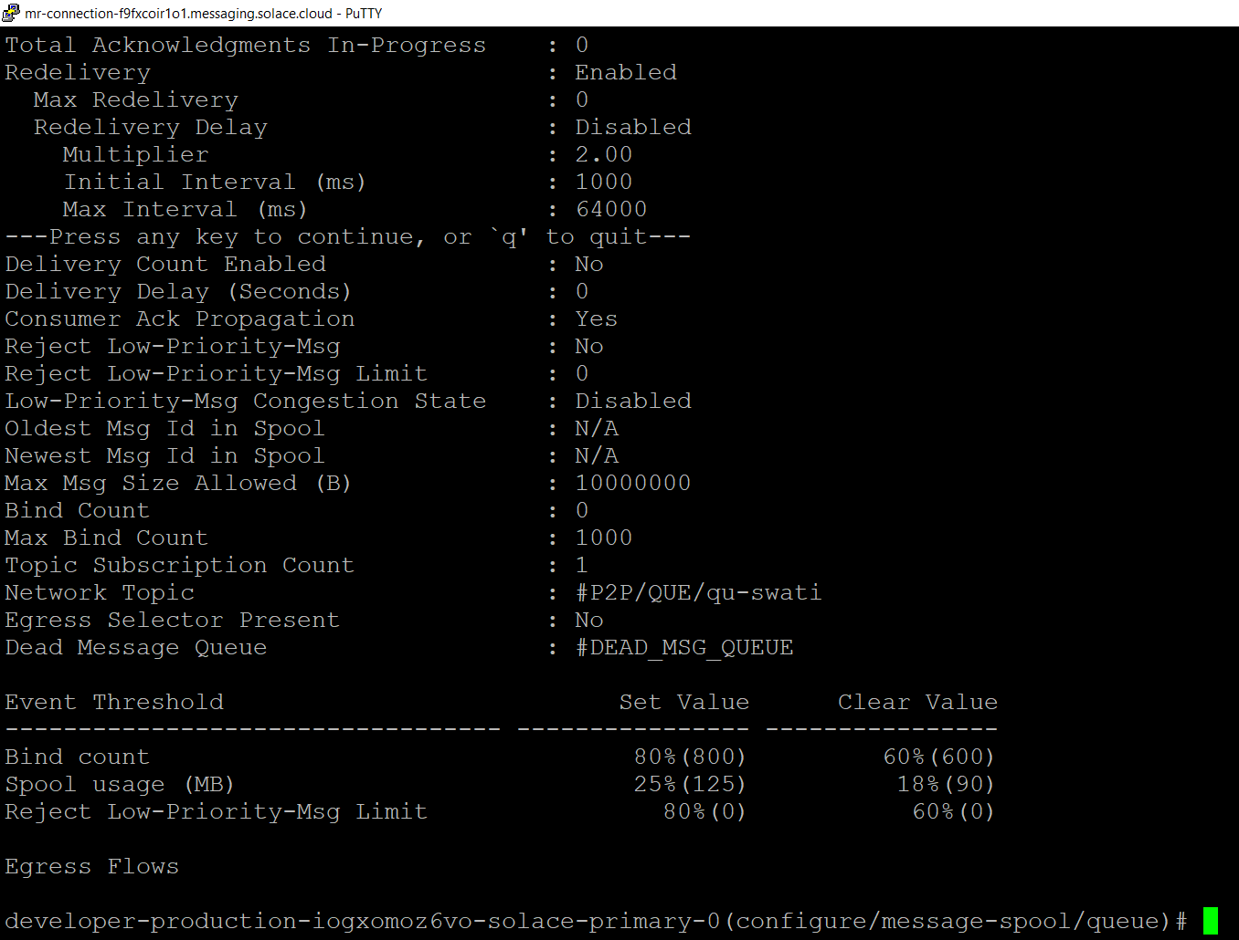

* **Show new Queue in Solace:**

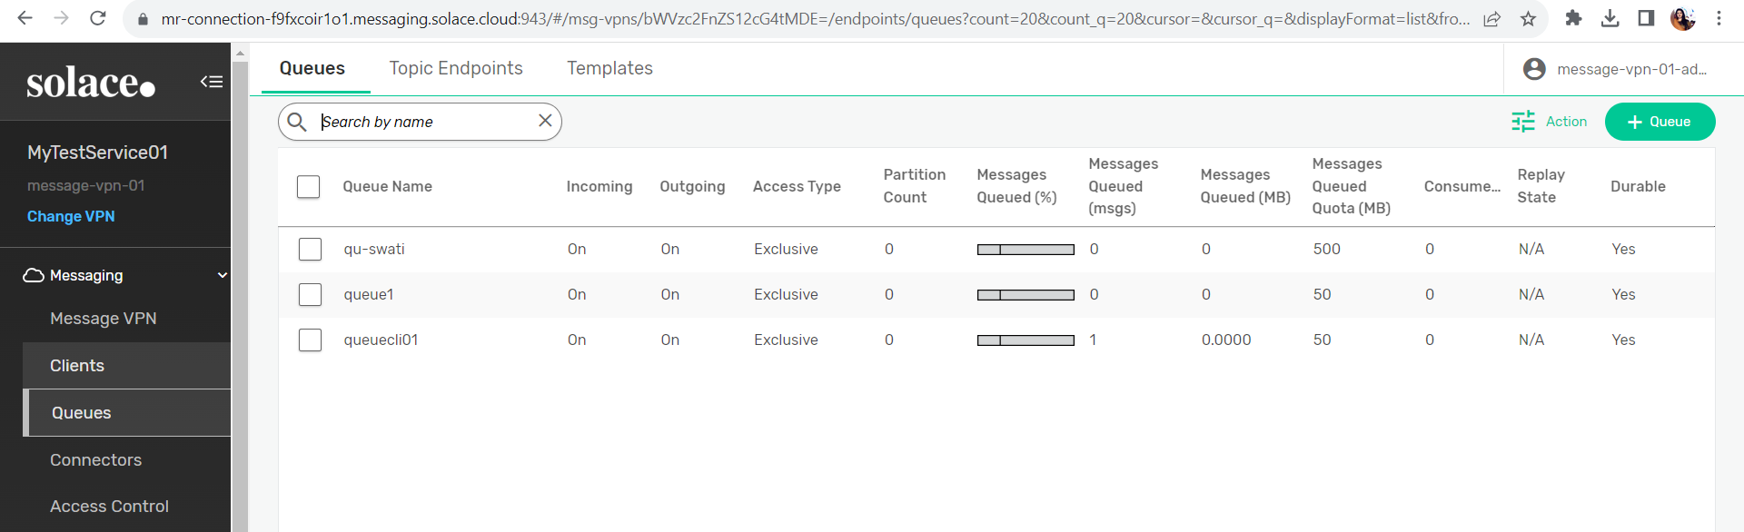

* **Show new Subscription Topic:**

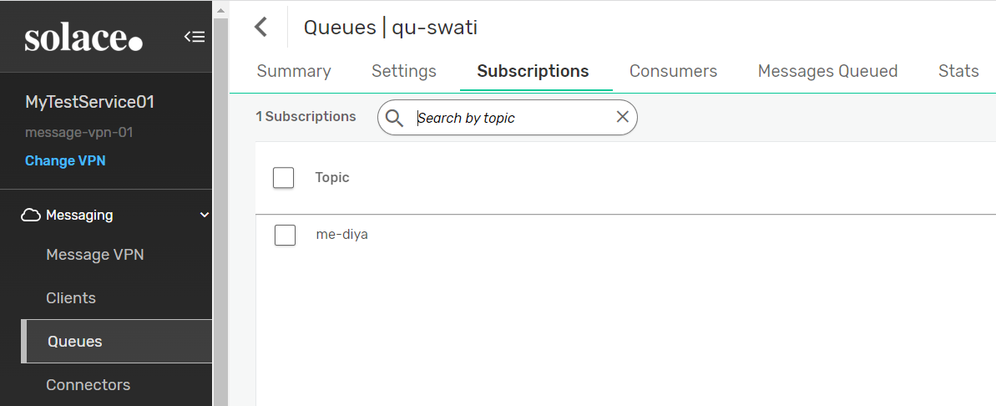

* **Publisher – Subscriber Connect:**

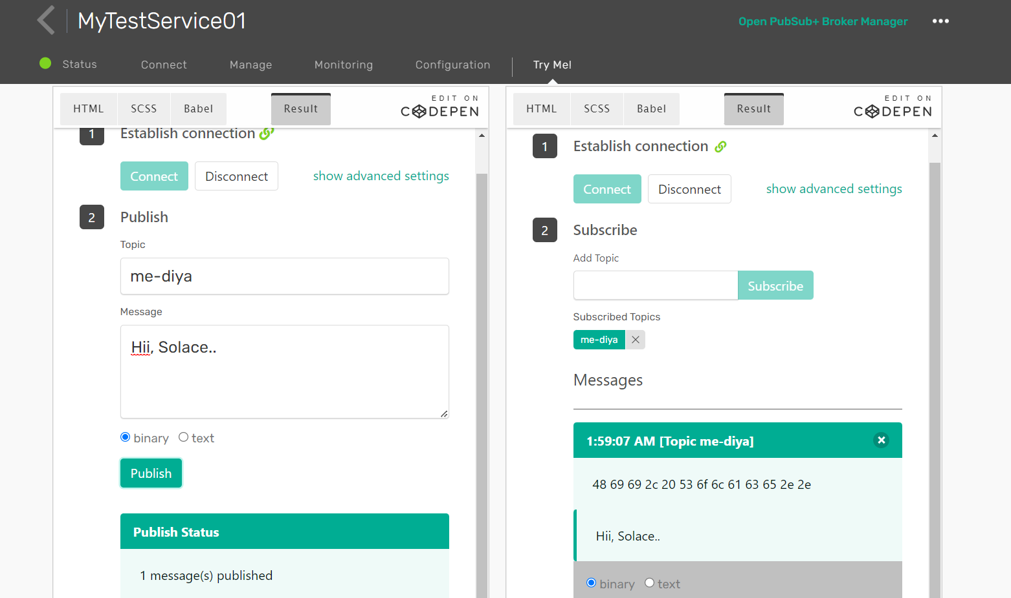

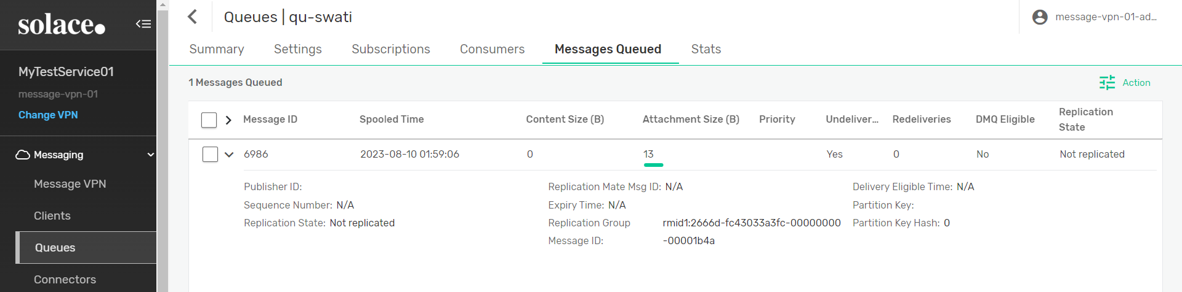

* **Show Session:**

