**3. Solace CLI --> show session: What is the default unit of the Timeout?**

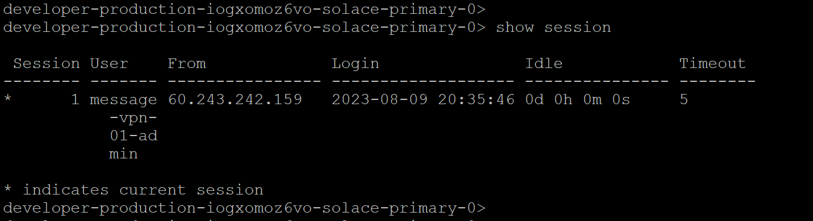

The default unit for timeouts in various systems and software can vary and might be specified in **seconds, milliseconds, minutes, or other units**.