**NAME : SWATI MAHAJAN (55) COURSE : DBDA**

**ASSIGNMENT -1**

1. In your home directory, create sets of empty practice files

* Create 6 files with names of the form songsX.mp3.
* Create 6 files with names of the form snapX.jpg.
* Create 6 files with names of the form filmX.avi.

In each set, replace X with the numbers 1 through 6.

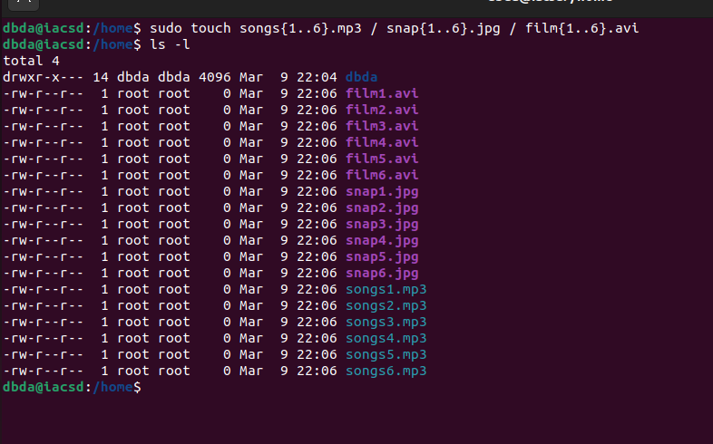

2. From your home directory,

* Move songs file into your Music subdirectory.

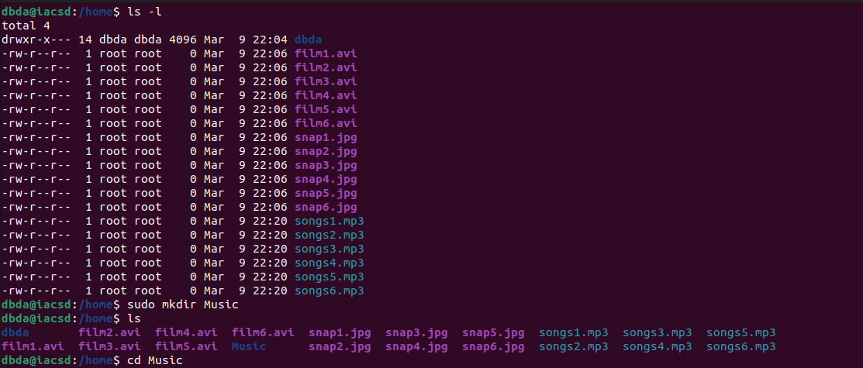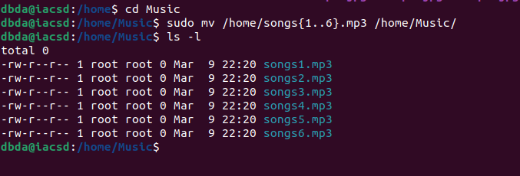

* Move snap file into your Pictures subdirectory.

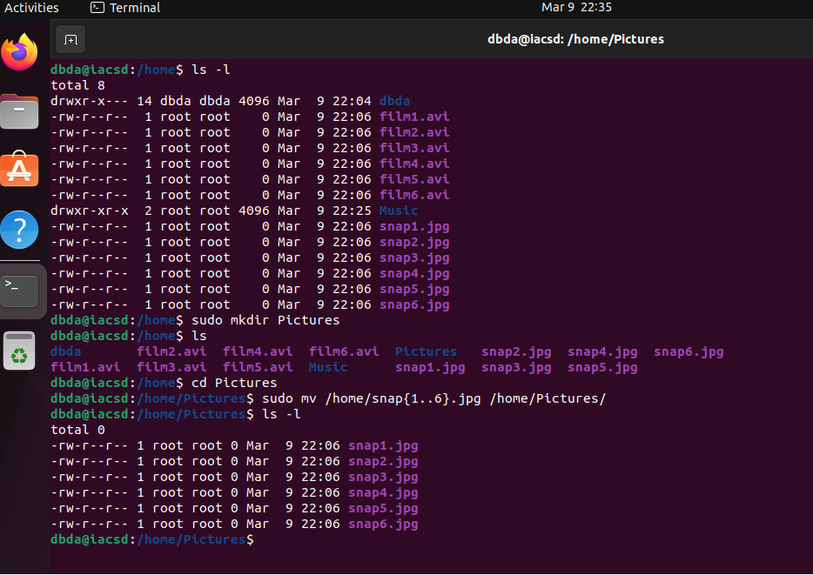

* Move your movie files into Videos subdirectory.

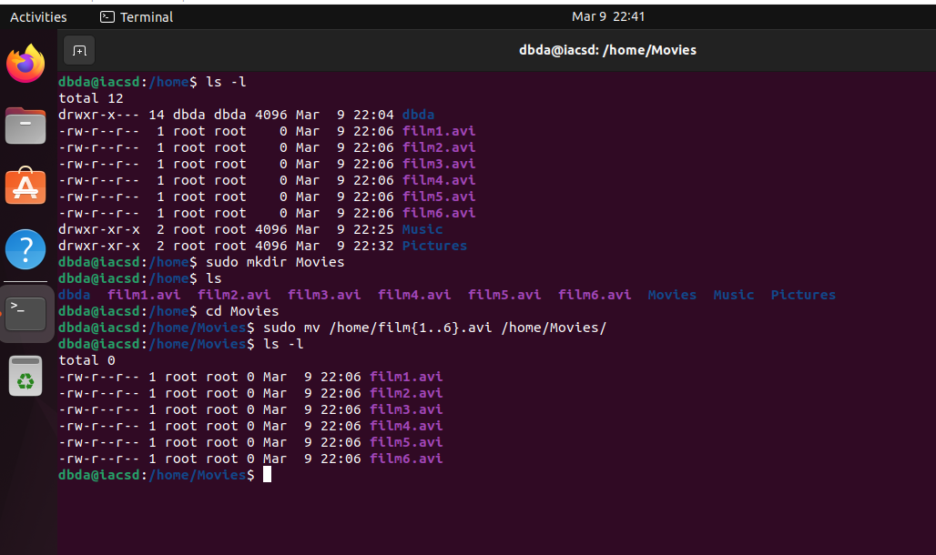

3. Create 3 subdirectories for organizing your files named friends, family, work.

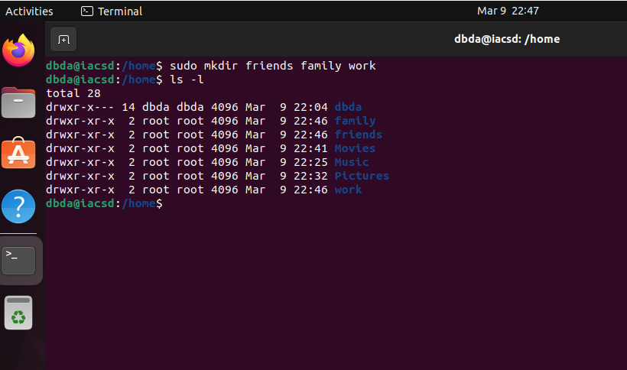

4. Copy files (all types ) containing numbers 1 and 2 to the friends folder.

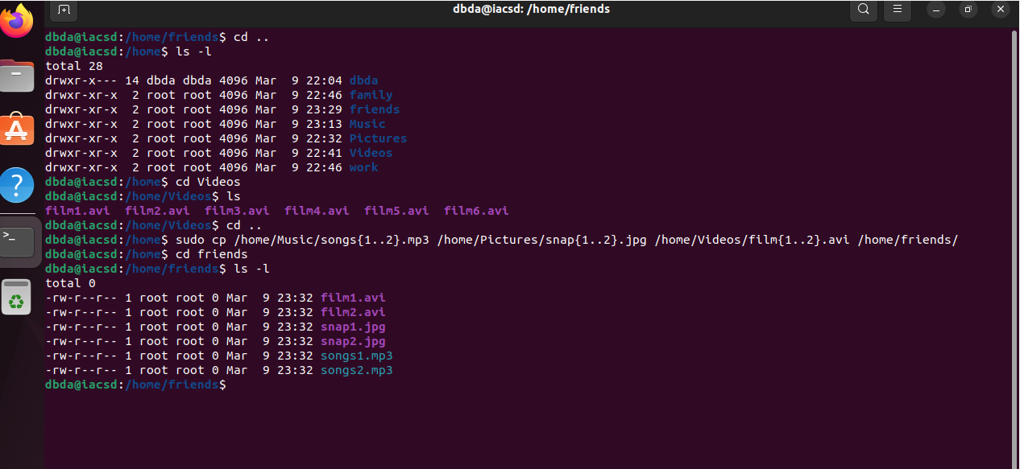

Copy files (all types) containing numbers 3 and 4 to the family folder.

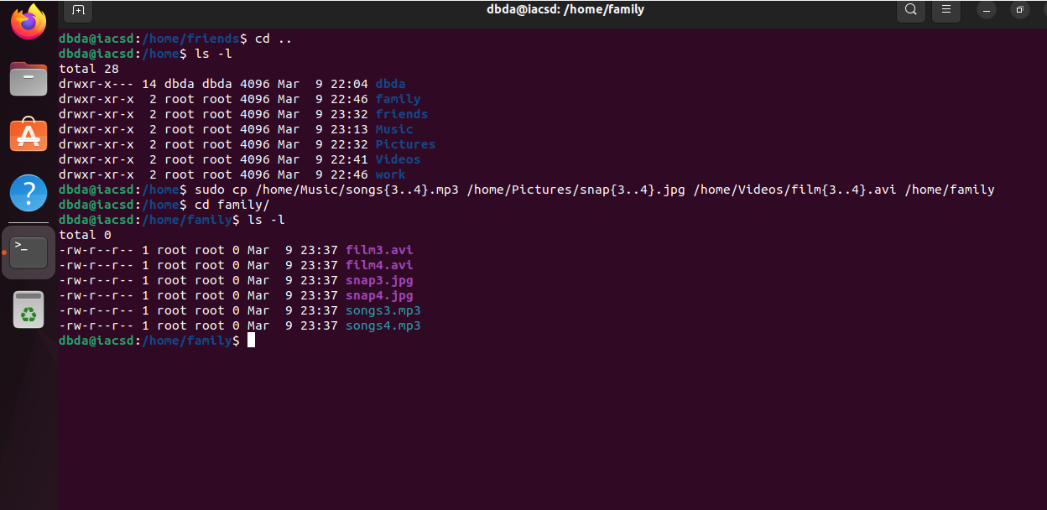

Copy files (all types) containing numbers 5 and 6 to the work folder.

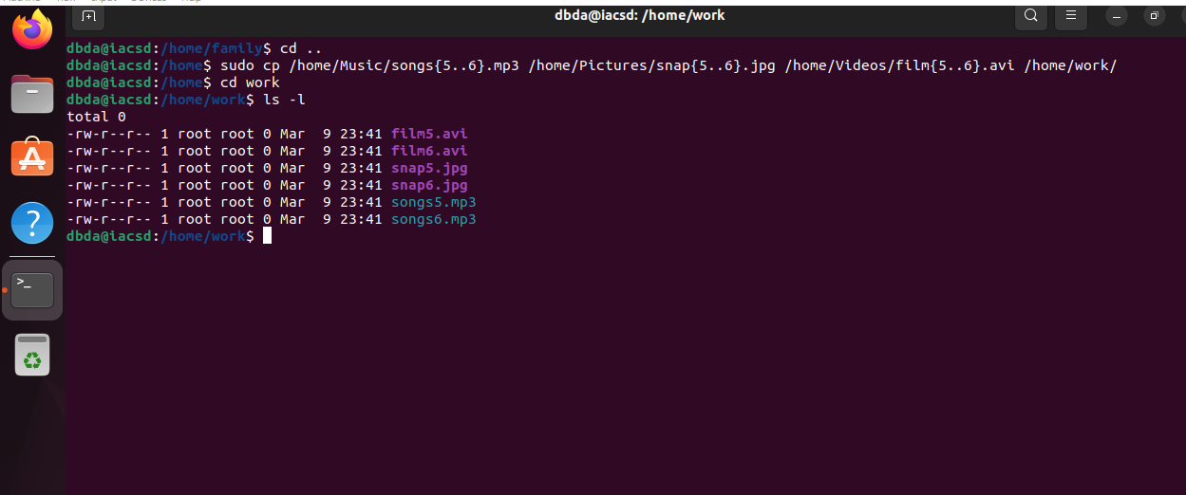

6. Delete all files in family subdirectory.

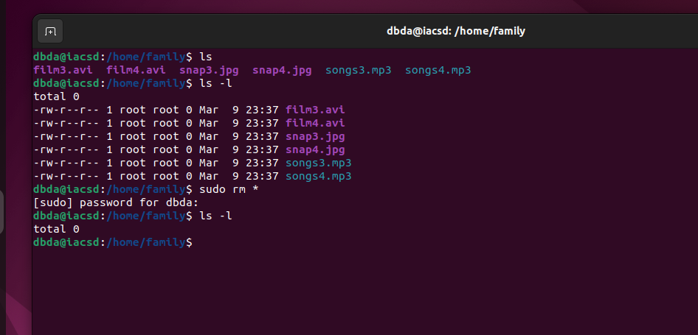

7. Delete friends subdirectory.

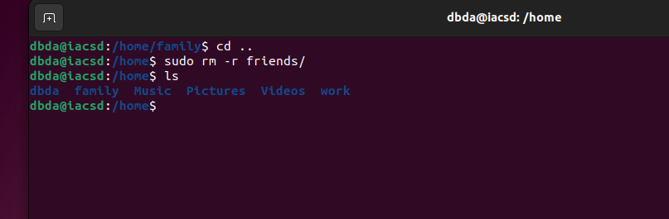

8. Create user tom , bob , sam , prince.

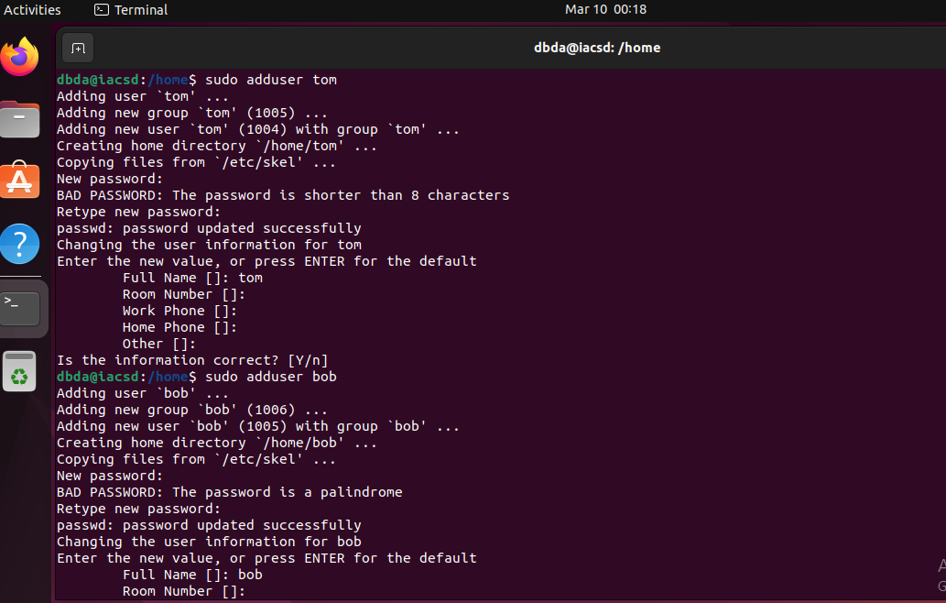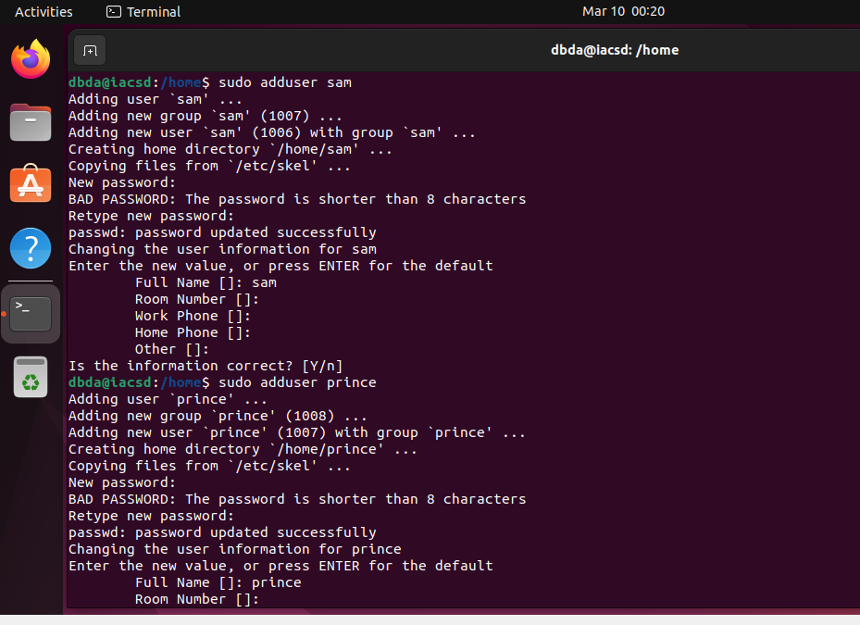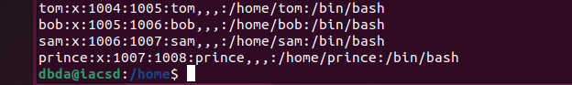

9. Create Group dac , dbda ,ditiss.

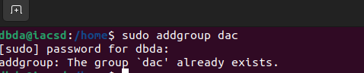

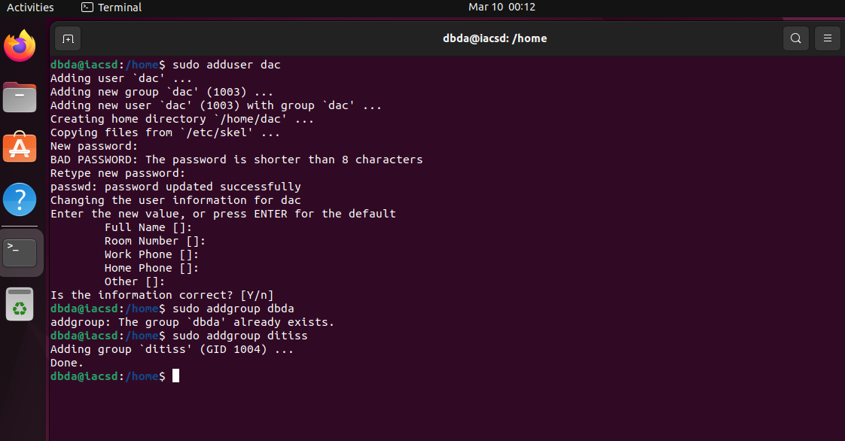



10. add user

Tom in dac

Bob in dbda

Sam in ditiss

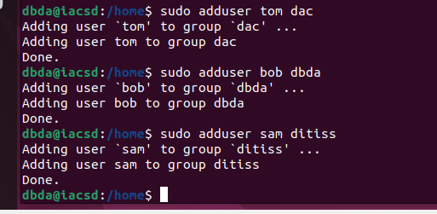

11. login as prince and create iacsd directory in /tmp and create 4 files in iacsd with name project-1 project-2 upto 4  
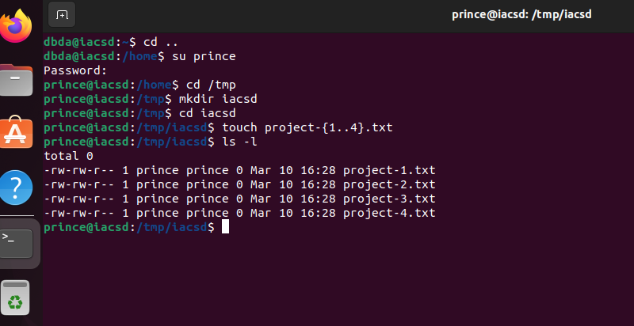

12. assign permissions to project files as below

Project-1 – tom should be owner of this

Project-2 – dac should be owner of this

(Both Project-1 and Project-2 are in below snapshot)

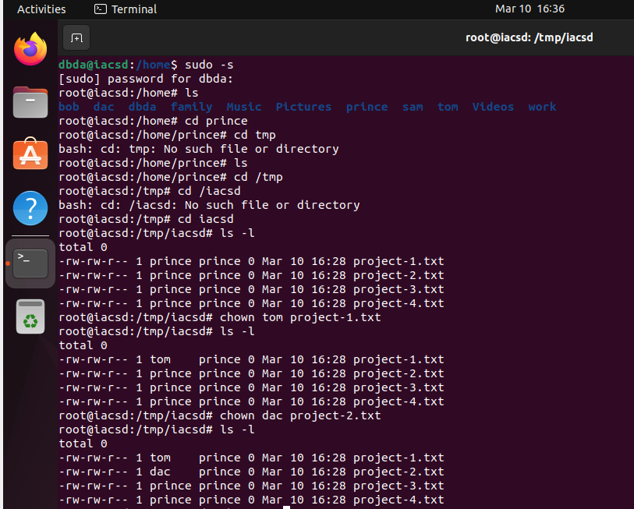

Project-3 --- others should not have any permission but tom should have rw access.

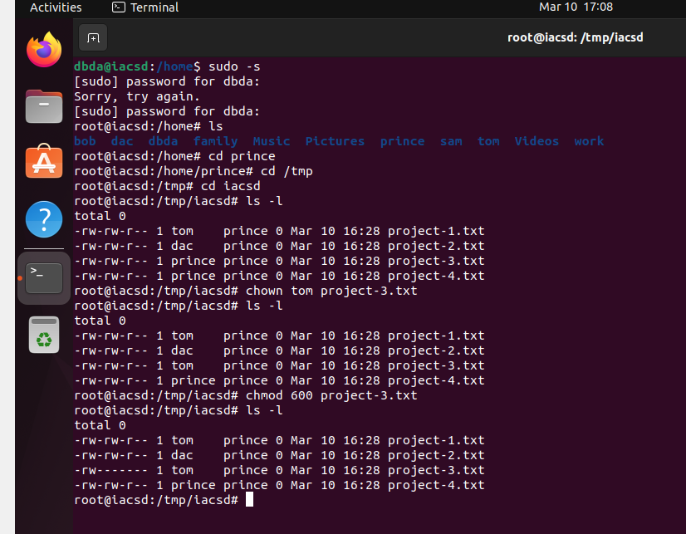

Project-4 – dbda group should have rwx permissions.

