Detailed Project Report (Power BI Projects)

Name: Swati Mahesh Kuravattimath  
Institution: P.A. College of Engineering, Mangalore  
Course: B.E. in Computer Science Engineering (Honors)  
Date: August 2025

# Abstract

This report presents a collection of Power BI projects that demonstrate data visualization, dashboard creation, and analytics skills. The projects focus on business insights, performance tracking, and effective data storytelling. Each project includes objectives, methodologies, tools used, implementation details, insights, and placeholders for dashboard screenshots to illustrate findings.

# Table of Contents

1. Introduction  
2. Project 1: Blinkit Dashboard  
3. Project 2: Prime Dashboard  
4. Project 3: Power Query in Power BI  
5. Project 4: Conditional Formatting in Power BI  
6. Project 5: Create & Manage Relationships in Power BI  
7. Project 6: Bins and Lists in Power BI  
8. Conclusion  
9. References & Appendix

# Introduction

Power BI is a powerful business intelligence tool that enables organizations to visualize data, analyze trends, and make data-driven decisions. The objective of these projects is to gain hands-on experience in transforming raw data into meaningful insights using Power BI features such as Power Query, DAX measures, data modeling, and interactive dashboards. Each project highlights a different aspect of Power BI’s capabilities, ranging from data cleaning to advanced visualization techniques.

# Blinkit Dashboard

## Problem Statement

Describe the problem or business requirement this project addresses.

## Objective

Define the main goals of the project, such as analyzing sales, tracking KPIs, or visualizing performance.

## Dataset Used

Mention the dataset used (e.g., Blinkit sales data, Prime Video dataset, or sample datasets).

## Tools & Features Used

Power BI, Power Query, DAX, KPIs, Conditional Formatting, Data Modeling, Visualizations.

## Methodology & Implementation

Explain step-by-step data cleaning, transformation, modeling, and visualization process.

## Results & Insights

Summarize the key insights derived from the dashboard and their business impact.

## Screenshot Placeholder

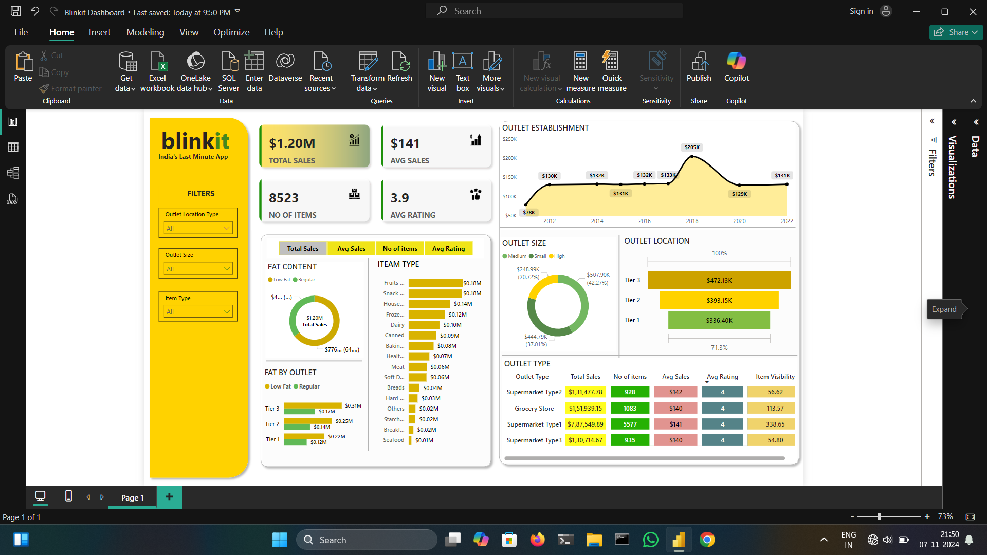

# Prime Dashboard

## Problem Statement

Describe the problem or business requirement this project addresses.

## Objective

Define the main goals of the project, such as analyzing sales, tracking KPIs, or visualizing performance.

## Dataset Used

Mention the dataset used (e.g., Blinkit sales data, Prime Video dataset, or sample datasets).

## Tools & Features Used

Power BI, Power Query, DAX, KPIs, Conditional Formatting, Data Modeling, Visualizations.

## Methodology & Implementation

Explain step-by-step data cleaning, transformation, modeling, and visualization process.

## Results & Insights

Summarize the key insights derived from the dashboard and their business impact.

## Screenshot Placeholder

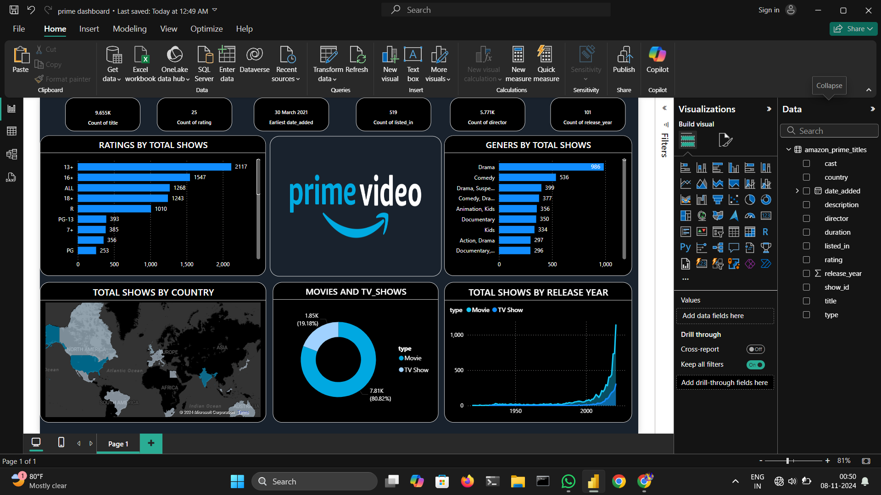

# Power Query in Power BI

## Problem Statement

Describe the problem or business requirement this project addresses.

## Objective

Define the main goals of the project, such as analyzing sales, tracking KPIs, or visualizing performance.

## Dataset Used

Mention the dataset used (e.g., Blinkit sales data, Prime Video dataset, or sample datasets).

## Tools & Features Used

Power BI, Power Query, DAX, KPIs, Conditional Formatting, Data Modeling, Visualizations.

## Methodology & Implementation

Explain step-by-step data cleaning, transformation, modeling, and visualization process.

## Results & Insights

Summarize the key insights derived from the dashboard and their business impact.

## Screenshot Placeholder

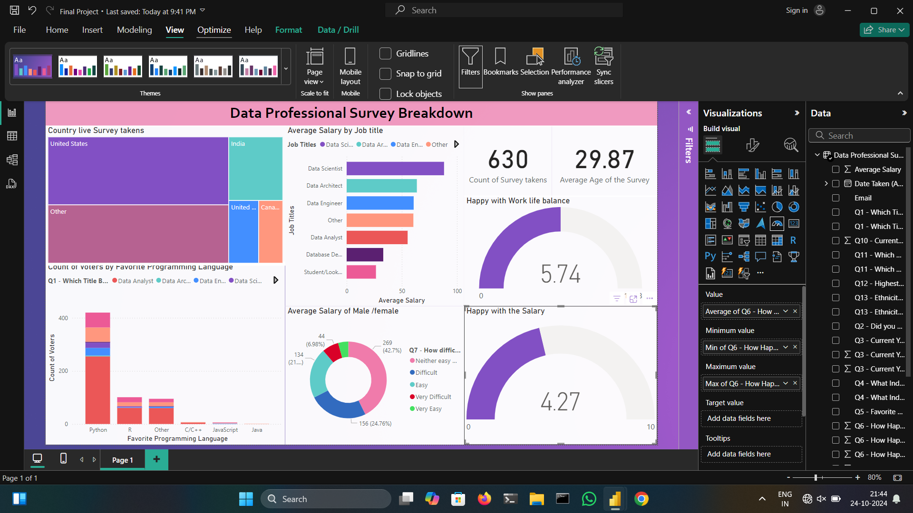

# Conditional Formatting in Power BI

## Problem Statement

Describe the problem or business requirement this project addresses.

## Objective

Define the main goals of the project, such as analyzing sales, tracking KPIs, or visualizing performance.

## Dataset Used

Mention the dataset used (e.g., Blinkit sales data, Prime Video dataset, or sample datasets).

## Tools & Features Used

Power BI, Power Query, DAX, KPIs, Conditional Formatting, Data Modeling, Visualizations.

## Methodology & Implementation

Explain step-by-step data cleaning, transformation, modeling, and visualization process.

## Results & Insights

Summarize the key insights derived from the dashboard and their business impact.

## Screenshot Placeholder

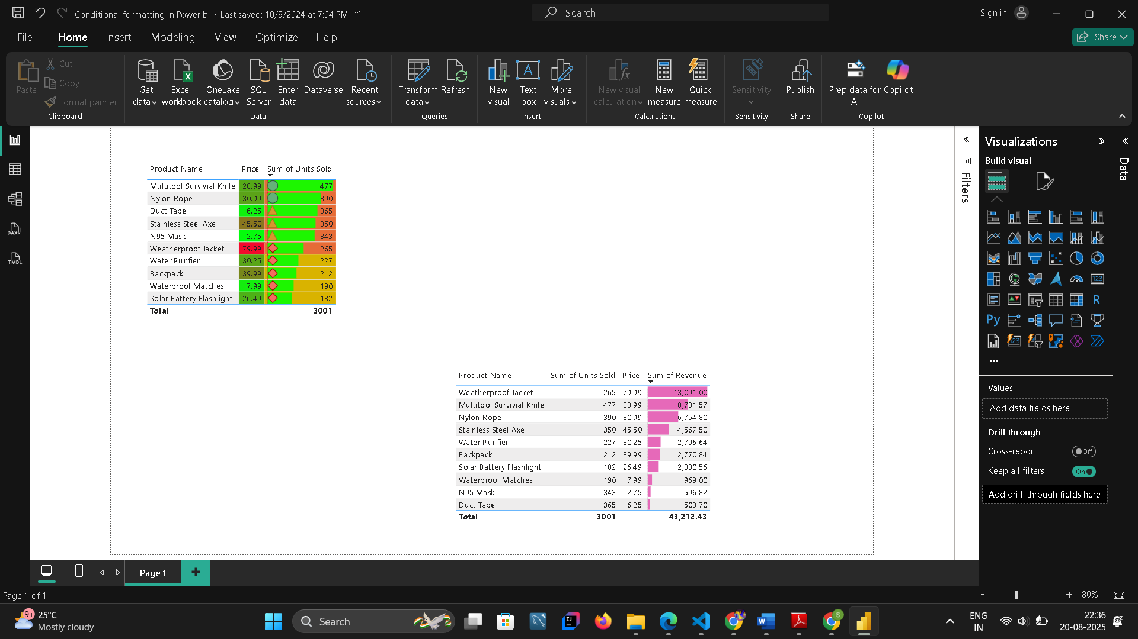

# Create & Manage Relationships in Power BI

## Problem Statement

Describe the problem or business requirement this project addresses.

## Objective

Define the main goals of the project, such as analyzing sales, tracking KPIs, or visualizing performance.

## Dataset Used

Mention the dataset used (e.g., Blinkit sales data, Prime Video dataset, or sample datasets).

## Tools & Features Used

Power BI, Power Query, DAX, KPIs, Conditional Formatting, Data Modeling, Visualizations.

## Methodology & Implementation

Explain step-by-step data cleaning, transformation, modeling, and visualization process.

## Results & Insights

Summarize the key insights derived from the dashboard and their business impact.

## Screenshot Placeholder

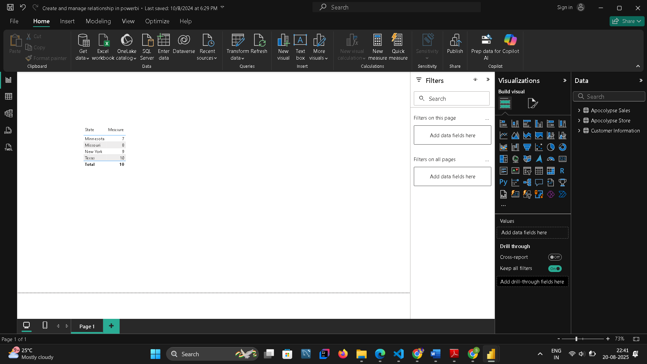

# Bins and Lists in Power BI

## Problem Statement

Describe the problem or business requirement this project addresses.

## Objective

Define the main goals of the project, such as analyzing sales, tracking KPIs, or visualizing performance.

## Dataset Used

Mention the dataset used (e.g., Blinkit sales data, Prime Video dataset, or sample datasets).

## Tools & Features Used

Power BI, Power Query, DAX, KPIs, Conditional Formatting, Data Modeling, Visualizations.

## Methodology & Implementation

Explain step-by-step data cleaning, transformation, modeling, and visualization process.

## Results & Insights

Summarize the key insights derived from the dashboard and their business impact.

## Screenshot Placeholder

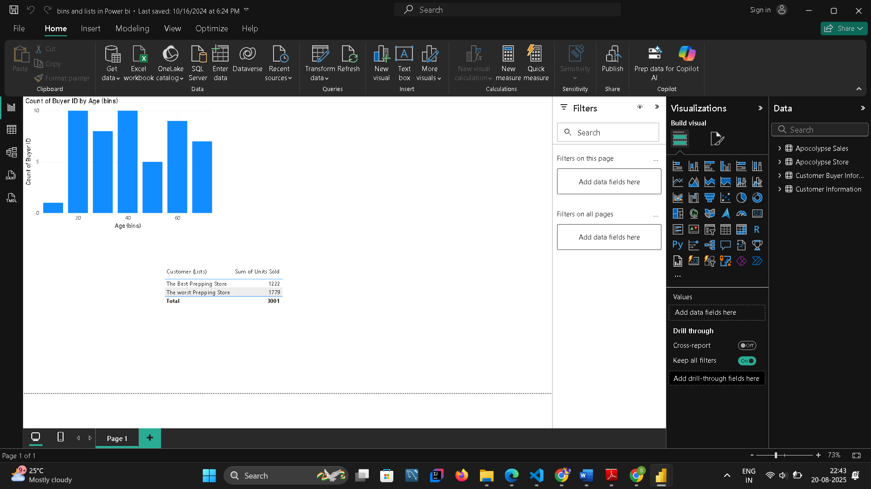

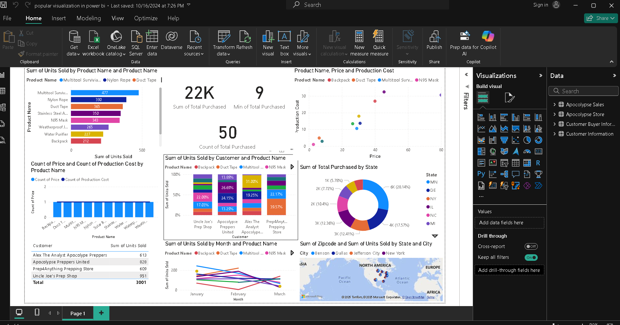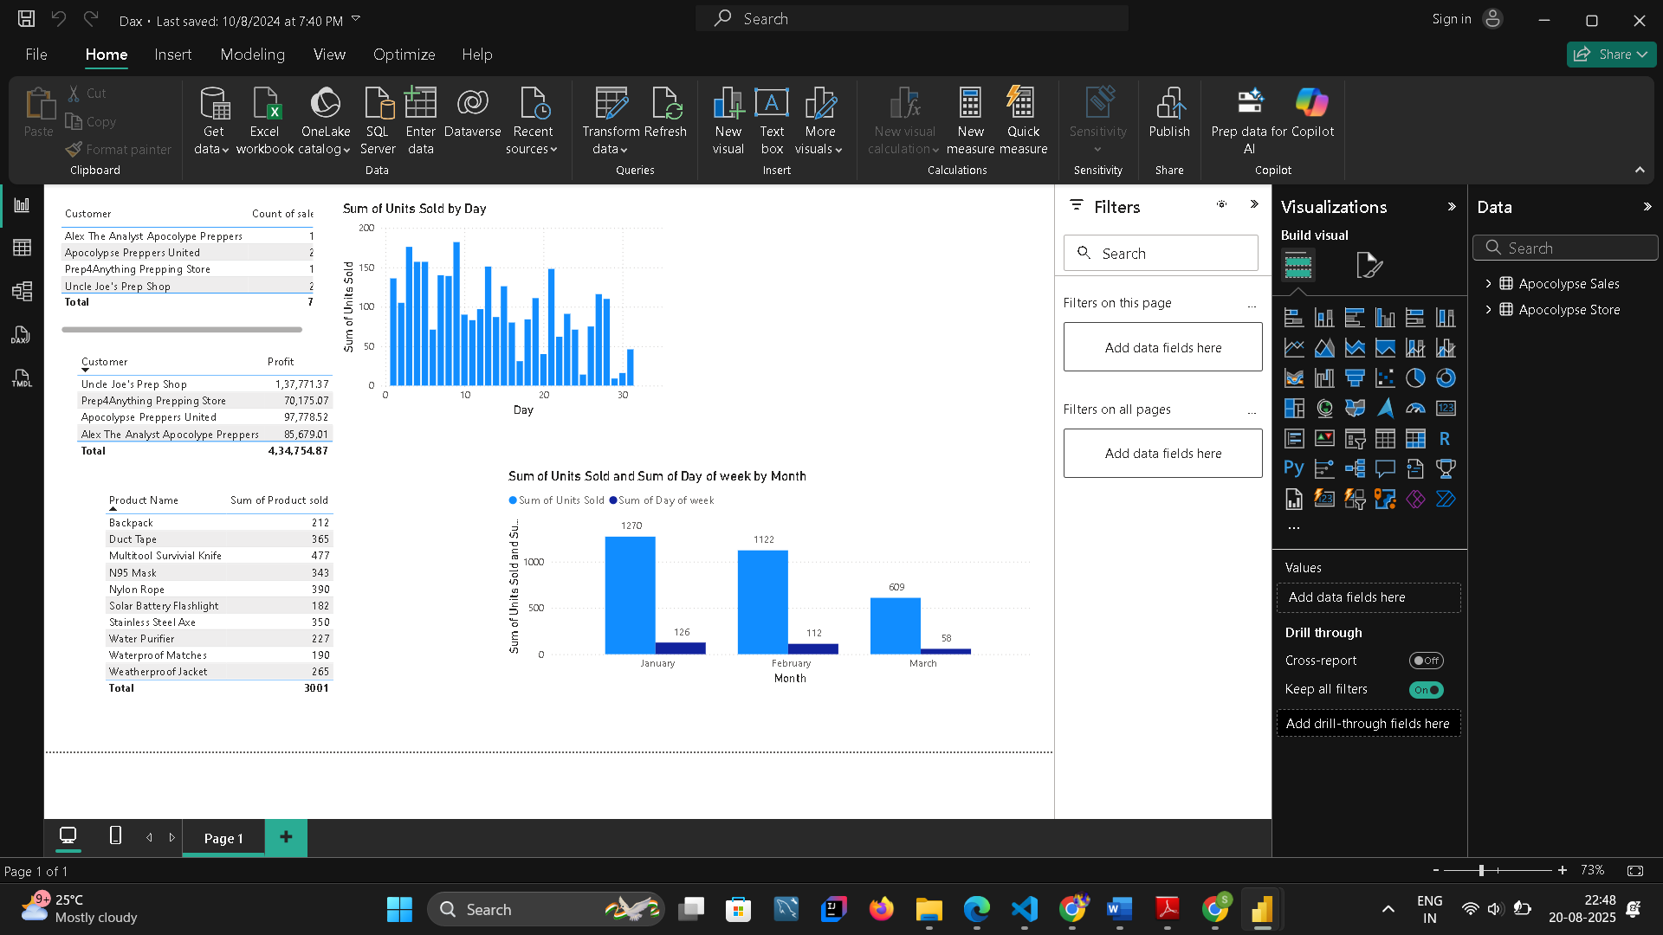

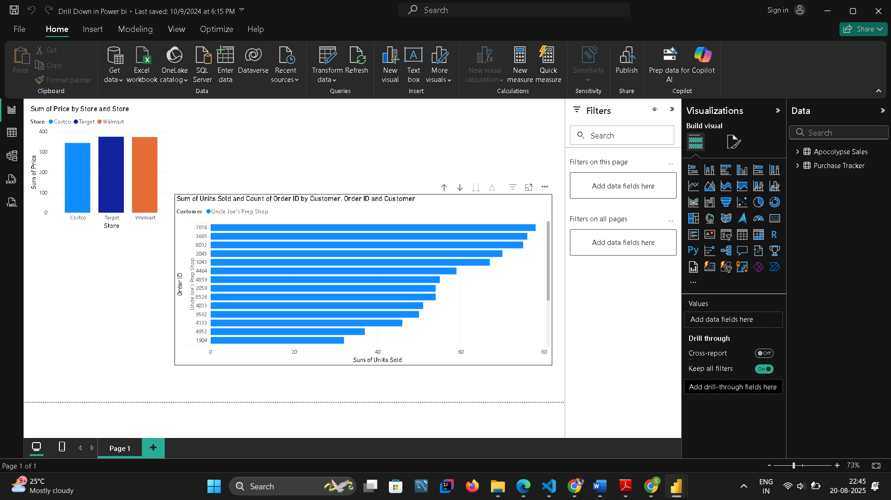

# Conclusion

The Power BI projects documented in this report demonstrate the ability to clean, model, and visualize data to generate actionable insights. These projects showcase expertise in using Power BI features to create interactive dashboards, implement DAX measures, and design visually appealing reports. Future work can include advanced AI integration, predictive analytics, and real-time dashboards to further enhance decision-making capabilities.

# References & Appendix

1. Microsoft Power BI Documentation  
2. Dataset sources: Kaggle, sample business datasets  
3. Online tutorials and workshops on Power BI