**AIDI-2004: Artificial Intelligence in Enterprise Systems**

**LAB1 SWATI PAL 100845961**

**Step1 :**

I have downloaded and installed Git in my local machine

**Step2:**

<https://github.com/Swatipal786>

<https://gitlab.com/Swatipal786>

**Step3:**

I have tried to use both github and gitlab, but, I am going to choose github as it is more user friendly easily and controllable for streamline task.

**Step 4:**

I have written basic code in two version, first one is Hello World and then finding Square roots of numbers and I am going to commit both of them separately from command prompt.

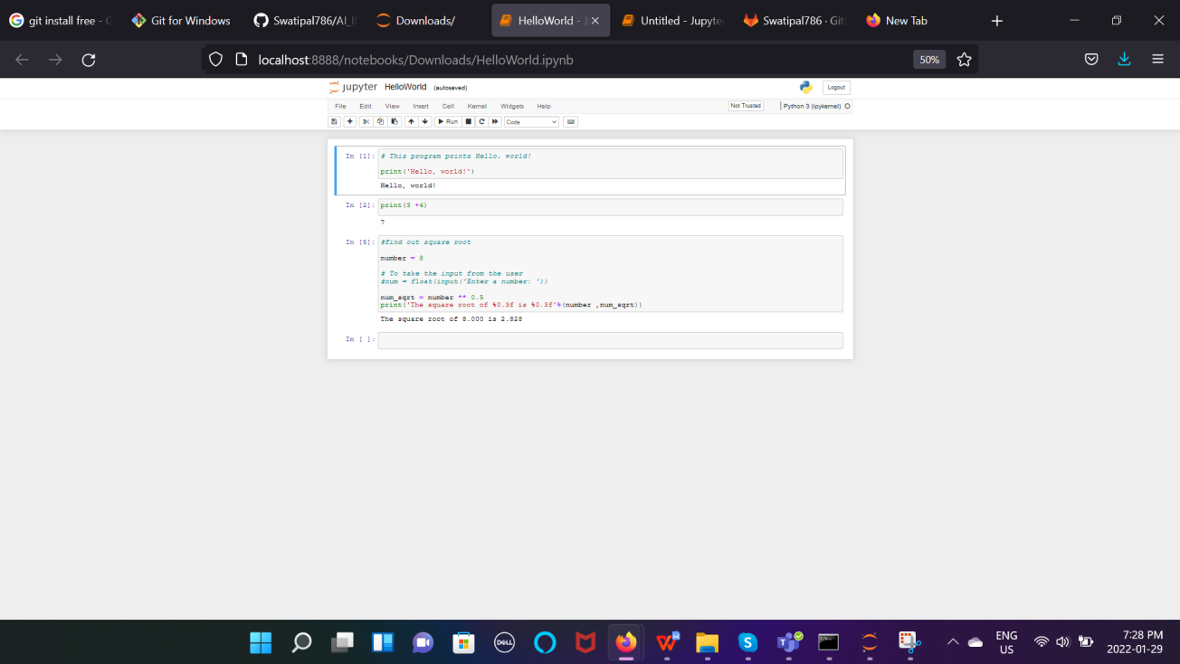

**Step 5:**

Connecting GIT with github and Commit Of HelloWorld.ipynb file.

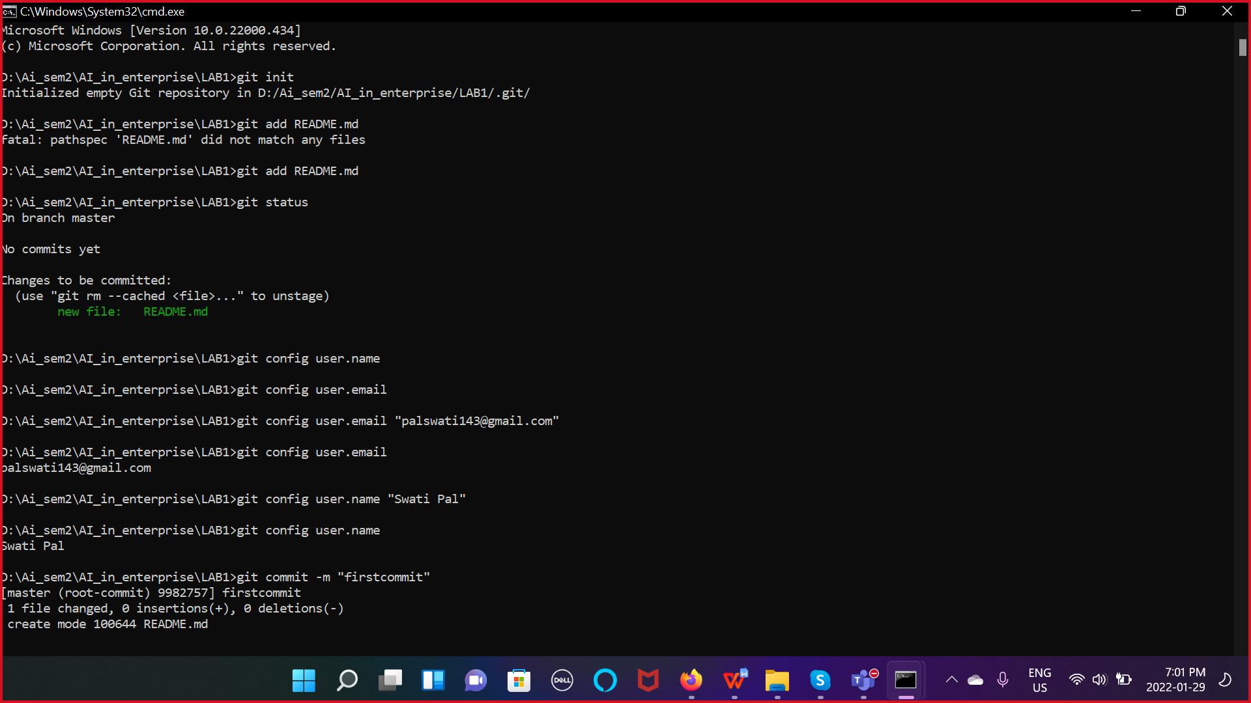

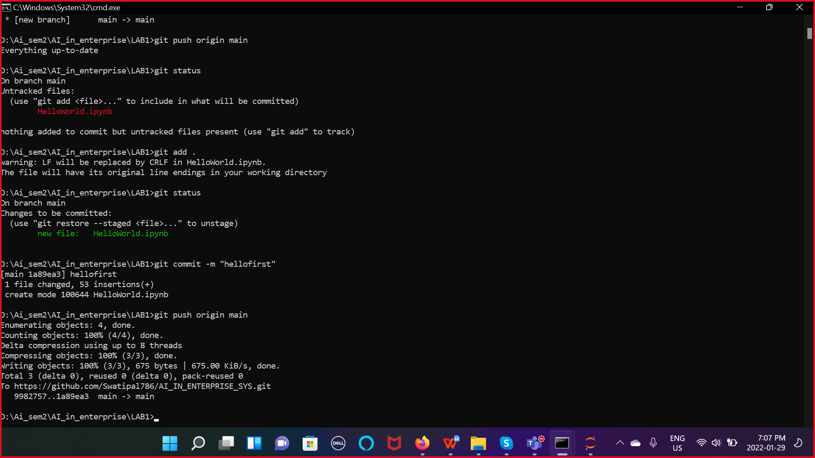

**Step 6:**

Screenshot of README.md file.

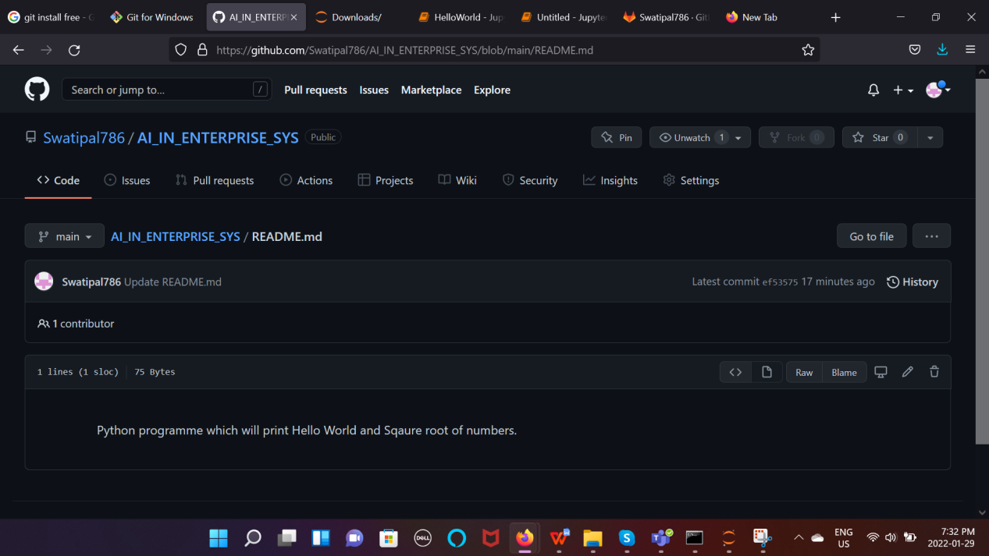

**Step 7:**

Branch in repository.

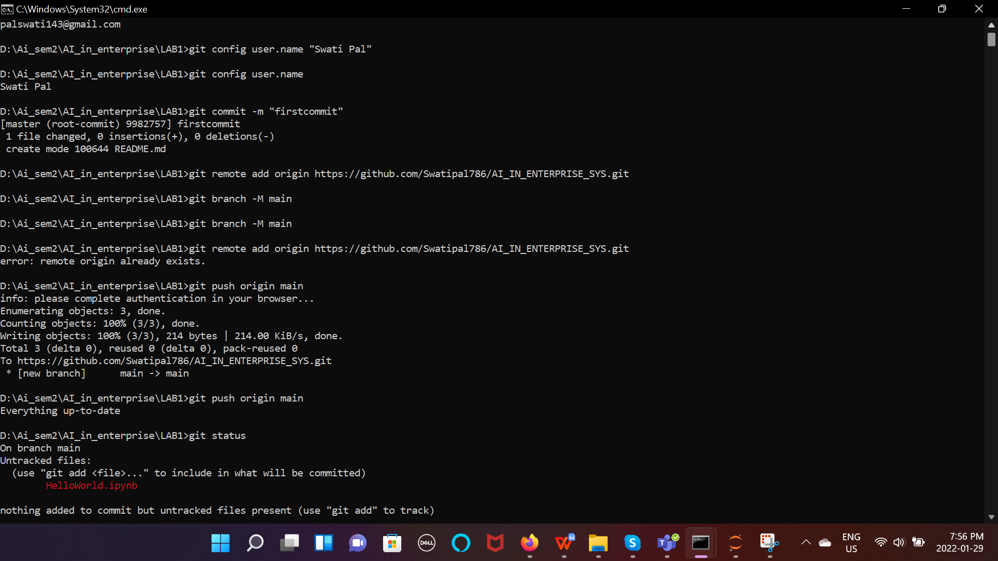

**Step 8:**

Newly added code into same file.

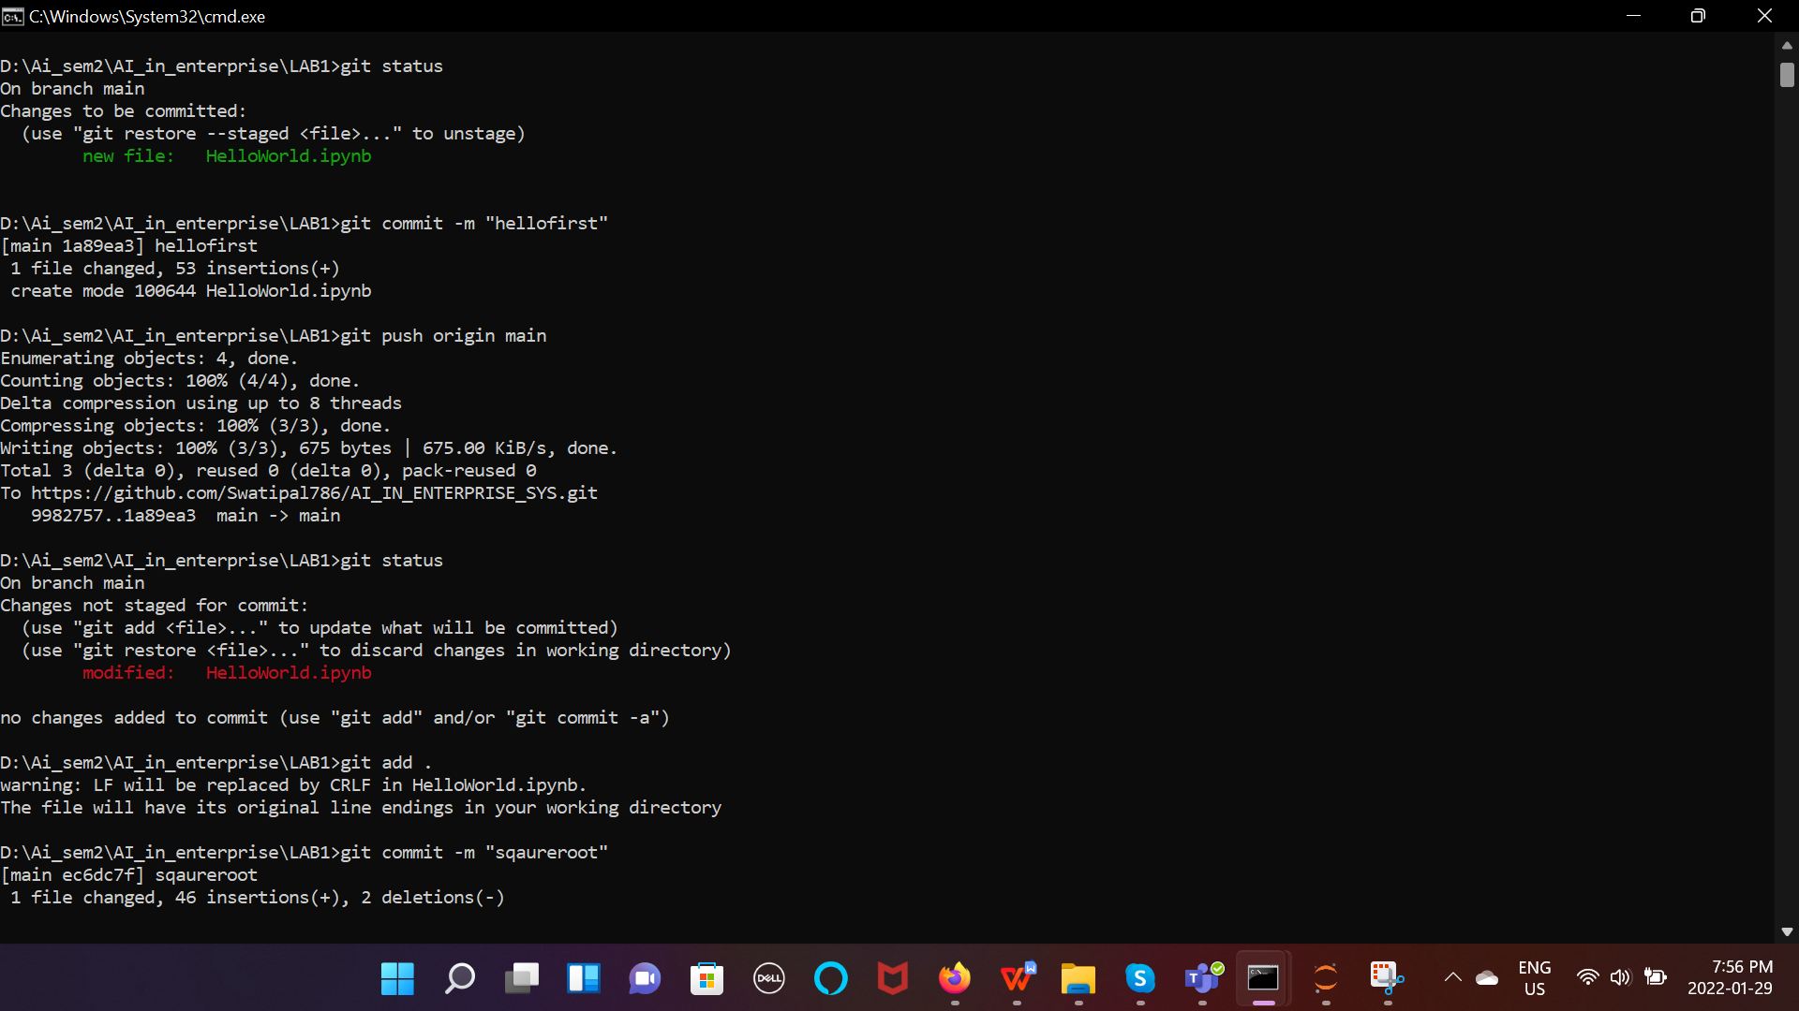

**Step 9:**

Showing history as number of commit in file.

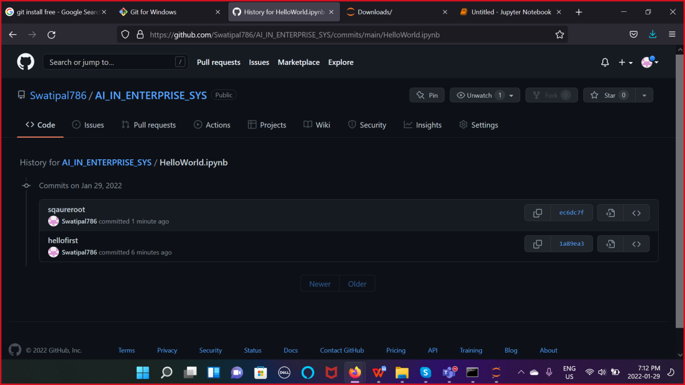

**Step 10:**

Link of our activity

<https://github.com/Swatipal786/AI_IN_ENTERPRISE_SYS>

So, in above steps we have actually use github for maintaining and committing our different version of code in same file, we can see each series of changes in history, so afterwards, if is there any code error, then we can verify and correct the same. We have created python file and firstly, we have just printed HelloWorld and then we have added square root of numbers code in same file. We have committed each code separately and checked history. In README.md we can specify path details, deployment details or code details. SO, in our README.md file we have mentioned about what our code prints.

We can use this steps while using Agile Technology in companies as in each increment we can add our code and in final we can deliver our output as whole. We can make each versions of our code and accordingly deploy them on server. For Example, in most of the IT companies people are using patchsets system, by which in each series of development of code patchset gets updated to new version and if there is any error in code then we can easily remove that version and check trial and error of our code. By using this method we have full control of our code and other person can also just follow our github path and easily understand flow of our code and deploy it, when required.