**AI IN ENTERPRISE SYSTEMS**

**Lab#4**

1. **ML Model for Fish Detection**

***1.A) Downloading the dataset***

The dataset has been taken from Kaggle. The url is<https://www.kaggle.com/aungpyaeap/fish-market>

***1.B) Creating python for prediction of fish type***

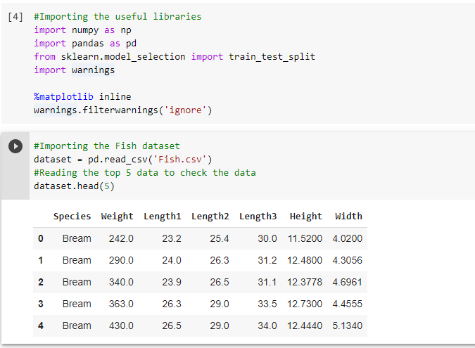

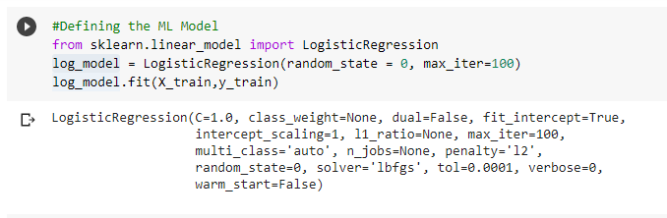

***1.c) Making prediction based on test dataset***

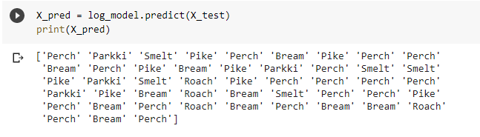

***1.D) Creating serialized object of the model using Pickle***

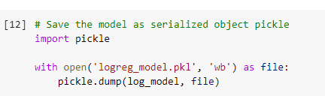

1. **Generating Python file for Flask**