Cloud Resume Hosting with view counter
- Introduction :
Here we create of a website to showcase my resume with a site view counter. It dives deeper by requiring the use of AWS Lambda, API Gateway, and DynamoDB to operate the view counter, host the site on an S3 bucket, and have the site delivered over HTTPS using CloudFront. Additionally, this all must be automated using the AWS Serverless Application Model (SAM) and a CI/CD pipeline.

- Steps to implement the project:
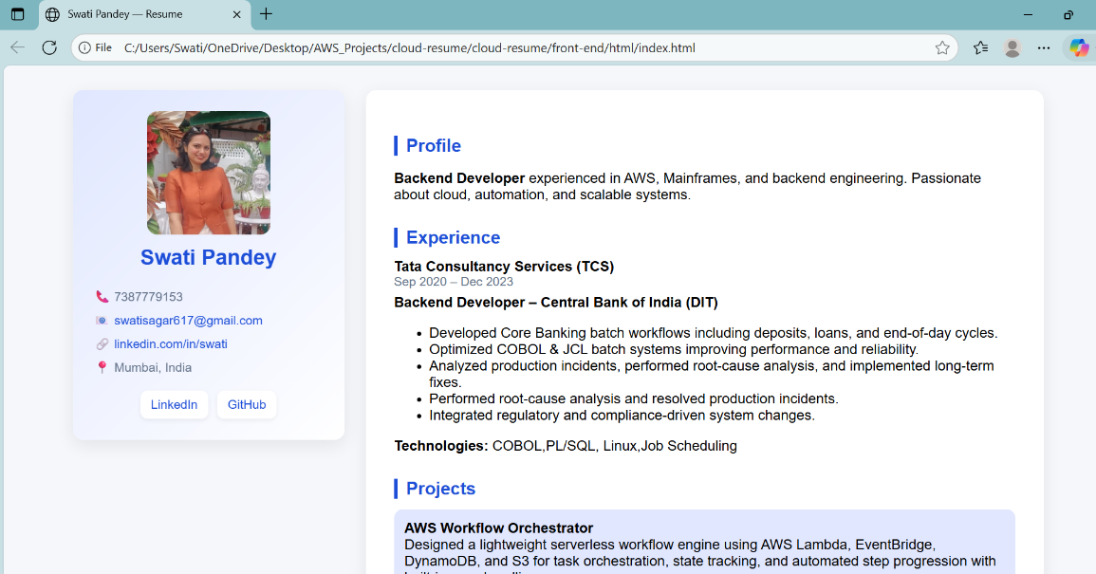
- Create resume website and organise its files in folder
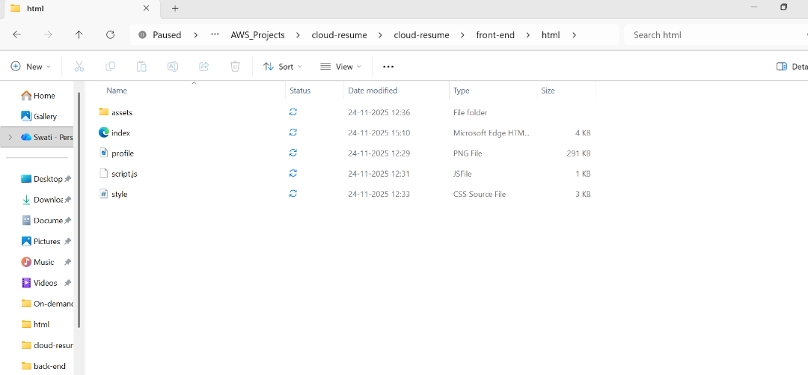

- Create template.yaml defining resources , which will be used to create cloud formation stack via AWS SAM commands

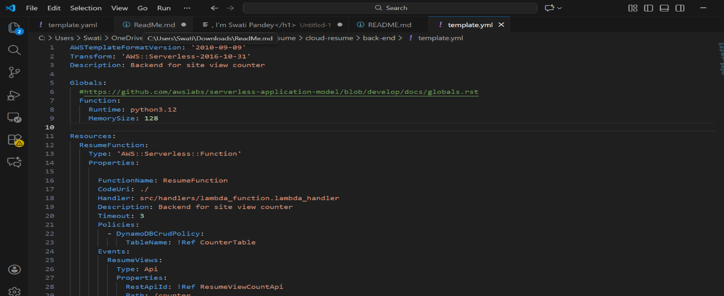
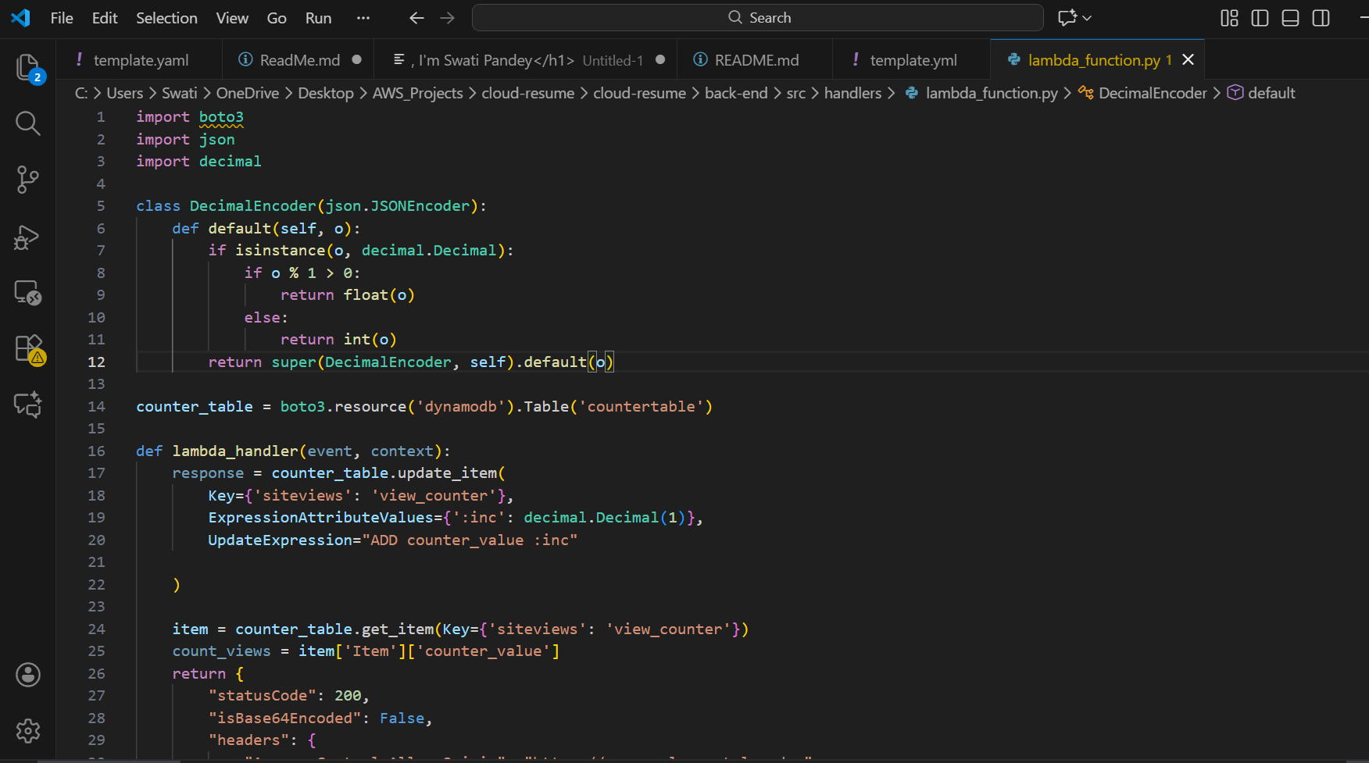
- Create lambda function

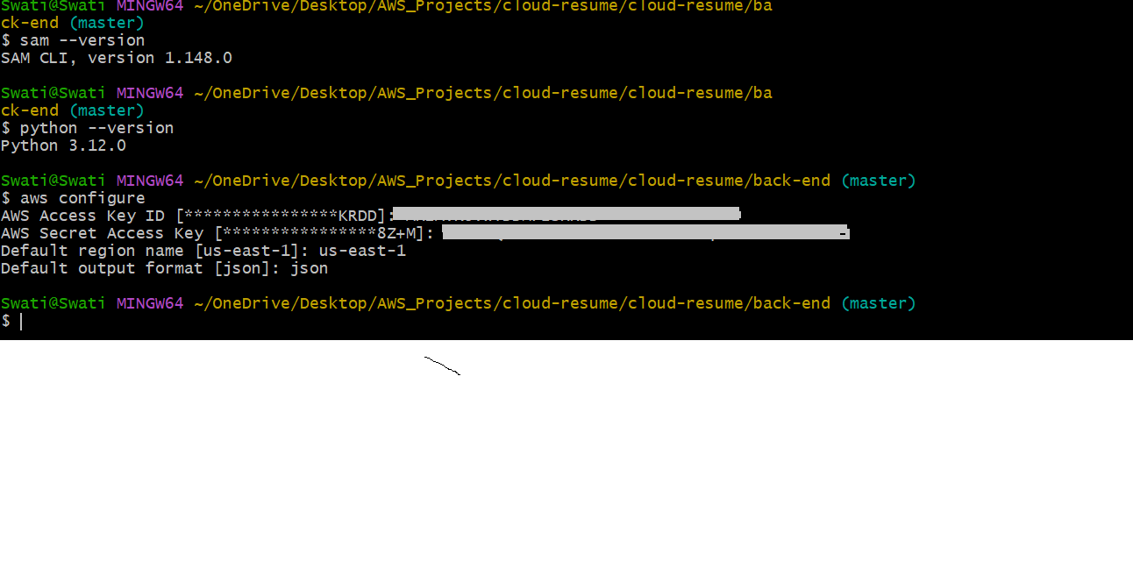
- Go to git bash cli and check pre-requisites

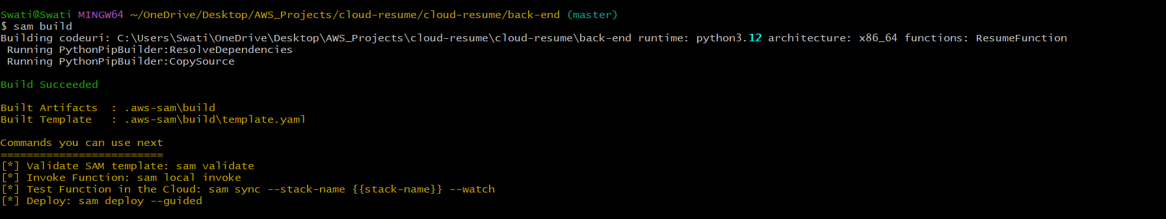
- Build and deploy SAM Package
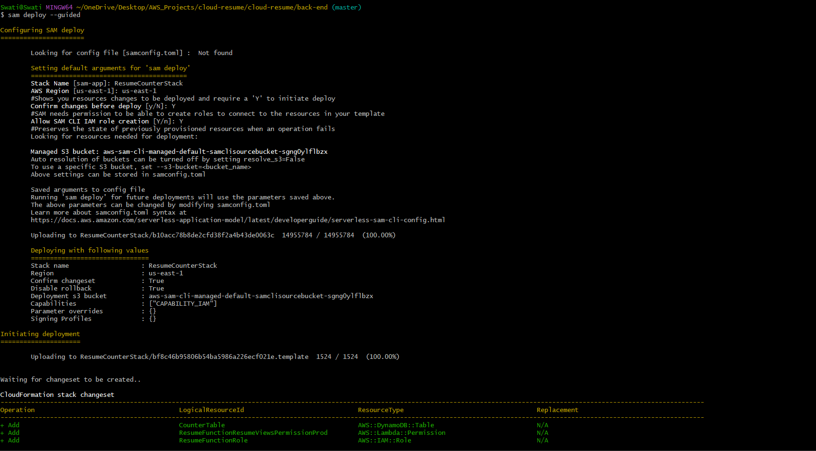
- Create S3 buket via AWS console and Upload frond-end files .

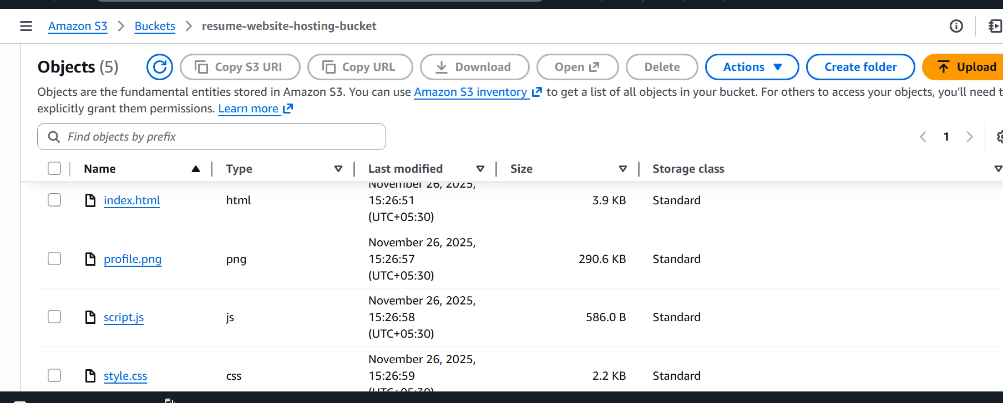
allow public access, enable static website hosting , add bucket policy .
then copy static website url and add in lambda CORS and check function working.
- Checking function
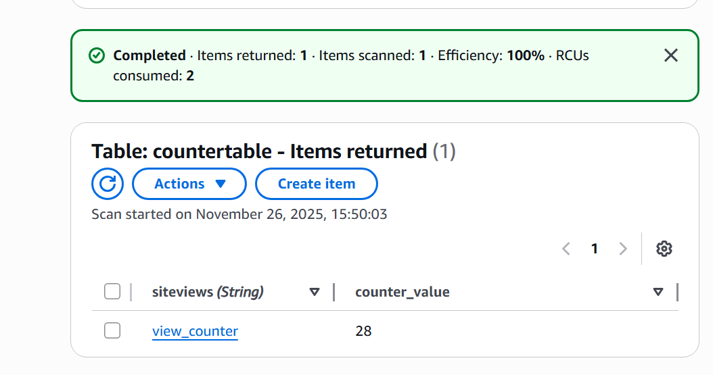
- Initial dynamodb table value
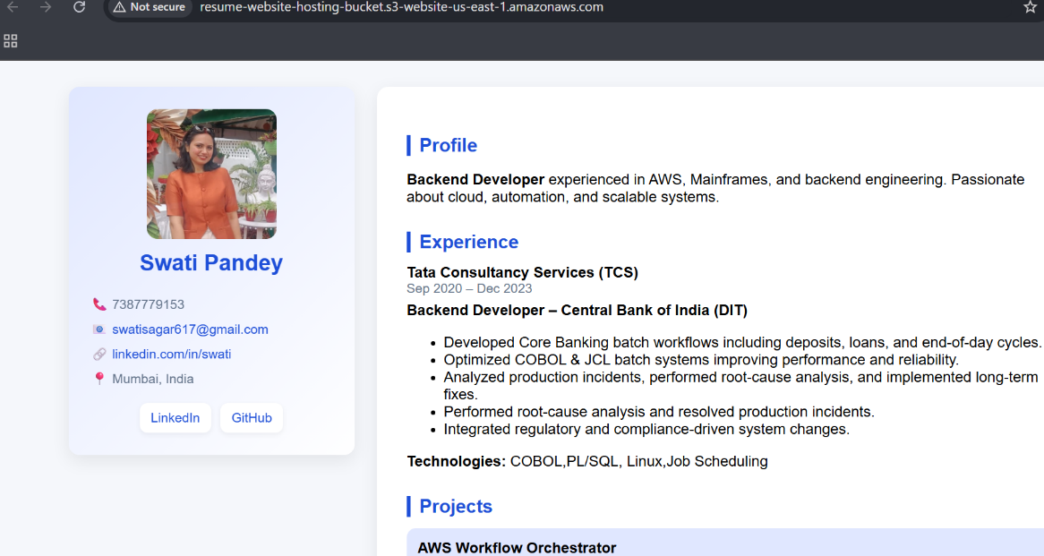
- Reloading resume website
- checking dynamodb table after website reload
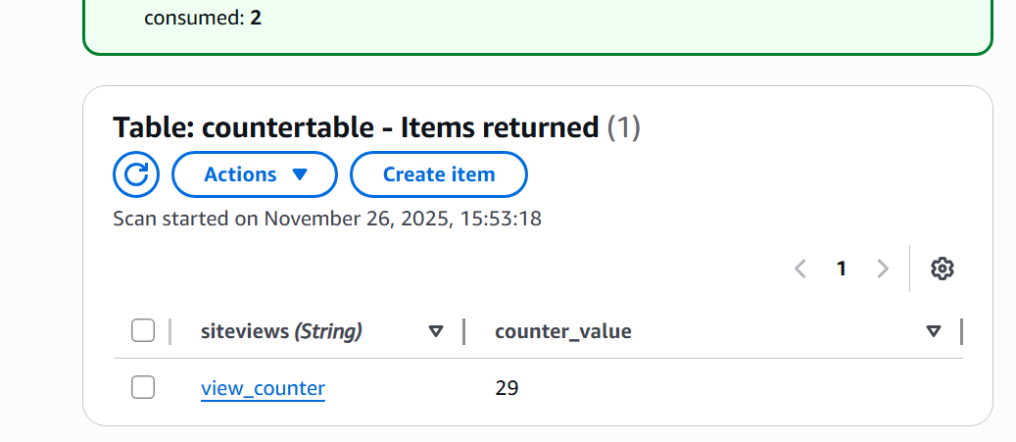

Counter incremented successfully.

- Adding Cloudfront+HTTPS
Create cloudfront distribution

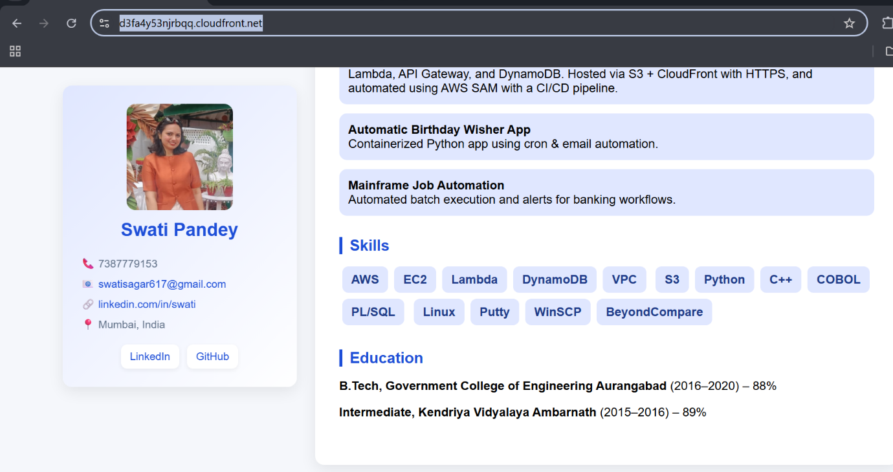

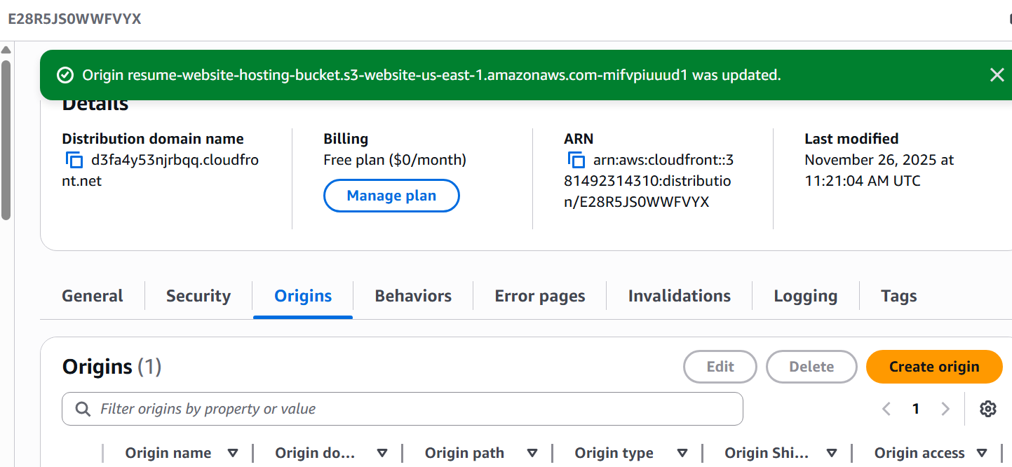
and update CORS of lambda function
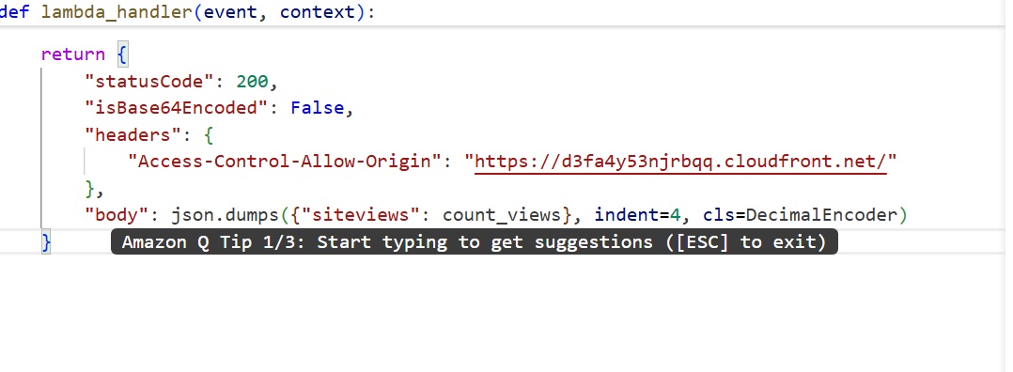

we can see that resume is hosted on s3 with cloudfront +HTTPS detailing.
- Now we will add GitHub Actions CI/CD — auto deploy frontend to S3 and invalidate CloudFront

