**A**

**PROJECT REPORT**

**ON**

**“Insurance Management System”**

**BY**

**MISS SWATI PRAKASH TAYADE**

**IN PARTIAL FULFILLMENT**

**OF**

**MASTER OF COMPUTER APLLICATION**

**SEM IV**

**SUBMITTED TO**

**SAVITRIBAI PHULE UNIVERSITY OF PUNE**

**ABHINAV EDUCATION SOCIETY'S**

**INSTITUTE OF MANAGEMENT & RESEARCH**

**(MBA & MCA)**

**NARHE PUNE-411041**

**2022-2023**

**Savitribai Phule Pune University, Pune**

ABHINAV EDUCATION SOCIETY’S

INSTITUTE OF MANAGEMENT & RESEARCH

(MBA & MCA),

NARHE PUNE-411041

2022-2023



A

PROJECT REPORT

ON

“Insurance Management System”

BY

Swati Tayade

Seat no :- 2134

Guide Name:- Prof. Priyanka Khopade

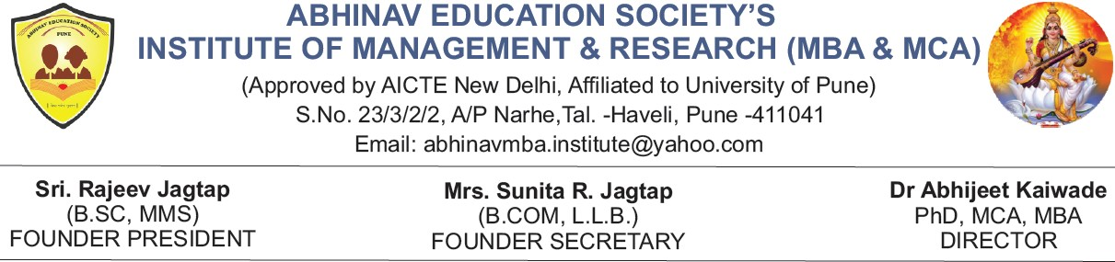

**Ref:AESIMR/[Roll No.56]/2022-23** Date:10/08/2023

**Ref:AESIMR/56/2022-23** Date:10/08/202

**CERTIFICATE**

This is to certify that **Swati Prakash Tayade** of “**Abhinav Education Society’s Institute of Management & Research Narhe, Pune**” has completed his Project on

**“Insurance Management System”** at **One for life pvt. Ltd** has submitted the Project report in partial fulfilment of the MCA Course Sem. IV of the Savitribai Phule Pune University (SPPU) for the Academic Year 2022-2023. He has worked under our guidance and the said report is based on the bonafide information.

**Prof. Priyanka Khopade Prof. Suraj Hingane**

**(Project Guide) ( HOD MCA Dept.)**

**Internal Examiner**  **External Examiner**

**Date of Exam:10/08/2023**

**Place: Pune**



**TO WHOMS OVER IT MAY CONCERN**

This is to certify that

**Miss. Swati tayade**

, student of

MCA

Management

from

Abhinav Education Society Institute of Management & Research

has

completed

her

Summer

Internship

in

our organization

from

1

st

Feb

,

202

3

to

31

st

July, 202

3

. she has

undertaken the project

Water Relief

as a

Mobile

Developer (React Native)

.

During the course of this internship,

**Miss.**

**. Swati tayade**

**,**

has been regular and

efficient with the tasks provided to him. Her performance was found to be

Outstanding

.

We wish him the best of luck for all her future

endeavors

.

Date:

31

st

July, 202

3

_________________

_

_

________________________

V

Swaminathan (Director)

Naman Dhayani (CTO)



**DECLARATION**

I, the undersigned hereby declare that the project titled

**“Insurance Management System”** being submitted for the award of degree of Master of Computer Application by me to Abhinav Education Society’s Institute of Management and Research affiliated to Savitribai Phule Pune University, Pune is the result of an independent work carried out under the guidance of **Prof. Priyanka Khopade**, is my original work. Further I declare that this project has not been submitted to this or any Institution for the award of any degree.

**PLACE: PUNE**  **Swati Tayade**

## ACKNOWLEDGEMENT

### Abhinav Education Society's Institute of Management & Research was established in 1999 by **Mr. Rajeev Jagtap** Founder president, it aims at quality education to science students. I also thank the authorities of College of Computer Sciences who have helped me by providing the resources necessary for the project.

### I want to express my deepest gratitude and regards towards all the teachers who have been very supportive and encouraging.

### I would specially thank to **Dr. Abhijeet Kaiwade** Director for their constant support.

### I would specially thank to my mentor Prof. Suraj Hingane (HOD) who have helped me to bring this project to a success.

### I thank for all support and cooperation they have extended for the successful completion of project apart from being a source of inspiration and motivation. I wish to express my profound and sincere gratitude to **Prof. Priyanka Khopade** value able guidance.

### Their keen interest in this project and constant and timely encouragement with affectionate attitude have inspired me a lot to finish my work successfully. Lastly, I would like thanks to all my teachers and friends who have contributed in bringing out this project in present format.

Swati Tayade

|  |  |  |  |
| --- | --- | --- | --- |
| **Chapter No** |  | **Details** | **Page no.** |
| **1** |  | **Introduction** |  |
|  | 1.1 | Company Profile / Institute Profile / Client Profile |  |
|  | 1.2 | Abstract |  |
|  | 1.3 | Existing System and Need for System |  |
|  | 1.4 | Scope of System |  |
|  | 1.5 | Operating Environment - Hardware and Software |  |
|  | 1.6 | Brief Description of Technology Used  1.6.1 Operating systems used (Windows or Unix) |  |
| **2** |  | **Proposed System** |  |
|  | 2.1 | Study of Similar Systems ( If required research paper can be included) |  |
|  | 2.2 | Feasibility Study |  |
|  | 2.3 | Objectives of Proposed System |  |
|  | 2.4 | Users of System |  |
| **3** |  | **Analysis and Design** |  |
|  | 3.1 | System Requirements (Functional and Non-Functional requirements) |  |
|  | 3.2 | Entity Relationship Diagram (ERD) |  |
|  | 3.3 | Table Structure |  |
|  | 3.4 | Use Case Diagrams |  |
|  | 3.5 | Activity Diagram |  |
|  | 3.6 | Modules |  |
|  | 3.7 | Sample Input and Output Screens (Screens must have valid data. All reports must have at-least 5 valid records.) |  |
| **4** |  | **Coding** |  |
| **5** |  | **Testing** |  |
|  | 5.1 | Test Case / Test Script |  |
| **6** |  | **Conclusion** |  |
| **7** |  | **Bibliography** |  |

**Company Profile**

* One For Life Pvt. Ltd. is one of the leading providers of Software Development.
* Leading solution providers in Information Technology Training and Corporate customers.
* Headquarters in Mumbai, one of the IT hubs of India, training activities.
* One For Life Pvt. Ltd. was established in 2020.
* Provides Training to Engineering Student and Working Employees.
* In training trainer provides the live (Industrial) Project to students that's why students absorb the knowledge through Classroom Training and analyses the Difference between academic projects and Live Projects having the high programming Knowledge.

**INTRODUCTION**

Online Insurance management system is a web application which is developed for tracking the details of the insurance policy, customer details and company details. This web site is an online insurance Analysis and information management system that provides easy access of information regarding the people and resources of insurance. User can view their own personal details when login into the Policy Holder module. This project is useful for any kind of insurance company to manage the insurance details, to sanctioned the insurance for customer, process the insurance policy details and all kind of insurance process through online. The Insurance management system is a complete solution for organizations, which need to manage insurance for their vehicles, equipment, buildings, and other resources.

This insurance management system can efficiently manage the company, records, provides instant access and one that improves the productivity. In this process the user enter into the website it will show details about insurance and its types, also it will show the details about different duration schemes to the corresponding insurance type or insurance policy. The main objective of the developed system is to allow admin users to register insured persons with their name, date of birth, residence address, medical history and also policy details.

In this process contains the user registration form which is used to apply for insurance policy through online. It also helps the customer to view their own insurance status information.

After giving registering all the insured persons, website should provide management facilities like delete unwanted persons’ data.

The developed system should allow admin users to register insured persons with their name, date of birth, residence address, medical history and also policy details. Then the admin send the permanent policy holder ID and password to the customer and also send status information about insurance policy to the corresponding policy holder. An online help documentation will be provided to help the users and visitors in using the facilities.

**1.2 Abstract**

**Insurance management system project** is implemented in java platform using oracle as backend application. Main aim of this project is to develop a online application for insurance company to atomize work procedure, using this system agents and policy holders can know details about present policies, schemes, policy specifications, terms and conditions on policy, policy registration by the customers. Agents commission is based upon customer policy registration and target agent achieves for every month or year. This system maintains information of branch managers who can deal with agents and customers.

Our aim is “Customers want to be able to buy online insurance with confidence”. According to business experts the news came that the entire insurance industry will be adopted by the e-commerce. For a new generation of working professionals, online insurance is the bridge that connects the digital age and the challenges of adult life. With internet access is rising and a young generation of working middle class professionals reaching the cusp of adult life, online insurance business is gathering momentum.

In existing system manual procedure is followed where records are used to maintain data which is a time taking process and require more man power and calculating commissions dues. etc are done manually.

In present system there is no need of human interference in calculating any details. Total work is done using management system which will save time and less paper work and even human resource.

**1.3 Existing System and Need for System**

* Existing Application does not help the Insurance Agents to Manage Policy Transactions easily.
* Existing Application does not help the Agents to Monitor and perform transaction easily.
* In the Customer view, it does not provides the Customers with their personal account through which they can perform the Transactions.
* Manual maintenance of records
* Very complex and manual calculation of policy premium
* time consuming to summarize these details to produce the reports
* Difficult to handle and manage bulk data.
* Difficult to Organizes and tracks insurance and the policies provided under different coverage
* If customer requests for any clarification the person in charge has to search through the written records and fetch the details regarding that particular customer, which is time consuming and cumbersome.
* Security of the information maintained is comparatively less.
* Maintenance of the ledgers occupy large space

**1.4 Scope of System**

**Insurance Management System is an application designed for a group of insurance agents, which supports the maintenance activities of Insurance Policies** and their associated company details their procedures in maintaining various types of policies, with the corresponding details of Policy holders, associated agents involved in the policy maintenance and etc.

An insurance agency management system or AMS is a SaaS (Software as a Service) tool that can optimize the existing agency business processes and run help the operations effectively. It tracks details of the insurance policy, improves agent productivity, and provides instant access to client data.

The application should provide quick access to the records maintained and must reveal the important reviews about the business so that the growth can be easily compared and should provide with the various reports showing the related details so that the important decisions could be taken easily.

Security of the stored information is achieved here. Only privileged users can gain access to the stored information. Storage of all the customer information and the transactions has been computerized.

**1.5 Operating Environment**

**Operating System**

* Windows
* Linux
* MAC

**Software Requirements**

* Web Server Apache Tomcat 9.0
* Browser.
* Mysql_8.0
* Editor Eclipse IDE 2022-12(4.26.0)
* JDK1.8.0.311

**Technology Used**

* Java
* J2EE
* jsp

**Hardware Requirements**

* Hard Disk – 20 GB.
* RAM – 6 GB.
* Processor – Dual Core or Above.
* Mouse.
* Keyboard.
* Monitor.
* Printer.

**1.6 Brief Description of Technology Used**

**Why Java is selected?**

Java was designed to meet all the real-world requirements with its key features, which are explained in the following paragraphs:

**Simple and powerful.**

Java was designed to be easy for the professional programmers to learn and use efficiently. Java makes itself simple by not having surprising features. Since it exposes the internal working of the machine, the programmers can perform his desired action without fear. Unlike other programming systems that provide dozens of complicated ways to perform a simple task, Java provides a small number of clear ways to achieve a given task. Secure

Today everyone is worried about safety and security. Using Java Compatible Browser, anyone can safety download applets without fear of viral infections or malicious intent. Java achieves this protection by confining a Java program to Java execution environment and by making it inaccessible to other parts of the computer.

**Portable.**

In Java, the same mechanism that gives security helps in portability. Many types of computers and operating systems are used throughout the world and are connected to the Internet. For downloading programs through different platforms connected to the Internet, some portable, executable ode is needed. Java’s answer to these problems is its well-designed architecture.

**Object-oriented.**

## Java was not designed to be source code compatible with any other language. Java team gave a clean, usable, realistic approach to objects. The object model in Java is simple and easy to extend, while simple types, such as integers, are kept as high-performance non-objects. ust

**SERVLETS:**

A servlet is a web component, managed by a container that generates dynamic content. Servlets are small, platform independent Java classes compiled to an architecture neutral byte code that can be loaded dynamically into and run by a web server. Servlets interact with web clients via a request response paradigm implemented by the servlet container. This request-response model is based on the behavior of the Hypertext Transfer Protocol (HTTP).

The servlet container, in conjunction with a web server or application server, provides the network services over which requests and responses are set, decodes MIME based requests, and formats MIME based responses. A servlet container also contains and manages servlets through their lifecycle. A servlet container can either be built into a host web server or installed as an add-on component to a Web Server via that server’s native extension API. Servlet Containers can also be built into or possibly installed into web-enabled Application Servers.

All servlet containers must support HTTP as a protocol for requests and responses, but may also support other request / response based protocols such as HTTPS (HTTP over SSL). The minimum required version of the HTTP specification that a container must implement is HTTP/1.0. It is strongly suggested that containers implement the HTTP/1.1 specification as well. A Servlet Container may place security restrictions on the environment that a servlet can executed In a Java 2 Platform Standard Edition 1.2 (J2SE) or Java 2 Platform Enterprise Edition 1.3 (J2EE) environment, these restrictions should be placed using the permission architecture defined by Java 2 Platform. For example, high end application servers may limit certain action, such as the creation of a Thread object, to insure that other components of the container are not negatively impacted.

## JAVA SERVER PAGES:

Java Server Pages™ technology is the Java™ technology in the J2EE platform for building applications containing dynamic Web content such as HTML and XML. The Java Server Pages technology enables the authoring of Web pages that create dynamic content easily but with maximum power and flexibility.

The JSP file extension is .jsp rather than .htm or .html. The JSP engine parses the .jsp and creates a Java servlet source file. It then compiles the source file into a class file, this is done the first time and this why the JSP is probably slower the first time it is accessed.

**Proposed System**

In the proposed system, all the work will be digitalized and is done via computers and internet. All the details regarding the insurance holder and schemes will be added via computer and the information data is being saved in servers. Backup should be there in case if by chance any of the information will be lost.

Time consume will be reduced and users will get any easy way to access their insurance related information and new upcoming schemes. Users just have to click on the button and just have to wait for some moments and they get an easy access to their information.

**2.1 Feasibility Study**

Preliminary investigation examines project feasibility; the likelihood the system will be useful to the organization. Feasibility report is the important outcome of the preliminary investigation. There are three aspects of feasibility study.

**Operational feasibility:**

There is lot of support from management; in fact they request it. Because of the persons in the organization has been facing problems with the existing system there is no resistance to the change. And also the current methods are not acceptable to the users that are why they are welcoming to the new system. From the beginning of this new system we made users to involve in some way reducing the resistance. The new system will not cause any problems in any way and also will show efficient performance in all respects. By considering all these things the proposed new system is operationally feasible.

**Technical feasibility:**

There is no technology and equipment to implement the new system but it can be acquired. It is not a burden rather than that of existing system. The proposed equipment can safely handle the data required to use the new system. The proposed new system can easily be expanded to satisfy the new requirements in future. There is lot of security, accuracy and reliability in the new system rather than existing system. By considering the above reasons the proposed new system is technically feasible.

**Economic feasibility:**

The cost to implement this new system includes cost of full systems investigation, cost of hardware and software and the cost of user training. The cost that may spend if the new system was not developed is greater than the cost of the new system. The cost to implement the proposed system is one time investment later they need not spent any more. The organization must get benefit if they invest on the proposed system development. By considering the above reasons the proposed new system is economically feasible.

As this proposed system has passed all the three aspects of feasibility study we can declare it as a feasible project.

**2.2 Objectives Of Proposed System**

1. Helps the Agents to maintain the details of all the Policy Holders electronically.
2. This project helps the Customers to be aware of the dues and also the previous payment details made for Updating Policy, Policy Maturity, Policy Premium, Policy renewal etc .
3. The application will provide quick access to the records for customer to maintain and reveal the important reviews about the policies.
4. It provides for effective maintenance of records regarding customers, transactions etc. Initially it may cost more but proves to be cost effective in the long run.
5. Helps to Provide with the various reports showing the related details so that the important decisions could be taken easily.
6. Application should provide quick access to the records maintained and must reveal the important review
7. High Security to sensitive and important data
8. Automated Premium calculator

**Analysis And Design**

**3.1 System Requirements:-**

Requirements analysis is very critical process that enables the success of a system or software project to be assessed. Requirements are generally split into two types: *Functional* and *Non-functional requirements*.

Functional Requirements: These are the requirements that the end user specifically demands as basic facilities that the system should offer. All these functionalities need to be necessarily incorporated into the system as a part of the contract. These are represented or stated in the form of input to be given to the system, the operation performed and the output expected. They are basically the requirements stated by the user which one can see directly in the final product, unlike the non-functional requirements.

Non-functional requirements: These are basically the quality constraints that the system must satisfy according to the project contract. The priority or extent to which these factors are implemented varies from one project to other. They are also called non-behaviaral requirements.  
They basically deal with issues like:

* Portability
* Security
* Maintainability
* Reliability
* Scalability
* Performance
* Reusability
* Flexibility

**3.2 Entity Relationship Diagram (ERD):-**

An Entity – Relationship (ER) diagram is a specialized graphic that illustrates the inter relationship between entities in a database.

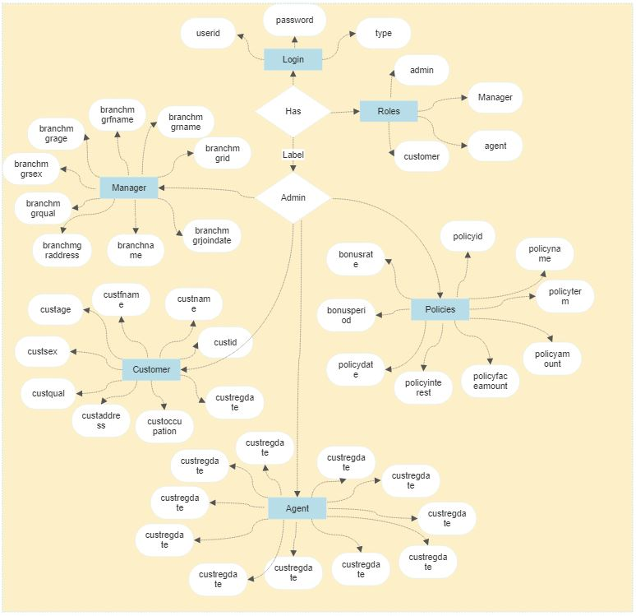

**(Entity Relationship Diagram)**

**3.3 Table Structure**

**Table:login**  
  
**Columns:**

|  |  |
| --- | --- |
| Field Name | Data Type |
| userid | int |
| password | varchar(20) |
| type | varchar(20) |

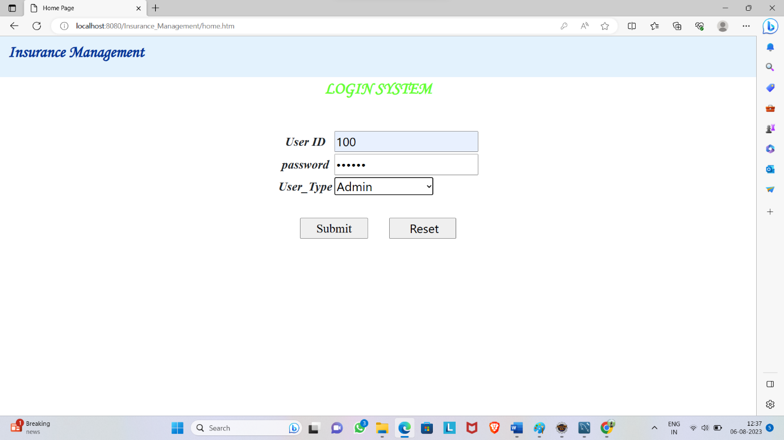

**Table:branch**  
  
**Columns:**

|  |  |
| --- | --- |
| id | int |
| bname | varchar(100) |
| location | varchar(100) |
| d2 | date |
| phone | varchar(15) |
| state | varchar(90) |

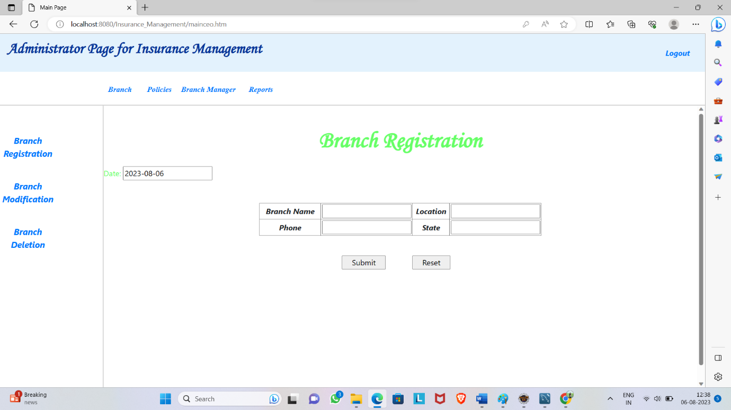

**Table:branchmgr**  
  
**Columns:**

|  |  |
| --- | --- |
| branchmgrid | int |
| branchmgrname | varchar(100) |
| branchmgrfname | varchar(100) |
| branchmgrage | int |
| branchmgrsex | varchar(1) |
| branchmgrqual | varchar(100) |
| branchmgraddress | varchar(100) |
| branchname | varchar(100) |
| branchmgrjoindate | date |
| **Table:agents**  **Columns:**   |  |  | | --- | --- | | agentid | int | | agentname | varchar(20) | | agentfname | varchar(20) | | agentage | int | | agentsex | varchar(1) | | agentqual | varchar(20) | | agentoccupation | varchar(20) | | agentaddress | varchar(20) | | agentregdate | date | | agentsecuritydeposit | double(10,3) | | branchmgrid |  | |  |

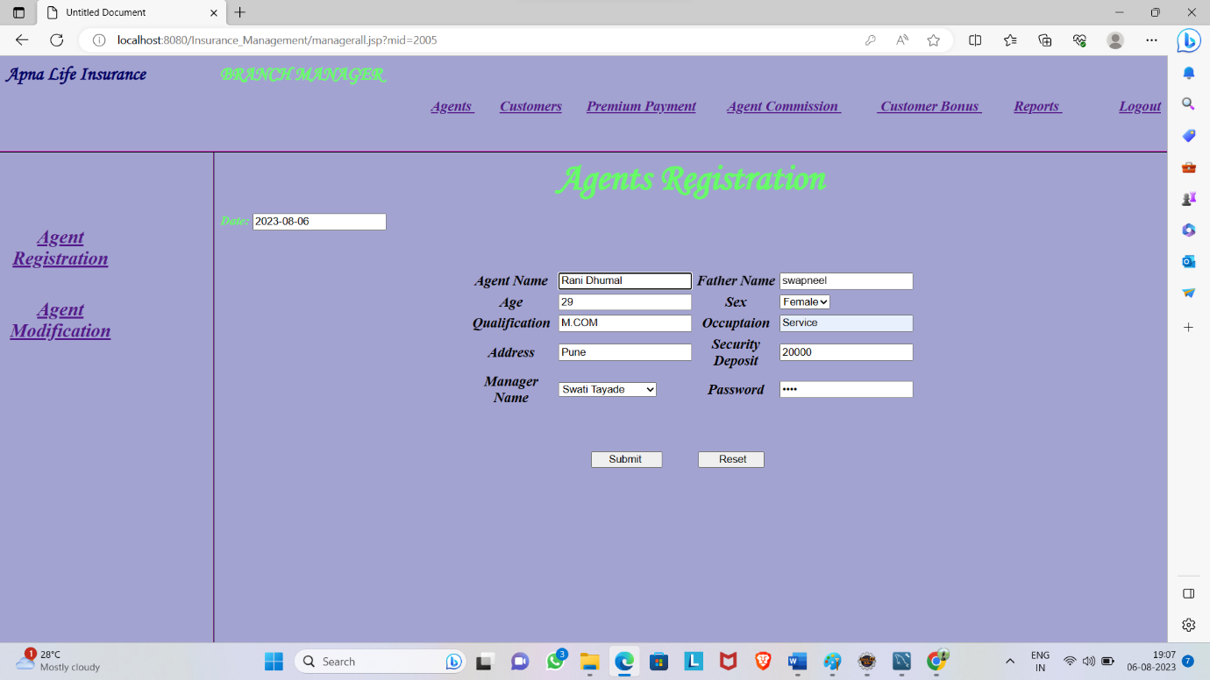

**Table:customer**  
  
**Columns:**

|  |  |
| --- | --- |
| custid | int |
| custname | varchar(33) |
| custfname | varchar(35) |
| custage | int |
| custsex | varchar(1) |
| custqual | varchar(35) |
| custaddress | varchar(35) |
| custoccupation | varchar(35) |
| custregdate | date |

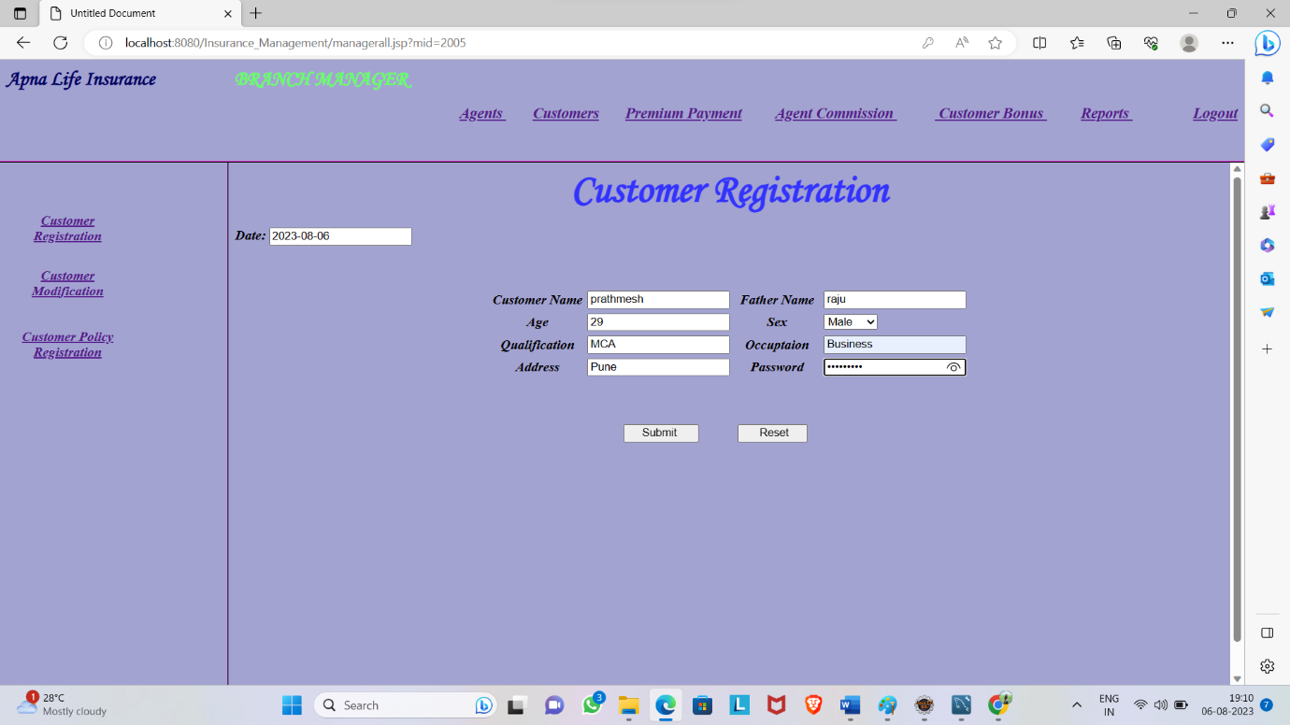

**Table:policies**  
  
**Columns:**

|  |  |
| --- | --- |
| policyid | int |
| policyname | varchar(50) |
| policyterm | int |
| policyamount | double(15,3) |
| policyfaceamount | int |
| policyinterest | int |
| policydate | date |
| bonusperiod | int |
| bonusrate | int |

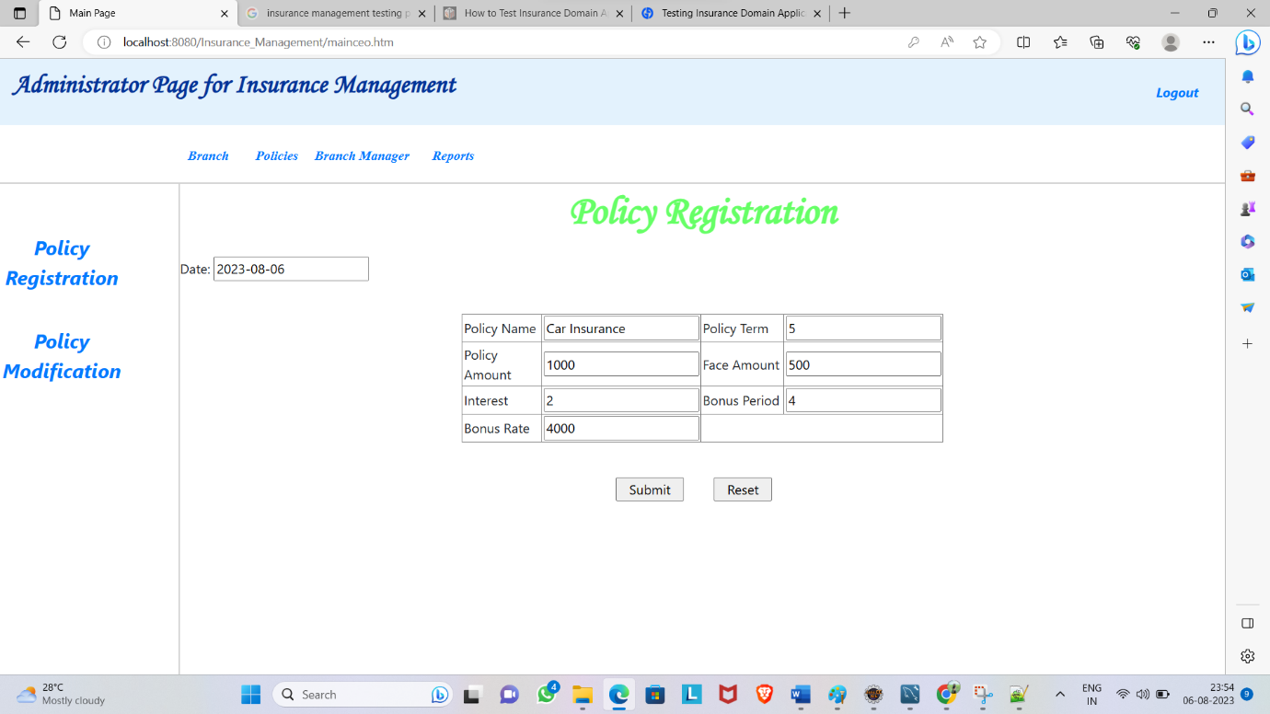

**3.4 Use Case Diagram**

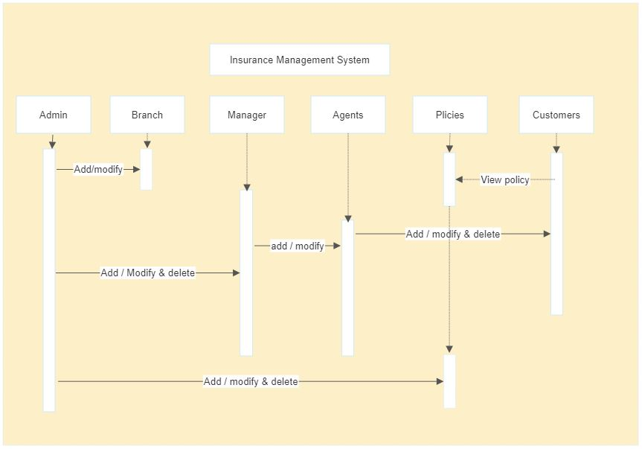

**(Case Diagram)**

**3.5 Activity Diagram**

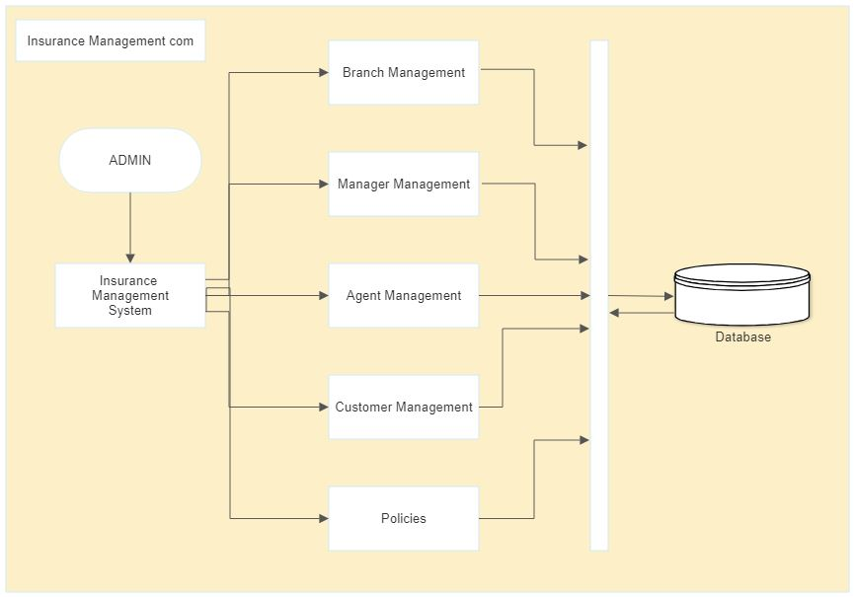

**3.6** **Modules**

**Admin :-**

Admin is a super user who refers customers for commission. Admin has to approve the registration of an agent. Agents need to provide necessary information to the customers and educate them.

**Agent :-**

The agents work for insurance company who provides information regarding the policies and schemes and brings new customers to the insurance company.

Admin adds agents by verifying their profile manually.

. Agent Resistration manually

. Agent Login module

. Agent Profile module

. Change Password module

**Customer:-**

A policy holder is called as customer to this system. He can log into this system in 24*7 modes. He can select the new policy an premium details. He needs to pay insurance premium. A customer can view the previous payment details. He can update his profile and password.

**3.7 Sample Input and Output Screens**

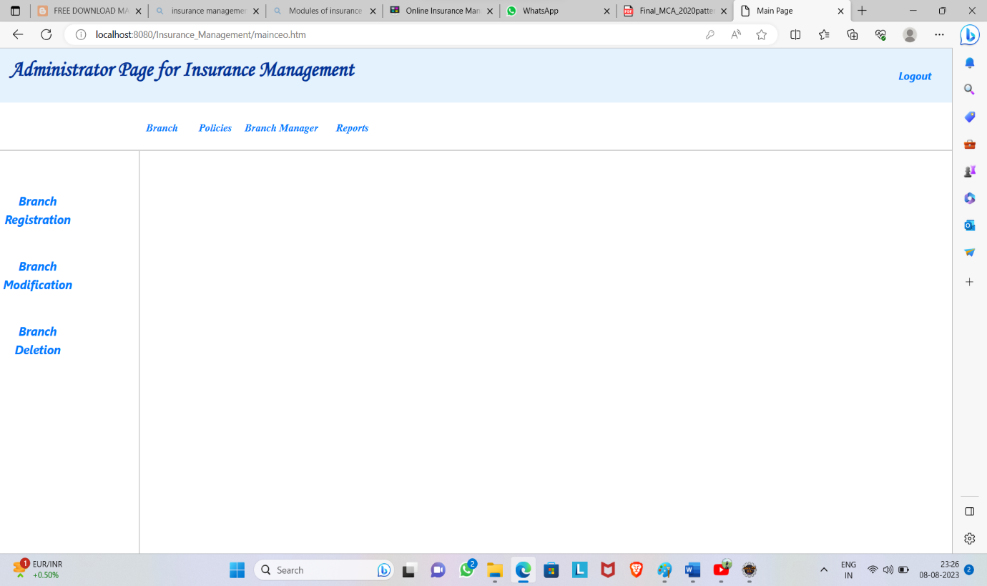

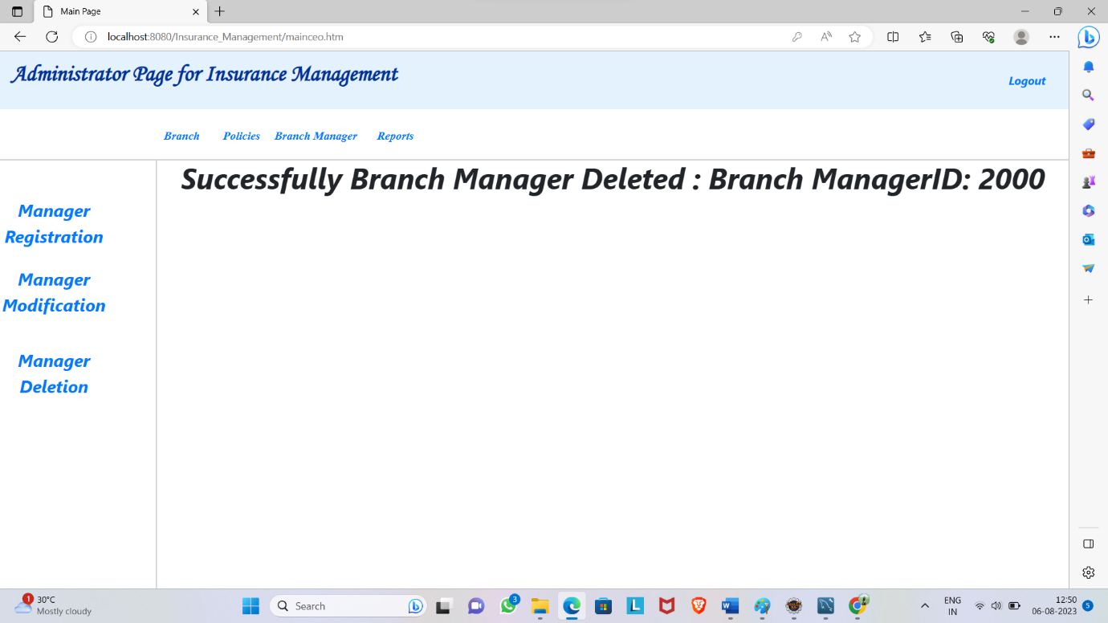

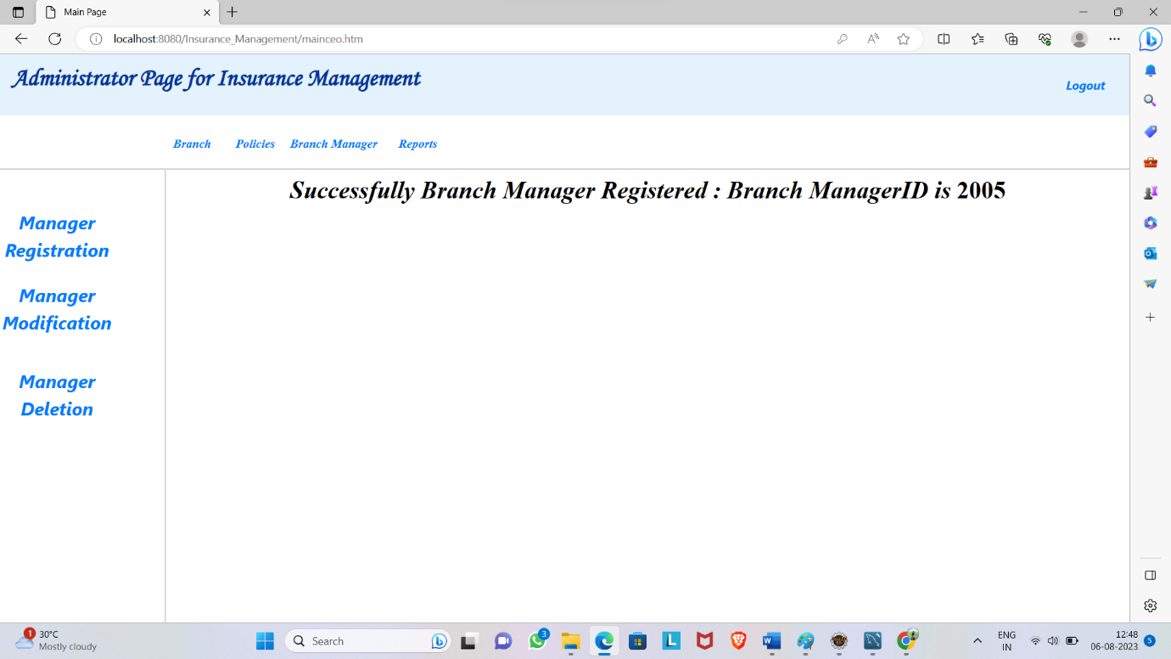

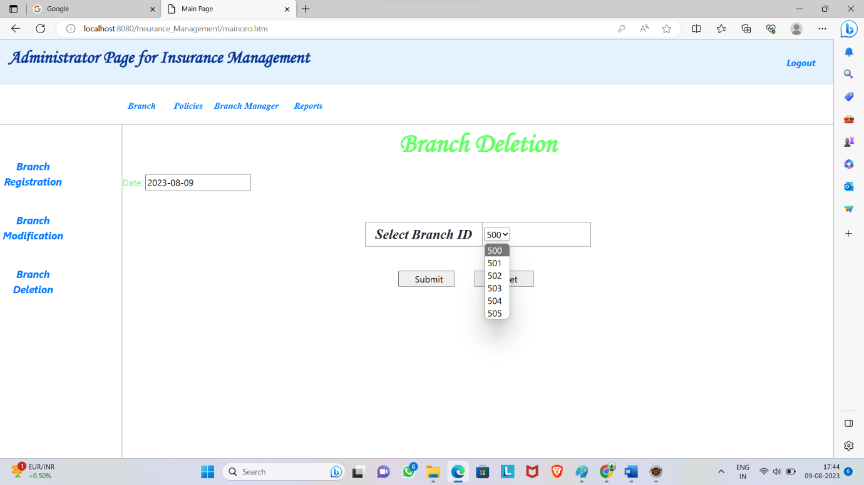

**Coding screenshot**

DB Connection code

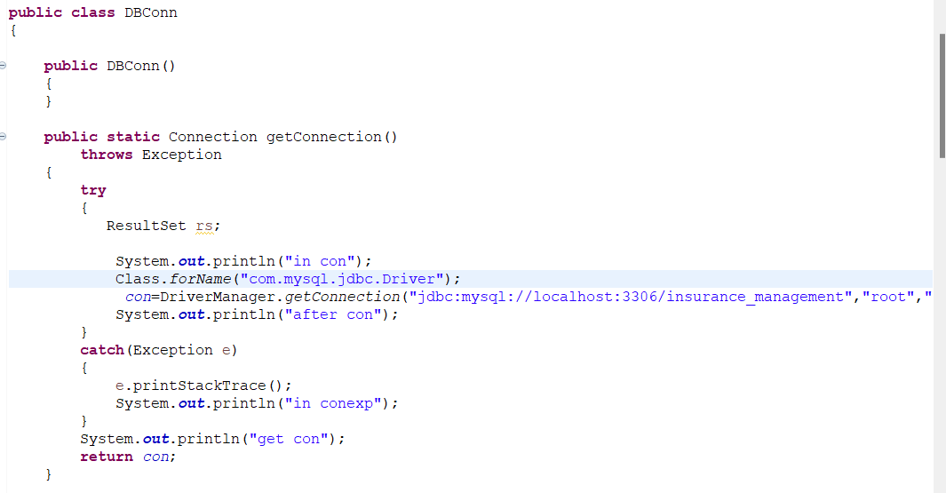

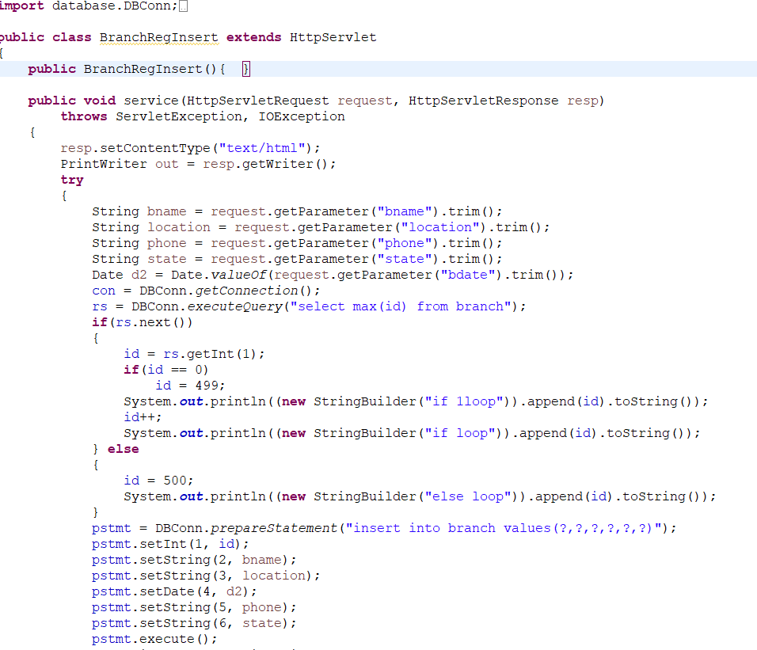

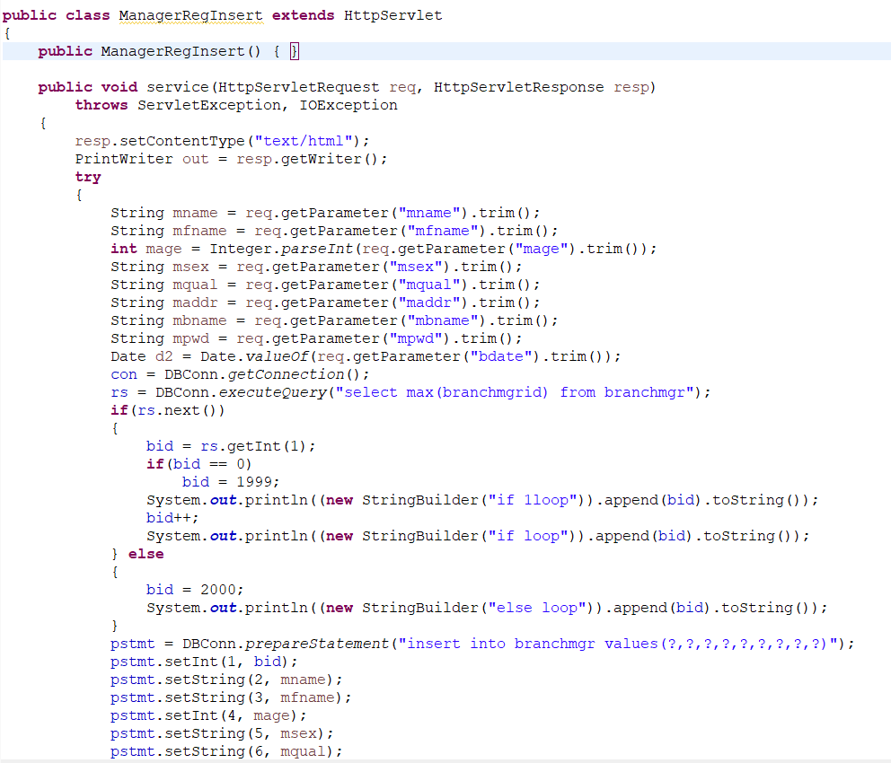

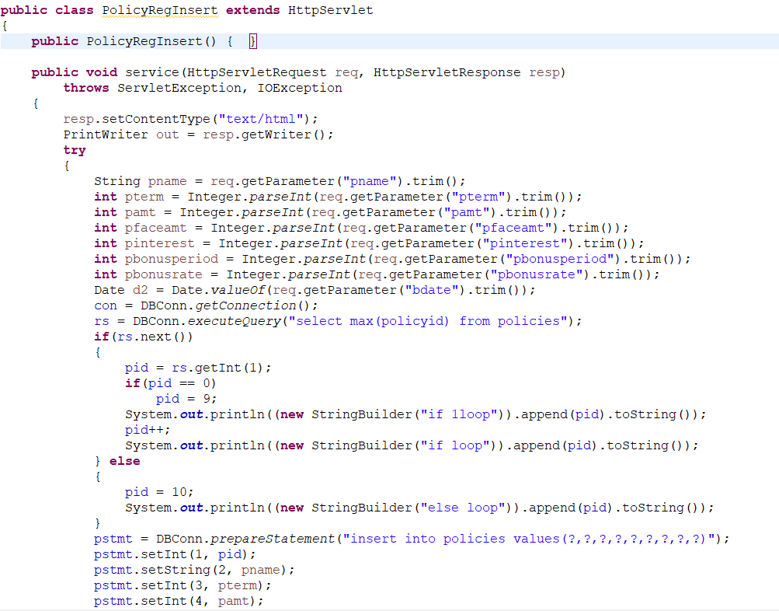

**Testing**

### **Test Case**

* Testing the application’s ability to accurately calculate premiums based on the information provided by the user.
* To test the application’s claims processing functionality to ensure that claims are processed correctly and in a timely manner.
* To test the application’s customer service functionality to ensure that customer inquiries are handled properly and in a timely manner.

**1. Testing the accuracy of an insurance company’s claims processing:**

This test case would test the accuracy of an insurance company’s claims by processing, to ensure claims are processed correctly and that payments are made to the correct policyholders. There are many ways to test the accuracy of an insurance company’s claims processing.

* One way would be to create a test case that includes a variety of different types of claims (e.g. medical, auto, homeowner’s, etc.) and submits them to the company for processing.
* The test case should include both simple and complex claims, as well as claims that would be considered “outliers” (e.g., very high-value claims, claims with a large number of line items, etc.).
* The results of the test case should be compared against the company’s stated accuracy rate to see if there is a discrepancy.
* Other ways to test the accuracy of an insurance company’s claims processing include submitting duplicate claims, submitting claims with invalid data, and submitting claims for services that were never rendered.
* The results of these test cases should also be compared against the company’s stated accuracy rate to identify any discrepancies.

**2. Testing the customer service of an insurance company:**

This test case would test the customer service of an insurance company to ensure customer inquiries are handled promptly and effectively. There are many different ways to test customer service for an insurance company.

* One way would be to create a customer profile and then submit a claim.
* Another way would be to call the customer service number and ask a series of questions.
* Another way would be to go through the process of buying a policy and see how the customer service team handles any questions or problems.

**3. Testing the billing and payment process of an insurance company:**

This test case would test the billing and payment process of an insurance company, to ensure that bills are generated correctly and payments are processed in a timely manner.

* The billing and payment process of an insurance company can be tested, by creating test scenarios that cover all of the different types of insurance domain applications.
* For each test scenario, the tester would need to input different types of data to test the different functions of the billing and payment process.

**4. Testing the website of an insurance company:**

This test case would test an insurance company’s website to ensure that it is easy to navigate and that all information is displayed correctly.

The steps followed to test the website of an insurance company are:

1. **Policy creation:** This test case is used to test the functionality of creating a new insurance policy.
2. **Policy retrieval:** This test case is used to test the functionality of retrieving an insurance policy.
3. **Policy cancellation:** This test case is used to test the functionality of cancelling an insurance policy.
4. **Claim filing:**This test case is used to test the functionality of filing an insurance claim.
5. **Claim status check:** This test case is used to test the functionality of checking the status of an insurance claim.

Conclusion

Insurance is a large investment and you will most likely purchase multiple policies throughout your lifetime. It is essential that you know what each type of insurance covers and how it works so you can make the best decision about what to buy. Do not base your decision on just what is cheapest, but look at what it provides.

Take the time to shop around and find the right insurance for your situation. People often say they cannot afford insurance, but the reality is that they cannot afford not to have it. It can save them from thousands or more dollars in unplanned expenses when unexpected situations arise. You do not want to waste your money on policies that do not meet your needs, but the right insurance policy can protect you and your family from unforeseen disasters.

**BIBLIOGRAPHY**

**1.** [**www.scribd.com**](http://www.scribd.com)

**2.**[**www.w3school.com**](http://www.w3school.com)

**3.** [**www.htmltutorial.com**](http://www.htmltutorial.com)

**4.**[**www.csstutorial.com**](http://www.csstutorial.com)

**5.www.caratlane.com**

**6.** [**www.stackoverflow.com**](http://www.stackoverflow.com)