Game Design Document

Fill up the following document

1. Write the title of your project.

UNIVERSAL TREASURE HUNT

1. What is the goal of the game?

GOAL IS TO DEFEAT THE FINAL BOSS AND TAKE THE TREASURE

1. Write a brief story of your game.

In this game there will be 5 levels where the plauer has to perform parkour and even kill some hostile mobs the higher the level the difficulty increases,and in the last the player have to defeat the evil boss and collect all the treasure but there would be a specific point limit if we can’t reach the minimum points required and we took treasure then too the payer will lose so the player has to make sure that he should have the best performance by which he could gain the minimum points.

1. Which are the playing characters of this game?

* Playing characters are the ones who respond to the user based on the input from the user.
* Cars, monkeys, dinos, wizards, etc., are the playing characters in the game.

|  |  |  |
| --- | --- | --- |
| Number | Character Name | What can this character do? |
| 1 | ALIEN | THIS CHARACER CAN JUST JUMP,KILL,ATTACK,DIE,TELEPORT,etc. |
| 2 |  |  |
| 3 |  |  |
| 4 |  |  |
| 5 |  |  |
| 6 |  |  |
| 7 |  |  |
| 8 |  |  |

1. Which are the Non-Playing Characters of this game?

* Non-Playing characters are the ones that don't have an action or behavior when the user interacts with the game.
* Hurdles, stones, bananas, coins, etc., are non-playing characters in the game.

|  |  |  |
| --- | --- | --- |
| Number | Character Name | What can this character do? |
| 1 | Universal zombies | These zombies have different weapons and these zombies try to kill the playing character. |
| 2 | Evil boss | Evil boss is in the last level of game this boss perform all posibilities to kill the playing character until he dies . |
| 3 | platforms | These are the platforms which are moving in level 2 these can work like elevator to transport the playing character |
| 4 |  |  |
| 5 |  |  |
| 6 |  |  |
| 7 |  |  |
| 8 |  |  |

Draw your imagination of this game. What does this game look like?

* Draw the game either on your computer or on paper.
* Add images of the game scenes to show each of the playing and non-playing characters at least once.

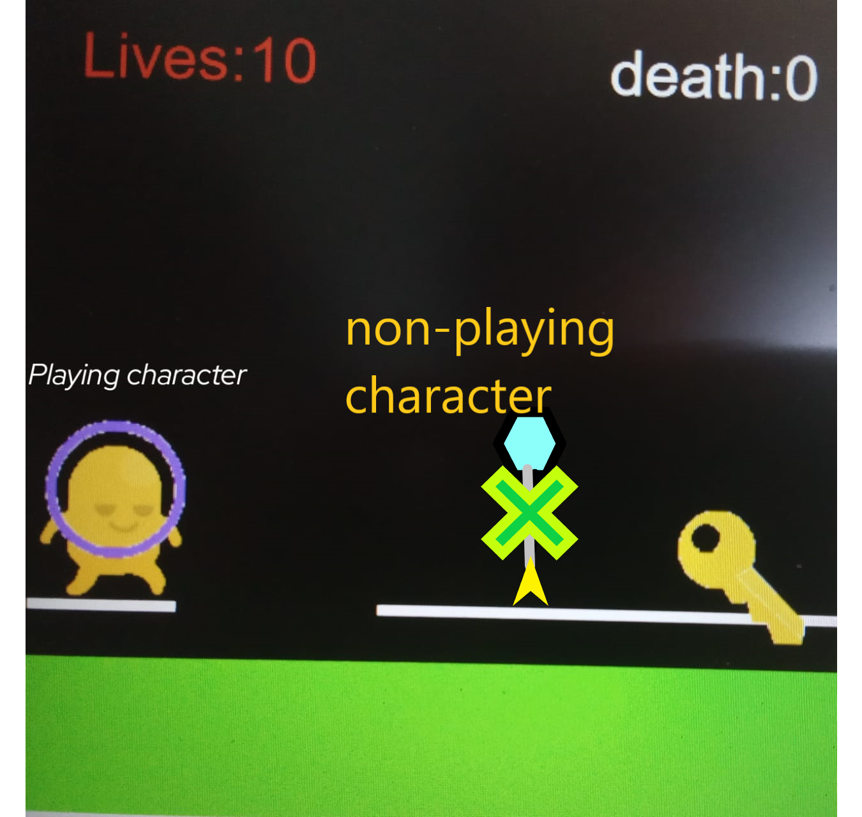

How do you plan to make your game engaging?

the higher the level the harder the game when in any level the player loses or wins sound will be there.and even the player will get resources from the zombies.I’ll even add the jump,shoot and some more functionalities.