E-commerce Backend API Testing (Postman)

Create a new Environment, Name = DummyJSON
base_url = https://dummyjson.com

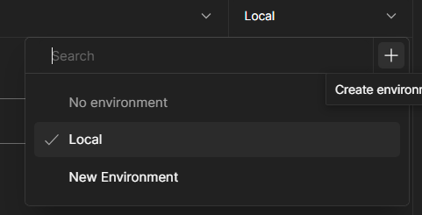
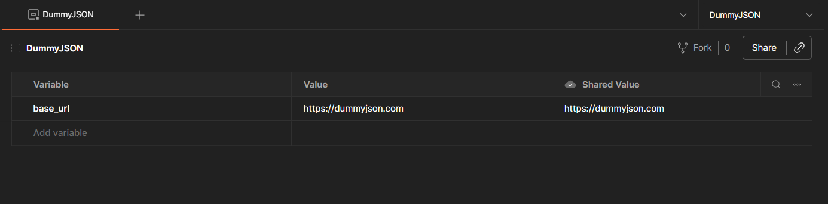

Feature | Endpoint
Login | /auth/login
Users | /users
Products | /products
Cart | /carts/user/1
Single product | /products/1
Search | /products/search?q=phone

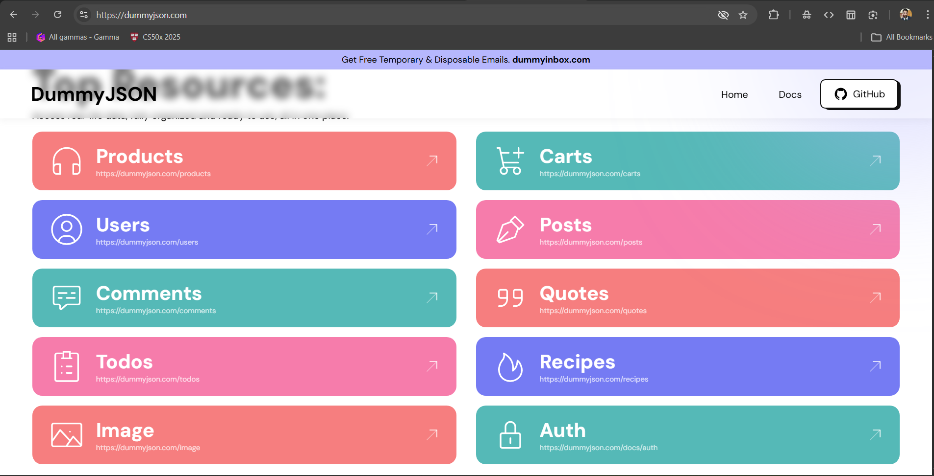

Name Post: {{base_url}}/auth/login
Save it on New Collection: DummyJSON
Authentication: -
Create request: POST {{base_url}}/auth/login
Body → raw → JSON:
{
"username": "emilys",
"password": "emilyspass"
}
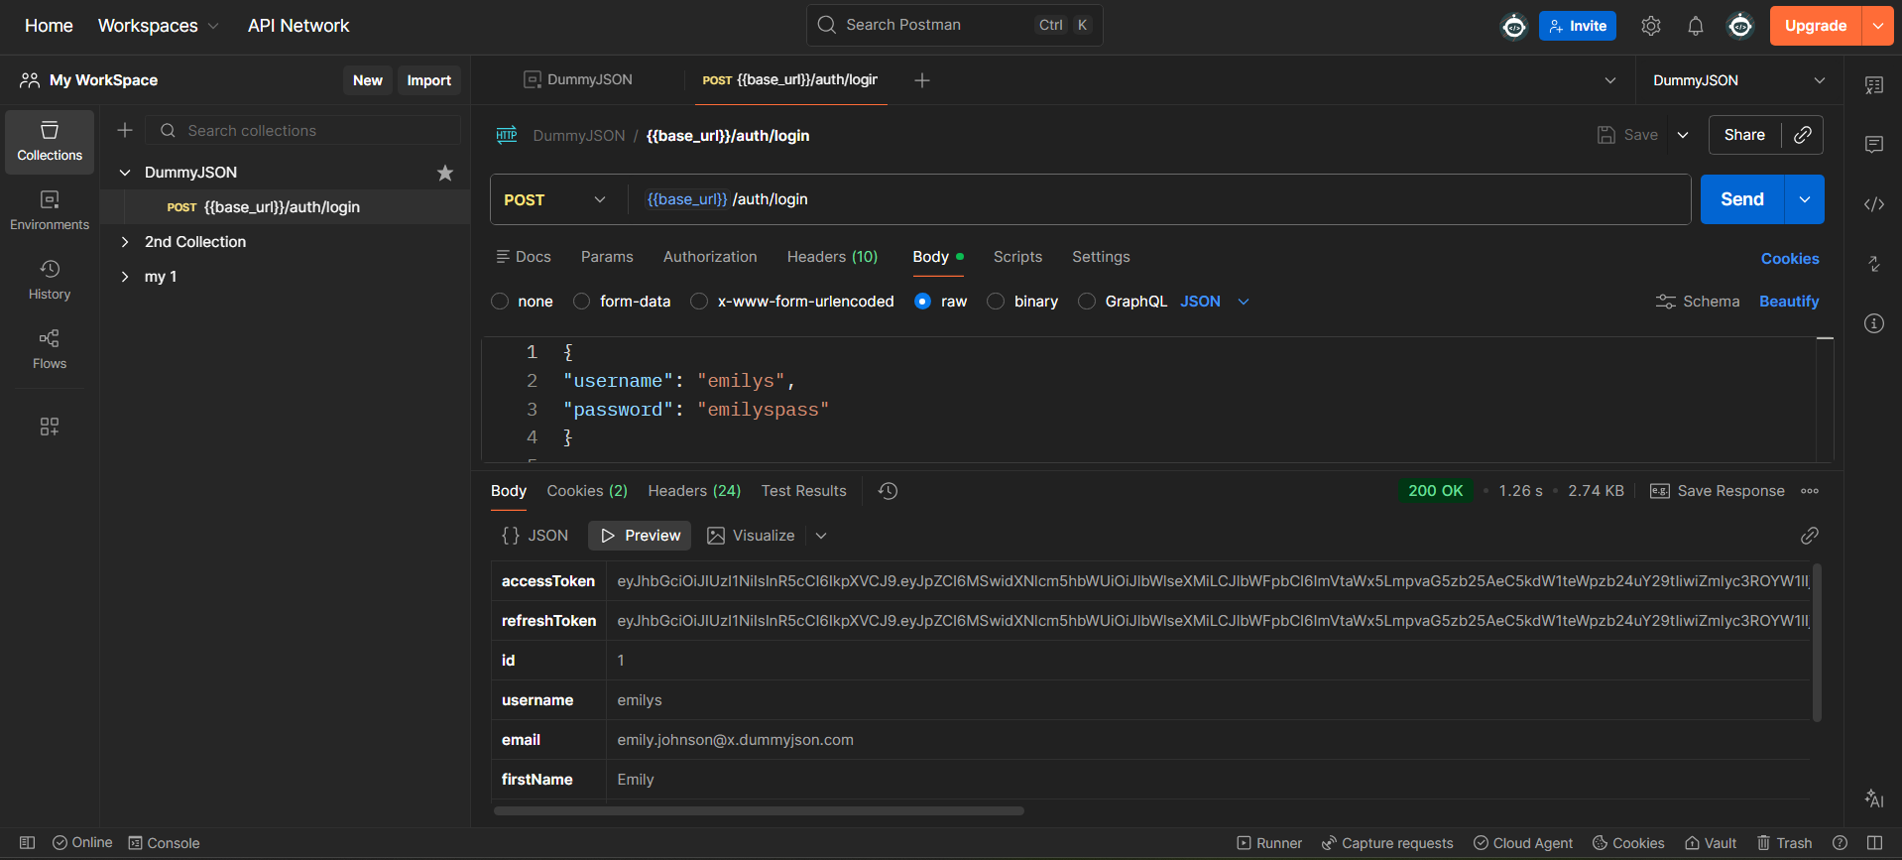

Save the Token Automatically: -
Open your Login request
Go to Tests tab (not Pre-request)
let jsonData = pm.response.json();
pm.environment.set("token", jsonData.accessToken);

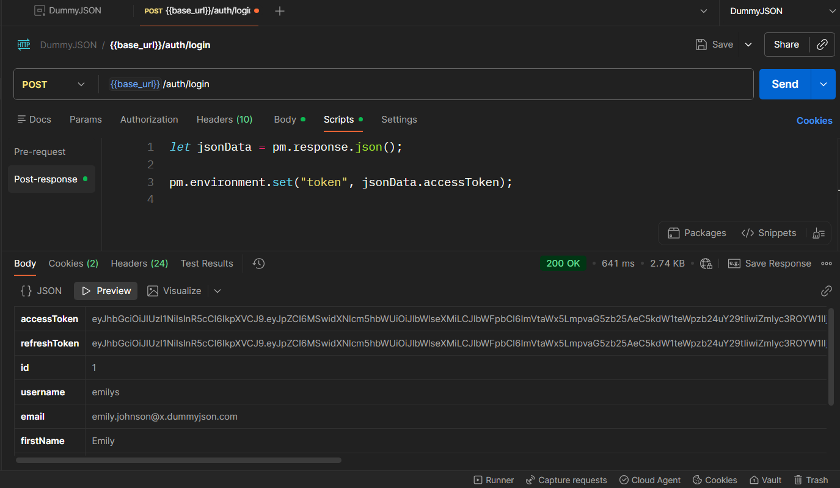
Prove the token is saved: -
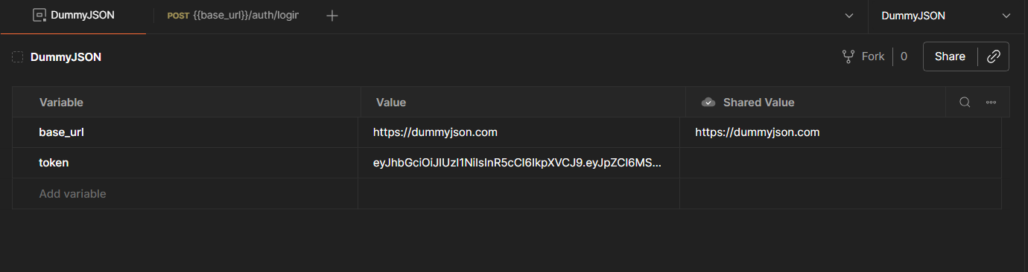

AUTHENTICATION TESTING: -
GET {{base_url}}/auth/me
Headers tab:
Key: Authorization
Value: Bearer {{token}}
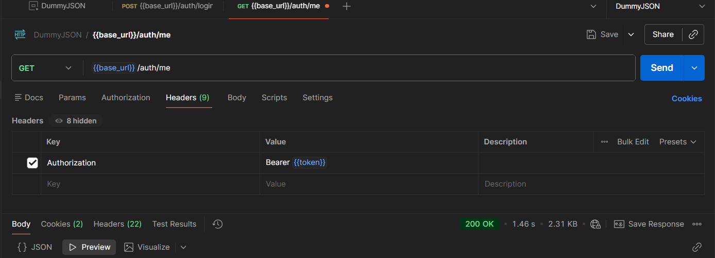

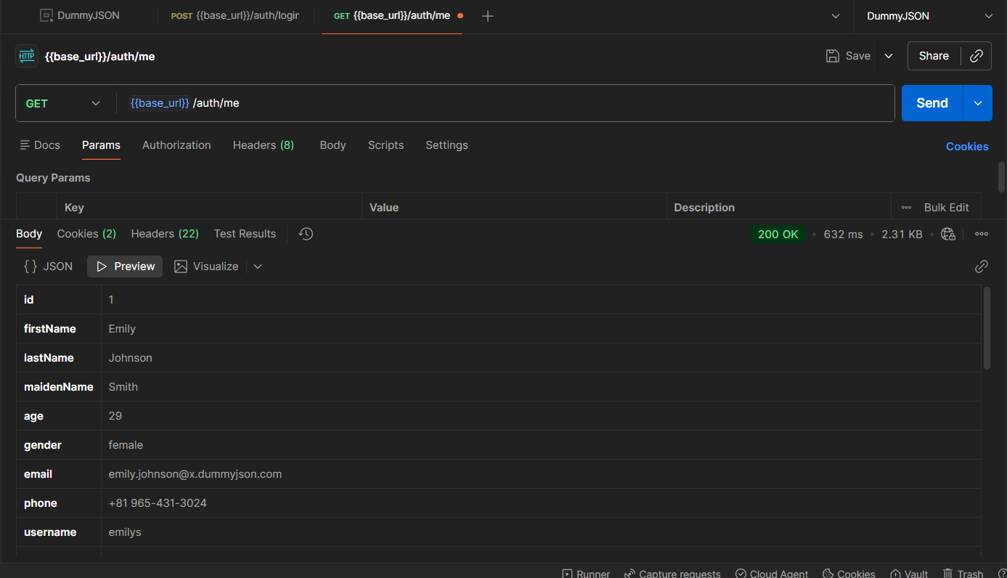

Add the automation: - put it at collection level.
Do this:
Right-click → DummyJSON → Edit → Pre-request Script

// Auto login if token not available
if (!pm.environment.get("token")) {
pm.sendRequest({
url: pm.environment.get("base_url") + "/auth/login",
method: "POST",
header: {
"Content-Type": "application/json"
},
body: {
mode: "raw",
raw: JSON.stringify({
username: "emilys",
password: "emilyspass"
})
}
}, function (err, res) {
let json = res.json();
pm.environment.set("token", json.accessToken);
});
}

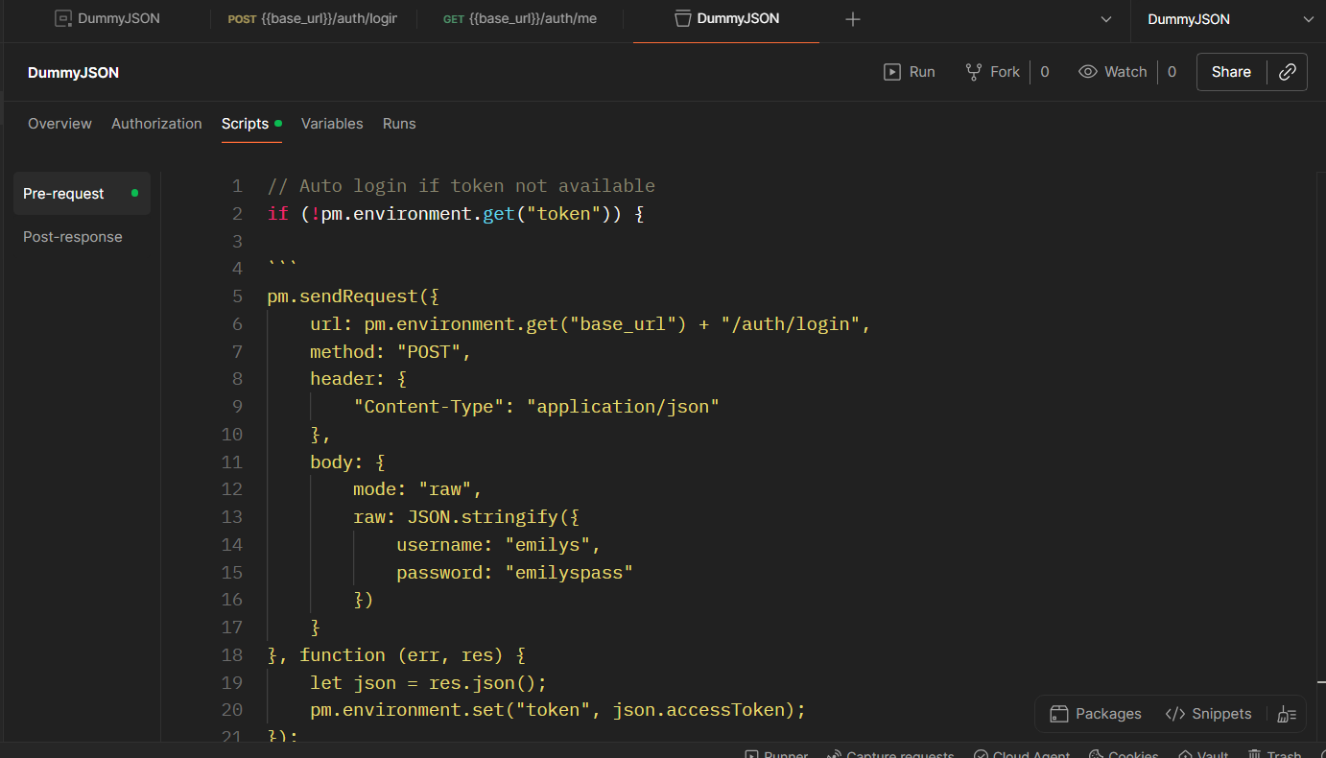

GET post: -
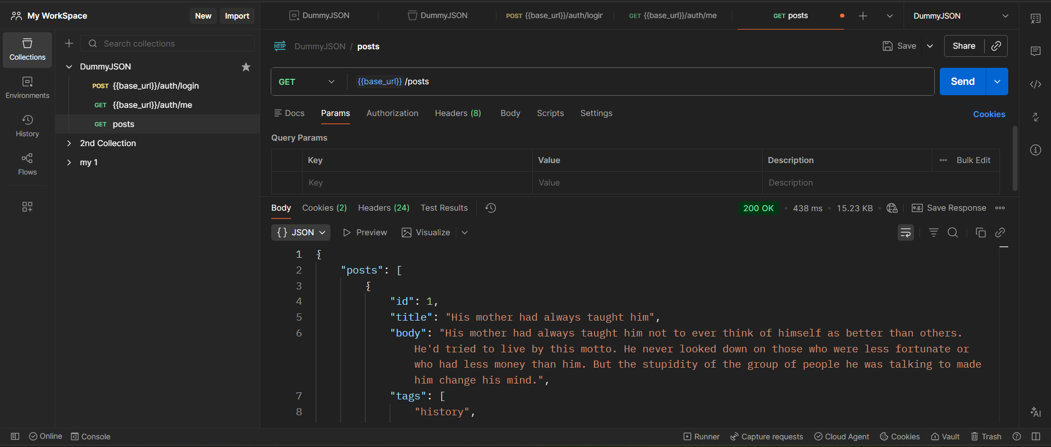

Get single post: -
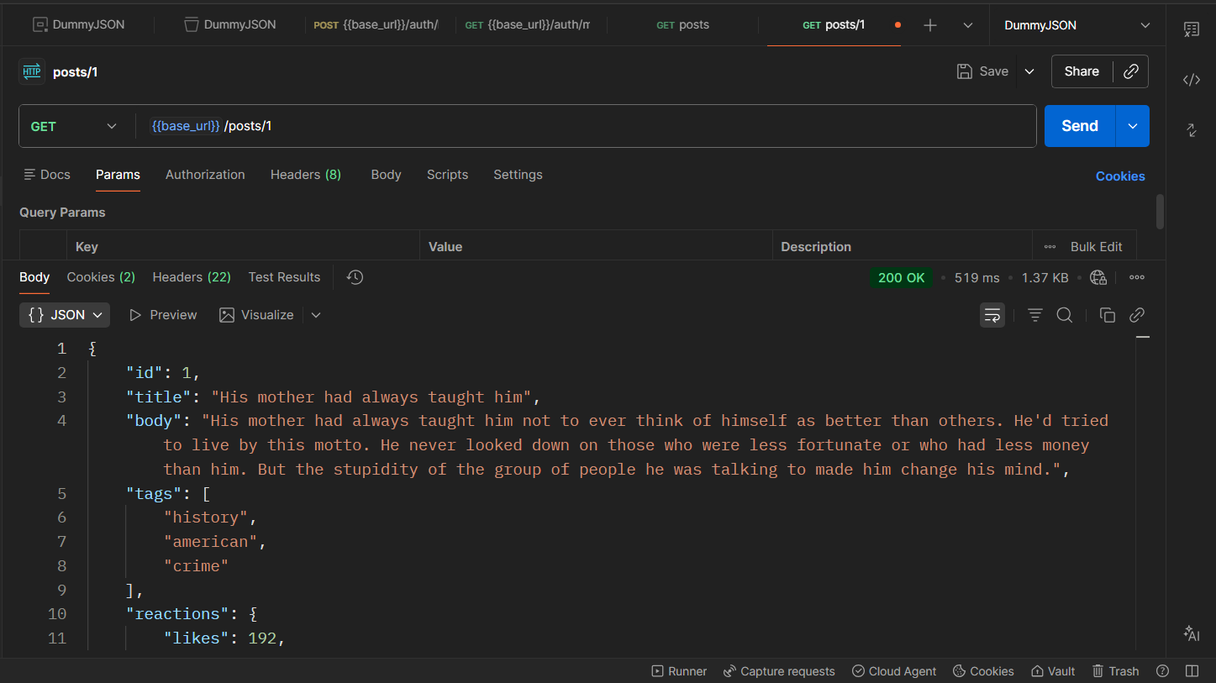

Create Post: -
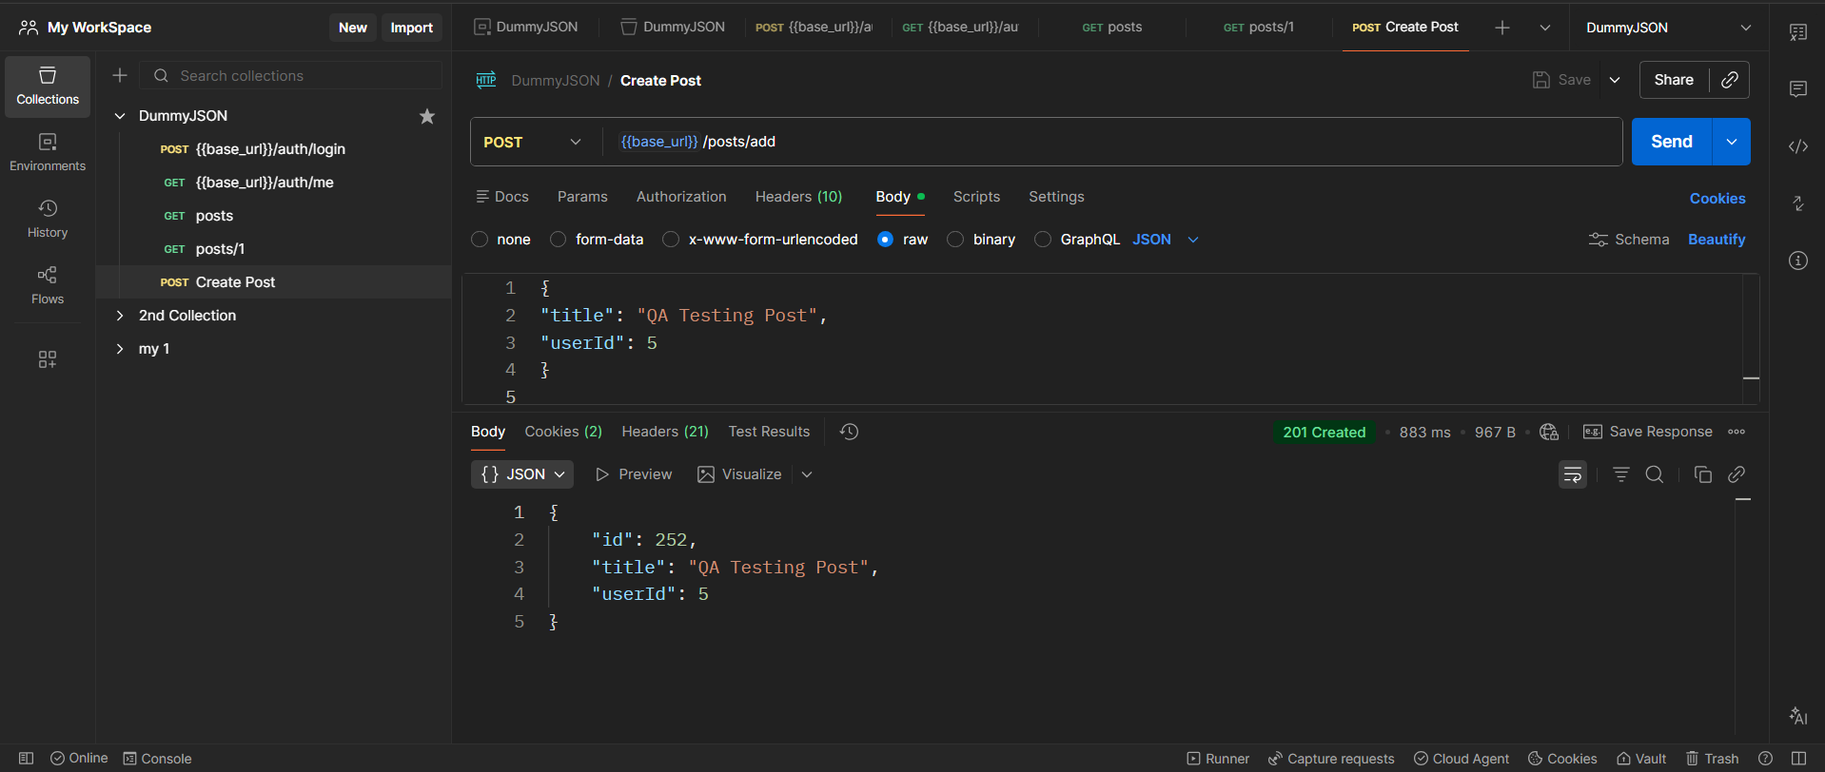

Update Post: -
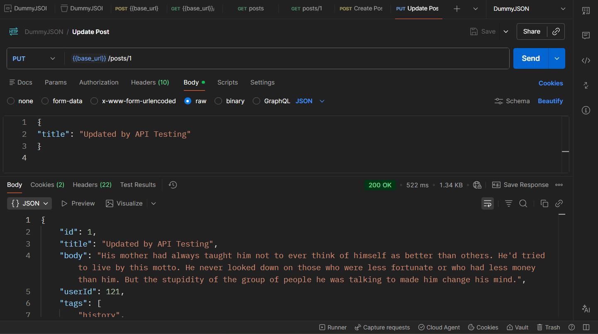

Test: -
Inside GET /posts/1 → Tests tab:
pm.test("Status code is 200", function () {
pm.response.to.have.status(200);
});
pm.test("Title exists", function () {
let data = pm.response.json();
pm.expect(data.title).to.exist;
});
pm.test("Response time < 2 seconds", function () {
pm.expect(pm.response.responseTime).to.be.below(2000);
});

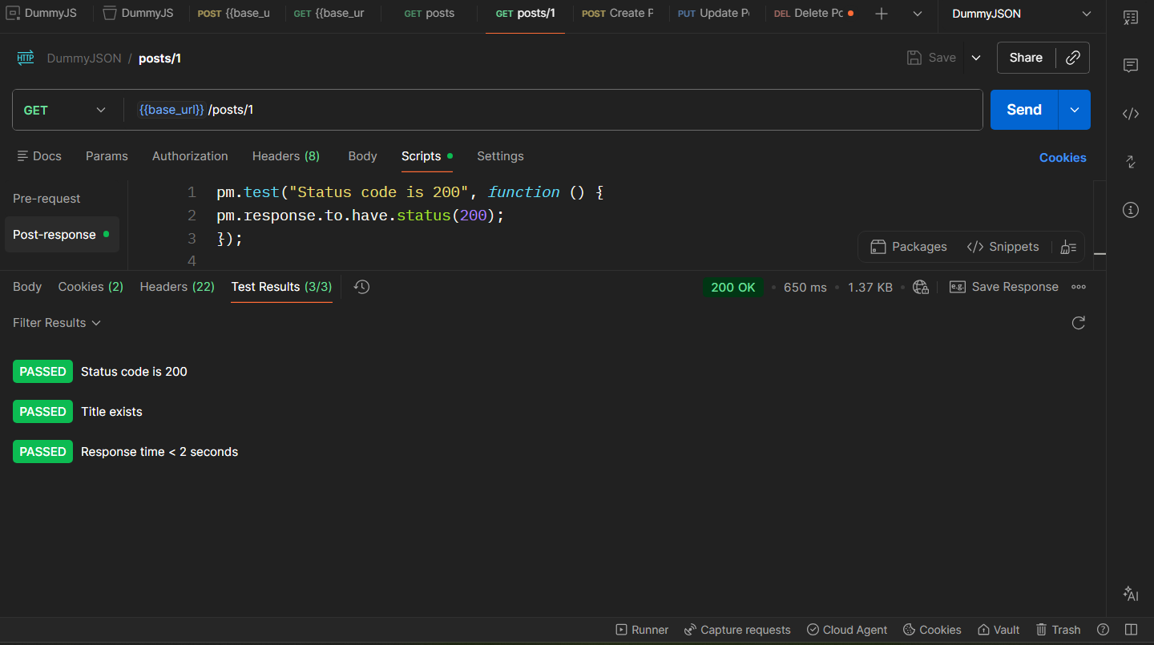

Delete: -
Open your DELETE request → Tests tab
pm.test("Status code is 200", function () {
pm.response.to.have.status(200);
});
pm.test("Delete response returned", function () {
let json = pm.response.json();
pm.expect(json).to.be.an("object");
});
pm.test("Response time < 2s", function () {
pm.expect(pm.response.responseTime).to.be.below(2000);
});

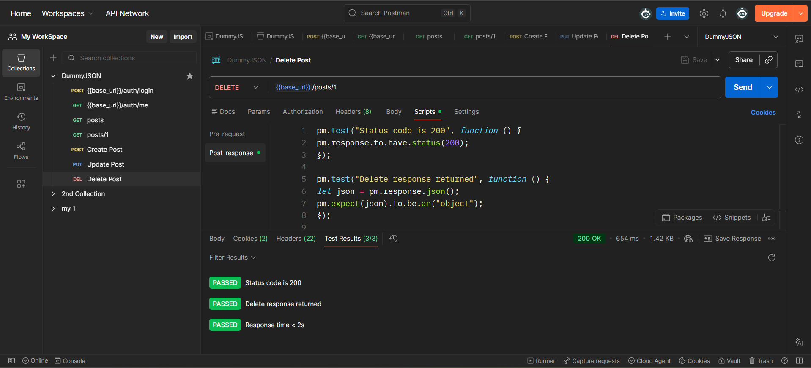

Negative Test: - (knowingly use false info)
POST {{base_url}}/auth/login
Body:
{
"username": "emilys",
"password": "wrongpass"
}
Test tab:
pm.test("Login should fail", function () {
pm.response.to.have.status(400);
});
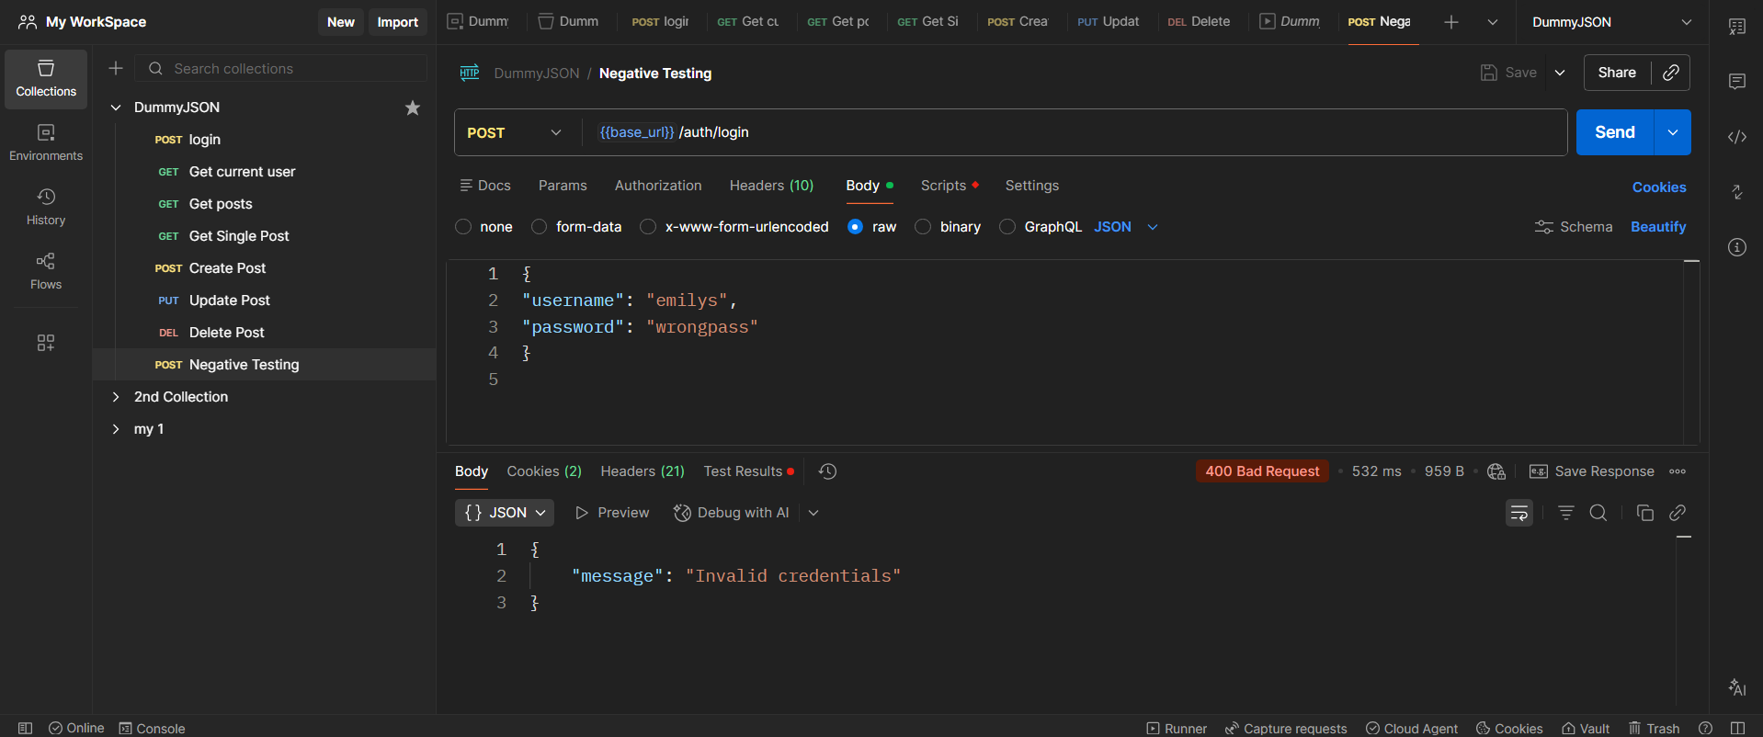

Name change Collection: -
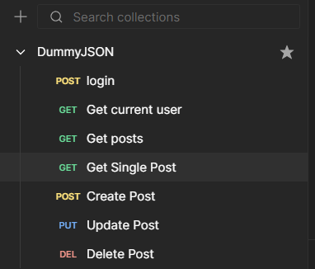

Performance Testing: -
Open any request(GET posts) → Tests
pm.test("Response time is under 1 second", function () {
pm.expect(pm.response.responseTime).to.be.below(1000);
});

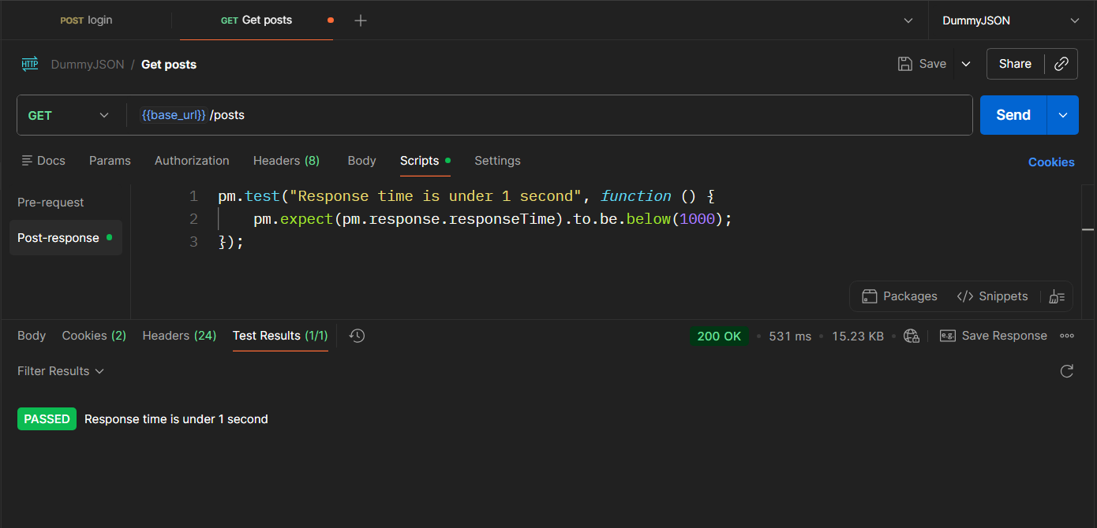

Functional Testing (Status Code + Data Validation): -
GET {{base_url}}/products/1 -> Test

pm.test("Status code is 200", function () {
pm.response.to.have.status(200);
});

let body = pm.response.json();

pm.test("Product has title", function () {
pm.expect(body.title).to.be.a("string");
});

pm.test("Product price exists", function () {
pm.expect(body.price).to.exist;
});
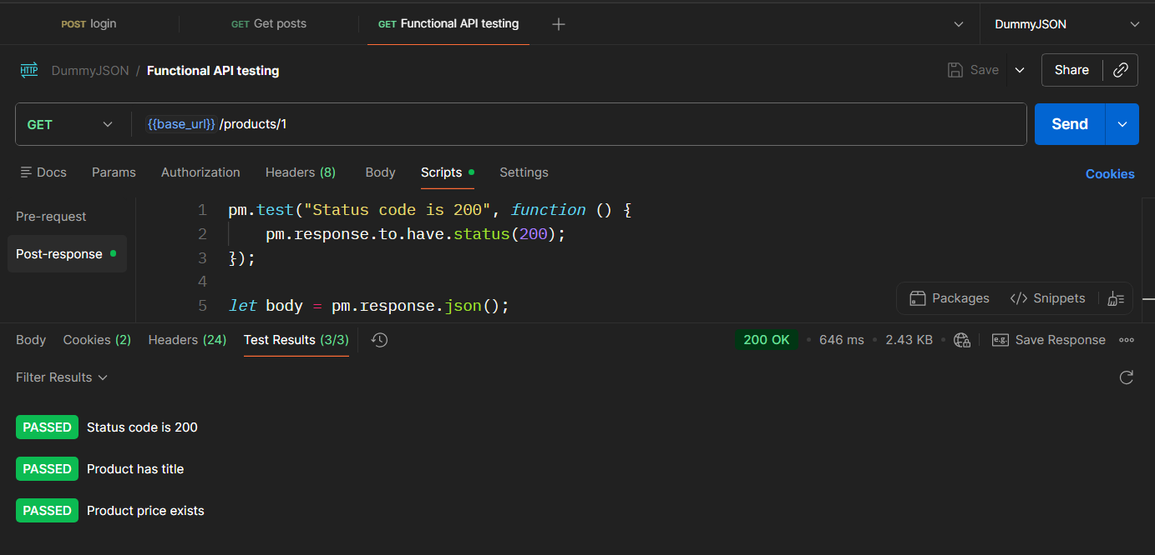

Schema Validation: -
GET {{base_url}}/products/1 -> Test

const schema = {
type: "object",
properties: {
id: { type: "number" },
title: { type: "string" },
price: { type: "number" }
},
required: ["id", "title", "price"]
};

pm.test("Schema is valid", function () {
pm.expect(tv4.validate(pm.response.json(), schema)).to.be.true;
});

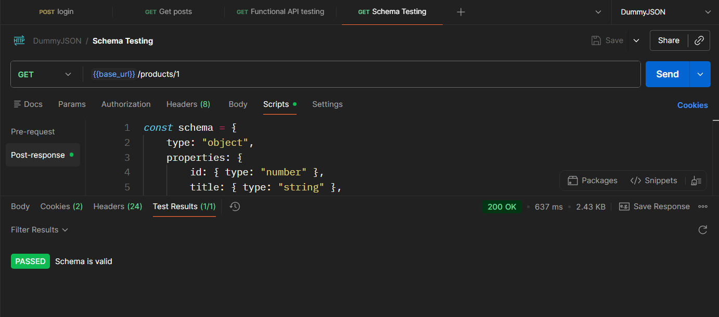

Edge case testing: -
GET {{base_url}}/products/999999

Test: -
pm.test("Should return 404", function () {
pm.response.to.have.status(404);
});

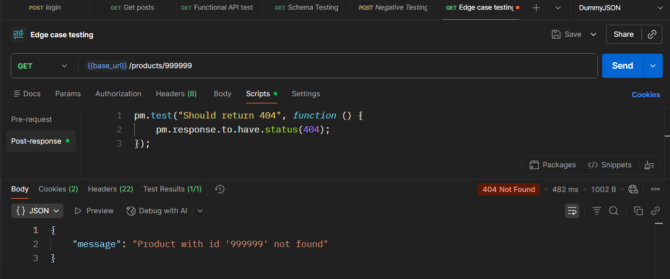
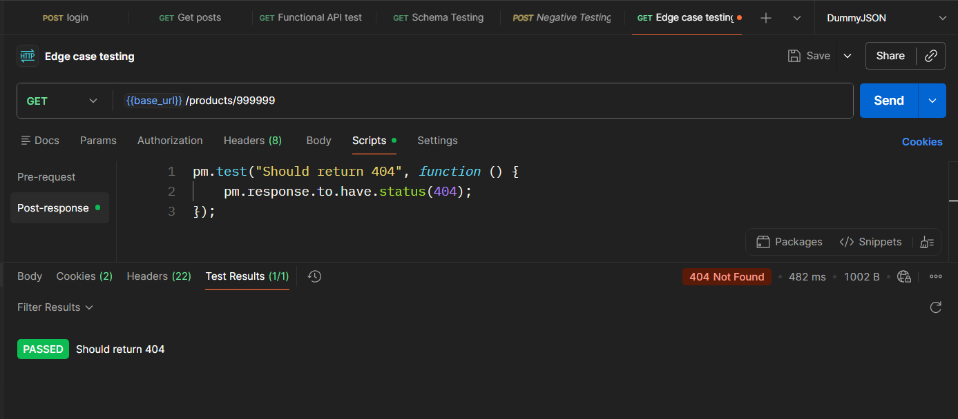

Security Testing — Invalid Token: -
GET {{base_url}}/auth/me

Header:
Authorization: Bearer abc123wrongtoken

Test:
pm.test("Unauthorized access blocked", function () {
pm.response.to.have.status(401);
});
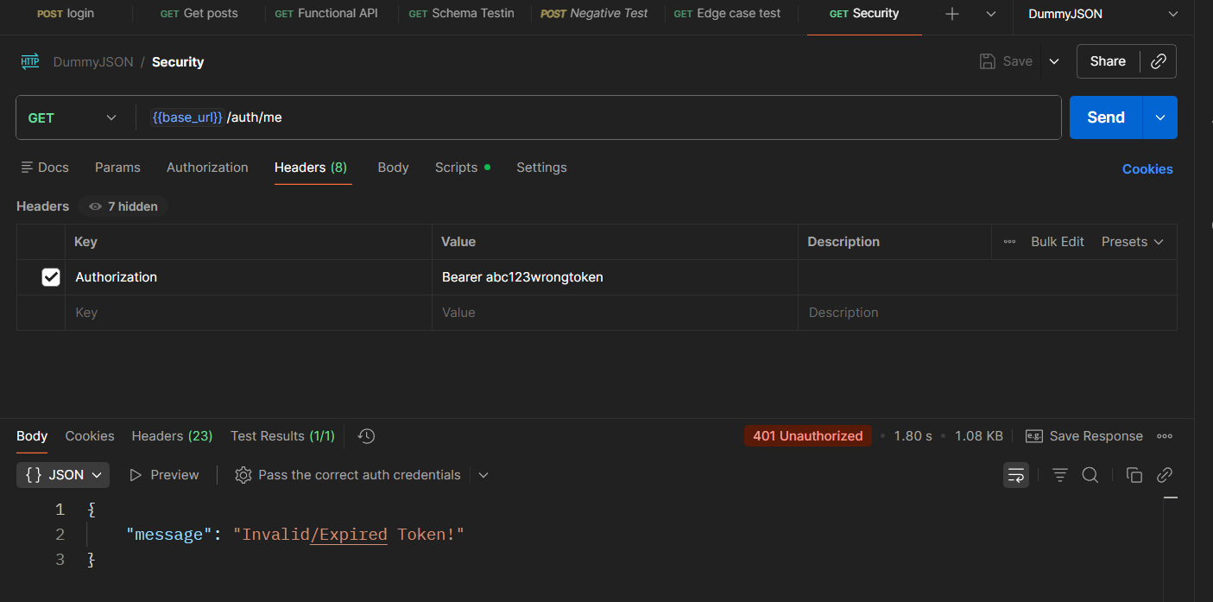
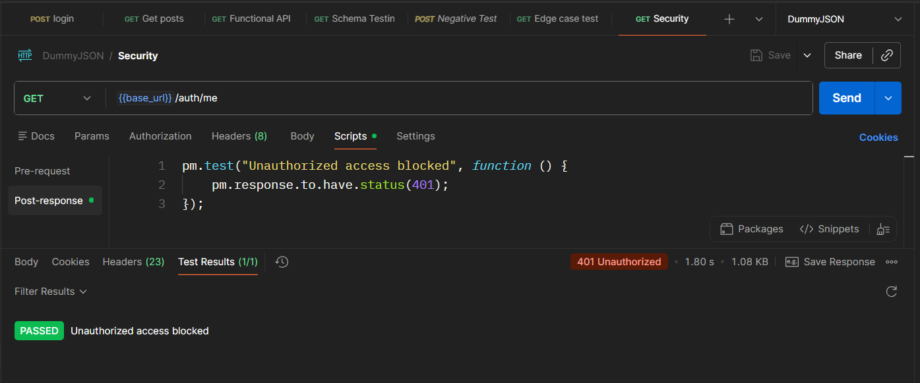

Run Collection: -
Top left → click Run (beside collection)
The Collection Runner window opens.
Select:
- Environment: your DummyJSON environment
- Iterations: 1
Then click:
Run DummyJSON

